ANGLAIS Préparation aux oraux : Que faire ce mois-ci ?
- SYNTHESIZE
Mettre à jour vos fiches thématiques sur les thèmes suivants :
- Racism and violence against African Americans (what is white supremacy? systemic racism? redlining? critical race theory? the end of Affirmative action in US colleges)
- Gender equality (pay gap, #metoo / Jean Carroll, Dobbs v. Jackson / threat on abortive pill, female political leadership, the (lack of) visibility of women in sports, the ‘Dad shift’ organization, SCOTUK’s controversial definition of a woman)
- Trump’s disruptive 2nd term (expanding executive power: challenging judges’ authority, challenging top universities’ authority, implementing mass deportation of illegal migrants, withdrawing military aid to Ukraine, undermining NATO and rules-based world order (Venezuela / Greenland / Cuba), upending global trade with his tariff war, interfering with European politics, straining the “special relationship” with the UK, quarrel with Pope Leo, voting rights in jeopardy, rewriting American history (minimizing past tensions between communities in the run-up to the 250th anniversary of America’s independence))
- Immigration (birthright citizenship, the Dreamers, ICE, the now-defunct Rwanda plan and the alleged “failure of multiculturalism” in the UK)
- Gun control (link this issue with the rise of political violence in the US! what still hinders gun control today? what is vigilantism? what are stand-your-ground laws? ghost guns? what is Gavin Newsom’s 28th amendment about?)
- Health (the NHS crisis, the opioid crisis, the murder of Brian Thompson and Sanders’s Medicare-for-all plan’s increasing popularity, e-cigarettes, Big Soda, the British ban on junkfood advertising)
- The rise of nationalism in the UK (a disUnited Kingdom? Sinn Fein in power in Northern Ireland, the SNP in power in Scotland, Plaid Cymru in Wales, the popularity of Reform UK in England, the death of a beloved queen + the BBC crisis = the end of a common British identity?)
- British monarchy: a fragilized institution ? (a sick king, an institution mired in scandals, Prince Andrew = a thorn in the side of the royal family?)
- Environmental concerns (COP 30 in Brazil/focus on the fight against deforestation, radicalization of environmental activism, rise of veganism among the young, lab meat, fast fashion, “Drill, baby drill”…)
- The world of work and business (telecommuting: here to stay? / the gig economy / the 4-day week v the hustle culture, the end of zero-hour contracts?, the revival of trade unionism)
- Higher education (student debt, Trump’s crackdown on student protests, British universities’ funding crisis, the “graduate premium” = a myth?)
- The media, social media (the “4th power” is weakening – job cuts in the BBC, Washington Post, etc… budget cuts for public media organizations, the rise of media behemoths = press freedom in danger? (ex: David Ellison buying Netflix/CNN), Facebook/Cambridge Analytica scandal, section 230, Musk/Zuckerberg, unlimited free speech vs “cancel culture”, the spread of fake news, Australia’s social media ban for people under 16)
- New technology (facial recognition systems, transhumanism: Neuralink, the spread of generative AI systems such as ChatGPT, AI 2027, AI actors / models / teachers = heightened fears around job displacement, deepfakes, driverless cars, the space race / Artemis II)
- The recognition of Indigenous rights (Australia, New Zealand, The United States, Canada…ex: King Charles replaced by aboriginal art on Australian $5bill)
- EU/UK relations (from Brexit to Bregret, Starmer/Macron heading “the coalition of the willing” to support Ukraine – a reset of EU/UK relations in a new geopolitical context)
- The economic and social crisis in the UK (ailing economy, housing crisis, rise of NEETs, rise of child poverty)
Useful sources for these revisions:
TLDR news for British politics / Last Week Tonight with John Oliver for American politics

Et apprendre noms, chiffres et dates par cœur + préparer 2 ou 3 problématiques sur chacun de ces sujets

- BRUSH UP ON
Some common acronyms :
DOGE, WHO, FDA, DOJ, BRICs, CCTV, EPA, GDP, a GP, an MA, an MP, an MEP, MIT, UCLA, NATO, an NGO, the NHS, a PhD, a PTA, VAT, a WASP… and many more !
Who is currently in power (name + party) in:
Scotland | Northern Ireland (Ulster) | The Republic of Ireland (Eire)
Canada | Australia | South Africa

The main news outlets’ political leanings (progressive or conservative views?)
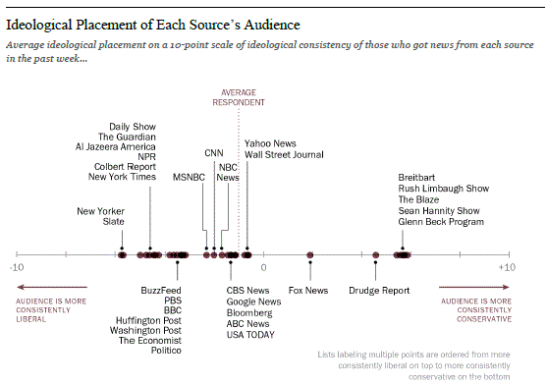

- KEEP ON IMPROVING YOUR SPOKEN ENGLISH
Reprenez vos feedbacks de colle de ces deux dernières années, listez vos fautes de phonétique récurrentes et travaillez la prononciation / l’accentuation de ces mots avec un camarade ou seul grâce à wordreference.com, ou youglish.com
- voyelles courtes ou longues: marquez bien la différence !
[i:]  [i]  [e]  [e]  [ei]  [æ]  [a:] | [i]  [e]  [ei]  [æ]  [ai]  [a:]  [ɒ] | leave / live  pin / pen  pen / pane  men / man  pane / pine  hat / heart  last / lost | sheep / ship  lid / led  sell / sale  bed / bad  mail /mile  match / march  sharp / shop | [ɒ]  [ɒ]  [ɔː]  [əʊ]  [ʊ]  [i:]  [ɪə]  [ɜː] | [ɔː]  [əʊ]  [əʊ]  [aʊ]  [u:]  [ɪə]  [eə]  [ʌ] | pot / port  cock / coke  law / low  no / now  full / fool  bee / beer  beer / bear  bird / bud | shot / short  not / note  ball / bowl  tone / town  pull / pool  fee / fear  cheer / chair  girl / gull

- veillez à bien prononcer la terminaison des verbes en –ed
 | p, t, k, f, s, ʃ, tʃ | jumped, liked, laughed, passed, pushed, searched…
 | d, t | added, hated, started, chatted, wanted…
 | autres sons et diphtongues | grabbed, hugged, lived, smoothed, dreamed, canned, pulled…

- travaillez cette liste de mots les plus souvent mal prononcés par les étudiants francophones :
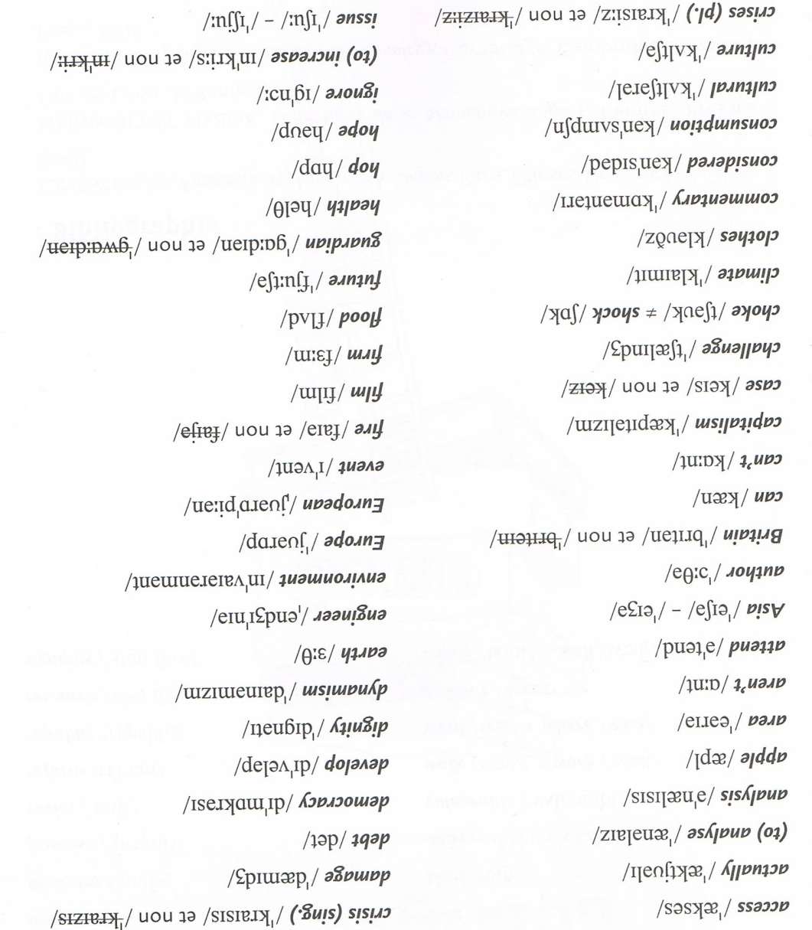
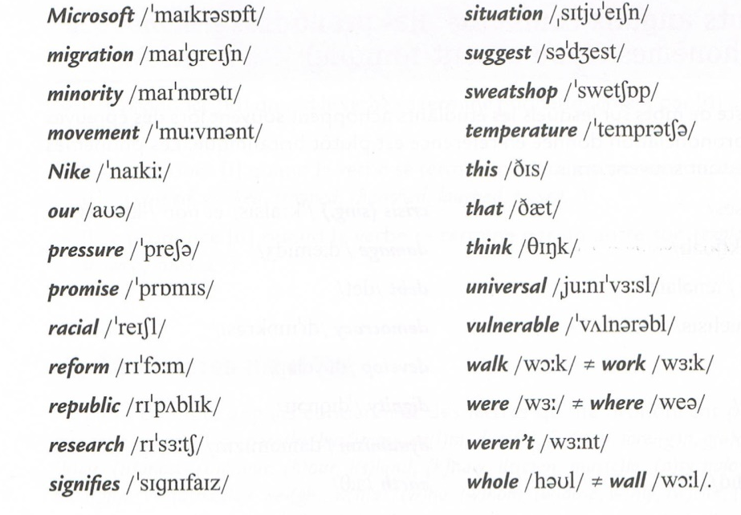

- LEXIQUE Révisez les faux-amis les plus courants :
ANGLAIS | TRADUCTION | Comment dirait-on… ?
NOMS

Affluence  Agenda  Bid  Bribe  Chance  College  Commodity  Demonstration  Drug(s)  Executive  Exhibition  Figure  Hazard  Journey  Lecture  Location  Occupation  Pensioner  Physician  Preservative  Relative  Résumé  Survey | richesse | l’affluence = the crowd
ADVERBES

Actually
Eventually
Fatally

VERBES

To abuse
To accomodate
To achieve
To advocate
To aggravate
To charge sb with
To attend
To deceive
To deliver (a speech)
To demand
To expose
To pass (an exam)
To purchase
To resign
To sympathize
ADJECTIFS

équilibré
doux
formidable
spectaculaire
raisonnable

GRAMMATICAL RECAP BEFORE D-DAY
Les erreurs courantes à éviter:
*The Mayor said ø the citizens → he said […] to the citizens BUT he told ø me [that …]
*A political man / a politic → a politician
*An economical crisis → an economic crisis
*The population is agree / is not agree → the population agrees with / disagrees with…
*The EU wants that Romania joins the union → The EU wants Romania to join the union
*It is different of / it depends of → it is different from / it depends on
*Pollution touches a lot of countries → Pollution affects a lot of countries
*The text speaks about → the text deals with / revolves around the notion of…
*To what extend → to what extent
*BRICs are knowing hyper inflation → BRICs are going through hyper inflation
*They have not / haven’t the same power as → they don’t have the same power as …
*The three first years → the first three years
*As states the journalist in the beginning of the article → As the journalist states in the beginning of the article…
*The poors / the youngs / the unemployeds → the poor / the young / the unemployed
*A such complicated situation → Such a complicated situation
*Labour promised to lift every British children out of poverty → every child
*The Great Britain recently voted out of the EU → Ø Great Britain recently voted out of…
*Brick-and-mortar shops have been struggling to compete with the e-commerce platforms → to compete with Ø e-commerce platforms

Règles d’or pour parler de chiffres :
Pour exprimer une tendance, il est possible d’utiliser :
Des nombres : three hundred and fifty, five million (invariables car précisément chiffrés), mais dozens of protesters, hundreds of animals, millions of people
Des fréquences : twice as much / many = ……………………….……….., three times as much/ many = ………………………………,
half as much / many = ……………………….…………………………………………..
Des périodes de temps = recently, over the past few years, in 2021, since 2008, for a long time, for years…
Attention aux prépositions : an increase in sales, a drop by 3%, an unemployment rate around 10%

READING NUMBERS
Lisez ces chiffres à haute voix :
- 1st, 2nd, 3rd
- The 10th, the 11th, the 12th
- The 100th
- 2/3
- 4/5
- 8 ½
- 7.9%
- 263
- 444
- 502
- 1000
- 6,921
- 850,000
- 2,579,138
- $14bn
- 1990
- January 23, 2014
- April 30, 2021
- The 20th century

Enfin, préparez-vous aussi à des questions personnelles dans l’entretien :
Comment parler de vos projets futurs ?
I plan on + V-ING / I intend on + V-ING / I look forward to + V-ING
Ideally, I’d love to join HEC / get into ESSEC as … / since …
My summer plans range from ….. to … (finally letting my hair down, travelling abroad with some close friends of mine, catching up on my favorite TV series, spending some quality time with my relatives, relaxing by the pool, wandering in Paris…)
In the near future, … but in the distant future / in the long term / in the long run…
I’m keen on working in the banking sector / the field of human resources / I(nformation) T(echnology)
I’ve always been fond of American independent cinema / classical music / travelling places

Write a few sentences to talk about your summer holidays / future school / ideal job / hobbies (pay attention to tenses):
Holidays …………………………………………………………………………………………………………………………………………………………………………………………….… ………………………………………………………………………………………………………………………………………………………………………………………………………………………………………………………………………………………………………………………………………………………………………………………………………………………………
Future school ………………………………………………………………………………………………………………………………………………………………………………………. ……………………………………………………………………………………………………………………………………………………………………………………………………………………………………………………………………………………………………………………………………………………………………………………………………………………………..Ideal job ……………………………………………………………………………………………………………………………………………………………………………………………… ………………………………………………………………………………………………………………………………………………………………………………………………………………………………………………………………………………………………………………………………………………………………………………………………………………………………
Hobbies ……………………………………………………………………………………………………………………………………………………………………………………………… ………………………………………………………………………………………………………………………………………………………………………………………………………………………………………………………………………………………………………………………………………………………………………………………………………………………………

