**Introductory class: The BRITISH INSTITUTIONS**

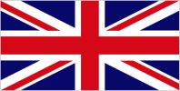

Use what you know and do some research to fill in the blanks in the following paragraphs and illustrations:

**Introduction:**

The United Kingdom is composed of **England, Scotland, Wales** (= Great-Britain) and **Northern Ireland (Ulster**).

Unlike the vast majority of countries, the United Kingdom has **NO** written constitution, so the political system is in constant evolution:

However, three texts constitute a basis for the working of the institutions:

* the **Magna Carta** signed in 1215
* the **Bill of Rights**, signed in 1689
* the **Act of Union** of 1707 (creation of the UK : England + Scotland)
* The **Acts of Union** of 1800 (creation of GB : England + Scotland + Ireland)

The Parliament in London is called “The **Mother** of Parliaments”, but three parts of the United Kingdom - Scotland, Wales and Northern Ireland - have a special status and have local administrations with a wide range of responsibilities, including a Parliament or an Assembly. This transfer of authority to the regions is called **devolution** and took place in the **1990s**.

Unlike in the USA or in France, there is no clear separation between the 3 “**arms of the state” (legislative, executive, judiciary)**

1. **The monarch: ‘reigns’, but does not ‘rule’**:

The United Kingdom is a **constitutional / parliamentary** monarchy. Therefore, since 1688 and the ‘Glorious Revolution’, the powers of the **monarch /king or queen** are limited by those of the **Parliament**: indeed, he/she must stay politically impartial and cannot vote.

Even if the monarch is Head of **State**, Head of the **Armed Forces**, Head of the **Church** of England, Head of the **Commonwealth**, his/her powers are mainly **ceremonial**.

**What are the functions of the monarch? - Appoints PM - Weekly meeting - « queen in parliament » : opens parliament (speech) and dismisses it  
- royal assent : signs laws - creates new peers and grants honours - « fountain of justice » - declares war – appoints bishops and archbishops**

1. **The legislative power** :

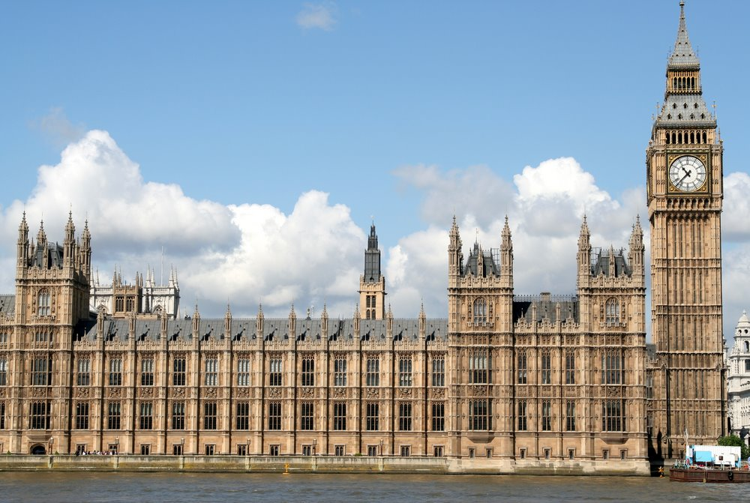

* How is the British Parliament often called? **Westminster**

How do you call a Parliament with two chambers? **bicameral**

It is divided into:

**Around 800 members (Peers): 92 hereditary peers + life peers (26 Lords Spiritual = bishops and Lords Temporal)**

**650 MPs (Members of Parliament)**

**Members** :

(name? number?)

**Elected in constituencies**

**General Election when called (maximum 5 years)**

**First-past-the-post system (simple majority)**

**Appointed by the monarch (proposed by the PM), except hereditary peers**

**Mode of election**?

Duration of term?

**Revise legislation and keep a check on government**

**Debate laws - Pass bills into laws – authorize taxes – can give the government a vote of no confidence**

**Powers** :

**In the Lower Chamber, what is the role of the Speaker? Who is currently Speaker? He is the chief officer of the House of Commons – Sir Lindsay Hoyle**

**What is a Front-bencher? What is a Back-bencher? A frontbencher is either a Government minister or an opposition Shadow spokesperson (sit in the front benches). A backbencher sits behind their parties’ spokespeople.**

1. **The executive power**

Who ? Mode of election / duration of term… Powers / Role

**Leader of government – responsible for the policies of the government**

**Chosen by the majority party after a General Election (5 years maximum)**

* Who is currently the Prime Minister? **Keir Starmer**

Where does he/she Live? **10 Downing Street**

What political party does he/she belong to? **The Labour party**

* What is the ‘Cabinet’ in the British System? **Body of senior ministers (PM + 20 ministers)**
  + un ministre: **a Secretary of State**
  + un secrétaire d’Etat: **a Minister of State**
  + un ministère: **a Department / Office**
  + le ministre de l’Intérieur : **Home Secretary : Yvette Cooper**
  + Le ministre des Finances: **the Chancellor of the Exchequer – Rachel Reeves**
  + Le ministre des Affaires Etrangères**: Foreign Secretary – David Lammy**
  + Le ministre de la Justice/ le Garde des Sceaux: **Lord Chancellor : Shabana Mahmood**

1. **The judiciary power**

Powers : **final court of appeal – hears appeals on arguable points of law of general public importance**

Number of members?

**12**

How are they called?

**Justices**

**What happened in 2009? Why? The Supreme Court was created, the judicial authority was transferred from the House of Lords to the Supreme Court (set in Middlesex Guildhall on Parliament Square) – for the judicial functions and the legislative functions of the House of Lords to be clearly separated.**