**DS2 ANGLAIS LVB**

**SAMEDI 7 décembre 2024**

**Type HEC (4 heures)**

**Consignes :**

**• écrire une ligne sur deux**

**• rédiger chacune des épreuves sur une feuille séparée**

**• indiquer le nombre de mots utilisés en fin de copie**

**CONTENTS**

**Document 1 –** “Trump’s dangerous attacks on rule of law have US historical precedents” ([Corey Brettschneider](https://www.theguardian.com/profile/corey-brettschneider), *The Guardian*, June 20, 2024)

**Document 2 –** “Politics is the law in Texas” (*The Economist*, May 23, 2024)

**Document 3 –** « Projet 2025 »(Alain Frachon, *Le Monde*, 30 mai 2024)

**Document 4 –** cartoon by Mike Smith (*Las Vegas Sunday*, 2024)

**Document 5 –** graph, “America’s trust in its institutions has collapsed” (*The Economist* , April 17, 2024)

1. **Compréhension - Résumé analytique comparatif (30/100)**

According to documents 1 and 2, why is the “rule of law”[1] increasingly threatened in the US?

Answer the question in your own words. (250 words +/- 10 %)

1. **Expression personnelle - Rédaction argumentée (50/100)**

Is it inevitable for politics to seep into[2] American institutions or should it be prevented at all costs to preserve democracy?

*Institution: an organization that exists to serve a public purpose such as education, support for people in need, the military, the judicial system, the national government, the voting system…*

Elaborate your personal opinions on this issue in your own words, supported by evidence and references drawn from documents 1-5 and at least two other pertinent cultural, civilizational or historical references from the English-speaking world (350 words +/- 10 %)

1. **Traduction (Thème) (20/100)**

Translate into English the two passages in bold letters (doc 3). Do NOT translate the title.

**Doc 1**

**Trump’s dangerous attacks on rule of law have US historical precedents**

* [Corey Brettschneider](https://www.theguardian.com/profile/corey-brettschneider), *The Guardian*, June 20th, 2024

Past politicians tried to undermine democracy. They failed because Americans refused to tolerate their wrongdoing.

Donald Trump’s threats to democracy – including his promise to govern as a dictator on “day one” and his refusal to abide by the norm of a peaceful transition of power – are often called unprecedented. While commentators and journalists are rightly focused on the danger of the moment, there are precedents for what we face today. A few examples, far from minimizing the current danger, show both how fragile American democracy has always been and how American citizens can fight successfully to save it.

The first example of a presidential threat to democracy came close to the founding. The second US president, John Adams, criminalized dissent and sought to prosecute his critics. (…) These cases were not just based on the hurt feelings of a thin-skinned president (although they were partly that). They came in response to reports that Adams’s party was attempting a kind of self-coup, not unlike the events of January 6. Specifically, when a newspaper editor published a plan that Adams’s Federalist party had developed to refuse to certify electoral votes for their opponents, Adams signed a retaliatory law that allowed for the punishment of critics of the president. (…)

The second example came more recently. Like Adams, Richard Nixon sought to silence his enemies, but not by signing a questionable law – by engaging in a criminal conspiracy. We know now that his plans included crimes well beyond those of Watergate (…)

The danger of presidencies like Adams’s and Nixon’s consisted not just of their attacks on legal and democratic norms. It also lay in the way they read the constitution to support an authoritarian vision of the presidency. Adams saw analogies between monarchs and presidents. (…) Nixon spoke of his vast domestic powers that were the result of what he saw as an ongoing civil war with student protesters – a view that led him to famously proclaim, in his interview with David Frost, that “when the president does it, that means that it is not illegal”.

In each of these three dangerous moments, however, American democracy fought back. During the Adams administration, the newspaper editors standing trial published stories about their own prosecutions to highlight Adams’s authoritarianism and to demand a right to dissent under the first amendment. (…) In the case of Nixon, journalists, rather than allowing themselves to be silenced, only grew bolder in criticizing the president. In fact, they used their own trials to expose Nixon’s abuses, just as newspaper editors had done under Adams. (…) Finally, the unknown citizens of Grand Jury One, convened in the Watergate trial, fought to gather the evidence of Nixon crimes, handing over information to Congress that led to his resignation. In stark contrast to Nixon’s authoritarian understanding of the constitution, these citizens emphasized the idea that no person, not even a president, was above the law.

These examples demonstrate that the danger to American democracy has always lain partly in the power of the presidency itself. At the founding, Anti-Federalists argued against ratifying the constitution on the grounds that presidential power was too vast and dangerous. (…)

Despite these precedents, however, there is one sense in which the current moment is uniquely dangerous. In these past examples, authoritarian presidents were cast into the dustbin of history, lacking the political power to continue their constitutional abuses. This time, a president who threatened democracy is doubling down, and we risk seeing him take office once again.

The current threat is also unique in that Trump has learned from his previous term where the choke points of American democracy lie. (…) Trump understands, for instance, that with a loyalist attorney general, he might never face accountability for his crimes. (…) Thanks in part to sympathetic justices he appointed, he might be immunized by the supreme court for any future crimes committed in office as long as these crimes are construed as “official acts”. While Nixon eventually resigned under threat of impeachment and indictment, Trump withstood two impeachments with no hint of even remotely backing down. Unlike Nixon, Trump not only shamelessly refused to resign but has continued his assault on democracy.

So, what can we learn about the threat of the moment from these historical examples? One lesson is clear: we the people are ultimately responsible for rescuing democracy and our democratic constitution. (…)

First, we should demand the legal accountability Nixon escaped. The jury in Trump’s New York case has made the first step here. And that legal accountability should continue in the other cases against the president.

Second, and most importantly, the American people need to seek accountability at the ballot box. This election (…) is a referendum on the future of self-government. In those past moments, the American people rejected authoritarianism and voted for presidents who sought to restore fundamental pillars of American democracy that were under threat.

Today, we must persuade our fellow Americans to do the same.

**Doc 2**

**Politics is the law in Texas**

* *The Economist*, May 23rd 2024

A governor’s pardon implies that courts cannot be trusted, just as Donald Trump says.

An American military veteran was killed in the street, presumed to pose a threat when he was exercising his right to carry a gun in public. You might expect America’s gun-rights advocates to demand justice for the dead man.

But here’s a bit of important context: when he was killed, that man, Garrett Foster, was marching in a Black Lives Matter (BLM) protest in Austin, Texas, in July 2020. The person who shot him, Daniel Perry, was sentenced to 25 years in prison for murder. On May 16th Governor Greg Abbott pardoned Mr Perry, saying he acted in line with Texas’s “stand your ground” law, which allows people to use deadly force if they feel threatened.(…)

To jump to the bottom line: whether or not you believe Mr Perry to be innocent, one lesson of this case, a bitter one, is that to be confident of getting justice under the law in Texas you must have political power. That is not just what Foster’s family has concluded. It is what the governor himself implied in voiding the conviction. He said Mr Perry was the victim of a district attorney who demonstrated “unethical and biased misuse of his office” in undertaking the prosecution.

In his proclamation justifying the pardon, Mr Abbott, a Republican, noted that Mr Perry was driving “on a public road” when he “encountered a group of protesters obstructing traffic” who pounded and kicked his car. He did not mention that witnesses testified under oath that Mr Perry accelerated into the protesters after running a red light. Mr Abbott said that Foster approached within 18 inches and “brandished a Kalashnikov-style rifle in the low-ready firing position”. He did not mention that Foster was acting legally, under Texas’s “permitless carry” law (…)

The governor did not mention that in the weeks before the killing, as Mr Perry posted racist complaints on social media about BLM (“like a bunch of monkeys flinging shit at a zoo”), he mused about killing rioters or looters. (…)

In his proclamation, the governor noted that the Texas Board of Pardons and Paroles recommended the pardon. Mr Abbott did not mention that the board acted unusually fast—not waiting for the appeals process—or that he had appointed all its members. He did not mention that he pledged to pardon Mr Perry the day after he was convicted, after Tucker Carlson, then a Fox News host, accused the governor of disregarding the right of self-defence.

Mr Abbott accused the district attorney, José Garza of Travis County, of directing an investigator to “withhold exculpatory evidence” from the grand jury that indicted Mr Perry. The governor did not mention that the judge in the case concluded that this accusation did not merit pursuing. But, then, like district attorneys, judges in Texas are elected, and Travis County includes the liberal city of Austin. The judge is a Democrat. Mark Jones, a professor at Rice University, says Mr Perry’s conviction was “in the most liberal county, overseen by a liberal Democratic judge, and overseen by the most progressive prosecutor in the state. Put all those things together, and that’s like waving a red flag in front of Republicans.”

Mr Abbott issued his pardon at a politically opportune moment, just before early voting began in Republican-primary run-offs in which he is pushing candidates who will support his legislative priorities. For their part, Democrats, who have not won statewide since 1994, have little political reason to make a fuss about the pardon. “​​The crossover voter is not necessarily wild about BLM protesters,” Mr Jones says.

All the more reason the rule of law, and perceptions of justice, should stand apart from politics. Mr Perry was convicted by a jury of his peers, the bedrock unit of the American legal system. The jury weighed all this context, including Mr Perry’s claims. That also went unmentioned in Mr Abbott’s proclamation. But maybe Texans believe a Travis County jury cannot be fair, just as Donald Trump has insisted a New York jury considering his criminal case cannot be fair to him. Politics, and assumptions about politics, are seeping into every American institution, and so is cynicism about what chance ideals of fairness have against the realities of power.

**Doc 3**

**Le candidat républicain, favori des sondages pour la prochaine présidentielle, a préparé avec ses troupes un « Projet 2025 » destiné à établir la prépondérance absolue du président**

* Alain Frachon, *Le Monde*, 30 mai 2024

Les Etats-Unis sont-ils immunisés contre la tentation autoritaire ? La question était posée, le 18 mai, en couverture de l’hebdomadaire *The Economist* – « Is America dictator-proof ? »(« L’Amérique peut-elle résister à une dictature ? »)*.* Cette seule interrogation portait la marque d’une forte appréhension. Qui a un nom : Donald Trump.

(…) Trump s’avance à visage découvert et multiplie les signaux qui vont tous dans un sens : la possibilité que l’ancien animateur de télé-réalité, de retour à la Maison Blanche, oriente la démocratie américaine vers le type dit « illibéral ».Ce qui ramène à la question de *The Economist*:les institutions et les pratiques politiques de l’Union protègent-elles les Américains d’un glissement progressif vers un régime « à la hongroise » ? Dans ce modèle, une fois les élections remportées, le chef de l’exécutif gouverne sans contre-pouvoirs. Entre deux scrutins, il est propriétaire de l’Etat.

(…) **Président de 2016 à 2020, l’homme à la casquette rouge supportait mal la nécessité du compromis démocratique. Il était allergique au jeu des pouvoirs et contre-pouvoirs imposé par la Constitution américaine. Avec l’appui de la Fondation Heritage, les trumpistes ont cette fois préparé un « Projet 2025 » destiné à établir, au moins dans la pratique, la prépondérance absolue du président – en lieu et place du dialogue permanent avec le Congrès voulu par les Pères fondateurs. L’équipe Trump sélectionne d’ores et déjà des milliers de collaborateurs, qui doivent, au préalable, signer un contrat de loyauté à son égard. (…)**

A quelles fins ? Le républicain entend créer des camps pour y interner les millions de travailleurs illégaux avant de les expulser. Il utilisera l’armée pour réprimer les émeutes urbaines. Il fermera les agences administratives indépendantes. Il placera le département de la justice sous contrôle. Il poursuivra ses opposants, *« de la* *vermine à déraciner »*, et *« s’en prendra »* aux médias, ces *« ennemis du peuple »*. *(…)*

Ne dramatisons pas, disent les optimistes, les institutions feront barrage. S’il est élu, ce sera à quelques milliers de voix près. Il n’aura pas la majorité dans les deux Chambres du Congrès – inutile d’imaginer les supermajorités nécessaires à l’amendement de la Constitution. Les juges ont bridé Trump de 2016 à 2020, ils agiront de même dans l’hypothèse d’un deuxième mandat. Trump II dégradera la mécanique de la démocratie libérale, il ne l’enraiera pas.

On se rangerait plus volontiers à cet argumentaire si les institutions, précisément, n’avaient pas déjà failli dans leur défense de la démocratie. Qu’il s’agisse du Congrès ou de la Cour suprême, elles ont trahi leur mission. **Passivité, complicité volontaire ou pas, elles sont responsables d’une étonnante anomalie politico-juridique : l’homme qui, le 6 janvier 2021, alors qu’il est encore à la Maison Blanche, a appelé ses partisans à *« marcher »* sur le Congrès pour empêcher la certification du scrutin de novembre 2020, gagné par Joe Biden, cet homme-là peut guigner à nouveau la présidence.**

*« Le seul fait qu’il puisse être candidat est une insulte à l’Etat de droit »*, dit l’essayiste républicain Bill Kristol sur [le site de la journaliste Christiane Amanpour](https://www.youtube.com/watch?v=dgYZzhqD3aA). Trump savait qu’il avait perdu l’élection, ses proches le lui ont dit et répété. Mais les élus républicains, collant lâchement au grand mensonge d’une élection « volée », ont fermé les yeux. Ils ont ainsi neutralisé une procédure en destitution qui aurait rendu le boss MAGA (« Make America Great Again ») inéligible.

Accédant à une requête de Trump, les supposées vestales impavides de la Constitution que sont les juges de la Cour suprême n’ont pas fait mieux. Ils doivent se prononcer sur le point de savoir si l’appel à l’émeute du 6-Janvier est couvert par l’immunité présidentielle ! En attendant leur verdict, les plus graves inculpations criminelles dont Trump est l’objet – son rôle dans ces événements – ne donneront pas lieu à procès avant le 5 novembre. L’encadrement institutionnel censé protéger la démocratie a de facto légitimé la deuxième candidature d’un fraudeur en série. Qui se trouve être aussi un autocrate en puissance.

**Doc 4**

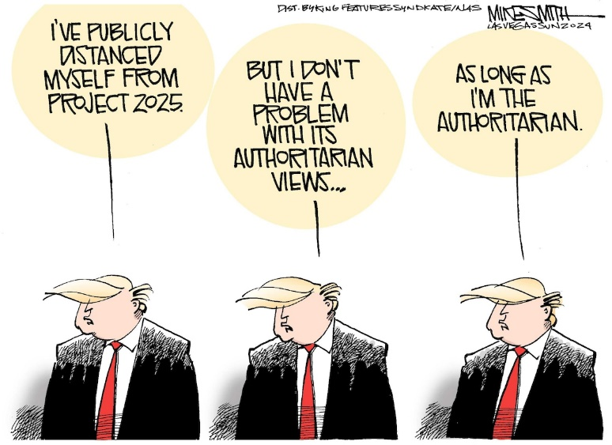

**Doc 5**

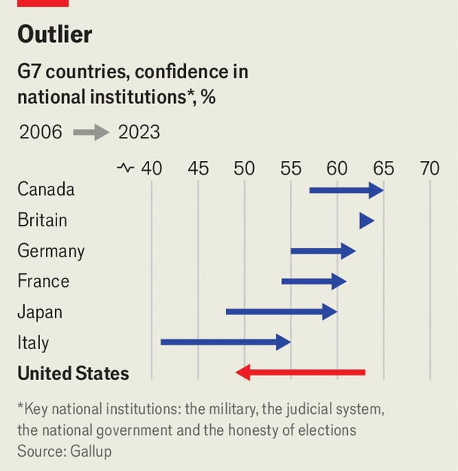

1. The rule of law = l’état de droit
2. To seep into = s’insinuer, s’infiltrer