**Paris’s stunning vision for the Olympics wins a gold medal**

* *The Economist*, Aug 10th 2024 | Paris

[Europe](https://www.economist.com/europe) | Le feel-good games

**It marks a shift away from sporting gigantism**

THE PARIS games are drawing to a close on a note of *ferveur olympique* in the French capital. Once sceptical, the French have been won over, both by the performance of their athletes, [who won](https://www.economist.com/europe/2024/08/01/the-olympics-are-teaching-the-french-to-cheer-again) more medals than at any previous Olympics, and the sheer beauty of the capital’s backdrops. The sight of BMX freestyle riders in the air above the Place de la Concorde, or triathletes finishing before the golden-domed Invalides, wowed spectators at home and abroad. So when Paris hands over the Olympic flame to Los Angeles, the host in 2028, at the closing ceremony on August 11th the city will transfer both a sporting symbol and a challenge.

Unlike aloof Parisians, sports-mad Californians will need no nudge to get behind their own games. As recently as April, according to a poll, the single most-frequent word used by the French to describe their attitude to the Olympics was “indifference”; only 19% declared themselves “proud”. But once the games got under way, and the medals flowed in, the French went wild. They found new heroes, notably Léon Marchand, the 22-year-old swimming champion and five-time medallist. Crowds have broken out into spontaneous renditions of *La Marseillaise* at any excuse, including the nightly rise into the sky of the Olympic cauldron beneath a golden helium balloon. Parisians who had fled their city, like Londoners in 2012, began to regret it.

What Paris and Los Angeles share, by contrast, is the principle of hosting the games with minimal new build. Fully 95% of the venues used for the Paris Olympics were already in place or temporary. The only new permanent sports facility was the stylish aquatics centre. It was built in the scruffy neighbourhood of [Seine-Saint-Denis](https://www.economist.com/europe/2024/03/31/the-new-geography-of-paris), and designed for local use afterwards. This has helped keep the overall cost of the Paris Olympics to an estimated €9bn, €2.3bn of which has come from the public purse; the rest has come from ticket sales, TV rights and sponsorship. This is less than the cost of Tokyo, Rio de Janeiro, London, Beijing or Athens, the five previous Olympic hosts. As Marie Barsacq, director of legacy at the Paris organising committee, put it: “the era of gigantism is over.” In line with this new mood, Los Angeles plans to stage the games without building a single new permanent sports facility. […]

In another respect, too, France has done what less imperious countries would not dare: closed down the capital’s centre for weeks and transformed it into a giant pedestrian sports arena. A vast stretch of Paris, from the Eiffel Tower to the Place de la Concorde, has been turned over to events in pop-up stands, from fencing and archery to skateboarding and beach volleyball. At the price of grumbling by residents and restaurant-owners, this has delivered spectacular scenery. In 2028 Los Angeles may have showbiz and glitz; in 2024 Paris has done historic elegance.

As ever, there have been criticisms: of the lack of air-conditioning (Paris wanted a “green” games); of the food in the athletes’ village (not enough meat, oddly for the French); of the cleanliness of the Seine (which only just passed the health test); of the cost of *steak-frites* in local brasseries (prices up by as much as 36%, according to an investigation by *Le Parisien*).  Barring last-minute incidents, however, when the closing ceremony takes place in the Stade de France, featuring stunts by Tom Cruise in a nod to Hollywood, it will be a moment for the French to feel rightly chuffed. They have managed to pull off *un feel-good* games, which has lifted the mood at home, and impressed spectators far beyond. ■

**VOCABULARY**

Find synonyms for the underlined words in the text

-

-

-

-

-

-

-

-

-

-

-

-

-

**COMPREHENSION**

1. What is the main feeling conveyed by the journalist about the Paris Olympics? Why?

………………………………………………………………………………………………………………………………………………………………………………………………………………………………………………………………………………………………………………………………………………………………………………………………………………………………………………………………………………

1. How will Los Angeles 2028 compare with Paris 2024 according to them?

………………………………………………………………………………………………………………………………………………………………………………………………………………………………………………………………………………………………………………………………………………………………………………………………………………………………………………………………………………

1. What about you, how did you feel about the Olympic Games? Indifferent, enthusiastic, proud, frustrated, angry…? Did your initial opinion change over time? Chat with your neighbour and compare your perspectives on the Games in a short paragraph using words such as *both, unlike, similarly to, whereas, while*…

……………………………………………………………………………………………………………………………………………………………………………………………………………………………………………………………………………………………………………………………………………………………………………………………………………………………………………………………………………………………………………………………………………………………………………………………………………………………………………………………………………………………………………………………………………………………………………………………………………………………………………………………………………………………………………………………………………………………………………………………………………………………………………………………………………………………………………………………………………………………………………………………………………………………………………………………………………………

1. Focus on the following cartoons : if you had to pick the worst scandal of these Olympics, which one would it be? (be ready to justify your answer)

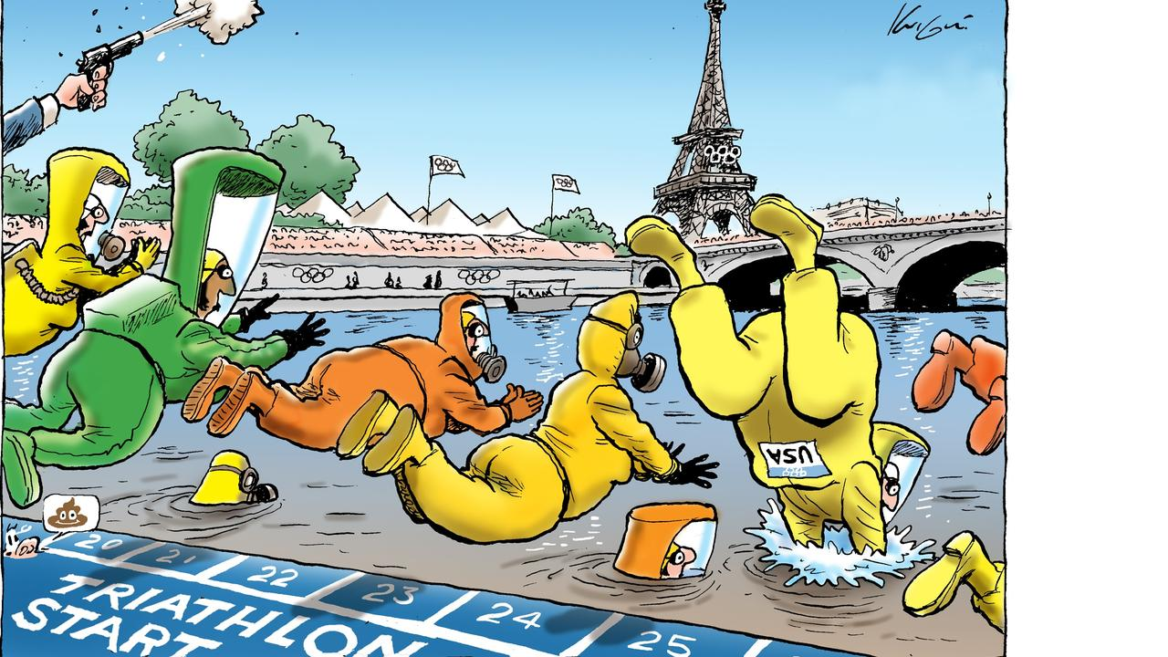

Mark Knight, August 4, 2024 Adam Zyglis, August 4, 2024

………………………………………………………………………………………………………………………………………………………………………………………………………………………………………………………………………………………………………………………………………………………………………………………………………………………………………………………………………………