Donald Trump is battling America’s elite universities—and winning
Briefing | Besieging the ivory tower
The Ivy League sees little point in fighting the federal government in court
Apr 10th 2025|WASHINGTON, DC
THIS WAS not a hidden plot, but an open plan. In the eyes of the right, America’s elite universities are guilty of a litany of sins: they propagate illiberal, left-wing ideas; they exclude or censor those who question woke views; they discriminate against the majority in the name of diversity, equity and inclusion (DEI); they allow antisemitism to fester. Before Donald Trump’s second term as president began, conservative activists had laid out in considerable detail the retribution they were preparing to exact for these misdeeds.
The retribution is now under way. Mr Trump’s administration has withheld hundreds of millions of dollars in federal grants from prestigious schools, mostly in the Ivy League, and threatened to yank billions more. It has rescinded visas for students who participated in pro-Palestinian protests last year, in some cases by having plainclothes officers grab them on the street and push them into unmarked cars. It has capped overhead costs for scientific research in ways that have already led to thousands of lost jobs. Other levers, over access to federal student loans, for instance, have not even been pulled yet.
The letter, not the law
Every university president in America dreads the arrival of “the letter” from the administration. The first was sent to Columbia University on March 13th, shortly after $400m of grants were withheld. To win the money back, the letter demanded that Columbia expel certain students who participated in protests, reform its admissions policies and place its Middle Eastern studies department into “academic receivership”. The university capitulated to all the demands. Its president, herself a stand-in, resigned a week later. “The Columbia opening salvo was incredible to me,” says Chris Rufo, a prominent culture warrior. “It’s almost unbelievable how weak, feckless, and pathetic these folks have been.”
More shakedowns have followed. On March 19th Christopher Eisgruber, the president of Princeton University, wrote in the Atlantic that the Trump administration’s actions presented “the greatest threat to the American universities since the Red Scare of the 1950s”. That may be an understatement: Joseph McCarthy, who hounded suspected communists, was a mere senator, without the weight of the federal government behind him. In late March the federal government informed Princeton that it was suspending research grants worth $210m, ostensibly because of antisemitism. On April 3rd a letter from the government arrived at Harvard threatening $9bn-worth of grants unless the university scrapped its DEI programmes and reformed “departments that fuel antisemitic harassment”. This week $1bn in funding for Cornell and $790m for Northwestern was frozen.
Disdain for elite universities is not new to the American right. Ronald Reagan won the governorship of California in 1966 by pledging “to clean up the mess at Berkeley” and clear out the “beatniks, radicals and filthy speech advocates” who had “brought such shame” to the flagship state university. But the long-running antagonism has gradually intensified as education has become more of a dividing line in American politics, with university graduates tending ever more strongly to vote Democratic. In the 1970s there were fewer than two academics who described themselves as liberal for every conservative. Four decades later the ratio was six to one.
To err is humanities
Humanities faculties, in particular, have championed ideas unpopular with ordinary voters: that American society is structurally racist, for example, or that everyone has a “gender identity” unrelated to their sex. Trust in universities has dropped precipitously over the past decade. In 2015 nearly 60% of respondents told Gallup, a pollster, that they had a great deal of confidence in higher education. That has since fallen to 36%, almost the same proportion as say they have “very little” or “no confidence”. Republicans are especially critical; only 20% of them express faith in universities, compared with 56% of Democrats.
“The isolation of the academy writ large, from the whole of society, is at the root of a lot of these problems,” says Greg Weiner, the president of Assumption University. Loud and lengthy protests against Israel’s war in Gaza over the past 18 months have further cemented the idea that campuses are out of kilter with mainstream opinion—and given the right an opportunity to attack universities for not doing enough to make Jewish students and faculty feel safe.
The administration has been using supposed antisemitism as grounds to demand reforms. “In some cases, these are not just unconstitutional demands, but there is also no statutory authority for them,” says Jameel Jaffer, a professor of law and journalism at Columbia University. Mr Jaffer points out that Title VI of the Civil Rights Act, which the administration has invoked on behalf of Jewish students and faculty, does allow for sanctions—but only after a formal investigation. Even then, “The remedial measures have to be limited to the programme found to be in violation.”
The withdrawal of grants could also be challenged. Universities might argue that the conditions the administration is imposing for their restoration amount to unconstitutional coercion. In 1967 in Keyishian v Board of Regents, the Supreme Court found that academic freedom is “a special concern of the First Amendment, which does not tolerate laws that cast a pall of orthodoxy over the classroom”.
The deportation of foreign students involved in protests is of dubious legality, too. In Bridges v Wixon in 1945 the Supreme Court affirmed, “Freedom of speech and of the press is accorded aliens residing in this country.” The Trump administration has explicitly rejected this idea. In its deportation proceedings against Mahmoud Khalil, a Palestinian graduate student at Columbia involved in protests against the war in Gaza, the administration is citing a seldom-used law allowing the secretary of state to cancel visas for migrants whose continued presence could yield “potentially serious adverse foreign-policy consequences”. The Supreme Court has never opined on this law, but in 1996 in Massieu v Reno, a federal district judge struck it down as unconstitutional. As it happened, the judge in question was Maryanne Trump Barry, the late sister of Mr Trump.
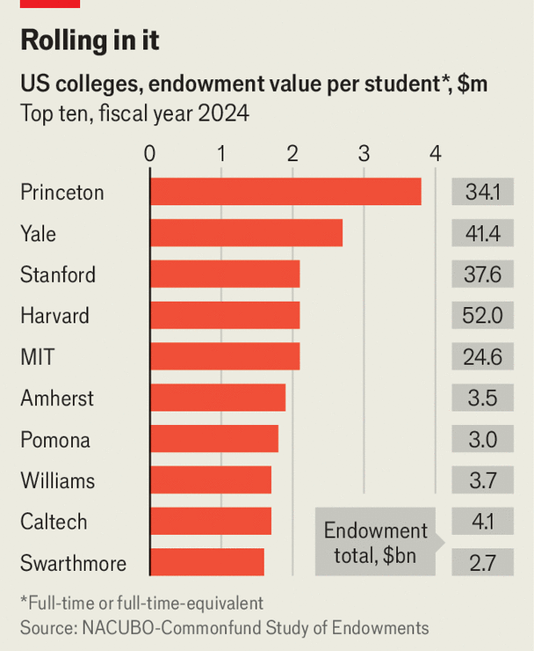Chart: The Economist
It seems unlikely that even the Supreme Court, with its conservative supermajority, would endorse all the Trump administration’s attacks on universities, if asked. Yet most of the victims seem more inclined to capitulate than litigate. That may be because universities are worried that even if they prevail in one instance, the administration will simply find other ways to punish and coerce them. Moreover, judicial relief comes only slowly; there would be lots of financial difficulties during the delay. Talented faculty might decamp to other institutions with fewer government headaches. By the same token, although many of the universities affected are enormously wealthy (see chart), the federal government can impose costs in so many ways that most see no hope of simply enduring the financial pressure.
Instead, universities, whether recipients of letters or not, are disavowing the policies the right so dislikes, academic freedom notwithstanding. The University of Michigan has shuttered its DEI office, on which it had lavished $250m over the past decade. The University of California, which pioneered the requirement that prospective hires provide “diversity statements” (in effect, professions of support for DEI), recently dropped them. “This is the Vichy moment. It’s a classic collaborationist dilemma,” says Michael Roth, the president of Wesleyan University, an as-yet-untargeted institution. “You can have preserved your school but you live in a sea of authoritarianism.”
Bringing universities to heel from “a position of savage strength”, as Mr Rufo puts it, may yield only superficial results. Because Mr Trump’s approach is so hostile and extreme, it may actually discourage universities from honestly assessing how they went wrong and correcting course. “None of this will make any difference in the long run unless it is accompanied by a full accounting of what has happened for the last two decades in higher education in America,” says Anthony Kronman, a former dean of Yale Law School.
There is also little logic in the government’s decision to switch off funding for science in order to punish ideas that emanated from humanities departments. Another recent decision, to cap the share of research grants that can be spent on overheads, will diminish the amount of scientific research conducted at all American universities, not just the elite ones. So will the gutting of the National Institutes of Health, which dispense huge amounts of funding for medical research. The administration’s general antipathy towards immigrants will presumably also take a toll. “Our universities are the best in the world. We drain the world of human capital. It’s the goose that lays the golden egg,” says Nicholas Christakis, a professor at Yale.
Mr Rufo is undaunted. He hints that the campaign against woke academics is only in its infancy. Certainly, more universities will come under attack and more means of coercion will be tested. There is talk in conservative circles of demanding the sacking of particular professors.
Mr Rufo gives short shrift to talk about the sanctity of academic freedom. “Freedom is the wrong lens to analyse the problem,” he says. “The Columbia post-colonial studies faculty are not engaged in academic research. They’re engaged in political activism. They’re engaged in ideological mania. And in order to have academic freedom, you have to accept academic responsibility.” But even accepting the remedies Mr Trump is dispensing does not seem to have been enough in Columbia’s case, at least. Although it has complied with the administration’s demands, it still has not received the $400m that had been frozen. ■

