**Epreuve ELVi (4h)**

Ce dossier est composé de :

Document 1: **Why the Fuss Over Quiet Quitting**, from *the Economist*, 8 Sept. 2022

Document 2:**While some say quiet quitting is over, the spirit of it may carry into 2023**, from *the Guardian,* 2 January 2023

Document 3: extract from Dans le Bus, de Nathalie Carreras (2022)

Document 4: **“Most important job satisfaction factors”** : study conducted in the US in 2021, cnn.com

Document 5: **‘Work-life balance’**, cartoon by Gatis Smuka, 28 Oct. 2020

**MERCI DE SAUTER DES LIGNES et DE NOTER LE NOMBRE DE MOTS UTILISES en fin de copie**

|  |
| --- |
| 1. **Compréhension : résumé analytique comparatif** **(30% de la note)**   According to documents 1 & 2, to what extent has workers’ relation to work changed recently in rich countries?  *Answer the question in your own words* *in 250 words (+ / - 10%)*  You may refer to the documents as "document 1" / (doc 2) if you wish.   1. **Thème suivi (20% de la note)**   Dans le document 3, vous traduirez le passage allant de « *Alcide prend le bus tous les matins...* » jusqu’à « ... *qui ne serait pas un pavé droit.*»   1. **Essai argumenté (50% de la note)**   Is personal fulfillment possible in today’s working environment ?  *Answer the question in 350 words (+/- 10%)*  You will elaborate your personal opinion on this question, using references from the documents in this file (there should be at least 3 of them) as well as some personal references. |

# Document 1

**Why the fuss over quiet quitting?**

*Bosses’ loud reactions to an anodyne idea are telling*.

It’s not the crime but the cover-up. And it’s not the video but the reverberations. In the past few weeks the term “quiet quitting” has entered conversations about the workplace. A 17-second clip on TikTok, a social-media platform, in which an American called Zaid Khan embraces the notion of not going above and beyond at work, has caused an awful lot of noise.

The video itself is amazingly anodyne. A piano tinkles. Bromides such as “Work is not your life” and “Your worth is not defined by your productive output” flash on the screen. Mr Khan implies that time not spent hustling at work can be better spent playing with a bubble machine and admiring trees.

Dull or not, it stamped on a nerve. Workers approvingly shared their stories about deciding not to work overtime, about prioritising work-life balance and about doing enough to get their job done without succumbing to burnout. Several bosses promptly lost their moorings[1]. Kevin O’Leary, a businessman-cum-television-personality, called it “the dumbest idea I’ve ever heard”. Arianna Huffington, another entrepreneur, wrote a LinkedIn post in which she described quiet quitting “as a step towards quitting on life”.

The fact that some employees feel unenthused about their work is hardly new. In all workplaces employees show varying degrees of commitment to their jobs. Some work late, others leave at 5 o’clock sharp, a few seem to do little more than respire. A survey of workers around the world by Gallup, a pollster, found that only 21% of them are engaged by their jobs. The very idea of going above and beyond requires a distribution of effort, with less committed colleagues providing a baseline against which others can be judged. The nature of the work also matters: it is easier to be engaged by some jobs than others. It is unsurprising, too, that quiet quitting has a particular resonance now. Lots of employees feel detached from their work.

The bargain of hard work for higher pay is less attractive than it once was. A succession of big shocks, from the financial crisis of 2007-09 to the pandemic, has made career planning seem pointless to some. Higher salaries go less far in many places: housing affordability is at its lowest level on record in Britain, according to Halifax, a lender. All of which may make some workers less motivated to pull all-nighters in search of a promotion.

The melodramatic reaction of some bosses looks stranger at first glance. This is not the start of a revolution, after all. Mr Khan’s post may have garnered 3.5m views on TikTok but the most viewed video on the platform has been seen 2.2bn times (it features an illusionist on a broomstick). Even slackers need to make money; showing application is still a pretty reliable way of getting ahead in the workplace.

Even so, for many chief executives, it may well feel as though the ground is shifting in new and disturbing ways. Consider the types of people who tend to make it to the corner office. These are individuals who almost certainly want to be on the highest rung of a career ladder, who are heavily influenced by monetary incentives and who have made work their life. Quiet quitting is simply not in their make-up.

Yet old certainties about what motivates people have changed. The pursuit of purpose matters more than it did during the formative years of many of today’s bosses. The modern version of Gordon Gekko would run a social-impact fund and say “green is good”. Research published last year showed that co-workers and culture matter more to people’s sense of job satisfaction than pay, a blow to anyone who thinks that the prospect of landing a bigger pay cheque is all it takes to gin up wild enthusiasm.

The pandemic has discombobulated bosses in other ways. Advice to burn the midnight oil jars when everyone else is worried about burnout. Plenty of corner-office occupants want employees to return to the office, the environment in which they built their careers; the end of summer has seen another push from many American companies to fill up the cubicles again. The idea that employees may all be playing with bubble machines rather than going the extra mile feeds suspicions about remote work.

The quiet-quitting kerfuffle tells a tale of two alienated groups. One comprises those disenchanted employees who wonder what the point is of working themselves to the bone. The other is a less obvious tribe: those in the corporate elite whose way of thinking about the workplace is under threat. ■ (774) **From *the Economist*, Sept 8th, 2022**

Document 2 :

# While some say quiet quitting is over, the spirit of it may carry into 2023

It started, as many trends do now, with a TikTok.

“I recently learned about this term called ‘quiet quitting’ where you’re not outright quitting your job, but you’re quitting the idea of going above and beyond,” a man calmly narrates over footage of New York City. “You’re still performing your duties, but you’re no longer subscribing to the hustle culture mentality that work has to be your life,” the voice continues as a clip showing a hand playing with bubbles out of a bubble machine.

The video got over 400,000 likes and soon after it seemed like everyone was talking about “quiet quitting”, the hot new trend. As summer turned into fall, more TikToks were created, talkshows featured jokes on the phenomenon, the Wall Street Journal and Bloomberg published over a dozen articles on quiet quitting. (...)

Now, as a new year begins, the stream of TikToks has slowed. Google searches for the term “quiet quitting” have dropped. Business Insider declared “*RIP, quiet quitting*” with reports that workers are back to the 50-hour work-week grind after some companies, particularly in tech, started laying off workers and freezing open roles.

But while “quiet quitting” looks like another « here today, gone tomorrow » viral trend, amid the current economic environment, the ethos that quiet quitting represents for workers is probably here to stay, say experts. Even if it is not neatly packaged in alliteration.

Quiet quitting was never really new. Between 13% and 20% of Americans have reported being actively disengaged at work since Gallup started conducting employee engagement surveys in 2000. To some, quiet quitting is just working – do your job, go home and forget about it. That something many people had always done – not volunteering for extra grind – was treated like a new trend shows how much the Covid-19 pandemic has influenced the relationship people have with their jobs. The pandemic made many people reassess their priorities.

(...) Cristina Banks, director of the Interdisciplinary Center for Healthy Workplaces at the University of California at Berkeley, said the emergence of quiet quitting speaks to the drop in personal drive around work, partly due to ongoing burnout. (...)

While the Covid-19 exacerbated loss of motivation, workers were already starting to feel detached from their work in the years before the pandemic. “Before the pandemic, there were unrealistic expectations of what people were supposed to do in their jobs, to go above and beyond what they’re paid to do or push themselves to the limit,” she said. “People don’t want to go back to the workplace, to go under that same pressure cooker.”

In his book The Importance of Work in an Age of Uncertainty, the Boston College professor David Blustein reports that even before the pandemic, “people were already experiencing a sense of uncertainty about work, a sense that the institution of work was eroding.” (...)

Blustein sees quiet quitting as a companion to the Great Resignation, which saw the national quit-rate rise from 1.6% in April 2020 to 3% in November 2021 – the highest rate since the government started tracking quit numbers. Over 47 million Americans quit their job in 2021. In a survey of quitters, Pew found most cited low pay, opportunities for growth and feeling disrespected as the top reason for quitting.

“Quiet quitting is part of a larger picture of this being a period of rethinking the institution of work,” Blustein said. “The pandemic was really a trigger point for working people.” (...) “We don’t know where this is going to land, and it may not really land. It may continue to be a very organic, dynamic process.” (601)

**From *the Guardian*, January 2nd, 2023**

Document 3 :

Alcide prend le bus tous les matins pour aller contempler des rectangles de ciel. Ou plutôt : Alcide part quotidiennement travailler en bus. Ou bien : Alcide a la chance d’avoir un métier qui lui permet d’être assis et de voir le ciel par la fenêtre. Ou encore : Monsieur Dornel effectue de vaines migrations pendulaires.

**Alcide n’est pas aussi grand qu’il le souhaiterait, pas aussi musclé, et il a sous les yeux des cernes[2] de classe mondiale. Il porte un costume bleu à rayures si fines qu’elles en deviennent presque invisibles, une sacoche noire. Dans la ville, il est fourmi[3] parmi les fourmis. Il sent confusément qu’il doit suivre la précédente, et il le fait, mais il n’a jamais déterminé de raison acceptable à toute cette agitation.**

**Lorsqu’il contemple oisivement l’extérieur, il sait bien qu’il est censé faire autre chose, assis à son bureau. Qu’il est payé pour cela. Et il le fait de manière suffisamment satisfaisante pour qu’on le garde, qu’on l’encourage par des augmentations et dernièrement par une promotion et l’accroissement de la surface de son ring quotidien. Il étudie les murs de son nouveau bureau. Il en fait tout le tour, gardant la main gauche plaquée contre la paroi, comme s’il cherchait la sortie d’un labyrinthe qui ne serait pas un pavé droit.** (...)

Lorsque les murs sont repoussés, que son bureau s’agrandit, son rectangle de ciel croît également. C’est là le seul avantage qu’Alcide trouve à ces changements. Combien de temps encore sera-t-il satisfait de passer de boîte en boîte ?

Alcide a toujours habité dans cette ville. Il y est né, il y a grandi, fait ses études. Il y a pris son indépendance, puisqu’il a emménagé seul dans une microscopique pièce qui ne méritait le nom d’appartement que sur les descriptifs d’annonces immobilières. La boîte-ville a un couvercle ouvert, mais elle lui procure la même sensation d’enfermement. Alcide s’y voit comme dans un aquarium. (...) De son domicile, il nage jusqu’à son lieu de travail, où il passe la journée en apnée.

(...) Toute la journée, il attend le soir. Il suppose que dans les autres cubes, ses anciens camarades font la même chose que lui. Mais il a toujours un doute, lorsqu’il rejoint ses collègues pour déjeuner et qu’ils n’ont que des mots d’affaire à la bouche.

Extrait de *Dans Le Bus* (chapitre 1), de Nathalie Carreras (2022)

# Document 4

Study conducted in the USA, 2021

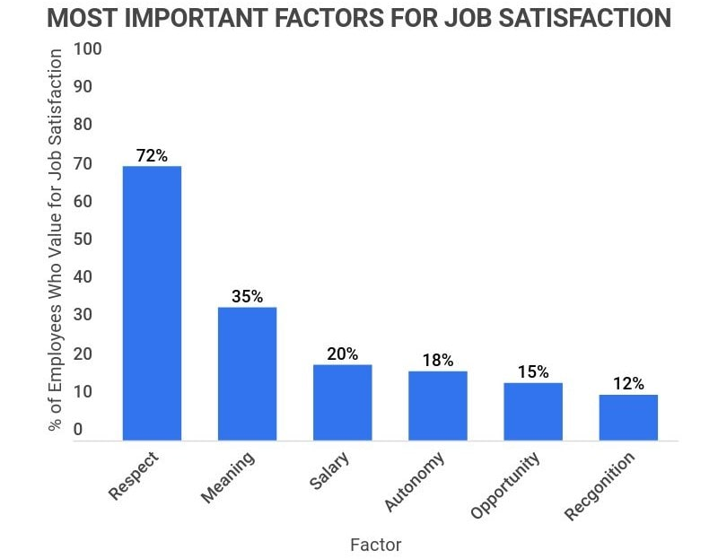

**Source : cnn.com, August 2021**

# Document 5

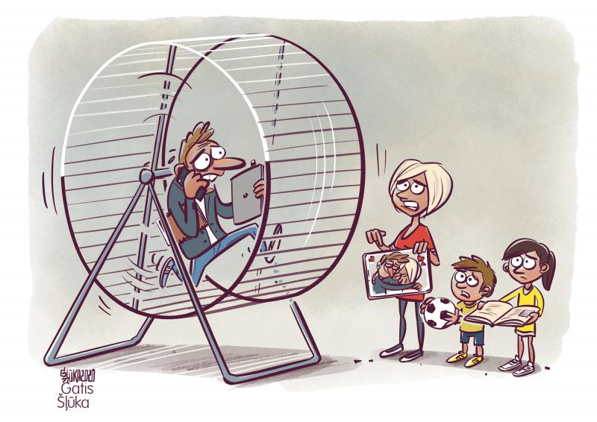

1. moorings : *des amarres*
2. Des cernes = dark rings / dark circles under one’s eyes
3. Une fourmi = an ant