**Trump’s Perfume Line Hits the Market With Jill Biden Photo**

* Katie Rogers, *The New York Times*, Dec. 9, 2024

**Trump Tests Ethical Boundaries With Branded Merch. (And All Sales Are Final.)**

Everything around President-elect Donald J. Trump has become something to monetize, including a moment of comity with Jill Biden at Notre-Dame over the weekend.

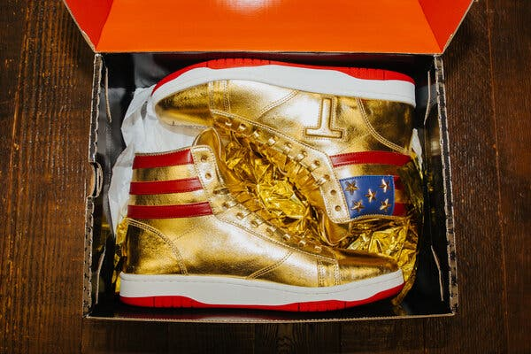

Limited-edition and autographed Trump high-top shoes purchased at Sneakercon earlier this year. Credit...Michelle Gustafson for The New York Times

Donald J. Trump learned a long time ago that photo opportunities could get him attention and that slapping his name on everything from skyscrapers to steaks could make him money.

As a three-time presidential candidate and now the president-elect, he is marrying the two concepts faster than ever, tying the high-profile visuals of his political life to perfumes, watches, sneakers and digital trading cards. Everything around Mr. Trump has become something to monetize, including a moment of comity with Jill Biden, the first lady, at Notre-Dame over the weekend.

“Here are my new Trump Perfumes & Colognes!” Mr. Trump wrote on social media on Sunday, along with a picture of his interaction with the faintly smiling first lady. “I call them Fight, Fight, Fight, because they represent us WINNING. Great Christmas gifts for the family.”

Under the photo was another caption, an apparent dig at Dr. Biden: “A FRAGRANCE YOUR ENEMIES CAN’T RESIST!”

Mr. Trump, in essence, used a civil moment with the first lady, a frequent critic, to sell fragrances that are “curated to capture the essence of success and determination,” according to the perfume website.

Before Mr. Trump was first inaugurated, his sons moved to [take over the family business](https://www.nytimes.com/2017/01/11/us/politics/trump-organization-business-conflicts.html), to at least create the perception of separation between a moneymaking enterprise and the highest office in the land. (Mr. Trump still maintained over 50 licensing deals in his name, according to [an analysis by *The Washington Post*](https://www.washingtonpost.com/graphics/world/trump-worldwide-licensing/).)

This time, there is no such presumption of distance, only the churn of a conveyor belt spitting out one Trump product after another. On Monday, officials working for Mr. Trump did not immediately reply to a question about whether Mr. Trump would continue promoting products after being sworn in.

With weeks until he takes office, Mr. Trump is capitalizing on the attention of his election victory, hawking fragrances and footwear to supporters who are in the mood to celebrate. There have been $299 “Trump Crypto President” sneakers on offer, along with $119 “Victory” cologne and $299 “First Lady” shoes. There is little information available about what materials the products are made from or where they are manufactured. And according to the products’ website, sales are final.

When Mr. Trump ran in 2016, several of his branded products sold through the Trump Organization [were made overseas](https://www.nytimes.com/2016/12/28/business/donald-trump-ivanka-clothes-global-trade-overseas-manufacturing.html), including sport coats made in India, suits made in Mexico and neckties made in China — business practices that were and are at odds with his current embrace of tariffs against economic competitors like Beijing. Mr. Trump’s daughter Ivanka was also criticized for selling products manufactured overseas.

Mr. Trump does not appear to be a manufacturer of the perfumes, watches, sneakers and other items he has lent his name to. The playbook goes like this: Mr. Trump creates companies that function like bank accounts, allowing the people or companies making the products to pay him royalties for the cost of licensing his name.

On his [2023 financial disclosure form](https://www.citizensforethics.org/wp-content/uploads/2024/08/Candidate-Report-Donald-J.-Trump-2024-Part-6.pdf), for example, a company Mr. Trump owns called “CIC Ventures LLC” reported income of $4.5 million for a book published by the conservative publishing company Winning Team, which is owned, in part, by his son Donald Trump Jr. Also according to the disclosure, [Mr. Trump made $300,000](https://www.nytimes.com/2024/08/15/us/politics/trump-financial-disclosure-bibles-liabilities.html) from a licensing partnership with LMA Productions, a company that produced a Bible endorsed by the “God Bless the U.S.A.” singer Lee Greenwood.

But unlike some of Mr. Trump’s earlier efforts, the identities of his current merchandise business partners are shielded through the creation of limited liability companies, which are structured to allow those partners to remain anonymous. At least two of the companies selling recently created Trump products were formed in Wyoming, a state home to strict privacy laws that shield the identities of L.L.C. owners.

45Footwear, the company behind the $499 “Trump Won” sneakers and the “Fight Fight Fight” fragrances, was set up in January by Cloud Peak, a law firm based in Sheridan, Wyo., that has formed over 100,000 such businesses around the world. In July, Cloud Peak also set up a Sheridan-based L.L.C. called TheBestWatchesOnEarth, which hawks gold-plated watches. For $899, supporters can buy one with an etching of the president-elect’s face.

Reporters who have visited the Sheridan addresses for those companies have reported finding rural strip malls or [buildings populated by unrelated businesses](https://www.cnn.com/2024/10/17/politics/trump-watches-wyoming-invs/index.html?cid=ios_app).

Jordan Libowitz, the vice president of communications for Citizens for Responsibility and Ethics in Washington, said that this practice posed several ethical issues.

“It’s a bit of a black box where the money’s coming in from,” he said, adding that people hoping to influence Mr. Trump could dump money toward one of his products.

“We worry a lot about all the time he spends at Mar-a-Lago, around people trying to influence policy,” Mr. Libowitz said. “You show up and show him like, ‘Hey, I spent $100,000 on Trump watches.’ That’s going to get his attention.”

Another concern is the speed and frequency with which Mr. Trump has unveiled new products before he assumes the presidency in just over a month. Without more information from the president-elect and his team, there is no way to know if Mr. Trump will try to monetize big moments in his presidency, and where the money to produce those goods will come from.

“Whatever norms he was responsive to before,” Mr. Libowitz said, “he does not seem particularly interested in them now.”