**Starmer may have weaponised the Windsors, but soft power is the royals’ great asset**

* Caroline Davies, *The Guardian*, Sat 1 Mar 2025

As Donald Trump [waved his personal invitation from King Charles III](https://www.theguardian.com/us-news/2025/feb/27/king-charles-invites-donald-trump-for-unprecedented-second-state-visit-to-uk) to pay a second historic state visit in the Oval Office, there was no disguising his delight before the TV cameras.

Keir Starmer had retrieved the letter from his jacket pocket and handed it to the US president with the dramatic flourish of Neville Chamberlain’s “I have in my hand a piece of paper” moment. From Trump’s gleeful response, there was no doubt: in weaponizing the Windsors, the prime minister had played a blinder.

Monarchists have long argued the soft power of royalty is among its greatest assets.

From George VI being dispatched to schmooze President Franklin DRoosevelt before the second world war, to Queen Elizabeth II [wooing Dublin in Gaelic on her historic 2011 visit](https://www.theguardian.com/uk/2011/may/19/queen-ireland-visit-respect-adams), this is what they do – at the behest of government.

They have little say in it. State visits, inward and outward, are decided by the royal visits committee, “with members from the Foreign Office and Buckingham Palace,” said Dr Craig Prescott, a constitutional expert at Royal Holloway, University of London, and author of the forthcoming book Modern [Monarchy](https://www.theguardian.com/uk/monarchy). “But fundamentally these are decisions made by the government to pursue its diplomatic objectives.”

A young Queen Elizabeth’s widely photographed foxtrot with the Ghanian president Kwame Nkrumah silenced his threat to split from the Commonwealth in 1961. Her decision to seat Nelson Mandela at an international dinner in Africa before he became South Africa’s president was loaded with symbolism.

Throughout her long reign, she was so deployed. She was not always grateful. Welcoming Romanian dictator Nicolae Ceaușescu and his wife to Buckingham Palace in 1978, in line with the government’s agenda, was particularly problematic. “He was among the most difficult of the queen’s guests at Buckingham Palace. The guest from hell: paranoid about his security, about being bugged,” said Joe Little, the managing editor of [Majesty magazine.](https://majestymagazine.com/) “The visit was particularly controversial at the time,” said Prescott. “But it aligned with the government’s priorities. The queen found him so frightful that when there was break she was walking through the gardens of Buckingham Palace with her corgis, and Ceaușescu was coming the other way and she hid in some bushes to avoid him. But when it came to ceremonies she did her duty.”

Zimbabwean president Robert Mugabe was “another out and out tyrant” that she entertained, said Little. “But the monarchy is there to do more or less what it’s told. Whilst I am sure objections are made in private, and adaptations must go on behind the scenes we would never hear about, at the end of the day that’s what they have to do, pretty much.”

If the queen felt any disquiet about shaking the hand of former IRA commander Martin McGuinness at Belfast’s Lyric theatre in 2012, it was not betrayed in her warm smile.

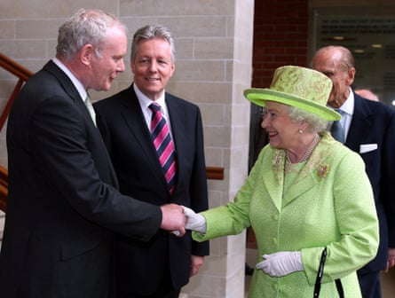

Queen Elizabeth II shakes hands with Martin McGuinness, then Northern Ireland’s deputy first minister, in Belfast in 2012. Photograph: PA

However, she did seem to be imparting a message of her own when, in 1998, she drove Saudi Arabian crown prince, later King Abdullah bin Abdulaziz, around the Balmoral estate at a time when women were not allowed to drive in Saudi Arabia, and terrified him so much that he implored her to slow down. […]

Soft diplomacy costs – massively. The travel for the royals and their entourages is paid from the sovereign grant given to the king. Security costs met from the public purse are not disclosed. “Although I would say if we had an elected president I am not sure the costs would be much cheaper, because this is something that every state does,” said Prescott. “But the royal family are just that little bit different. It was President Obama who said state visits at Buckingham Palace aren’t like state visits anywhere else.”

Monarchists argue it brings businesses to the UK and promotes the UK brand. “It is very difficult to quantify the benefits of such visits. There are photo ops and glad-handing. But does it have a long-term benefit? I think it’s almost impossible to say,” said Little.

Sometimes it backfires. The then Duke and Duchess of Cambridge’s 2022 Caribbean tour was [widely viewed as being misjudged.](https://www.theguardian.com/uk-news/2022/mar/25/william-and-kate-caribbean-tour-slavery-reparations-royals) “It just seemed to accentuate the colonial past in many ways, particularly going round in this open-top Land Rover. Clearly the plans were laid in place by the Jamaican government and alarm bells should have rung with William and Kate’s aides that perhaps this wasn’t such a good idea. But of course as a guest you don’t want upset your host. So that was a misstep. And, of course, the picture of shaking hands through a wire was very unfortunate.”

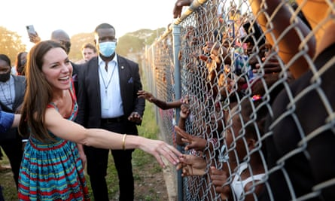

An infamous image of the then Duchess of Cambridge shaking hands with Jamaican locals through a fence. Photograph: Reuters

This will be an unprecedented second state visit for a US president. “One reason we hosted the state visit of Trump in 2019 was our trying to get that trade agreement post-Brexit, though it didn’t materialise,” said Prescott.

“Interestingly, when Rishi Sunak was prime minister and state visits started again after Covid, the king’s two first visits were to Europe. And that was post-Ukraine, and to sort of say the UK might have left the EU but hasn’t left Europe, which is another theme of British government policy.

“You can see what our whole foreign policy is by the state visits that are undertaken,” he added.