**2024 Presidential elections ACTIVITY WORKSHEET**

1. 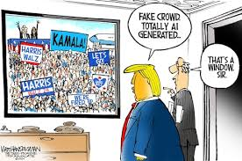**Classify the words into 3 groups and translate them into French:**

To hold an election, to call for an election, to queue at a polling station, to gain ground, to lose ground, to be defeated, to campaign for/against an idea, to rally the electorate, to elect, to fulfill a promise, a crushing defeat, a landslide victory, to run for president, to go to the polls, to cast a ballot, an opinion poll, to be ahead/behind in the polls

|  |  |  |
| --- | --- | --- |
| **BEFORE ELECTION DAY** | **ELECTION DAY** | **AFTER ELECTION DAY** |
|  |  |  |

|  |  |  |  |  |  |  |  |  |
| --- | --- | --- | --- | --- | --- | --- | --- | --- |
| **To compete** | **To reject** | **To approve** | **To appoint** | **To trust** | **To withdraw** | **To fail** | **To win** | **To lose** |
|  |  |  |  |  |  |  |  |  |

1. **Find the corresponding noun and translate it into French:**
2. **Read those snippets of the news and translate the words/expressions in bold :**
3. Thirty-four Senate seats and all 435 House of Representatives seats **are on the ballot**, giving the two main parties an opportunity **to drastically change the makeup of Congress**.
4. The **odds of success** of the GOP are great in the Senate.
5. President Biden and Democratic nominee Kamala Harris have warned that **American** **democracy is on the line** in the presidential election in the face of numerous challenges, from **gerrymandering** and **voter suppression** to Trump’s false claims about **vote-rigging**.
6. Joe Biden’s **low approval rating (38%)**, combined with concerns about the state of the US economy and the immigration system, two issues on which Republicans are seen as stronger, **had lowered Democrats’ expectations**.
7. But Kamala Harris’s emergence as her party’s new **presidential nominee** immediately **renewed hope among Democrats** that the election was maybe **not a losing battle after all**.
8. More than 1.4 million people have already voted in the presidential election, as Kamala Harris and [Donald Trump](https://www.theguardian.com/us-news/donaldtrump) continue to crisscross the country in **the final stretch of a neck-and-neck** campaign. Harris **retains a slight lead**, but the numbers have yet to reflect the vice-presidential debate. The simplest path to winning the 270 electoral votes needed to win the presidency continues to be **winning the battleground states** of Pennsylvania, Michigan, Wisconsin, Nevada, North Carolina, Georgia, and Arizona.
9. Many Democratic candidates have focused strongly on protecting abortion rights **in the wake of the US supreme court’s reversal of Roe v Wade** in 2022.
10. Measures to protect abortion rights are among the many initiatives that will appear on ballots in ten out of 50 states in November. These initiatives **can garner support across party lines** in a way that is otherwise impossible **in a highly polarized partisan political climate.**
11. Since 2016, when Mr. Trump shocked the Republican establishment with a **thoroughly dominating takeover** of the G.O.P., his political style has resulted in more collateral damage for fellow conservatives than electoral success. **He was the first president in decades to lose the House, the Senate and the White House within four years (2016-2020).** Donald Trump has nevertheless managed **to tighten his grip on the party**.



**VIDEO 1:** [**The History of U.S. Voting Rights | Things Explained (youtube.com)**](https://www.youtube.com/watch?v=No7ewLdJU_Y)

to enfranchise = to disenfranchise =

1. What are the requirements to be able to vote in the USA?
2. Who sets the requirements and is responsible for the organisation of the elections?
3. Fill in the timeline below, focusing on who was allowed to vote

|  |  |
| --- | --- |
| **1789** |  |
| **1820s-1830s** |  |
| **1840** |  |
| **1868** | ……… th Amendment = |
| **1870** | ……… th Amendment = |
| **1890** |  |
| **1920** | ……… th Amendment = |
| **1945** |  |
| **1965, March 7th** |  |
| **1965, August** |  |

1. What does the ‘Jim Crow system’ consist in? Where was it implemented? What are the consequences?
2. Focus on Georgia and fill in the timeline.

**1877**

**1908**

**The Grandfather clause:**

**1920-1930: share of eligible Black voters who could vote =**

**1943**

1. What is the paradox of the Women’s suffrage movement?
2. How did the following amendments improve the access to vote?

**23rd amendment**

**24th amendment**

**26th amendment**

1. What was the Civil Rights Acts so far-reaching?
2. What are the different ways to cast a ballot?

VIDEO 2: **The Electoral College, explained (Vox)**

**Write down the key numbers and key ideas : be ready to explain how the system works!**

VIDEO 3: **Swing States: how 0.008% of voters made the 2020 election**

**Write down the key numbers and key ideas : be ready to explain why swing states are so important but also problematic.**



**Video 4: What is gerrymandering?**

**“Gerrymandering Explained”, *The Washington Post***

<https://www.youtube.com/watch?v=bGLRJ12uqmk>

1. What is gerrymandering?
2. Who gets to decide how election districts are drawn?
3. Precise example?
4. What’s wrong with this practice?

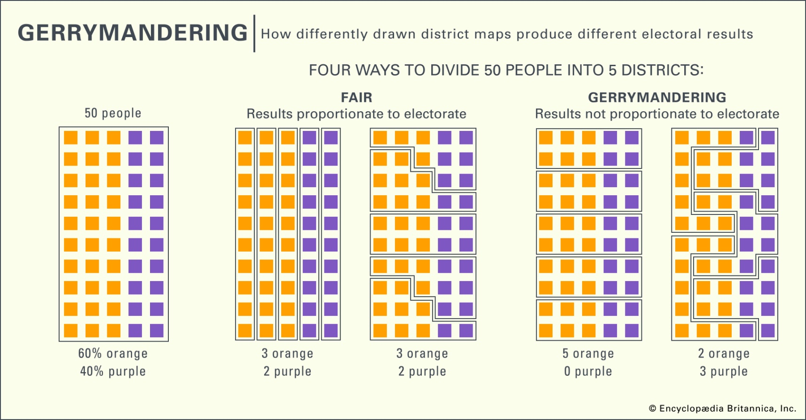

**Podcast de France Culture : « Gerrymandering : comment les Américains ont-ils inventé la triche électorale ? » (58-min)**

<https://www.radiofrance.fr/franceculture/podcasts/sans-oser-le-demander/gerrymandering-comment-les-americains-ont-ils-invente-la-triche-electorale-3445821>

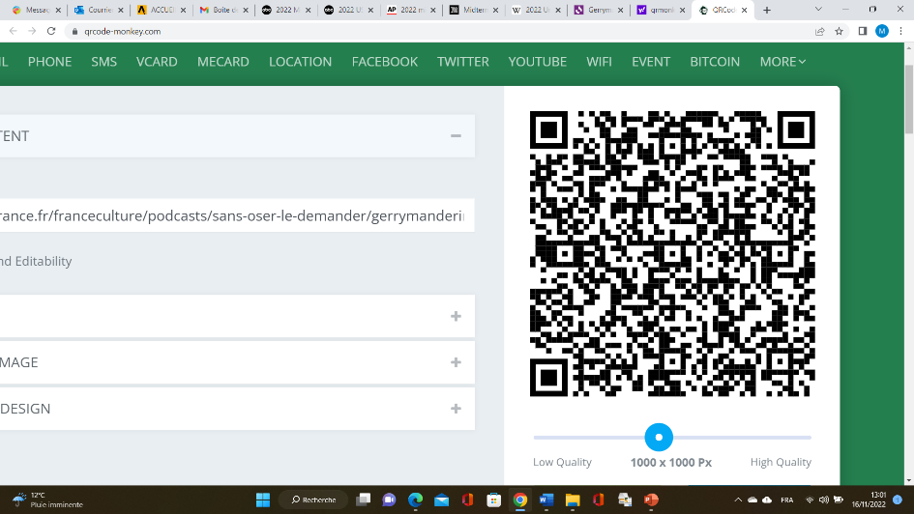Take some extra notes :