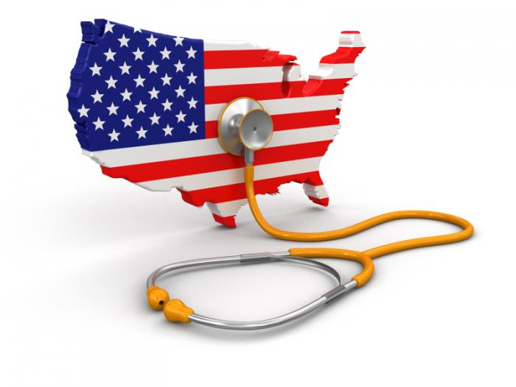The Economics of healthcare: crash course

<https://www.youtube.com/watch?v=cbBKoyjFLUY>

**0'48-> 2'50**

**Listen and watch. Then, fill in the gaps:**

1. covered
2. either
3. funds
4. insurers
5. Medicaid
6. operating tables
7. practices
8. premiums
9. prescription
10. providers
11. required
12. single payer system
13. taxpayers
14. tend to
15. the poverty line
16. unlike
17. veterans
18. Medicare

Private insurers periodically collect money, in the form of..............................., paid by individuals or their employers.

Public insurance programs collect money from .........................You’ll hear some countries have free healthcare, but it’s not “free.” They’re paying for it: ......................directly, through......................., or through taxes.

**Canada** has a public insurance system where the government ....................... healthcare for everyone through taxation. Doctors’ offices ............................. be private businesses that get paid directly by the government. But hospitals and ................................. are public property. And the hospital staff are public employees. This is often called a ................................................ since the government is doing most of the paying. Canadians have to pay for .......................................... drugs, eyeglasses and dental care themselves or get them through supplemental private insurance.

**France** technically doesn’t have a single payer system because health care ............................. are paid by several non-profit insurance funds. All citizens are ........................... to get health insurance and they’re free to choose their doctor. ............................. Canada, .......................... (la plupart) French providers, including hospitals, are private businesses.

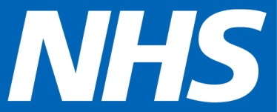

**The UK** is different still. It has a socialized healthcare system which is funded and controlled by the government through taxes. The majority of doctors, specialists, and hospitals are all paid by the government, not insurance companies.

**The US** has little of everything. ___________________ (presque tous) providers – hospitals, clinics, doctor’s

................................– are private firms. ____________ (la plupart) households with adults under 65 are ................... by private insurance, either through their employer or through individual policies. But the US has single payer system for those over 65 and those below.......................................

................................ is a taxpayer-funded public insurer that pays providers to care for seniors and

................................ is a similar program for low-income households.

The US also has a small UK-style system with government-run hospitals and government-employee doctors for ............................which is called the VA.

According to the Census Bureau in 2014 10.4% of Americans didn’t have health insurance coverage, down from 13.3% in 2013. [FYI it’s around 8% today in 2025]

**3'23 -> 4'**

**Who are the uninsured? Listen then list 5 characteristics**

1. ..................................................................
2. .................................................................
3. .................................................................
4. ..................................................................
5. ...................................................................

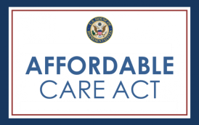**In 2010**, the US Government passed the ___________________ Care Act, sometimes called ___________Care. This stab (= attempt) at reforming the American healthcare system has been controversial, **to say the ___________.**

|  |  |
| --- | --- |
| **What the law doesn't do** | **What the law does** |
| ObamaCare did not **………….** (mis en place)a UK-style system where hospitals are public property and doctors  are public employees.  It also didn’t **………………..** (établi) a Universal Public Insurance system, like expanding Medicare to everyone.  The act rewards doctors for cutting costs, and  **………………..** (requiert) greater price transparency.  It also **……………..** (réclame) a move to electronic record-keeping. | Instead, the Affordable Care Act tries to increase health **coverage** :  - by requiring private health insurers to insure everyone who applies.  - to ………….. (faire payer) the same premiums to people of the same age,  - and to cover pre-existing conditions.  - It requires that everyone obtain health insurance or pay a fee to **……………** healthy people …….. only buy**ing** (empêcher de) health insurance when they get sick.  -The law also **……………………** (subventionne) health insurance premiums for those who **………………………** (ne peuvent pas se permettre) to pay market rates. |

**Conclude and react:**

Obamacare reflects the peoples' attitude towards government and capitalism: Americans don’t fully trust either one of them. As a consequence, Obama's healthcare reform has left private insurers and providers in place, but at the same time has increased regulation. Now that Donald trump is in office, the Republicans are determined to **repeal the ACA**. In the end, **the recurring question is: when, if ever, should the US government get involved to help markets achieve the most effective and fair outcome?**

**As far as I'm concerned**, ..................................................................................................................................................

............................................................................................................................................................................................

............................................................................................................................................................................................

............................................................................................................................................................................................