**ANGLAIS LVB**

**LUNDI 30 janvier 2023**

**Type HEC (4 heures)**

**Consignes :**

**• écrire une ligne sur deux**

**• rédiger chacune des trois épreuves sur une feuille séparée**

**CONTENTS**

# Document 1 – “Vancouver wants to decriminalise possession of many hard drugs” (*The Economist*, July 24, 2021)

**Document 2 –** “As overdoses soar, Rhode Island embraces a daring addiction strategy” (*The New York Times*, October 12, 2022)

# Document 3 – « Deux Etats légalisent par référendum le cannabis » (adapté de *Mediapart*, 5 novembre 2012)

**Document 4** **–** graph on drug-related deaths across high-income countriesin 2016-2020(Jesse C. Baumgartner, Evan Gumas, and Munira Z. Gunja, “Too Many Lives Lost: Comparing Overdose Mortality Rates and Policy Solutions Across High-Income Countries,” *To the Point* (blog), Commonwealth Fund, May 19, 2022)

**Document 5** **–** “Mandatory Sentencing” cartoon by Adam Zyglis (*Buffalo News*, August 20, 2013)

1. **Compréhension - Résumé analytique comparatif (30/100)**

How have North American drug policies evolved recently, according to documents 1 and 2?

Answer the question in your own words. (250 words +/- 10 %)

1. **Expression personnelle - Rédaction argumentée (50/100)**

Is it time for North America to put an end to the “war on drugs”?

Elaborate your personal opinions on this issue in your own words, supported by evidence and references drawn from documents 1-5 and at least two other pertinent cultural, civilizational or historical references from the English-speaking world (350 words +/- 10 %)

1. **Traduction (Thème) (20/100)**

Translate into English the passage in bold letters (document 3).

**Document 1**

# Vancouver wants to decriminalise possession of many hard drugs

* *The Economist*, July 24, 2021

AS A STUNT, it took some beating. A Vancouver city councillor joined activists outside a police station on July 14th to distribute free heroin, meth and cocaine. These “safe” samples of illicit drugs, the councillor tweeted, could save users from a poisoned street supply that has caused an overdose crisis on Canada’s west coast.

If the measure seems desperate, it suits the moment. The health officer of British Columbia (BC), where Vancouver is located, declared an emergency over deaths from drug overdoses five years ago. Dealers were lacing street drugs with lethal levels of fentanyl, a cheap and potent opioid. BC’s rate of illicit-drug deaths has more than doubled since then, with around 2,000 people dying from overdoses in the year to May—more than those killed by covid-19. “It’s really stretched all our traditional policy responses,” says Kennedy Stewart, Vancouver’s mayor. The pandemic appears to have worsened the crisis, since deaths are more likely if users inject alone.

So in May, Vancouver submitted a proposal to exempt it from Canada’s drug laws. It would decriminalise possession up to defined personal limits: two grams of heroin; three of cocaine; ten rocks of crack, for example. Drug prohibition deters addicts from seeking treatment, the request says, and criminal records make it hard to get a job. The proposal would also allow possession of drugs prescribed legally but sold on the black market, and of “party drugs” like LSD, MDMA and psilocybin mushrooms. It’s an all-or-nothing approach: decriminalising only the most harmful substances risks making users of other drugs turn to these more dangerous ones.

There are precedents for decriminalisation. Portugal is an example. This year Oregon became the first American state to stop making arrests for possession of small quantities of all drugs. But most such places still issue fines, confiscate drugs or impose mandatory treatment, whereas the Vancouver model proposes no penalty.

For decades, Vancouver has led Canada towards a drug policy that emphasises harm reduction. The country’s first supervised injection site for drug users opened there in 2003. Dozens of similar sites now operate across the country, even while they remain banned in America. The Canadian government has funded programmes—known as “safe supply”—that give users access to alternative opioids such as hydromorphone. Some clinics in the Vancouver area prescribe untainted, medical-grade heroin to the severely addicted.

The city’s submission includes letters of support from organisations of indigenous people in British Columbia. They died from overdoses last year at five times the rate of the rest of the population. But some advocacy groups think the proposal does not go far enough. Garth Mullins of the Vancouver Area Network of Drug Users (VANDU) says the proposed possession limits are too low and that the city has deferred too much to its police department.

The mayor says it was politically important to get the police onside. He is hoping for a government decision within weeks. “This is the prime minister who legalised cannabis,” he says of Justin Trudeau. “I think there’s a willingness to experiment with approaches that will save lives.”

But not everyone is convinced that decriminalisation alone will save lives. “In practice, it’s not going to be particularly effective in the short term,” says Scott Bernstein of the Canadian Drug Policy Coalition. Suppliers will continue to poison the west coast’s heroin with fentanyl, and only a small portion of users will have access to safe-supply programmes.

And safe-supply schemes, too, have shortcomings if not managed properly. Like many addiction-medicine specialists, Lori Regenstreif, a physician at McMaster University in Ontario, says she is worried that the government is encouraging the “overprovision of prescription-opioid consumption, without proper supervision” under the safe-supply scheme.

She knows of many people who take the easily obtained hand-outs of hydromorphone tablets, sell them on the street because they are not strong enough, and buy fentanyl on the black market. This, she says, means the government may be worsening the problem, not solving it.

**Document 2**

**As Overdoses Soar, Rhode Island Embraces a Daring Addiction Strategy**

* Noah Weiland
* *The New York Times*, Oct 12, 2022

It is the first state to legalize supervised drug consumption sites, which some addiction experts believe will help lower record overdose rates.

A group named Project Weber is preparing to open the first supervised drug consumption site legalized by a state — one of the most daring experiments in [“harm reduction”](https://www.nytimes.com/2021/06/27/health/overdose-harm-reduction-covid.html) in America to date. By letting people use drugs on site and under the supervision of social and medical workers, rather than alone, Project Weber hopes to curb overdose deaths and infectious diseases and coax more users like Ms. Ramsey into using medication and supplies for safer drug use.

Many public health experts see this strategy as a possible template for transforming how the United States addresses drug use. The concept has drawn considerable interest in recent years: New York City [allowed two sites to open](https://www.nytimes.com/2021/11/30/nyregion/supervised-injection-sites-nyc.html) last year, and some state legislatures have considered following suit.

Research has shown that supervised consumption sites in Canada, Australia and some European countries have [saved lives](https://pubmed.ncbi.nlm.nih.gov/34218964/) and [led to people getting treatment](https://pubmed.ncbi.nlm.nih.gov/20800976/).

Top Biden administration officials have also [signaled openness](https://www.nytimes.com/2022/07/26/us/politics/biden-drug-czar-rahul-gupta.html) to the idea. In 2019, the Trump administration [sued a Philadelphia group](https://www.nytimes.com/2019/02/06/health/safe-injection-opioids-overdose.html) that aimed to open a site, but under Mr. Biden, the Justice Department is weighing whether to drop the lawsuit. If it decides to do so, that could serve as a tacit endorsement of the strategy.

Brandon Marshall, an epidemiologist at the Brown University School of Public Health who studies the strategy, said the sites “require us to shift our thinking in how we treat people who use drugs and how we address health issues they face, and how as a society we want to provide care to people, or not.” “So much of the history of the drug war in the U.S. is pushing people into the shadows, criminalizing their drug use,” he added. “These facilities do the opposite. They say, ‘We want to bring you in and give you a safe environment where you will be respected.’”

But the idea of government-sanctioned infrastructure for drug use has not yet attracted broad political support. Conservatives and even some Democratic leaders remain wary: Citing “a world of unintended consequences,” Gov. Gavin Newsom of California, a Democrat, [recently vetoed](https://www.nytimes.com/2022/08/22/us/gavin-newsom-vetoes-drug-injection-sites.html) a bill that would have legalized supervised consumption in some cities there.

Critics of the sites see them as not helping users like Ms. Ramsey but hurting those users by facilitating the use of drugs that can lead to quick and fatal overdoses. Some who live near proposed sites have said they fear loitering and drug use outside them. “Supervised injection sites have led to an increase in crime, discarded needles and social disorder in the surrounding neighborhoods,” a group of Republicans in the U.S. Senate [wrote to President Biden](https://www.grassley.senate.gov/imo/media/doc/grassley_et_al.tobidenfundingforsmokingkitsandsupervisedinjectionsites.pdf) this year.

Harm reduction experts say that research has already shown that the sites do not lead to upticks [in crime](https://pubmed.ncbi.nlm.nih.gov/33485010/) or [community drug use](https://www.bmj.com/content/332/7535/220).

Rhode Island has mirrored the nation’s [record-shattering tally](https://www.nytimes.com/2022/05/11/us/politics/overdose-deaths-fentanyl-meth.html) of overdose deaths. More people in the state died of accidental overdoses in 2021 than [any other year on record](https://www.providencejournal.com/story/news/local/2022/05/02/ri-drug-overdose-deaths-set-record-2021-fentanyl-cocaine/9616004002/); roughly three-quarters of the 435 deaths involved fentanyl, an extremely potent class of synthetic opioid that is often found mixed into other drugs.

To open the site, Rhode Island has a novel source of funding: $2 million [in legal settlement money](https://www.nytimes.com/2022/02/25/health/opioids-settlement-distributors-johnson.html) from litigation against prescription opioid manufacturers and distributors that has been earmarked for supervised consumption by [a state committee](https://eohhs.ri.gov/Opioid-Settlement-Advisory-Committee). […] State lawmakers say that the pervasiveness of fentanyl has sped up acceptance of helping people use drugs safely.

Supervised consumption is not just about dispensing supplies and preventing overdoses and infections, said Colleen Daley Ndoye, Project Weber’s executive director. The location, she said, will allow the group’s staff to work with users, earning their trust and linking them to other services. Ms. Daley Ndoye said that as with other harm reduction programs, the site would not aim to force people to enter treatment, but it would offer the option if participants were interested.

**Document 3**

# Deux Etats légalisent par référendum le cannabis

Parmi les nombreux référendums locaux, deux États (le Colorado et le Washington) ont vu adopter la légalisation complète de la marijuana. Cela signifie que la production, la distribution et la vente devraient se faire sous contrôle public, recettes fiscales à la clé. Une brèche est ouverte dans la “Guerre contre la drogue”, la politique répressive lancée dès 1970 par Richard Nixon contre la toxicomanie.

* [Thomas Cantaloube](https://www.mediapart.fr/biographie/thomas-cantaloube)
* *Mediapart*, 5 novembre 2012

**Dans un pays qui est généralement perçu comme très conservateur sur les questions de société, et qui a fait de la « *[War on drugs](http://fr.wikipedia.org/wiki/War_on_Drugs)*» l’alpha et l’oméga de toute sa politique sur les drogues depuis la fin des années 1960, cette brèche n’est pas insignifiante. En 1992, le *baby-boomer* héritier des *sixties*, Bill Clinton, s’était dégonflé en expliquant qu’il avait bien un jour tiré sur un joint, mais *« sans inhaler »*. George W. Bush lui, n’avait jamais caché avoir été alcoolique, mais il restait extrêmement discret sur l’usage d’autres drogues (sa consommation de cocaïne durant sa jeunesse est un secret de Polichinelle, mais l’herbe ne faisait pas partie de sa panoplie récréative). Quant à Barack Obama, il a admis dans son autobiographie avoir consommé régulièrement de la marijuana et expérimenté d’autres substances.**

**Cette attitude de plus en plus** [**décomplexée**](http://en.wikipedia.org/wiki/List_of_United_States_politicians_who_admit_to_cannabis_use) **des politiciens américains** (Michael Bloomberg, Al Gore, Sarah Palin ou Arnold Schwarzenegger reconnaissent également avoir fumé) **ne s’est pas pour autant traduite dans les discours ou la législation.** *« La question de la drogue est toujours traitée comme le test de la qualité morale d’un candidat »*, explique l’universitaire et spécialiste des drogues Mark Kleiman. *« Le résultat, c’est que le discours au niveau national est terriblement en retard sur l’attitude générale des Américains et ce qui se passe au niveau local. »*

En effet, selon la plupart des instituts de sondages, un Américain sur deux se déclare aujourd’hui [favorable](http://www.pollingreport.com/drugs.htm) à la légalisation du cannabis (cette proportion est en progression constante depuis une vingtaine d’années) ; il y aurait environ vingt à trente millions de consommateurs réguliers ou occasionnels ; et l’on compte désormais 17 États (sur 50) qui autorisent l’usage de la marijuana pour des raisons médicales.

**Document 4**

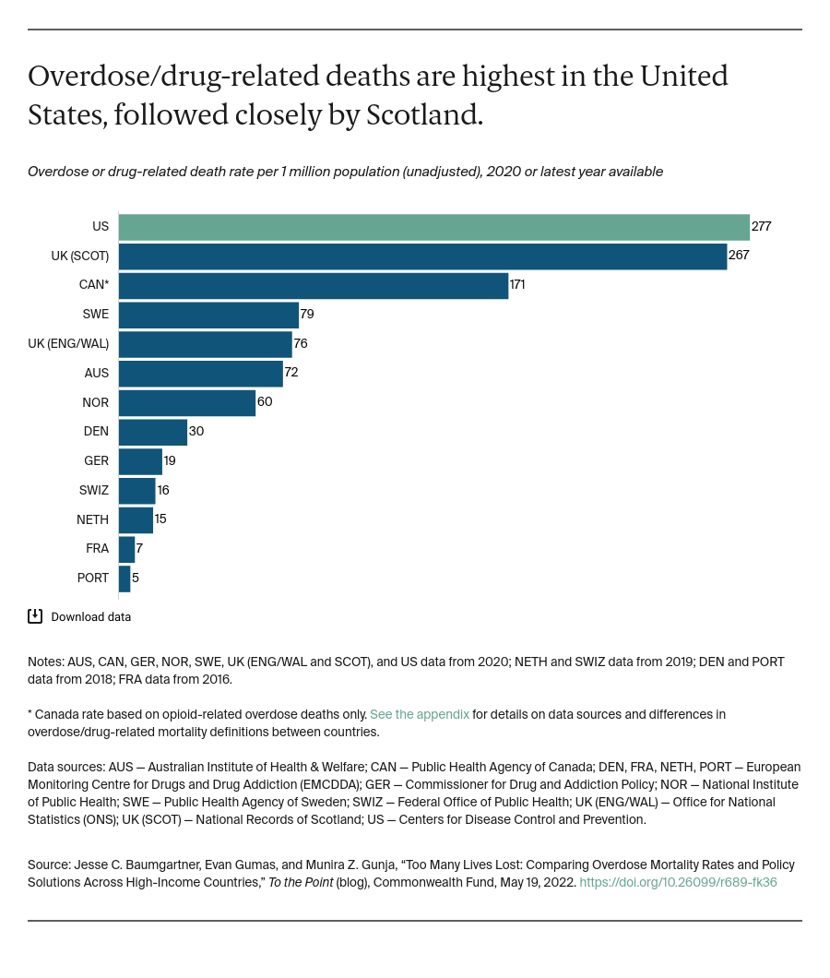

**Document 5**

