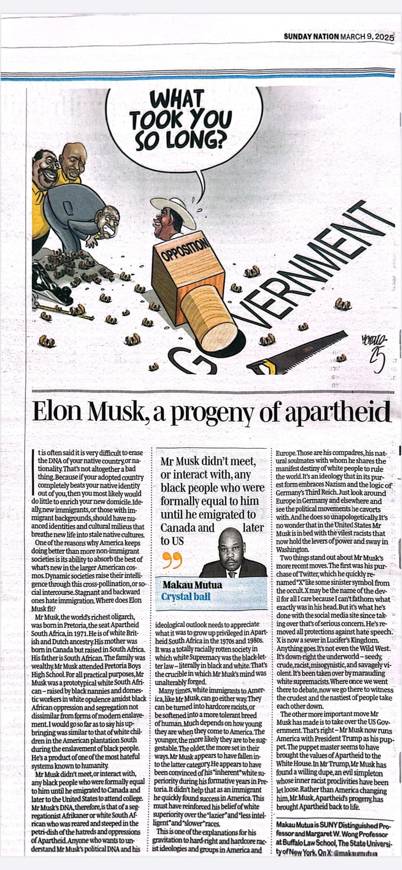

*Sunday Nation*, March 9, 2025