The economist

Politics
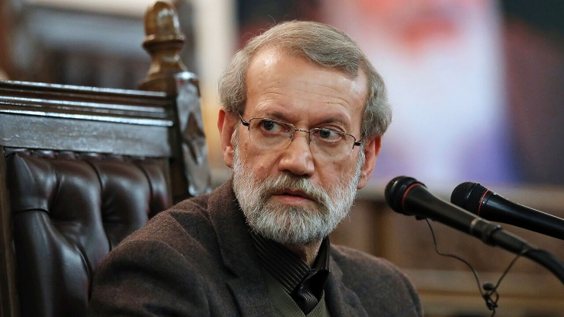Photograph: AP
Mar 19th 2026|
1 Israel killed Ali Larijani, Iran’s security chief and one of the most prominent remaining figures in the regime. Gholamreza Soleimani, the head of the paramilitary Basij force, died on the same day. Iran’s intelligence minister was killed in a separate strike. Iran’s army chief vowed a “decisive” response to the assassination of Mr Larijani.
2 Donald Trump condemned an attack by Iran on the Ras Laffan gas complex in Qatar and threatened to “massively blow up” Iran’s South Pars natural gas field if it struck Qatar again. Mr Trump claimed he had not been informed in advance of the Israeli strike on South Pars that preceded Iran’s attack on Qatar.
3 Joe Kent, a senior American counterterrorism official, resigned over America’s war in Iran. Mr Kent, from the anti-war wing of MAGA, said that Iran posed “no imminent threat” to America. Mr Trump derided Mr Kent as being “very weak on security” and said it was a “good thing” he was out.
4 At least three Palestinians were killed in the West Bank in the first deadly Iranian missile attack to hit the territory since the war began three weeks ago. Iranian missiles also struck the Emirati port of Fujairah, and Dubai’s airport. America hit dozens of Iranian military targets on Kharg Island, home to Iran’s main oil-export terminal, including storage depots for missiles and naval mines.
5 The Israel Defence Forces (IDF) told people to evacuate southern Lebanon as it intensified its operation against Hizbullah, launching air strikes on central Beirut and south Lebanon.
6 Israel has more than doubled the number of troops it has along the border with Lebanon and began destroying bridges over the Litani river, perhaps in preparation for a ground invasion. Over 950 people have been killed in Lebanon and almost 1m displaced since Israel’s latest campaign began.
7 A former Belgian diplomat will face trial for his alleged involvement in the assassination in 1961 of Patrice Lumumba, the first democratically elected prime minister of independent Congo. Étienne Davignon, 93, is the sole survivor of the ten Belgians accused by Lumumba’s family of complicity in his death. A parliamentary commission in Belgium, the former colonial power, had found that the country supported the killing.
8 Denis Sassou-Nguesso will remain president of the Republic of Congo after a farcical election marred by an internet blackout and suppression of the opposition. Official results say the 82-year-old, who has ruled the country since 1979 except for a five-year period in the 1990s, won 95% of the vote.
9 Bobi Wine, a Ugandan opposition leader, said he had left the country because he feared he would be killed by the government. Mr Wine’s exile follows the re-election in January of Yoweri Museveni, the president since 1986. The head of the Ugandan army, who is also Mr Museveni’s son, had threatened to kill Mr Wine in a string of now-deleted posts on X.

Lend a hand?
10 Donald Trump repeated his demands for NATO allies to help open up the Strait of Hormuz, to no avail. European leaders made it clear they would not get involved. Friedrich Merz, Germany’s chancellor, said “we will not participate in this war”; Emmanuel Macron, president of France, said that the country was “not a party to the conflict”. Later Mr Trump exclaimed on his Truth Social media platform that “WE DO NOT NEED THE HELP OF ANYONE!” sans succès
11 France voted in the first round of mayoral elections. Marine Le Pen’s populist right and Jean-Luc Mélenchon’s populist left made gains. Emmanuel Macron’s centrists did poorly. Eric Ciotti, backed by Ms Le Pen, topped voting in Nice. The Socialist incumbent came first in Marseille. A tough race for Paris is, in effect, down to Emmanuel Grégoire, a Socialist, and Rachida Dati, on the right. Final voting is due to take place on March 22nd. Municipales candidat sortant
12 A spying scandal upended Slovenia’s election campaign ahead of polls on March 22nd. Mladina, a local news outlet, reported that operatives from Black Cube, an Israeli political-intelligence firm, met Janez Jansa, the country’s populist opposition leader. The report linked the company to the publication of videos that appeared to implicate government-linked figures in corruption. They deny wrongdoing and say the videos were manipulated. Mr Jansa denied working with Black Cube, which did not respond to our request for comment. Chambouler organe de presse méfait

Better when we were together
13 Rachel Reeves, Britain’s chancellor, said she wants closer alignment with the European Union to boost economic growth. Ms Reeves’s comments follow the Labour government’s “reset” with the EU since coming to office in 2024. The politics have changed since the Brexit referendum in 2016: Britons now clearly favour rejoining.
14 Donald Trump said he may soon have the “honour of taking Cuba”. Millions on the island were left without power for more than 24 hours amid a worsening energy crisis. No fuel has entered the Caribbean country since the United States imposed an oil embargo on it three months ago. Meanwhile, Rodrigo Chaves, the president of Costa Rica, announced the closure of the country’s embassy in Havana. Mr Chaves, a Trump ally, denied the legitimacy of the Cuban regime, adding that “we must cleanse the hemisphere of Communists.”
15 Venezuela’s acting president, Delcy Rodríguez, sacked her defence minister in a sweeping cabinet reshuffle. Ms Rodríguez thanked Vladimir Padrino, the longest-serving military appointee under dictator Nicolás Maduro, for “his loyalty to the homeland”. Mr Padrino will be replaced by Gustavo Gonzalez Lopez, the country’s intelligence chief. Ms Rodríguez has run Venezuela since Maduro’s capture by American special forces. remaniement ministériel d’envergure
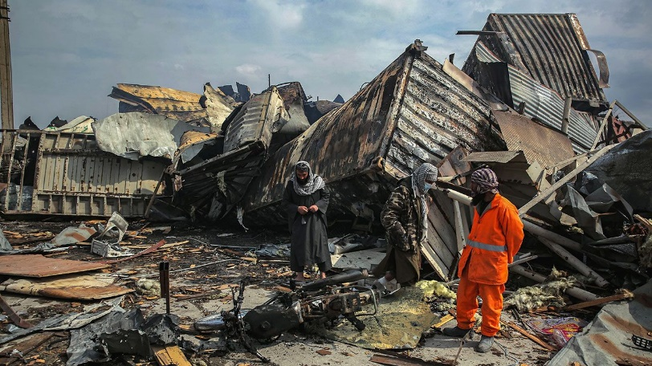Photograph: Shutterstock
16 Pakistan and Afghanistan agreed to pause fighting to mark Eid al-Fitr, the end of Ramadan. The temporary reprieve of four days comes after a Pakistani air strike on Kabul killed at least 143 people. The Taliban government claimed the attack hit a hospital and that the death toll was as high as 400. Pakistan denied this and said that its forces “precisely” targeted terrorist infrastructure.
17 Mr Trump said he was postponing a visit to China as a result of the war with Iran. He had been due to travel to Beijing on March 31st to meet President Xi Jinping. Mr Trump says the trip will now take place in “about five or six weeks”.

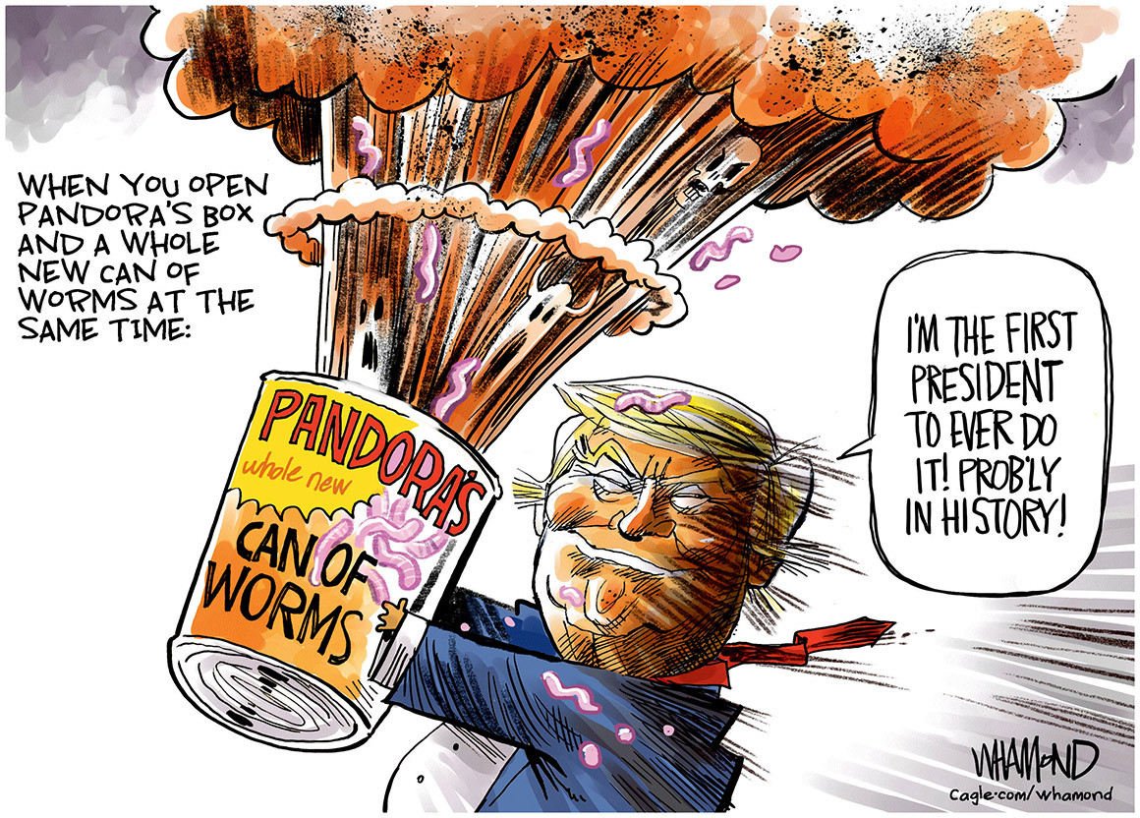Politico

