Politics The Economist

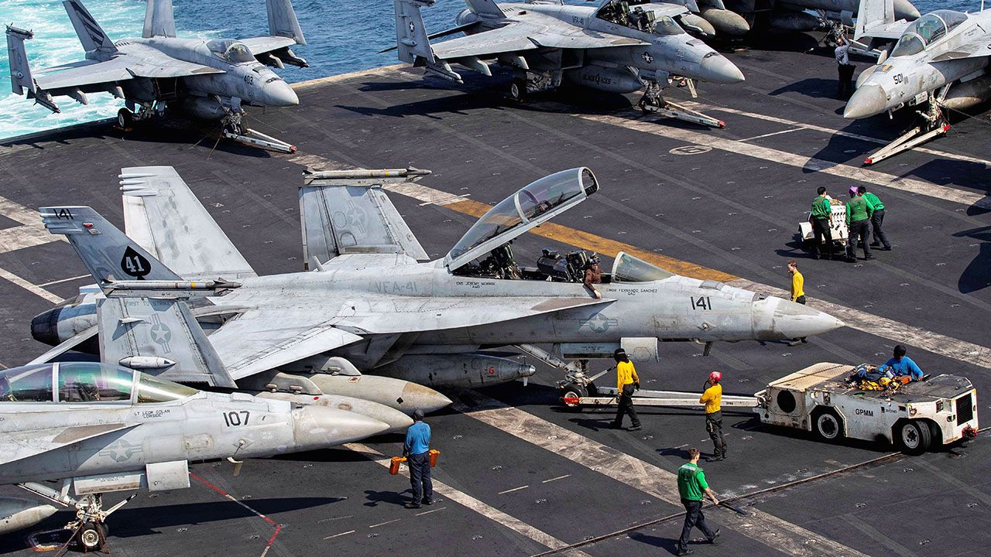Photograph: Reuters
Apr 1st 2026
1 Donald Trump suggested that America would end the conflict with Iran within “two or three weeks”, whether or not a peace deal was reached. The president made his remarks before a scheduled TV address to Americans. Masoud Pezeshkian, Iran’s president, said the regime would consider ending the war, but only if it received security “guarantees”. Meanwhile, more American troops arrived in the Gulf region. Iran continued its attacks on Israel and across the Gulf, striking a Kuwaiti oil tanker that docked in Dubai. The Iranian-backed Houthis in Yemen launched their first strike against Israel since the start of the war. Their involvement increases the risks to shipping in the Red Sea. Transport maritime
2 Several countries criticised the Israeli parliament after it passed a law that in effect makes it mandatory for Palestinians to receive a death sentence if they are convicted by a military court of deadly terrorist acts. It also bars a right to appeal. Israeli civil- and human-rights groups say the law is racist; the language implies that it could be applied to Israeli Arabs, for example, but not to Jewish citizens. Meanwhile, parliament passed a $271bn budget, Israel’s biggest ever thanks in large part to increased defence spending.
3 Israeli police stopped the Latin Patriarch of Jerusalem from holding mass at the Church of the Holy Sepulchre on Palm Sunday, citing security concerns as holy places were being targeted by Iranian missiles. The Catholic archbishop’s office said it was the first time in centuries that access had been denied to the area, which Christians believe is the site of Jesus Christ’s crucifixion and burial. The matter was later resolved after Israel’s president, Isaac Herzog, intervened.
4 Iran’s ambassador to Lebanon was still in Beirut, despite the government ordering him to leave for meddling in domestic affairs. Nabih Berri, the speaker of the Lebanese parliament and an ally of Hizbullah, a militia supported by Iran, asked the ambassador to remain, according to reports. The Iranian government said he was there to stay. Meanwhile, two UN peacekeepers from Indonesia were killed by a roadside bomb in southern Lebanon, and another was killed by a projectile in a separate incident. Interférer dans bombe artisanale
5 Marco Rubio, America’s secretary of state, said that NATO’s lack of support during the Iran war was “very disappointing” and that America would need to “re-examine” its military alliance when the conflict is over. Mr Trump has described NATO countries as “cowards”. This week Italy refused to allow American military aircraft to land at a base in Sicily and Spain closed its airspace to military planes involved in the war. Britain has restricted the use of its bases to America for “defensive action” only.

Out of action
6 The USS Gerald R. Ford, the world’s biggest aircraft-carrier, docked in Split, Croatia, for repairs. The vessel had been sailing in the Red Sea supporting the military operation against Iran. A fire not related to combat operations broke out in its laundry room. Housing 5,000 service personnel and 75 aircraft, the ship has also been beset by plumbing problems. s’amarrer vaisseau blanchisserie
7 Gunmen killed at least 74 people in an attack on a mine in South Sudan. The site has been at the centre of a conflict over illegal gold mining in the past. The opposition party of the suspended vice-president, Riek Machar, blamed government forces. The government accused the opposition of being behind the atrocity.
8 Mr Trump sent more mixed signals about his intentions for Cuba. “Cuba is next”, he said in a speech that praised the American armed forces’ actions in Venezuela and Iran. Two days later he said he had “no problem” with countries sending oil to the island, adding that “Cuba is finished.” A Russian tanker carrying 100,000 tonnes of crude oil docked in Cuba, the first such shipment in three months, according to the Cuban government.
9 America formally reopened its embassy in Venezuela, a few weeks after re-establishing diplomatic relations. The State Department recently determined that Americans are no longer at risk of being detained in the country and lifted its “do not travel” advisory.
10 Local human-rights groups said that 70 people were massacred by a gang in Haiti’s Artibonite region, and that attacks were continuing. Local officials put the death toll at 16. It is thought that the Gran Grif gang carried out the attack as part of a turf war. The same gang is responsible for killing 115 people in October 2024 in an attack on the same area.
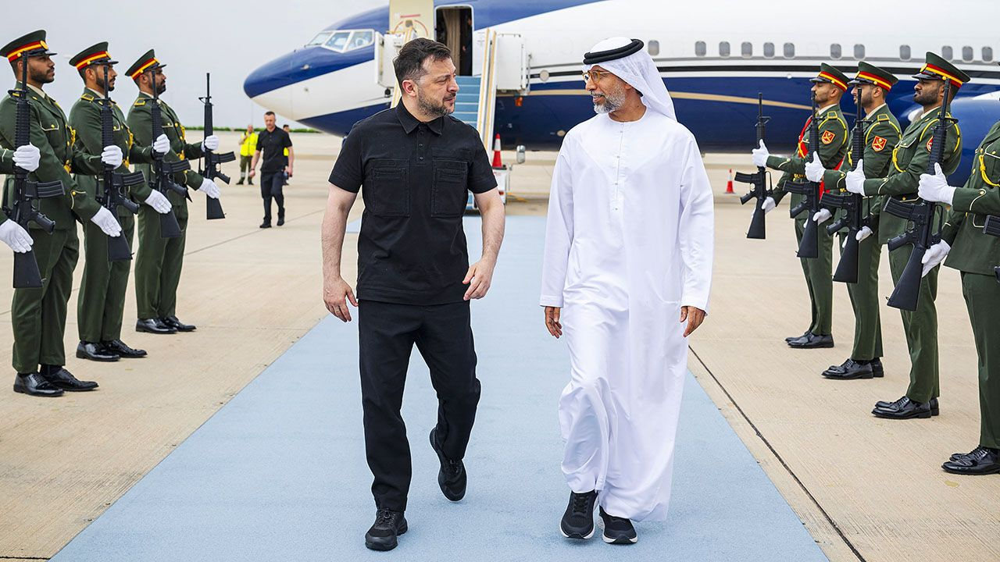Photograph: Getty Images
11 Volodymyr Zelensky visited Jordan, Qatar, Saudi Arabia and the United Arab Emirates, where he struck co-operation agreements on security and defence. The Ukrainian president has offered to share air-defence and drone technologies; more than 200 Ukrainian security experts are in the Middle East advising countries how to intercept ​drone attacks. While he was in Saudi Arabia an Iranian drone attack on an air base wounded 12 American servicemen.
12 Russia expelled a British diplomat whom it accused of gathering sensitive information on the Russian economy, and threatened to retaliate if Britain responded by expelling a Russian diplomat. Britain’s Foreign Office said the accusations were “malicious and completely baseless”, and part of Russia’s “campaign of harassment”.
13 The International Olympic Committee banned transgender athletes from competing in women’s categories, starting with the Los Angeles Olympics in 2028. Kirsty Coventry, who was elected last year as the first female president of the IOC, said it was not “fair for biological males to compete in the female category” and that in some sports it simply wasn’t safe.
14 Donald Trump’s $400m ballroom construction project at the White House was put on hold by a judge, who ruled that Congress must first give its approval. The Justice Department immediately lodged an appeal against the decision. The lawsuit was brought by the National Trust for Historic Preservation, which Mr Trump has described as a bunch of left-wing “lunatics”. Mettre en pause cinglés
15 America’s Supreme Court overturned a law in Colorado that banned conversion therapy for children under 18. Conversion therapy seeks to change the sexual orientation of gay people, which many experts say doesn’t work and is ultimately harmful. Colorado may think its ban is in the interest of public health and safety, said the court, but it interferes with free speech.
16 India’s census got under way. Delayed since 2021, three million officials have begun the year-long process of counting the country’s more than 1.4bn people, which will include door-to-door surveys. The people-counters will also use mobile apps to gather data for the first time.
17 K.P. Sharma Oli, Nepal’s former prime minister, was arrested in connection with the crackdown on last year’s protests in which 77 people died. Mr Oli resigned and a subsequent election was won by Balendra Shah, a former rapper and one of the leaders of the Gen Z movement behind the protests. A former government minister was also arrested, after a commission recommended that both men be charged with criminal negligence.

Rapper’s delight
18 Mongolia’s parliament appointed the country’s third prime minister in a year. Uchral Nyam-Osor is seen as a compromise candidate who can unite two bickering political factions. A former minister of digital communications, he has pressed for reforms to streamline Mongolia’s regulatory quagmire, much of it a hangover from its time as a Soviet satellite state. Mr Uchral also used to be a hip-hop artist, known as Timon. Se querellant moderniser et simplifier le labyrinthe des règlementations ( quagmire: bourbier) relique

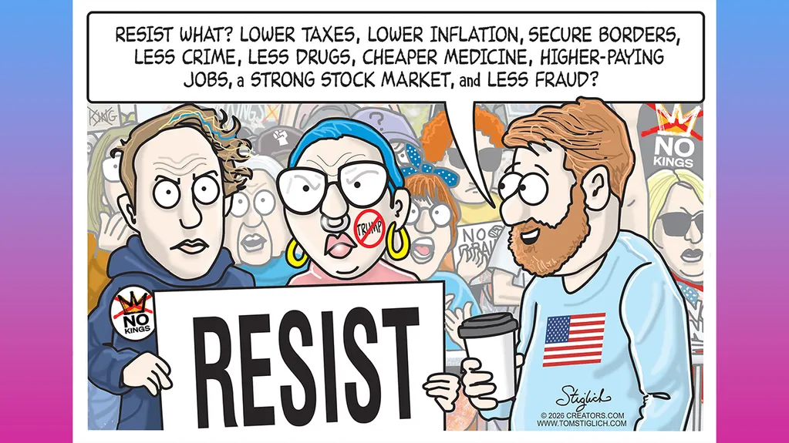
Fox News

)
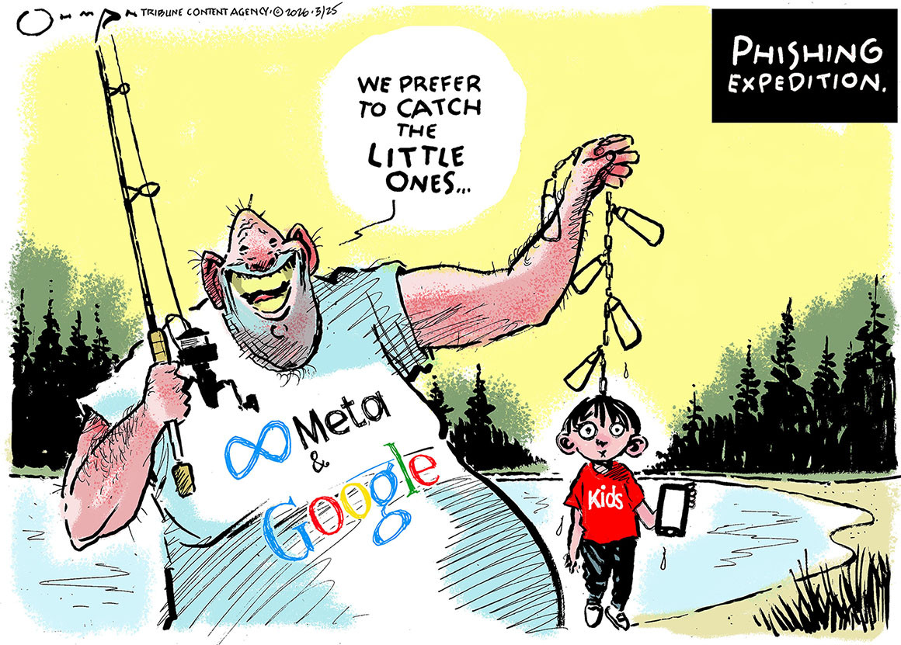

Jack Ohman Tribune content agency ( Politico)

