Politics

Nov 7th 2024
1 Donald Trump won America’s presidential election, handily beating Kamala Harris and becoming the first Republican to win the popular vote since 2004. He won all the crucial states that decided the election, including Michigan, Pennsylvania and Wisconsin. Iowa, which a recent poll suggested Ms Harris would unexpectedly win, ended up plumping for Mr Trump by a margin of 13 percentage points. Mr Trump said the results gave him a “great feeling of love” and “a powerful mandate”. He will be the first president to enter office who has been convicted of a felony. Facilement
A clean sweep
2 The Republicans had a good night in Congress too. The party won control of the Senate after taking seats from the Democrats in Montana, Ohio and West Virginia. It is also on track to retain a narrow majority in the House of Representatives. en bonne voie
3 Ballot initiatives aimed at protecting abortion rights passed in several states, including Missouri, where an existing ban on the procedure was overturned. Restrictions will remain in Florida, Nebraska and South Dakota.
4 Binyamin Netanyahu, the Israeli prime minister, sacked Yoav Gallant, his defence minister. Mr Netanyahu blamed a “crisis of confidence” between the pair; the two men have long disagreed over Israel’s strategy in Gaza and Lebanon. Mr Gallant has supported a ceasefire in Gaza that would lead to the release of the remaining hostages; the prime minister is reluctant to pursue such a deal.
5 An Israeli court partially lifted a gag order to reveal that a spokesperson working with the office of Mr Netanyahu has been accused of leaking top-secret documents that may have undermined negotiations for a ceasefire in Gaza and the release of hostages. Mr Netanyahu has denied any wrongdoing by his staff. Lever une consigne de silence
6 Human-rights campaigners called on Iran to release a woman who was detained after taking off her clothes and walking around a university in Tehran in her underwear in an apparent protest against Iran’s compulsory hijab laws. The university said the woman suffered from a “mental disorder” and had been taken to a psychiatric hospital.
7 Fighting broke out at a Hindu temple near Toronto, reportedly between Sikh separatists and other Indian-Canadians. The trouble was sparked by a visit from Indian consular officials. Relations between Canada and India are at a low ebb over the murder of a Sikh activist in Vancouver and claims that Indian officials were involved. Narendra Modi, India’s prime minister, said the violence was an assault on a Hindu place of worship and an attempt to intimidate diplomats. Au plus bas
8 Australia’s High Court ruled that the government could not force certain migrants to wear tracking devices on their ankles. Around 200 migrants with criminal records but who can’t be deported were made to wear the trackers, after the same court ruled late last year that they could not be held in custody indefinitely. It has now decided that they can’t wear the devices either, because only judges, and not politicians, can impose punishments. Mouchard être en garde à vue
9 Germany’s coalition government unravelled, torn asunder by rows over the budget. Olaf Scholz, the Social Democratic chancellor, sacked his finance minister, Christian Lindner of the pro-business Free Democrats, accusing him of putting his party before his country. With the economy in the doldrums, Mr Scholz wants to loosen Germany’s strict fiscal rules in order to borrow more. He has called for a vote of confidence in parliament on January 15th, which he will probably lose. Déchirer en berne
10 The Spanish government sent 10,000 troops, police and national guard to help the rescue effort in the Valencia region, the largest such peacetime deployment in Spain’s history. The death toll from the recent flooding climbed to 219, and was expected to rise. In chaotic scenes some angry residents shouted abuse at King Felipe and local officials, whom they blame for being unprepared for the deluge, during a visit to the scene. The prime minister, Pedro Sánchez, had to be driven away for his safety.
11 Ireland’s prime minister, Simon Harris, called a general election for November 29th.
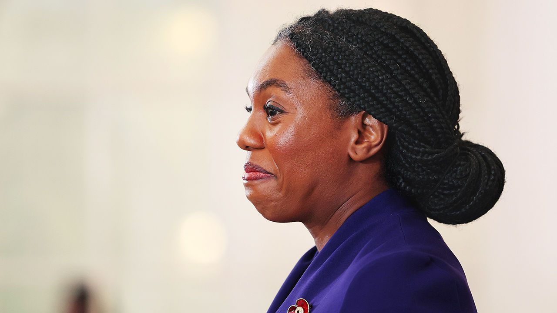Photograph: EPA
12 Kemi Badenoch was elected leader of Britain's Conservatives, becoming the first black person to head one of the country’s big parties. Straight-talking, blunt and at times abrasive, Ms Badenoch is vocally anti-identity politics and blames regulation for many problems. She says she will fight against what she claims is “left-wing nonsense” from the new Labour government. It is a difficult job. After July’s historic election defeat, the Tories have five years in opposition ahead. franche
13 Maia Sandu was re-elected as Moldova’s president for a second four-year term, despite the Kremlin’s underhand efforts to bolster her pro-Russian opponent, Alexandr Stoianoglo. Ms Sandu’s national security adviser confirmed there had been “massive interference” from Russia during the election. En sous-main
14 A senior Ukrainian official said that Ukrainian troops had fired on North Korean soldiers, who are bolstering Russian forces. The incident took place in Russia’s Kursk border region, which Ukraine marched into in August. Volodymyr Zelensky, the Ukrainian president, noted the “increase in North Korean forces, but, unfortunately, we do not see an increase in response from our partners”. Meanwhile Vladimir Putin, Russia’s president, held a meeting with North Korea’s foreign minister at the Kremlin.
15 A Russian missile strike on the south-eastern Ukrainian city of Zaporizhia killed six people. Europe’s largest nuclear plant sits just 50km (31 miles) from the city. Russia has stepped up its attacks in the area.
16 Eight people went on trial in Paris over the murder in 2020 of Samuel Paty, a teacher who was beheaded by a Muslim fanatic for showing pictures of Muhammad the Prophet in a lesson on free speech. The perpetrator was shot dead by police. The trial focuses on local residents who whipped up a campaign of hate and lies against Paty on social media. décapité

Entrée interdite
17 New traffic restrictions came into force in Paris, banning cars from entering a five square km (1.9 square miles) zone covering four central arrondissements. Residents who live in the zone can still drive in it. The first six months of the scheme is a “pedagogical period”, where motorists who enter the area will be politely told of the new restrictions. After that they face a stiff fine.
KAL

