Politics
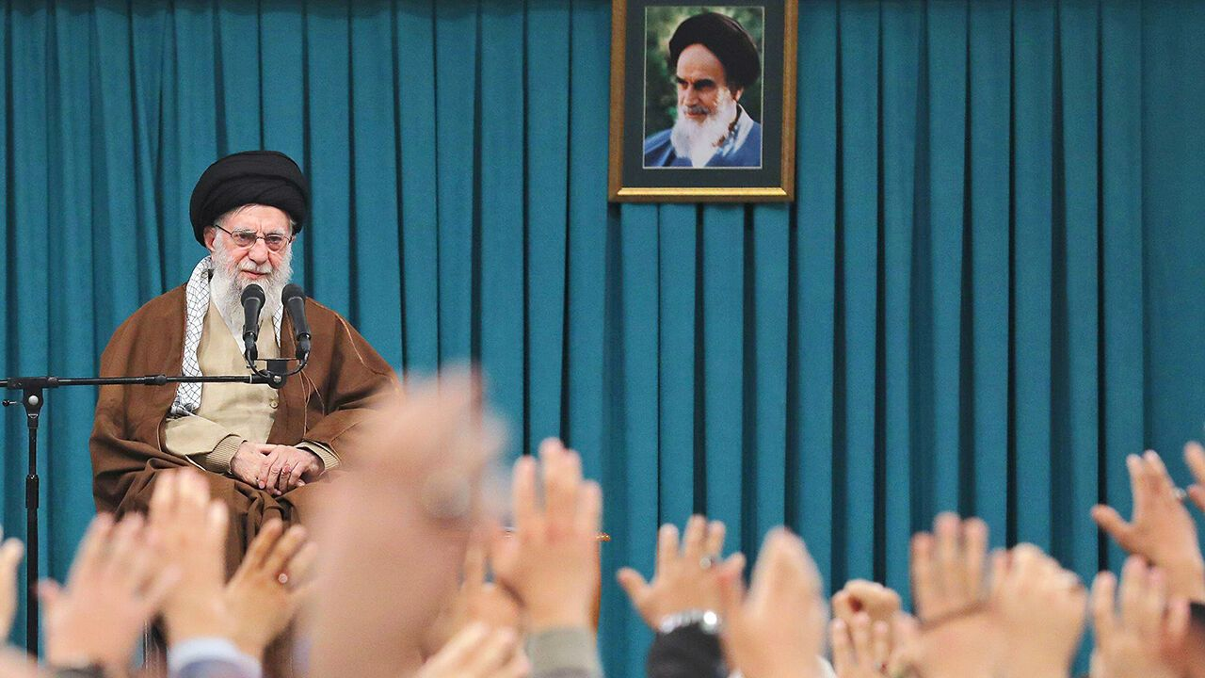Photograph: Alamy
Jun 19th 2025

1 Donald Trump called for Iran’s “unconditional surrender”, as Israel continued its bombardment of the country. As Tehran’s residents began fleeing the city, Mr Trump publicly toyed with the idea of America joining military action. He also said that America knows the location of Ayatollah Ali Khamenei, Iran’s supreme leader, but will not “take him out…for now”. Israel’s devastating strikes on Iran have killed a number of senior regime officials, including General Mohammad Bagheri, chief of staff of Iran’s armed forces. The head of the Islamic Revolutionary Guard Corps and several other high-ranking IRGC commanders were also killed, as were at least nine nuclear scientists. Israel struck ballistic-missile bases, air-defences and nuclear facilities.
2 The G7 meeting in Kananaskis, Canada, issued a statement affirming Israel’s right to defend itself in the face of Iranian threats to destroy it. The G7 called Iran the “principal source of regional instability and terror”, adding that the Islamic Republic must never have a nuclear weapon. Mr Trump left the summit a day early to deal with the crisis.
3 The Israel Defence Forces is investigating reports by Gaza’s civil-defence agency that 51 Palestinians were killed and 200 wounded at a UN World Food Programme aid hub near Khan Younis. The Hamas-run agency did not say how many of the dead were civilians or combatants and blamed Israeli forces. Shootings have taken place almost daily at a number of other new aid-distribution sites run by Israel and American security firms. Centre de distribution d’aide
4 Rwanda and Democratic Republic of Congo agreed on the terms of a peace deal at a meeting in Washington. A formal signing is expected soon. The Trump administration hopes that peace would pave the way for mineral deals. But past deals have usually unravelled. Se défaire
3 Some 200 people were killed in armed attacks in north-central Nigeria, with thousands more forced to flee their homes. The killings mark the latest escalation of a long-running conflict between farmers and herders. Locals say successive governments have neglected the problem. Éleveurs nomades de bétail
5 A court in Mali ordered Barrick’s gold mine to reopen under state control, escalating a dispute between the country’s military rulers and the mining giant. Barrick suspended production in January after the junta blocked shipments from the site and confiscated some of its stockpiled gold. En réserve
6 Following an extensive manhunt a 57-year-old man was arrested and charged with murdering Melissa Hortman, a Democratic representative in Minnesota’s state legislature, and her husband, and for carrying out a separate gun attack that wounded a Democratic state senator and his wife. The man was disguised as a policeman when he attacked his victims and had a list of scores of other targets.

At least it didn’t rain
7 On Donald Trump’s birthday, a military parade was held in Washington to celebrate the 250th anniversary of the founding of the army. It was poorly attended. Spectators may have stayed away because of the threat of trouble. Hundreds of protests against the president were held across America under the slogan of “No Kings”, a reference to Mr Trump’s monarchical tendencies.
8 Russia carried out more big bombardments of Ukraine, killing at least 28 people in one attack on Kyiv that lasted for hours, during which Russia deployed 440 drones and 32 missiles. One drone destroyed dozens of flats in a residential building. The mayor of Kyiv, Vitali Klitschko, accused Russia of using cluster bombs filled with ball bearings to maximise casualties. Two people were killed in Odessa. Bombe à fragmentation
9 Volodymyr Zelensky called on America and Europe to respond, suggesting they were now turning “a blind eye” to Russian brutality. Mr Zelensky had hoped to talk to Mr Trump at the G7 summit, but the American president’s early departure meant there was no meeting. Mr Trump earlier criticised the G7 for kicking Russia out of what was then the G8 in 2014 after it invaded Crimea, suggesting that this is what caused Vladimir Putin to invade Ukraine.
10 The mayor of Budapest said that the Hungarian capital would hold a gay Pride march on June 28th, defying recent legislation from Viktor Orban’s right-wing government that bans the events. The march will be defined as a “municipal” celebration.
11 In Spain Pedro Sánchez came under pressure to resign as prime minister after a senior official in his Socialist party stepped down to answer claims in court of awarding public works for kickbacks. At a news conference Mr Sánchez insisted he had been unaware of the alleged corruption. pot-de-vin
12 Cristina Fernández de Kirchner, Argentina’s leftist president from 2007 to 2015 and vice-president from 2019 to 2023, was placed under house arrest to serve her six-year sentence for corruption. The Supreme Court recently rejected Ms Fernández’s appeal against her conviction from 2022. A judge decided that as she is 72, she should serve her punishment at home wearing an electronic tag.
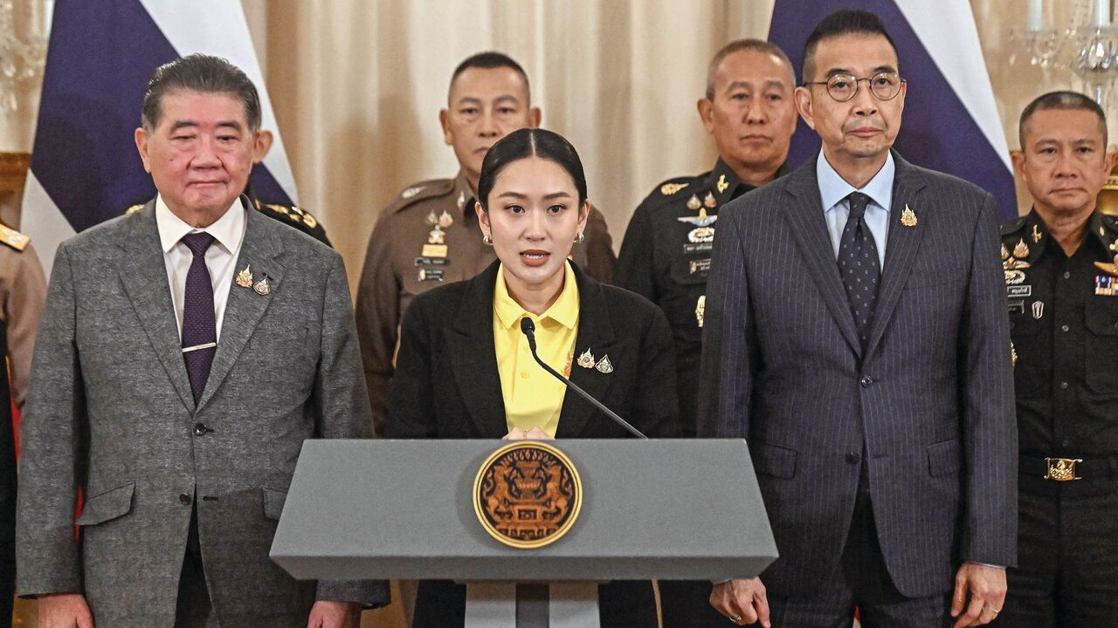Photograph: Getty Images
13 In Thailand protesters called on Paetongtarn Shinawatra to resign as prime minister following the leak of a phone conversation between her and Hun Sen, Cambodia’s former strongman, who still wields considerable power. In the call Ms Paetongtarn seemed to dismiss the Thai army’s concerns over a border skirmish that has heightened nationalist fervour in both countries. Her government was on the brink of collapse after the second-largest party in the ruling coalition withdrew its support. écarter
14 The death toll from the Air India crash in Ahmedabad rose to at least 270. All but one of the 242 people on board died when the Boeing 787-8 Dreamliner failed to gain altitude after take-off. Around 30 people were also killed when the plane hit a hostel for medical students. There was one survivor, a 40-year-old British national, who pushed through a hole in the fuselage to crawl out of the wreckage. “I still can’t believe how I survived,” he said.
15 Taiwan announced that it had completed a sea test of the first submarine to be built in the country. The submarine, the first in a fleet of eight, was built with technology from America and elsewhere, using a combat system made by Lockheed Martin. More testing needs to be done but Taiwan hopes to deploy two submarines by 2027.
16 Lee Jae-myung, South Korea’s new president, held his first summit with Ishiba Shigeru, Japan’s prime minister, on the margins of the G7 gathering in Canada. Mr Lee had once called his predecessor, Yoon Suk Yeol, a “puppet” of Japan and described a 2023 summit with Japan as “humiliating”. But he now says that the two countries have an “inseparable” relationship, and are bound together by common security and trade interests.
17 Britain’s Labour government conceded and agreed to hold a national inquiry into grooming gangs following a report it had commissioned into “group-based child sexual exploitation”. The report found evidence of a disproportionately large share of Asian men among suspects in local data, and argued that authorities had shied away from looking into the crimes in part because of the ethnicity of perpetrators. The government said that the National Crime Agency would take over hundreds of cold cases. Organisation de pédopiégeage, groupe d’abus sexuel sur mineurs Hésiter à, craindre
18 As part of an amendment to a broader crime bill, MPs in Britain voted to end prosecutions of women for later-term abortions. Current rules forbid most terminations after 24 weeks of pregnancy, and doctors and clinics would still be required to abide by those rules. But women who take early abortion pills at home would no longer be investigated by police.

From Q to C, with love
MI6, Britain’s foreign-intelligence service, appointed its first-ever woman as chief. Blaise Metreweli, formerly head of Q branch (technology) will be known as ‘C’ from October. Will James Bond bond with his new boss?

