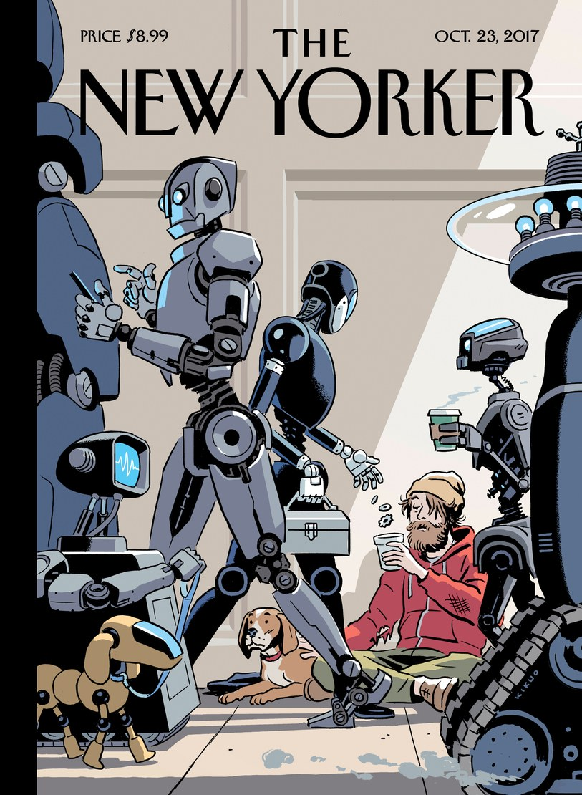
The document under examination is a magazine cover from The New Yorker issued on October 23 2017 which depicts a dystopian world where robots have superseded humans. After describing the cartoon, I shall provide a thorough analysis of it around the following question: to what extent should we fear AI might outsmart humanity?
The scene takes place on a pavement and shows a homeless human sitting on the floor with his dog. They both look quite dull as the man is handing out an empty cup in order to get a few coins from the robot passers-by. Instead of getting coins, all he gets is a couple of bolts.
We may argue the picture is divided into 2 parts owing to the contrast of colours and the position of the characters. If the human sitting on the floor stands out because it is the only colourful element in the picture, the grey robots walking in the foreground seem to grab all the attention owing to the fact that they outnumber the humans.
Cleverly enough, the cartoonist chose an angle shot that makes the viewer on the same level as the human, hence in an inferior position to the robots.
I believe the cartoonist aims at warning against AI creations getting out of control to the point of raising several issues, be they social, ethical or else that could threaten/jeopardize human existence.
Progress in AI: boon
AI as a bane
Food for future thoughts: how to tame AI

Welcome to the next industrial revolution. After steam, mass production and information technology, the so-called "fourth industrial revolution" will bring ever faster cycles of innovation, posing huge challenges to companies, workers, governments and societies alike.
The promise is cheaper goods and services, driving a new wave of economic growth. The threat is mass unemployment and a further breakdown of already strained trust between corporations and populations. (...)
Robots are already on the march, moving from factories into homes, hospitals, shops, restaurants and even war zones, while advances in areas like artificial neural networks are starting to blur the barriers between man and machine. (...)
1/ The term artificial intelligence, or the simulation of intelligence in computers or machines, was coined back in 1956, only a decade after the creation of the first electronic digital computers. In the 2000’s scientists were developing AIs that excelled in specific areas, such as winning at chess, cleaning the kitchen floor and recognising human speech. Such “narrow” AIs, as they are called, have superhuman capabilities, but only in their specific areas of dominance. A chess-playing AI cannot clean the floor or take you from point A to point B. We may argue robots will take on dull repetitive tasks that humans won’t do and in that sense it may be welcome.
2/ But there are deep worries, as well as awe, at what technology can do.
More darkly, I am convinced that that superintelligence could lead to an explosion or breakout of AI that could threaten human existence – that ultrasmart AIs will take our place on the evolutionary ladder and dominate us the way we now dominate apes. Or, worse yet, exterminate us.
A new report from UBS released in Davos predicts that extreme levels of automation and connectivity will worsen already deepening inequalities by widening the wealth gap between developed and developing economies. “The fourth industrial revolution has potentially inverted the competitive advantage that emerging markets have had in the form of low-cost labor,” said Lutfey Siddiqi, global head of emerging markets for FX, rates and credit at UBS.
There will be winners and losers among companies, too, as new players move into established industries with disruptive new technologies. That is something uppermost in the minds of Davos attendees such as General Motors CEO Mary Barra, who is confronting the threat of driverless cars - another science fiction that has become science fact.
Such innovations, coupled with the rise of robots in both the manufacturing and service sectors, could automate vast numbers of jobs. Oxford University researchers predicted in 2013, for example, that 47 percent of U.S. jobs were at risk.
The question is whether this time will be different, given the speed to change and the fact that machines now offer brain as well as brawn* (= intelligence plus muscles) , threatening professions previously seen as immune, such as entry-level journalism or routine financial analysis.
Artificial consciousness could give way to serious ethical questions. If machines become self-aware, could they react in a negative way to the situation they're in? Could machines object to being used as tools? Would they have feelings?
There's a lot of debate on the subject. Since no one has managed to create an artificially conscious machine, it's impossible to say what features it will and won't have. But if machines gain the ability to be self-reflective, it could require us to reconsider the way we think about them. At what point would a machine possess the sort of intelligence and consciousness that would necessitate us bestowing (= giving) them legal rights? Or would machines remain tools and possibly consider themselves to be slaves?
Conscious machines form the basis of several apocalyptic science fiction tales. Movies like "The Matrix" or "The Terminator" envision a world in which machines have subjugated (= controlled) mankind.
So the question that remains is how to ensure human control over AI.
3/ It is inevitable that such advanced AI solutions will be developed. After all, if OpenAI can develop it, another organisation can do the same. However, that organisation might not be as responsible as OpenAI and decide to release the full research. Or they might be bad actors and use the system for their benefit.
The challenges that we face with AI are enormous. The challenge is that the developments of AI are going much faster than the adaptability of humans in terms of regulations, culture and norms and values. Before we know it, someone might have developed advanced AI to use against us, and there are no proper measures we can take to prevent it.
The only way to move forward with advanced AI is, in my opinion, a global new deal for AI. A series of programs and projects instituted by global organisations such as the G20 or the United Nations to prevent misuse of (advanced) artificial intelligence and to establish guidelines and policies in terms of AI development.

