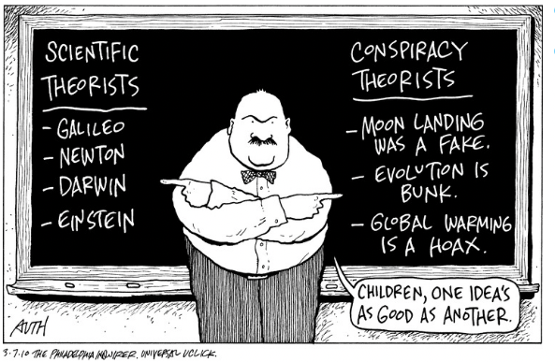
By American cartoonist Tony Auth March 7, 201,The Philadelphia Inquirer

