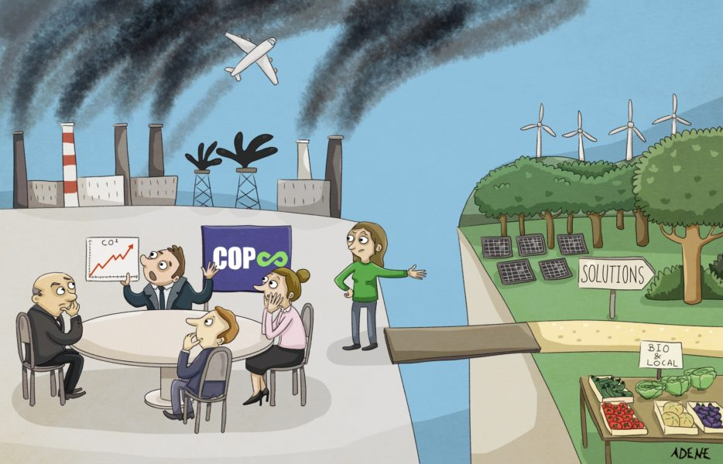

With the armada of private jets departed from Glasgow after the COP26 climate change conference, the world is left to reflect on yet another round of nonbinding commitments, watered-down resolutions and promises to revisit the problem next year. The science on climate change may be clearer than ever, but so too is the failure of the world’s current strategy for countering it hence leaving young activists in despair facing government’s inaction.
The document under study was released in the aftermath of the COP 26 climate change conference and sheds light on how broken the dialogue between politicians and activists is when it comes to taking actions. The cartoon raises the following issue: to what extent does the economy act as a hurdle in the fight against climate change?
The cartoon is clearly divided into 2 parts which altogether differ in terms of colours and of interests.
The left part of the cartoon depicts world leaders sitting around a table trying to find solutions or reach agreements to curb CO2 emissions responsible for climate change. They seem to be deliberately turning their backs to what can be accounted for air pollution: big factories belching out smoke, extensive industrialization, transports… The line graph shows the constant increase of CO2 emissions. The cartoonist has deliberately chosen not to shame one COP in particular which aims at showing that climate change conferences come one after the other with little or no effect. This is what Greta Thunberg said about the COP 26 climate summit qualifying it as a “failure” hence lambasting the U.N- brokered talks.
The world leaders are turning a blind eye to a young woman (who may embody young activists) showing them the way for a better future, showing them down-to earth solutions: using more solar panels, wind energy, planting trees, growing organic food and consuming local food. Her voice however remains unheard, as politicians seem to rather concentrate on economic interests. It illustrates how broken the dialogue is in an approach to climate change which lacks mutual cooperation, altruistic collective action especially when priorities are competing.
This can be related to what Great Thunberg said during the COP 26: “Inside COP, there are just politicians and people in power pretending to take our future seriously,” (…) “Change is not going to come from inside there, that is not leadership. This is leadership, this is what leadership looks like…” Net zero by 2050. Blah, blah, blah. Net zero. Blah, blah, blah. Climate neutral. Blah, blah, blah. This is all we hear from our so-called leaders. Words that sound great but so far have led to no action. Our hopes and dreams drown”

