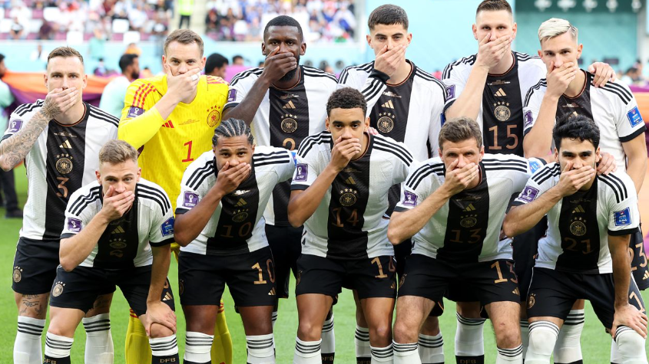

Despite moves to boycott it, the football world cup eventually took place in Qatar, a nation known for baffling all sorts of human rights.
The document under examination shows Germany players posing with their hands covering their mouths as they line up for the team's photo prior to the World Cup game against Japan. They acted this way to suggest they had been gagged by football’s governing body, Fifa.
The photo questions the role of sports/ activism in sports/to what extent should sports be politized?
Their message was reinforced by the German interior minister, Nancy Faeser, who also wore a OneLove armband, which promotes tolerance, diversity and LGBTQ+ rights, as she sat next to Fifa’s president, Gianni Infantino. It was a calculated act of defiance against Fifa, who has warned seven nations, including England and Wales, that they will face sporting sanctions if their captains wear OneLove armbands during matches.
Six players, including captain Manuel Neuer and Manchester City’s Ilkay Gundogan, also wore Adidas boots with rainbow stitching during the team’s shock 2-1 defeat against Japan, while the entire German squad sported tops with rainbow colours on their sleeves in the warm-up. In a strongly worded statement, the Germans made clear their anger, telling Fifa: “We wanted to use our captain’s armband to take a stand for values that we hold in the Germany national team: diversity and mutual respect. Together with other nations, we wanted our voice to be heard.
“It wasn’t about making a political statement – human rights are non-negotiable,” it added. “That should be taken for granted, but it still isn’t the case. That’s why this message is so important to us. Denying us the armband is the same as denying us a voice. We stand by our position.”
The campaign was meant to raise awareness of marginalized groups in the host country, Qatar, which criminalizes homosexual conduct. The teams had notified FIFA about their plans in September but only got a response hours before England, the first among the teams to pledge to make a stand, was set to open its campaign on Monday. The teams said they had expected to be fined for breaching FIFA’s strict uniform regulations, but instead were told their captains would receive a yellow card.
It is not the first time athletes take a stand. The history of sports protests goes deep. There have been all sorts of protests about race, gender, money and nationality in American and Olympic sports history, but they all have this in common: the constant struggle for justice, supported by the U.S. Constitution. Athletes in modern times have often been moved to protest conditions, to demonstrate that they are citizens of conscience by speaking truth to power.
The politically and socially conscious athlete Muhammad Ali was stripped of his boxing title because he refused to serve in the Vietnam War after being drafted into the Army, and John Carlos and Tommie Smith became pariahs for raising their fists in a Black Power salute on the medal stand at the 1968 Olympics in Mexico City.
Sports activism got momentum in 2010, after the killing of Trayvon Martin, an African American teenager who was followed and ultimately shot in Sanford, Florida, by a neighborhood watch member who found him suspicious even though he was merely walking home from the store. As a form of protest, the Miami Heat of the NBA took a team photo with every player wearing a hoodie similar to the one Trayvon was wearing when he was shot, their way of commenting on the injustice of a Black teen being considered dangerous merely for wearing a hooded jacket.
But it was Colin Kaepernick’s kneeling during the national anthem in 2016, in protest of police shootings of African Americans, that appears to have triggered the full reawakening of athletes’ social conscience. “That was the moment where I said, I don’t want to just tweet. I don’t want to just wear a T-shirt with some words of protest,” says Malcolm Jenkins, a New Orleans Saints defensive back who co-founded the Players Coalition, an organization of National Football League players devoted to social causes, including racial inequities in the criminal justice system. “I want to do something that truly makes a difference.”
Hundreds of players clearly feel the same way. Athletes in nearly every sport have stepped forward in a variety of ways to address what they consider to be social injustices, with the hope of spearheading efforts to get things changed.
If the football pitch is the right place to address those issues is debatable but facing government’s inaction, athletes seem to have endorsed more political responsibilities lately.

