Daryl Cagle: Donald Trump and Twitter (December 8 2017)
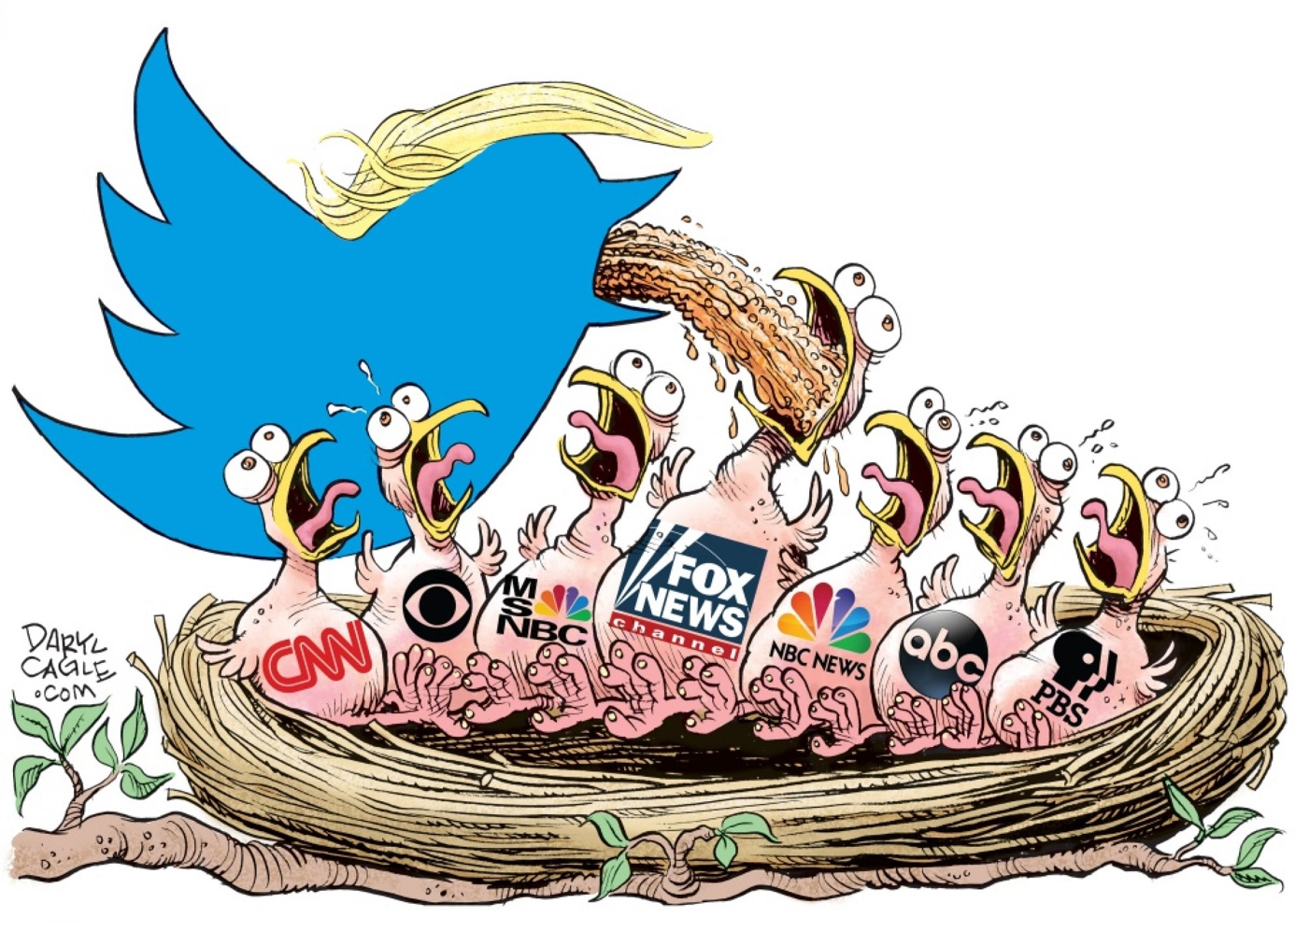
(Daryl Cagle illustration / caglecartoons.com)
The term “fake news” has been popularized by President Donald Trump in recent years, with the spreading of false information allowing to fulfill a political agenda while also giving way to the ongoing global erosion of trust in the media .
The editorial cartoon under study questions the role of journalism and to what extent Trump has instrumentalized and lured the news media into taking his bait.
The cartoon depicts a caricature of Trump as a Twitter bird with blond hair characteristic of former US president “feeding “newly-born birds in a nest carrying the names of poor-quality journalism channels such as Fox News, ABC…. Rather than feeding them we may argue that Trump is throwing out , deluging the birdies with fake news.
Depicting news media as baby birds is a way for the cartoonist to denounce some media’s lack of initiative and free will to filter the news (unable to provide reliable information). He aims at literally brand-shaming media companies whom he seems to account responsible for the spreading of false information. We may also interpret Trump’ s throwing out into the birdies’ throats as evidence of Trump’s little respect for journalists.
The cartoonist does not seem to aim so much at Donald Trump as at social media for helping foster the sharing of unsubstantiated claims by public figures. Daryl Cagle probably wants to raise an awareness as for the need to regulate social media and fake news for the role they play in increasing polarization.
Although this cartoon was published the year following Trump’s election as president, his numerous tweets had already bred countless news cycles full of confusion, spreading political propaganda, undermining trust altogether. Truth distortion has demonstrated how uncertainty in information can become a major source of societal polarization on a major public issue.

Twitter has, in the past, given world leaders a lot of leeway, even when they post false information, because, it says their tweets are newsworthy.
In June 2019, the company created a warning label to flag and suppress political tweets that break its rules on acceptable speech.
The debate over what tech platforms can and should do about Trump's posts underscores their dilemma between encouraging free speech and cracking down on misinformation, harassment and election interference. That balance becomes even harder to strike when a public figure like Trump is involved.
Donald Trump’s controversial removal from social media platforms has reignited debate around the censorship of information published online. But the issue of disinformation and manipulation on social media goes far beyond one man’s Twitter account.
In the past four years, social media manipulation has evolved from a niche concern to a global threat to democracy and human rights.
A strong, functional democracy relies upon the public’s access to high-quality information. This enables citizens to engage in informed deliberations and to seek consensus. It’s clear that social media platforms have become crucial in facilitating this information exchange.
These companies should therefore increase their efforts to flag and remove disinformation. Otherwise, the continued escalation in computational propaganda campaigns will only heighten political polarisation, diminish public trust in institutions, and further undermine democracy worldwide.

Work-at-home-dad
Illustration by Dave Granlund, politicalcartoons.com, https://www.cagle.com/dave-granlund/2009/06/work-at-home-dads, June 17, 2009
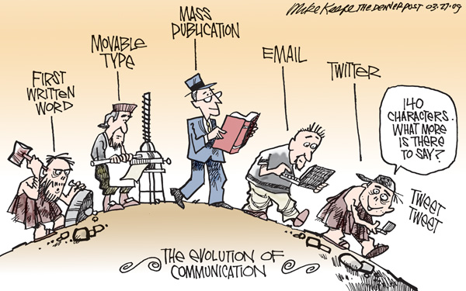
Document A
Mike Keefe, Denver Post, 27 March, 2009

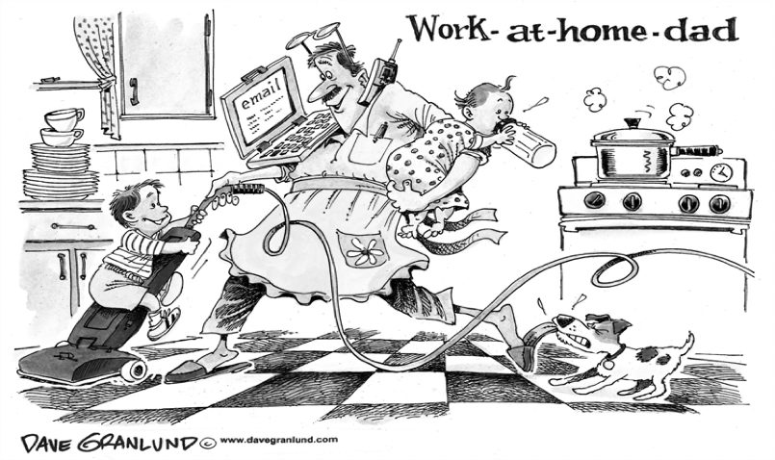

For as long as humans have been on this planet, we've invented forms of communication—from words carved in stones to the telephone and email—that have constantly affected how we interact with each other. One of the biggest developments in communication came in the digital era with the proliferation of smartphones and the use of social media platforms.
The cartoon under study perfectly illustrates the dilemma new technologies have enabled, both making communication between people easier while virtually distancing/ isolating them.
We shall then analyze the cartoon around the following issue: to what extent has digitalization impacted human relations?
The cartoon depicts the evolution of communication while echoing the representation of the evolution of species . From left to right we see a caveman carving the first written word in stone. The second man depicts the invention of the printing press, the third one of mass publication. From then on, the evolution seems to have stopped as the 4th and 5th men do not seem much evolved to such a point that the last man looks like the caveman. The cartoon reads as a way of lambasting the role digital technology has played in man’s regression where digital methods have superseded almost all other forms of communication

The latest mode of communication in the digital era is the use of social media platforms. It has become more available because of the proliferation of smartphones where social media apps can easily be installed. In 2004, Facebook was created by Mark Zuckerberg. Today, the Messenger is one of the most widely used messaging apps. There are more than two billion Facebook users worldwide. In 2006, Twitter began to dominate the social media scene. Other social media platforms have followed.
Since the mid-1990s, the Internet has had a revolutionary impact on communication. True the internet has made communication easier and faster, it’s allowed us to stay in contact with people regardless of time and location but it has also shaped the way societies and people behave, grow, evolve, and develop, both within their own lives and in their relationships with others. While technology has developed over the millennia that humans have existed , the last century has seen an explosion in technology that has influenced subtle but crucial changes in how humans see the world and interact with others.
Specifically, the Internet and mobile devices (i.e. smartphones, tablet computers, etc.) have radically altered the way people interact with each other. Mobile devices brought groundbreaking change to human interaction due to the innate nature of always being connected to the digital world via an easy-to-carry device that one carries around..
Computer systems and the Internet have altered human interactions arguably in the most critical ways when compared to non-computer technological systems that have been developed in the last few centuries, as thedumb-looking man on the right suggests.
While technology has helped to bridge a global gap by connecting people via the digital world, those who are physically close together are often far apart due to their inability to separate themselves from their mobile devices. This is called Virtual Distance.
Technology has both eliminated a gap and created one. Virtual distance is the phenomenon where people are physically together but detached from each other due to being completely absorbed with their technological device, such as a laptop or smartphone/tablet (mobile device). This translates to all types of human interactions being relegated to the background while people are busy connecting with others in digital space via their technological device.
It is not uncommon for people to prefer texting instead of actually meeting, or at the very least, calling and thus hearing another human voice. It is also not uncommon for people to walk around, or even sit with others, head bowed to their digital device without saying a word or even noticing anything about anyone else. Human interactions and relationships have thus largely decreased, while intimacy and human-to-human interactions have been replaced with human-to-machine interactions. Technology has helped to modify human behavior by creating a gap between people and reducing intimacy. In an age where robots and AI are slowly replacing humans within the workplace, this interaction between humans and machines is only set to increase.
Though technology has helped to bridge global gaps, devices and social media/messaging apps, for instance, have largely helped to create a larger disconnect between people. Increased isolation, reduced social interaction and social skills, and increased human-to-machine interactions are all a result of an overuse of technology, which has created a wall between many people globally. Instead of physically experiencing the emotions of another, most people who solely utilize technology for interactions rely on emoticons, for instance. And instead of meeting physically, many people opt to chat via text over the Internet. When meetings do occur, social interactions are often reduced and relegated to chats in between being glued to one’s mobile device.

“ Kate and William expecting 2nd ”, Dave Granlund, Davegralund.com, 8 September 2014

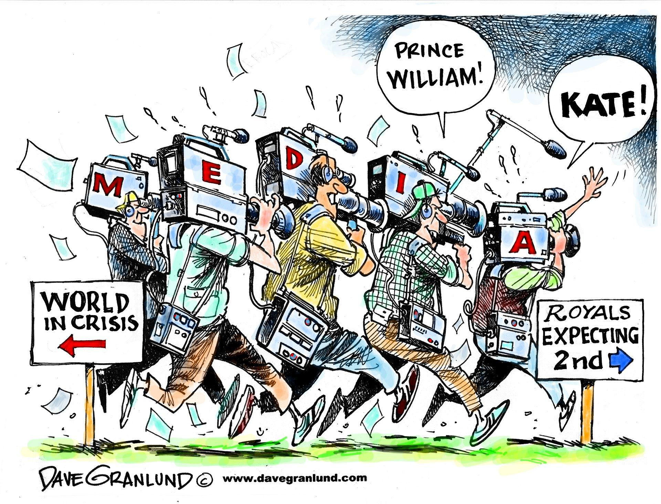
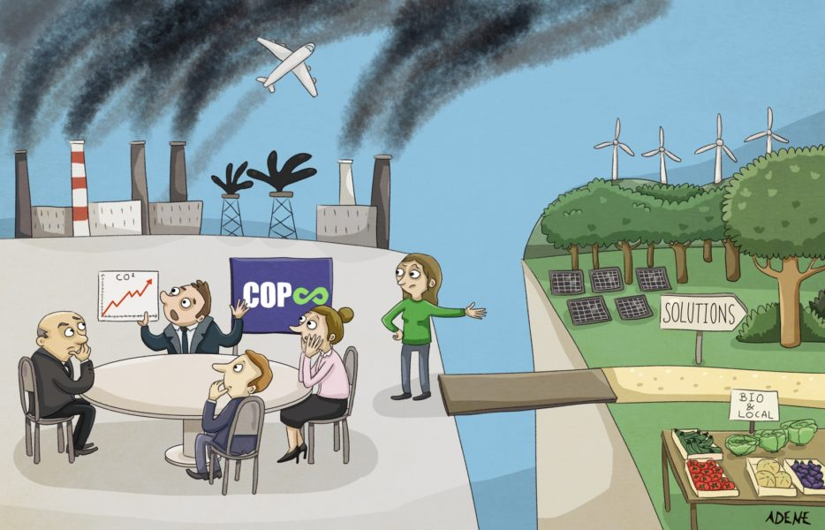

With the armada of private jets departed from Glasgow after the COP26 climate change conference, the world is left to reflect on yet another round of nonbinding commitments, watered-down resolutions and promises to revisit the problem next year. The science on climate change may be clearer than ever, but so too is the failure of the world’s current strategy for countering it hence leaving young activists in despair facing government’s inaction.
The document under study was released in the aftermath of the COP 26 climate change conference and sheds light on how broken the dialogue between politicians and activists is when it comes to taking actions. The cartoon raises the following issue: to what extent does the economy act as a hurdle in the fight against climate change?
The cartoon is clearly divided into 2 parts which altogether differ in terms of colours and of interests.
The left part of the cartoon depicts world leaders sitting around a table trying to find solutions or reach agreements to curb CO2 emissions responsible for climate change. They seem to be deliberately turning their backs to what can be accounted for air pollution: big factories belching out smoke, extensive industrialization, transports… The line graph shows the constant increase of CO2 emissions. The cartoonist has deliberately chosen not to shame one COP in particular which aims at showing that climate change conferences come one after the other with little or no effect. This is what Greta Thunberg said about the COP 26 climate summit qualifying it as a “failure” hence lambasting the U.N- brokered talks.
The world leaders are turning a blind eye to a young woman (who may embody young activists) showing them the way for a better future, showing them down-to earth solutions: using more solar panels, wind energy, planting trees, growing organic food and consuming local food. Her voice however remains unheard, as politicians seem to rather concentrate on economic interests. It illustrates how broken the dialogue is in an approach to climate change which lacks mutual cooperation, altruistic collective action especially when priorities are competing.
This can be related to what Great Thunberg said during the COP 26: “Inside COP, there are just politicians and people in power pretending to take our future seriously,” (…) “Change is not going to come from inside there, that is not leadership. This is leadership, this is what leadership looks like…” Net zero by 2050. Blah, blah, blah. Net zero. Blah, blah, blah. Climate neutral. Blah, blah, blah. This is all we hear from our so-called leaders. Words that sound great but so far have led to no action. Our hopes and dreams drown”
Rajout sur economic matters/ conclusions COP 26

