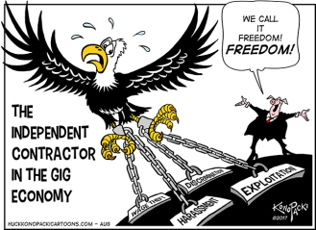

The document under scrutiny is a black and white cartoon by Konopacki published in august 2017 for the Capital Times. It depicts the way the gig economy works by casting a critical eye on the false promise it is based on.
After describing the cartoon , we shall provide a thorough analysis of it around the following issue: To what extent is the gig economy a new/modern form of enslavement?
Context/concepts:
The Great Recession that began in 2007 made the rise of the “gig economy “particularly pronounced. The phrase refers to self-employed workers performing on- demand tasks or “gigs” directly for clients, often on a short-term basis. Some workers work gigs to supplement traditional wage income, while others piece together multiple gigs to make a living.
When it comes to the cartoon, self-employed workers are epitomized by the very powerful symbol of the Eagle which stands for the American values of freedom, free enterprise, the can-do spirit. As viewers, we are forced to take part in the Eagle’s point of view due to the fact that the Eagle takes up two thirds of the cartoon in the foreground and stands out on a blank background while the man/pig in the background is seen in a long-distance shot.
Voc: A close-up/ a low-angle shot/ a high angle shot
However, the Eagle is held prisoner by a man/pig embodying greedy capitalists. The pig may also recall George Orwell’s novel entitled Animal farm in which the pigs who spearheaded the rebellion gradually set up a tyrannical regime that is worse than the previous one, hence denouncing the betrayal of the promises of the revolution.
The promises Silicon Valley makes about the gig economy can sound appealing.(freedom, flexibility) Its digital technology lets workers become entrepreneurs or independent contractors...In reality, there is no utopia at companies like Uber or Lyft, whose workers are often manipulated into working long hours for low wages…
Since workers for most gig economy companies are considered independent contractors, not employees, they do not qualify for basic protections like overtime pay and minimum wage and may suffer from “exploitation, harassment, wage theft and discrimination”. The shackles holding the Eagle back therefore symbolize the subjection of workers to this new system where they have to sweat blood or work flat out for starvation wages.

The cartoon aims at sensitising people to gig workers’ conditions as well as at pushing for regulations to improve their predicaments, to make them less vulnerable.
To conclude, governments should reject the idea that “any job is better than no job.” That may be true from a destitute worker’s perspective, but it makes little sense as poor-quality jobs exacerbate inequality and waste productive potential.

