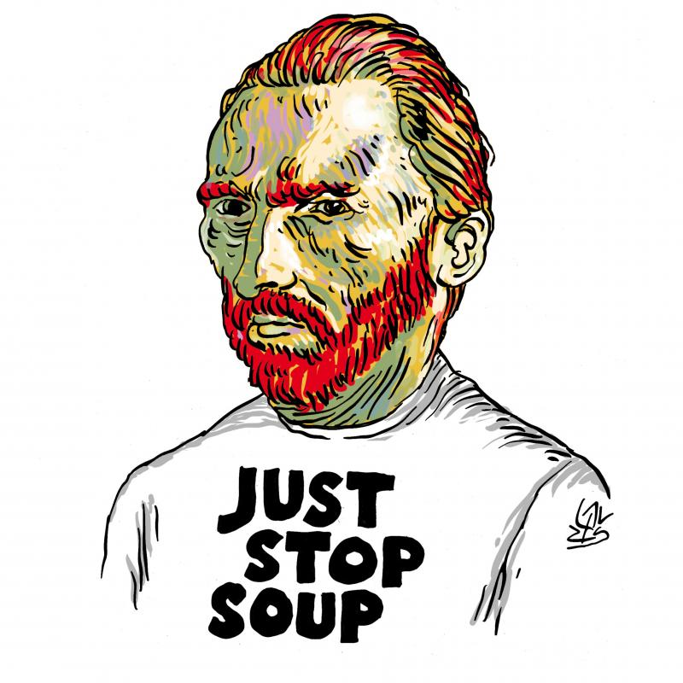
Alen Lauzán
14 October 2022
Waves of controversy were sparked recently when the Just Stop Oil activists threw tomato soup over Van Gogh’s Sunflowers at the National Gallery in London. Although the painting was behind glass so not damaged, politicians were quick to condemn their “attention-seeking” vandalism while media commentators proclaimed that the act had “lost them” to the cause. The cartoon was drawn by Alen Lauzan on October 14th 2022. It depicts Van Gogh wearing a T shirt on which is written “Just Stop Soup” in reference to the soup thrown over the famous canvas Sunflowers by Just Stop Oil, a climate activist group.
The Issue raised is the following:
Is aggressive climate activism harming or prompting debates around the emergency of acting?

ARGUMENTS supporting this sort of activism | ARGUMENTS debunking these aggressive actions
Get international attention/ visibility/ get viral  Make people wonder/ spur discussions. Targeting art without any connections: raise questions  Push government to act# inaction  Emergency / natural disasters . Bolder actions to get governments to act/ to push  Recognize the young activists’ bravery (get into trouble/ risk they run)  First off, museums and art galleries have long been used by fossil fuel companies for the purposes of artwashing – the ethically acceptable process of funding art and culture to smooth over their very unethical corporate practices. Some of the more conscientious institutions (including The National Gallery) have cut ties with any sponsorship from oil companies, but others have doubled down on it. Corporations plough money into art institutions and art pieces themselves because it buys them validity in the eyes of the public. Art becomes a shield for their more nefarious planet-destroying practices.  Just Stop Oil’s action with soup on Sunflowers was to symbolise that we’re attacking something we love. The level of ire at those symbolically ruining – remember, it was behind glass so has not be destroyed – a precious art piece should be given a million-fold to those who are actually ruining our precious planet.  Fighting class oppression and climate change is the same  The second critique, often coming from the left, accuses climate activism of being inherently middle-class. | This tactic was certainly a provocative act and Van Gogh’s work is undoubtedly some of the most important artwork of modern times.  It alienates people who are sympathetic to the climate cause by attacking a much-loved and important piece of art  The Just Stop Oil activists who defaced the Van Gogh threw soup when many people can’t afford to even buy and heat soup.  Climate fanatics? Vandalism, which uses shock therapy, provokes more than convey

TO GO FURTHER….

Forms of agitation include sit-ins, occupation of public spaces (the Occupy movement), marches (with placards, candle-light), civil disobedience, boycott, hunger strikes, demonstration (Greta Thunberg at World Economic Forum at Davos in 2020 and leading a global school-children protests)
Just Stop Oil isn't alone in these series of shaken-and-stirred acts. Some of them are Extinction Rebellion (XR), Insulate Britain and Tyre Extinguishers in the UK, Blockade Australia and Fireproof in Australia, Ultima Generazione (Last Generation) in Italy, Letzte Generation (Last Generation) and Rocks in the Gearbox in Germany, Återställ Våtmarker in Sweden, Declare Emergency in the US, Save Old Growth in Canada, Renovate Switzerland, Stopp Oljeletinga! in Norway, Dernière Rénovationin France.
While blocking roads, traffic, and transport systems (in 2019, Extinction Rebellion blocked and glued themselves to trains in Canary Wharf) seem common praxis, here is a hit list of other targets of disruption in the name of climate:
Art
Earlier this year, a cake was flung at, and cream smeared on, Leonardo da Vinci's 16th century work Mona Lisa at the Louvre, Paris (Mona Lisa has been attacked in the past, too, by a rock in 1956 and a tea cup in 2009). Victims in the UK include the JMW Turner's 1809 romantic painting Tomson's Aeolian Harp, at Manchester Art Gallery (for it portrays a bucolic London around the Thames, which would be regularly flooded come 2030), Da Vinci's The Last Supper at The Royal Academy (to protest against crop failure and malnutrition), John Constable’s 1821 idyllic work The Hay Wain, at the National Gallery (on which was glued a colour printout showing a paved road, dead trees, factory smokestacks, airplanes). In Germany, Peter Paul Rubens' The Massacre of the Innocents, 1612, and in Italy, the ancient Laocoon sculpture in Vatican and Sandro Botticelli’s 15th century painting Primavera/Spring) faced the protesters' ire.
Would you call graffiti vandalism or protest art? Cultural vandalism has a longer history. Somewhere in that history, a British suffragette, used a meat cleaver to slash a portrait of philosopher Thomas Carlyle in London in 1914. Artist provocateur Ai Weiwei's 1995 black-and-white triptych photographic artwork Dropping a Han Dynasty Urn has him, literally, and symbolically, holding, dropping, and standing over the remains of the 2,000-year-old Chinese cultural symbol.
Banks
In April 2021, nine women, members of Extinction Rebellion, wielding hammers and tools labelled with “Love” and “We Act with Love”, smashed to smithereens 19 windows of the HSBC bank’s London headquarters building at the Canary Wharf, to protest against the said bank’s links to the fossil fuel industry. "Despite HSBC's pledge to shrink its carbon footprint to net zero by 2050, their current climate plan still allows the bank to finance coal power," noted a statement on the group's website. HSBC is Europe's second-largest financier of fossil fuels after Barclays, according to a 2020 study by Rainforest Action Network (RAN).
April this year saw a group of climate scientists chain themselves to — not vandalise — the investment bank JPMorgan Chase's Los Angeles building, to make the company stop funding fossil-fuel projects.
Oil companies
In April 2019, the Anglo-Dutch oil giant and world's leading natural-gas producer Shell's London headquarters was vandalised by Extinction Rebellion, causing around $7,800 worth of damage (smashed doors and glued their hands to windows), in a bid to draw attention to fossil fuels with their message "Shell Knows", which is a direct reference to Shell's 28-minute film, Climate of Concern (1991), which the oil company had issued as a warning of the catastrophic risks of climate change, it was meant for public viewing.
Coal plants
This September, the German police cleared protestors off the rail lines and a coal power plant near Hanover. In 2020, coal-fired power plant Datteln 4, owned by utility company Uniper, was occupied by over 100 activists. In 2019, thousands blocked the Lausitz Basin coal mines in east Germany.
In 2008, a coal train was halted outside Drax, Britain's biggest power station, and more than 20 tonnes of coal dumped on the tracks.
In November 2021, Blockade Australia shut down activity at the Port of Newcastle, a key bottleneck in the multibillion-dollar coal supply chain in the nearby Hunter region, bringing coal export to a standstill.
Car showroom
Tyre Extinguishers and Rocks in the Gearbox vandalise high-end cars (Jaguar, Land Rover, Aston Martin). This week, Just Stop Oil sprayed orange paint on Aston Martin's showroom in London.
Fashion shows
In October 2021, Extinction Rebellion members barged in and walked the ramp at Paris' Louis Vuitton fashion show with banner-messages such as "Overconsumption = Extinction". They hoped the government would enforce "an immediate reduction in production levels in the sector, since 42 garments were sold per person in France in 2019."
Sports tournaments
This September, at the Laver Cup, at the O2 Arena in London, in the middle of a match between Stefanos Tsitsipas and Diego Schwartzman, an activist rushed to the middle of the court and set his arm, and the playing surface, on fire. The man wore a white shirt and the message: "End UK Private Jets".
In June's semi-final match of the French Open between Marin Cilic and Casper Ruud, a woman walked on to the court and glued herself to the net, her T-shirt read: “We have 1028 days left”, signalling the UN report on climate change.
In July, nine activists from Dernière Rénovation group ambushed Tour de France, spraying thick smoke of colourful fumes, squatting on the bicycle race track, demanding French government to renovate all buildings for energy efficiency by 2040.
Same month, five Just Stop Oil members barged on to the British Grand Prix circuit demanding a halt on all new gas and oil projects in the UK.
Sure, these guys have no right to disrupt life and order. Sure, these White protesters aren't half as affected as the rest of us in the developing world. But while we question why they are resorting to such acts, it's high time we taxed the makers of decision, policies and profit.

