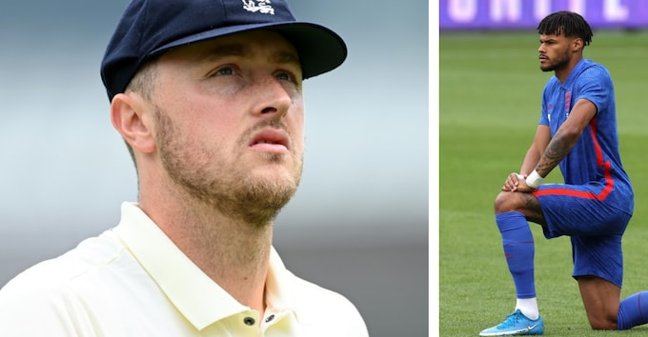
Ollie Robinson (left) was suspended by the ECB, while the England football team has been criticised by some for taking a knee ahead of their matches in the countdown to the European Championships Credit: GETTY IMAGES

Government clashes with cricket and football over 'woke' behaviour

PM refuses to condemn booing of players taking a knee and Culture Secretary says ECB should 'think again' over Ollie Robinson suspension

By Ben Rumsby and Gordon Rayner, 7 June 2021, www.telegraph.co.uk

The England and Wales Cricket Board is under pressure to review its treatment of Ollie Robinson after the Prime Minister condemned its “over the top” suspension of the bowler over historical Twitter posts. It came after Oliver Dowden, the Culture Secretary, told the ECB it should “think again” over the tough sanction, saying the racist and sexist tweets were “over a decade old and written by a teenager”.

In a separate row between the Government and sporting bodies over “woke” behaviour, the England football team’s decision to carry on taking the knee when Euro 2020 starts this weekend was put under intense scrutiny. Boris Johnson refused to condemn fans who booed players during the pre-match ritual, and senior MPs called on the Football Association to show “leadership” over an issue that is leaving supporters increasingly divided.

Robinson, 27, has been suspended indefinitely by the ECB pending a disciplinary investigation into social media posts he wrote in 2012 and 2013, which came to light when he made his Test debut at Lord’s last week. The seamer apologised for the tweets, saying he was “embarrassed” and “ashamed” by what he had written in his teens, but has been offered no guarantees that his international career will continue. Mr Dowden said that while the posts were “offensive and wrong”, the teenager who wrote them “is now a man and has rightly apologised. The ECB has gone over the top by suspending him and should think again”.

The Prime Minister’s official spokesman said: “As Oliver Dowden set out, these were comments made more than a decade ago, written by someone as a teenager, and for which they have rightly apologised.”

The ECB declined to comment when asked about the ministers’ remarks.

Robinson, who took seven wickets and scored 42 runs during the first Test against New Zealand, has been told he will not figure in the second and final Test at Edgbaston, which starts on Thursday.

Craig Overton, his possible replacement in Birmingham, was himself banned for two matches after he was alleged to have told the then Sussex player Ashar Zaidi to “get back to your own country” in 2015. He has always denied making the comment.

Meanwhile the issue of taking the knee threatens to overshadow England’s Euro 2020 preparations, with increasing numbers of fans hostile to the gesture which has become a pre-match ritual over the past year. Although players insist that dropping down on one knee before kick-off is simply a show of support for racial equality, others say it cannot be separated from the more radical politics of the Black Lives Matter movement. One MP even compared taking the knee to England players being forced to make Nazi salutes before a 1938 match in Hitler’s Germany, saying “the mixing of politics and football had disastrous consequences”.

Analysis by Telegraph Sport suggests as many as 18 of the 24 teams taking part in the Euros will not be taking the knee, with several countries opting instead to back a politically neutral campaign supporting racial equality and human rights.

The toxic stand-off between Gareth Southgate’s team and its supporters intensified on Sunday when fans again loudly booed the gesture before the team’s final pre-tournament warm-up game against Romania.

Boris Johnson has said in the past that he would not take the knee because he does not believe in “gestures” and on Monday his official spokesman repeatedly refused to say it was wrong for fans to boo players if they objected to it.

Other senior ministers, including Mr Dowden, Home Secretary Priti Patel and Foreign Secretary Dominic Raab have said in the past that they would not take the knee and do not agree with it.

Amid fears the booing will continue when England take to the field for their Euro 2020 opener against Croatia on Sunday, MPs and England supporters have hit out at the FA over its handling of the row.[...]

Brendan Clarke-Smith, the Conservative MP who drew the comparison between taking the knee and players making a Nazi salute in 1938, said: “The main point I’m trying to make is that we should be keeping politics and football separate. Whilst I have no doubt that the players have honourable intentions, I don’t think they fully appreciate that the political element of Black Lives Matter is inextricably linked to the other part and this is what is now causing conflict.” [...]

I. Vocabulary

1) Find equivalents in the text for:

- to make a sound to express contempt or disapproval:
- very exaggerated:
- pitcher (cricket):
- to be excluded / dismissed:
- to disagree / to be in conflict:
- close examination:
- to wait for (archaic):
- a deadlock:
- to show aggression to:
- an argument:

2) What do the following abbreviations stand for?

- PM:
- MP:
- FA:

II. Comprehension

- Pick out the names of the different people and parties involved and say who/what they are.

- What type of article is this?

- What is it about? Explain the problem at stake.

III. References to look into

- BLM (Black Lives Matter)

- Taking a knee

- Woke

IV. Commentary Possible key question / outline / development?

V. Translate the article from its headline to line 25

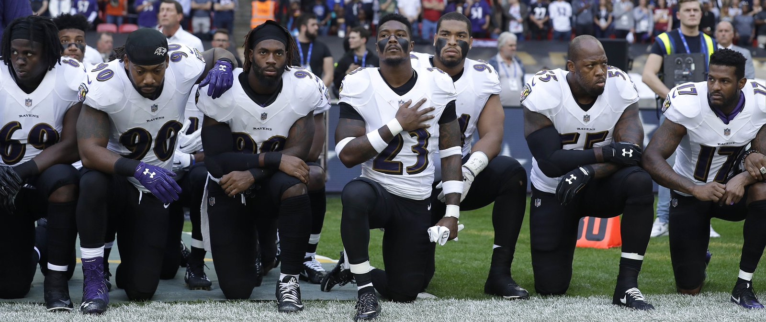

Baltimore Ravens players kneel down during the playing of the U.S. national anthem before an NFL football game against the Jacksonville Jaguars at Wembley Stadium in London, Sunday Sept. 24, 2017. (AP Photo/Matt Dunham)

I. Vocabulary

1) Find equivalents in the text for:

- to make a sound to express contempt or disapproval: to boo
- very exaggerated: over the top
- pitcher (cricket): bowler / seamer
- to be excluded / dismissed: to be suspended
- to disagree / to be in conflict: to clash
- close examination: scrutiny
- to wait for (archaic): to pend
- a deadlock: a stand-off
- to show aggression to: to hit out at
- an argument: a row

2) What do the following abbreviations stand for?

- PM : Prime Minister
- MP : Member of Parliament
- FA : Football Association

II. Comprehension

1) Pick out the names of the different people and parties involved and say who/what they are.

- Boris Johnson: British Prime Minister since 2019 (Conservative)
- Oliver Dowden: British politician who has served as Secretary of State for Digital, Culture, Media and
Sport since 2020 (Conservative)
- The ECB: The England and Wales Cricket Board
- Oliver Dowden: cricket player
- The FA: The Football Association

2) What type of article is this?

- Factual article/ news report

3). What is it about ? Explain the problem at stake

Heated debate between the British Government and sporting bodies (ECB + FA) over recent events linked to attitude towards racism ("woke"). ECB + FA have been blamed by the government for being too "woke "(= too sensitive to racist issues): ECB sanctioned a cricket player after he posted racist slurs/abuse/ insults on twitter and FA has done nothing to stop football players from taking a knee before matches during the Euro 2020 football championship.
Why this attitude from Conservative Government? They interpret the taking the knee ritual as a radical political statement by associating it with the BLM movement (which they compare to a marxist movement) while in most players' minds, they are only advocating racial equality.
Since the players taking a knee have been repeatedly booed at the beginning of matches, the Government is concerned this "woke attitude" is responsible for dividing the public as well as the country, on top of being detrimental to the sports event itself.

III. References to look into

- BLM (Black Lives Matter): international human rights movement, originating in the African-American community, that campaigns against violence and systemic racism (1) towards Black people. BLM regularly protests speaking out against police killings of Blacks, and broader issues such as racial profiling, police brutality and racial inequality in the United States criminal justice system.

This movement was created in 2013 with the use of the hashtag #BlackLivesMatter on social media following a shooting death of an African-American teenager. This movement has gained momentum and became a global movement since George Floyd's murder which led to worldwide protests against police brutality and racism.

(1) systemic racism (= institutional racism) : policies and practices that exist throughout a whole society or organization, and that result in and support a continued unfair advantage to some people and unfair or harmful treatment of others based on race

- Taking a knee: Taking the knee (or taking a knee) is a symbolic gesture against racism whereby an individual kneels upon one knee in place of standing to attention for an anthem or other such occasion.
It started during the American football pre-season in 2016 when the player Colin Kaepernick knelt instead of standing during the national anthem.
Kaepernick said at the time: "I am not going to stand up to show pride in a flag for a country that oppresses black people and people of colour."
The act is now performed by people across the globe as part of the Black Lives Matter movement, which is battling racism in particular within the police following the George Floyd's murder

- Woke: What are the origins of woke? (cf The Economist)

- Once upon a time, it simply meant the past participle of ‘wake’. While that has rapidly changed in recent years, the modern definition of the word isn’t that new in the US.
In 1962 the New York Times published an article of “phrases and words you might hear today in Harlem”, a neighbourhood in the northern section of the New York City where many African-Americans live.
The African-American novelist William Melvin Kelley wrote the earliest known use of the word under its new definition in an article titled, “If you’re woke, you dig it”.
Ten years later in 1972, a character in the Barry Beckham play Garvey Lives! says he’ll “stay woke” via the work of pan-Africanist, Marcus Garvey, with the line: “I been sleeping all my life. And now that Mr Garvey done woke me up, I’m gon stay woke. And I’m gon’ help him wake up other black folk”.

When did Black Lives Matter use it?
- The term’s break into mainstream language came from the Black Lives Matter movement, which used the hashtag #staywoke in the wake of racial injustices spreading across the US.
- In 2012, when unarmed teenager Trayvon Martin was shot dead in Florida by neighbourhood watch volunteer George Zimmerman, the term was used heavily to raise awareness of the movement.
- This has led to criticism by some that those who mock ‘woke’ are being insensitive to its modern usage and the plight of racism. Others argue that its specific link is not widely known.

Why do some people dislike the term?
- It has become a common term of derision among some who oppose the movements it is associated with, or believe the issues are exaggerated. It is sometimes used to mock or infantilise supporters of those movements.
In January last year, the actor Lawrence Fox re-ignited an argument over the use of the term, after he branded an audience member who labelled him a “white privileged male” for saying he was “bored” of racism accusations.
He subsequently accused subscribers to woke views of being “racist”, telling Julie Hartley-Brewer’s radio show: “The wokist are fundamentally racist. Identity politics is extremely racist.”

IV. Commentary Possible key question and outline?

Should sports and politics be kept separate?

When British football player Marcus Rashford spoke out about hungry children in Britain last summer, he was accused of "playing politics". The implication was that it was not his place as a sporstman to get involved in politics. However, even if many claim that sport should be kept politics free and sporting prowess pure expression of sublime skill that transcends human nature, I strongly believe that sports and politics are inextricably linked.

Sports and politics are intertwined on a number of levels. During Roman times, the use of the famous motto "Panem et circenses" ("Bread and games") demonstrated the power of sport to maintain social order. Besides, the purpose of many sports has always been to enforce social needs, such as Japanese martial arts, meant to enhance spiritual development and social order. Another relevant example is cricket, which was a tool for Victorians to assert the power of the ruling class in 19th century England.

Furthermore, sport can be seen as much more than just a game in so far as many sportsmen and women have used theirs as a megaphone for the purpose of making a political point. From US athletes Tommie Smith and John Carlos who raised their black-gloved fist on the podium at the 1968 Olympic games, to NFL quaterback Colin Kaepernick who took the knee in 2016 during the national anthem as a protest against racist violence, activist-athletes have become icons who have inspired others to contribute to building a more egualitarian and fair world.

In his Politics, Aristotle claimed that man is by nature a "political animal" because he is a social creature with the power of speech and moral reasoning. If so, sports and politics are bound to be inseparable as it seems only natural that the sports arena, filled with political men and women, should be the perfect place for self-expression and protest.

V. Translate the article from its headline to line 25

L'attitude "woke" : pomme de discorde entre le Gouvernement et les instances du cricket et du football.

Le Premier ministre refuse de condamner le fait de huer les joueurs qui mettent un genou à terre, et d'après le ministre de la Culture, la fédération de cricket d'Angleterre et du Pays de Galles (ECB) devrait y réfléchir à deux fois avant de suspendre Ollie Robinson.

La fédération de cricket d'Angleterre et du Pays de Galles subit des pressions pour revenir sur sa sanction à l'encontre d'Ollie Robinson, depuis la condamnation de cette sanction par le Premier ministre. Ce dernier trouve fortement exagérée/ tout à fait excessive cette suspension du joueur ("lanceur") prononcée en raison de la découverte de tweets historiques.

Cela s'est produit après qu'0liver Dowden, ministre de la Culture, a demandé à la fédération de cricket d'y réfléchir à deux fois avant d'appliquer une telle sanction. D'après lui en effet, ces tweets racistes et sexistes sont vieux de plus de dix ans et ont été qui plus est écrits par un adolescent".

Autre contentieux entre le Gouvernement et les instances sportives à propos du comportement "woke" : la décision très controversée de l'équipe d'Angleterre de football de continuer à mettre un genou à terre lors de l'ouverture de l'Euro 2020 ce week-end.

Boris Johnson a refusé de condamner les fans qui huaient les joueurs pendant ce rituel précédant chaque match, et certains députés éminents ont appelé la fédération de football à faire preuve de fermeté afin de résoudre ce problème qui divise de plus en plus les supporters.

Robinson, âgé de 27 ans, a été suspendu indéfiniment par la fédération de cricket (BCE), en attendant le résultat d'une enquête disciplinaire sur les messages qu'il a publiés en ligne / sur les réseaux sociaux en 2012 et 2013, messages étalés au grand jour lors de ses débuts à Lord's la semaine dernière.

Le joueur/lanceur s'est excusé pour ses tweets. Il a affirmé se sentir "gêné" et "honteux" de ce qu'il avait écrit étant adolescent, mais il n'a reçu aucune garantie concernant l'avenir de sa carrière internationale.

Selon Oliver Dowden, "même si ces tweets sont "offensants et déplacés", l'adolescent qui en est l'auteur est désormais un homme, et celui-ci a présenté des excuses comme il se doit. La fédération de cricket est allée trop loin en le suspendant et devrait revoir son jugement/ y réfléchir à deux fois."

D'après le porte-parole officiel du Premier ministre, "Comme l'a souligné Oliver Dowden, il s'agit de commentaires vieux de plus de dix ans, écrits par quelqu'un qui était à l'époque un adolescent, et pour lesquels cette personne s'est excusée comme il se doit."

La fédération de cricket à qui l'on a demandé son avis sur les remarques des ministres n'a pas souhaité s'exprimer à ce sujet / s'est refusée à tout commentaire.

