H&M greenwashing is ‘disguising the reality’ of fast fashion

By Aimee Pearcy, The Big Issue, August 5, 2021
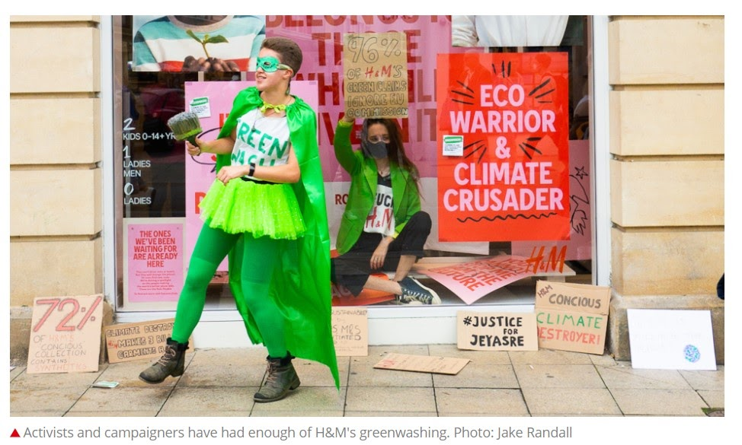

You might have noticed H&M’s recent window displays that feature colourful pink and red posters. Its slogans, such as “climate crusader” and “eco warrior”, bear a striking resemblance to placards used by activists on protests.
The inviting colour schemes and big bold fonts look very similar to those used by the global environmental movement, Extinction Rebellion. The displays also include photographs of child activists.
“It was so bold in the shop window, you couldn’t miss it,” Tolmeia Gregory, a 21-year-old artist and climate justice activist, told The Big Issue. “It is disguising the reality of it because it’s the first thing you see when you walk past.”
The window in question is just a small part of H&M’s most recent global marketing campaign. “THE ONES WE’VE BEEN WAITING FOR ARE ALREADY HERE,” the company’s campaign page reads. The jarring, bright red font takes up most of the screen. “They can’t drive, vote or tweet. But they will change the planet. Or even find new ones. We’re shining a spotlight on the people making the world a better place: kids. These are the Role Models.”
The reason behind H&M’s new marketing tactic seems obvious: sustainability is on-trend
right now. According to Garnier’s One Green Step report, 73 per cent of UK consumers
want to be more sustainable in 2021.
And yet, research published in June revealed that fashion brands are “routinely” misleading the public over their green credentials, and accused many of Europe’s biggest fashion brands of being “all style and no substance”.
The report slammed many of the most popular brands for being “riddled with greenwashing”. H&M in particular was found guilty of tricking customers with misleading claims.
“H&M’s Conscious collection, pitched as a clothing line made from more sustainable materials such as organic cotton or recycled polyester, was found to contain a higher share of damaging synthetic materials than its main line (72 per cent compared to 61 per cent),” The Big Issue reported in June. Some 96 per cent of its claims flouted the guidelines in some way — followed by 89 per cent from Asos and 88 per cent from M&S.
Gregory and her friends were so outraged by H&M’s greenwashing campaign that they decided to take a stand against it themselves. “We were just a group of friends and we
just wanted to do it because we cared, and we did it alone,” said Gregory. “If we’re sitting in a window, people aren’t going to be able to miss that. If they’re walking past and there’s someone sitting in a shop window, it’s a little bit disruptive because it’s taking up space.”
The display appears particularly hypocritical given that it was only in 2019 when H&M chief executive Karl-Johan Persson told Bloomberg that he was worried about protests encouraging consumers to “stop doing things, stop consuming, stop flying” because it “may lead to a small environmental impact, but it will have terrible social consequences.”
Tolmeia, and many activists like her, are beginning to see through fashion brands’ greenwashing attempts. “You will never be sustainable for as long as your business model is based on fast fashion and profits. It doesn’t matter how many organic t-shirts you make. It doesn’t matter how quickly you make your path, get packaging recycling,” she said.
“If you are not addressing the volume of stuff that you produce and starting to think about de-growth and changing your business model drastically, then you are not doing anything
that young climate activists actually want you to be doing.
“It’s our future. And it’s not even in the future. Greece is on fire right now. London was flooding last week. It’s here and it’s now. We haven’t really got time for them to continue
with greenwashing. It should have stopped yesterday.” H&M declined to comment.
The day after Tolmeia staged her sit-in, the H&M store at the centre of the protest took down the offending display. People are now putting pressure on the fashion brand to take down its
window display in other areas. Gregory emphasises the importance of working together as a group. “There’s a lot of individualisation within activism, focusing on the individual and the
one person, such as the one person sat in the window rather than the group of people who put up the idea. You need people who can support you. I could look through the glass and just get some reassurance that everything is going okay,” she said. “Have a group around you. You can’t do it alone”.

II. Vocabulary : Matching exercise
- window display | ○ |  | ○ | A. En caractères gras
2. striking | ○ |  | ○ | B. marquant/qui retient l’attention
3.bold font | ○ |  | ○ | C. Mettre sous les projecteurs
4. jarring | ○ |  | ○ | D. Vitrines
5. shining a spotlight | ○ |  | ○ | E.Discordant (criard/incompatible/incohérent)
6.making the world a better place | ○ |  | ○ | F. A la mode
7.Role Models | ○ |  | ○ | G. Durabilité/viabilité
8. sustainability | ○ |  | ○ | H. D’après
9. on-trend | ○ |  | ○ | I.Rendre le monde meilleur
10. According to | ○ |  | ○ | J. Exemple à suivre/personne à qui s’identifier
11.consumers | ○ |  | ○ | K. Passeport vert/ecolabel
12.brands | ○ |  | ○ | L. Pourtant/cependant
13. yet | ○ |  | ○ | M. trompeur
14. misleading | ○ |  | ○ | N. Consommateurs
15. green credentials | ○ |  | ○ | O. Marques
16. slammed | ○ |  | ○ | P. Critiquer violemment/descendre en flammes
17.be riddled with | ○ |  | ○ | Q. Etre rempli de
18.was found guilty | ○ |  | ○ | R. mépriser/bafouer
19. to trick | ○ |  | ○ | S. Recommandations
20. flouted | ○ |  | ○ | T. Duper
21. guidelines | ○ |  | ○ | U. Être accusé de
22. outraged | ○ |  | ○ | V. Indigné
23. take a stand against | ○ |  | ○ | W. Mener à
24. as long as | ○ |  | ○ | X. chemin/voie
25. growth | ○ |  | ○ | Y. Être inquiet
26. flooding | ○ |  | ○ | Z. Tant que
27. path | ○ |  | ○ | Z. 1 Inondation
28. to address | ○ |  | ○ | Z.2 croissance
29. lead to | ○ |  | ○ | Z.3. Prendre position contre
30. be worried | ○ |  | ○ | z.4 S’attaquer à

Préparez cette vidéo comme pour une khôlle (20mn de préparation/10mn PPC 10mn entretien) et préparez un plan détaillé
THE TRUE COST OF FAST FASHION (Script)
(Before you buy your next piece of clothing, think about where it came from nothing story behind it.
I once rather infamously, walked into a Kmart) and bought seven pairs of $7 shoes. I bought the store out of my size, and I just did it because, I was like: “what? They're gonna fall apart, like…Why not? I might as well just buy a bunch of them”. And that's what I did. I just would wear them for about three weeks, they would get a hole in them, and then I would throw them away, and then I put on another pair and it just… The cycle would repeat itself. I just had this total “Ahah” moment, where I was like “this is ridiculous. I am paying so much money for clothes that don't last”, and I just decided that I wanted to own something that was slightly better made... That would last longer.
My name is Elizabeth Cline, I am a journalist and the author of, Over-Dressed, The Shockingly High Cost of Cheap Fashion, and The Conscious Closet: The Revolutionary Guide to Looking Good While Doing Good.
I was a huge bargain shopper, and I realized, at some point, I had no idea where the stuff was made, what kind of impact it was having on the environment, and just out of my own personal consumption habits, I went on this journey to discover that hidden story of the environmental impact of what we wear. There's a growing awareness about reducing waste in the US, which is great, but a lot of people aren't making that connection yet, about clothing. And clothing is actually 6% of landfill waste in the United States. So, while we're really doing, I think, a lot of good work, to reduce our waste to landfills in other areas, plastic bottles, cardboard, we know to recycle those things, but we don't often make that connection when it comes to clothes.
Most Americans, especially most American women, own a lot of clothes, and I think, because they're hidden away in our closet, sometimes we don't even register it. I know that was my experience. I just opened my closet one day, and I was like: “Oh my gosh, I own more clothing, than anything else in my life”. I owned 350 items of clothing, and I wore maybe, 10% of it.
And one of the first things that I discovered in my research is that I was a typical American consumer. Americans are the biggest consumers of clothing in the world. Americans only wear about 14% of what's in their closet. And I think it's really interesting how extreme this is compared to other places in the world.
We buy 21 billion garments per year, as a country, and it's estimated that 100 billion garments get made around the world every year. That means we're buying one in five garments, manufactured, in the world. So really like, the heart of what makes clothing disposable, is the quantities that it's produced in. So, you know, it used to be that chains would make 2000 pieces of something, now they make two million pieces of something. I think most people, now see clothing as something that's almost disposable. It's something you can consume, almost mindlessly. You can go into a store and you're shopping for something else, and you're like: “oh, it's whatever, three for one T-shirts!” So, clothing has just become something that we don't have to put a lot of thought into, but I always try to get people to understand that those choices have impacts. So it is something that we do need to be mindful about consuming.
Americans are throwing away, into the trash, 25 billion garments every year. It's either inconvenient to donate, or people spend so little on their clothes that they are just thinking, “why not? I paid five dollars for it, so I'm just gonna put it in the trash”.

