Séquence: FAST FASHION

Thématique(s) :
Axe(s) :
Tâche Finale: POC

- Dans un court clip vidéo (3 - 5 minutes) explique ta relation à la mode. Quel type de consommateur es-tu ? Ta position a-t-elle changé dernièrement ? Pourquoi ?
- Présente une marque de mode éthique et responsable aux valeurs opposées à la Fast-Fashion et fais-en la promotion.
STEP 1: From dirty production, to trends, to trash

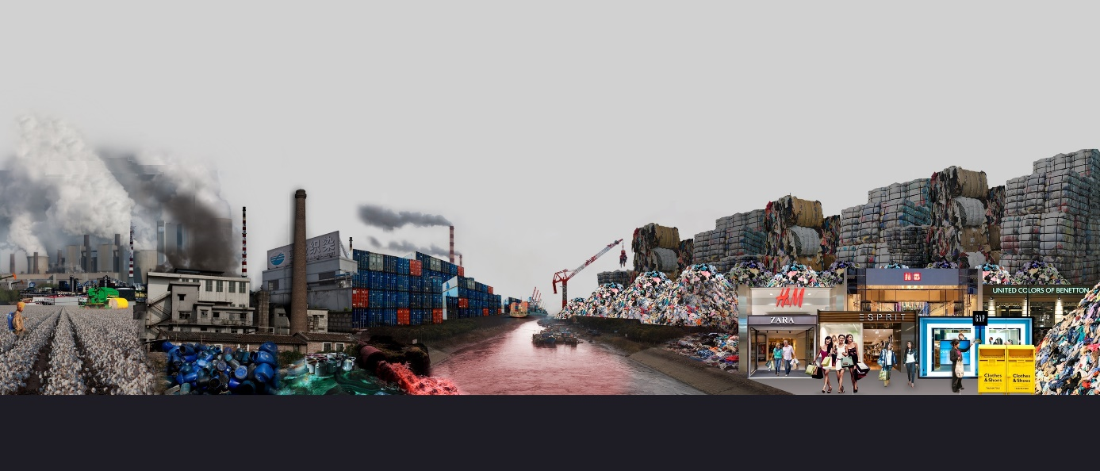

Activité (PPT):
- D’abord donner l’image sans les indications/flèches/titre:
- React and analyse the document
Manufacture of fast fashion clothes harms the environment / pollutes water and air / to make trendy clothes / so people can throw away the garments / vicious circle / never-ending

- Ajouter le titre: From dirty production, to trends, to trash
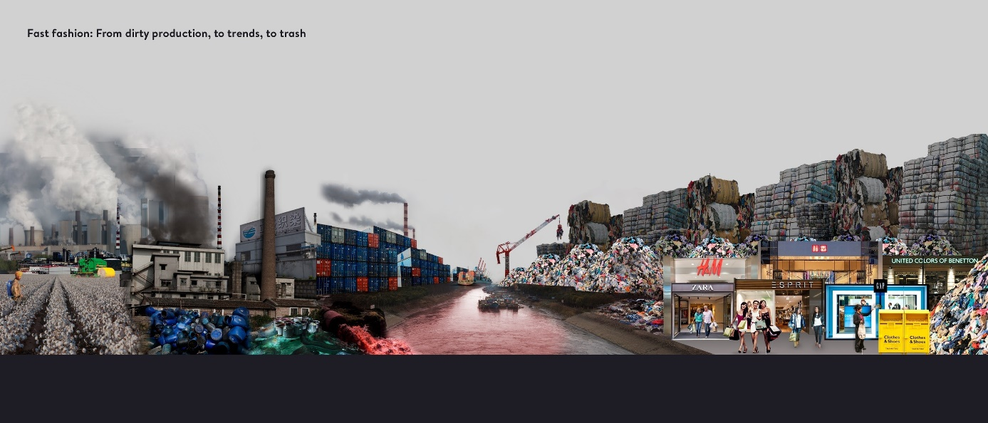
- Color of the river? (dye or blood)
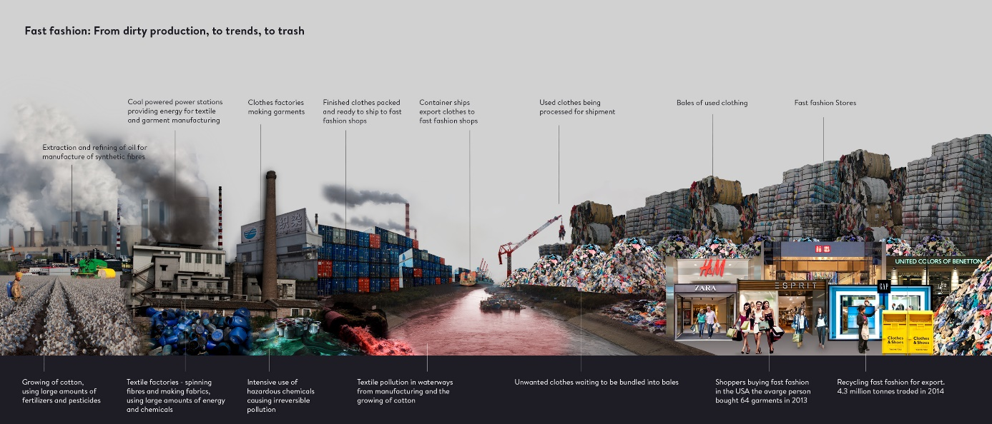

Read the document from left to right (steps?)

Vocabulaire: landfill - factory - fumes - garbage - container - shipments convey new clothes to stores via the river / ships transit up and down the river with old garments for recycling / river of life / river is blood red / bleeding / “angry” / “abused” / damaged / polluted by fast fashion / scene of death /in the centre of the cycle
3. React and compare with your first impressions
Left: grey / gloomy / smoke-filled / chimneys / factories / growing of cotton / cotton picker / farm machinery / use of pesticides and fertilisers / oil is refined to produce energy / energy and chemicals used to make textiles / clothes are packed into containers / transported by container ship / hazardous chemicals pollute water and air

Right: background: a crane is lifting a bale / a mountain of used / discarded clothes / unwanted garments / made into bales / ready for shipment / foreground: fast fashion stores / shoppers / recycling bins
https://news.mongabay.com/2020/04/trendy-cheap-and-dirty-fashion-is-a-top-global-polluter/

STEP 2: H&M Greenwashing
https://www.bigissue.com/latest/environment/hm-greenwashing-is-disguising-the-reality-of-fast-fashion/

Anticipation:
- Projeter image “activists and crusaders”
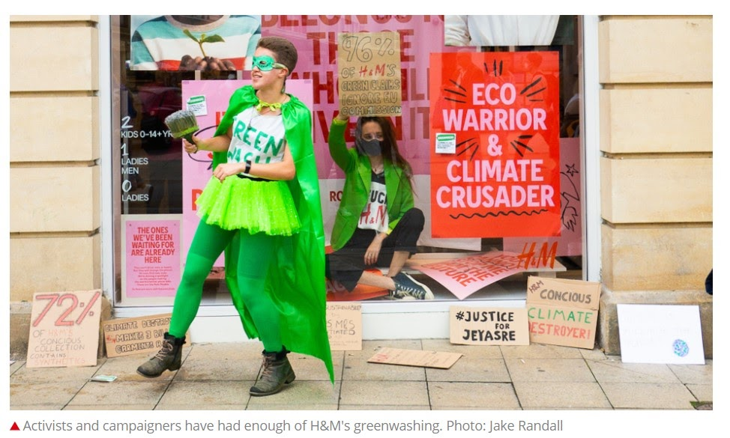

- React ! (People ? Behavior ? Clothing ? Colors ? Posters ? “Climate crusader”/”eco warrior”?)
- Tell what the boy is holding in his hand ? Reason ?
- Deduce the meaning of “greenwashing”

Vocabulaire: Protest, raise awareness, activists, costumes, display, greenwashing...
Activité:

H&M greenwashing is ‘disguising the reality’ of fast fashion

By Aimee Pearcy, The Big Issue, August 5, 2021

You might have noticed H&M’s recent window displays that feature colourful pink and red posters. Its slogans, such as “climate crusader” and “eco warrior”, bear a striking resemblance to placards used by activists on protests.
The inviting colour schemes and big bold fonts look very similar to those used by the global environmental movement, Extinction Rebellion. The displays also include photographs of child activists.
“It was so bold in the shop window, you couldn’t miss it,” Tolmeia Gregory, a 21-year-old artist and climate justice activist, told The Big Issue. “It is disguising the reality of it because it’s the first thing you see when you walk past.”
The window in question is just a small part of H&M’s most recent global marketing campaign. “THE ONES WE’VE BEEN WAITING FOR ARE ALREADY HERE,” the company’s campaign page reads. The jarring, bright red font takes up most of the screen. “They can’t drive, vote or tweet. But they will change the planet. Or even find new ones. We’re shining a spotlight on the people making the world a better place: kids. These are the Role Models.”
The reason behind H&M’s new marketing tactic seems obvious: sustainability is on-trend
right now. According to Garnier’s One Green Step report, 73 per cent of UK consumers
want to be more sustainable in 2021.
And yet, research published in June revealed that fashion brands are “routinely” misleading the public over their green credentials, and accused many of Europe’s biggest fashion brands of being “all style and no substance”.
The report slammed many of the most popular brands for being “riddled with greenwashing”. H&M in particular was found guilty of tricking customers with misleading claims.
“H&M’s Conscious collection, pitched as a clothing line made from more sustainable materials such as organic cotton or recycled polyester, was found to contain a higher share of damaging synthetic materials than its main line (72 per cent compared to 61 per cent),” The Big Issue reported in June. Some 96 per cent of its claims flouted the guidelines in some way — followed by 89 per cent from Asos and 88 per cent from M&S.
Gregory and her friends were so outraged by H&M’s greenwashing campaign that they decided to take a stand against it themselves. “We were just a group of friends and we
just wanted to do it because we cared, and we did it alone,” said Gregory. “If we’re sitting in a window, people aren’t going to be able to miss that. If they’re walking past and there’s someone sitting in a shop window, it’s a little bit disruptive because it’s taking up space.”
The display appears particularly hypocritical given that it was only in 2019 when H&M chief executive Karl-Johan Persson told Bloomberg that he was worried about protests encouraging consumers to “stop doing things, stop consuming, stop flying” because it “may lead to a small environmental impact, but it will have terrible social consequences.”
Tolmeia, and many activists like her, are beginning to see through fashion brands’ greenwashing attempts. “You will never be sustainable for as long as your business model is based on fast fashion and profits. It doesn’t matter how many organic t-shirts you make. It doesn’t matter how quickly you make your path, get packaging recycling,” she said.
“If you are not addressing the volume of stuff that you produce and starting to think about de-growth and changing your business model drastically, then you are not doing anything
that young climate activists actually want you to be doing.
“It’s our future. And it’s not even in the future. Greece is on fire right now. London was flooding last week. It’s here and it’s now. We haven’t really got time for them to continue
with greenwashing. It should have stopped yesterday.” H&M declined to comment.
The day after Tolmeia staged her sit-in, the H&M store at the centre of the protest took down the offending display. People are now putting pressure on the fashion brand to take down its
window display in other areas. Gregory emphasises the importance of working together as a group. “There’s a lot of individualisation within activism, focusing on the individual and the
one person, such as the one person sat in the window rather than the group of people who put up the idea. You need people who can support you. I could look through the glass and just get some reassurance that everything is going okay,” she said. “Have a group around you. You can’t do it alone”.

- QUESTIONS:
- Find information about the new H&M campaign.
The company launched a new campaign to promote ecological activism to make people believe that they take part in the movement. The signs and posters promoting this campaign look like a real activist campaign.
- Compare and contrast their claims with reality. (Quote and rephrase)
The company is only surfing on an ecological trend to make more profits. Their H&M conscious label claims to be harmless for the environment but it is not.
- Explain the problem.
It is a marketing strategy. It is deceptive.
- Explain line 13 “They can’t drive, vote or tweet. But they will change the planet. Or even find new ones.”
Children are our hope and if they can’t fix our mistakes, they’ll probably be able to find another planet for us to live on (and ruin all over again).
- Deduce the meaning of “Greenwashing”. Compare with the definition you gave at the beginning of the activity.
Greenwashing: a superficial or insincere display of concern for the environment that is shown by an organization or a company
- Give a definition of “Fast Fashion”: clothes that are made and sold cheaply, so that people can buy new clothes often.
- Comment on the following statement: (pour mes CPGE)
“It doesn’t matter how many organic t-shirts you make. It doesn’t matter how quickly you make your path, get packaging recycling,” she said. “If you are not addressing the volume of stuff that you produce and starting to think about de-growth and changing your business model drastically, then you are not doing anything that young climate activists actually want you to be doing”
New generations of activists think that offering organic clothes is not enough to claim that a brand is doing enough for the environment. The whole paradigm is to be thought anew. from production to consumption.
- Translate the following passage into French: (pour mes CPGE)
The reason behind H&M’s new marketing tactic seems obvious: sustainability is on-trend
right now. According to Garnier’s One Green Step report, 73 per cent of UK consumers
want to be more sustainable in 2021.
And yet, research published in June revealed that fashion brands are “routinely” misleading the public over their green credentials, and accused many of Europe’s biggest fashion brands of being “all style and no substance”.
The report slammed many of the most popular brands for being “riddled with greenwashing”. H&M in particular was found guilty of tricking customers with misleading claims.
“H&M’s Conscious collection, pitched as a clothing line made from more sustainable materials such as organic cotton or recycled polyester, was found to contain a higher share of damaging synthetic materials than its main line (72 per cent compared to 61 per cent),” The Big Issue reported in June. Some 96 per cent of its claims flouted the guidelines in some way — followed by 89 per cent from Asos and 88 per cent from M&S.
Les motivations de la nouvelle stratégie marketing de H&M semblent évidentes: la tendance du moment est au durable. Selon un rapport de Garnier’s One Green Step, 73% des britanniques veulent consommer durable en 2021. Et pourtant, une recherche publiée en juin révélait que les marques à la mode trompent régulièrement le public sur leurs bilan écologique, et accusait de nombreuses marques européennes de n’être que dans l'esbroufe/ reprochait à de nombreuses marques européennes leur engagement uniquement pour la forme/ sans fondement.
Le rapport accusait vivement la démarche écologique de beaucoup de marques les plus populaires d’être totalement feinte/le rapport descendait en flammes beaucoup des marques les plus populaires pour leur engagement écologique totalement de façade. H&M en particulier se vit accusée de duper les consommateurs avec des déclarations trompeuses.
“On a découvert que la collection H&M conscious, présentée comme une ligne de vêtements faite à partir de matières telles que le coton biologique ou le polyester recyclé contient une part plus grande de matières synthétiques néfastes/nuisibles/préjudiciables que sa ligne normale/principale (72% comparé à 61%) a rapporté The Big Issue en juin. Environ 96% de ses déclarations bafouent les recommandations d’une manière ou d’une autre, suivies à 89% par Asos et 88% par M&S.

II. Vocabulary : Matching exercise
- window display | ○ |  | ○ | A. En caractères gras
2. striking | ○ |  | ○ | B. marquant/qui retient l’attention
3.bold font | ○ |  | ○ | C. Mettre sous les projecteurs
4. jarring | ○ |  | ○ | D. Vitrines
5. shining a spotlight | ○ |  | ○ | E.Discordant (criard/incompatible/incohérent)
6.making the world a better place | ○ |  | ○ | F. A la mode
7.Role Models | ○ |  | ○ | G. Durabilité/viabilité
8. sustainability | ○ |  | ○ | H. D’après
9. on-trend | ○ |  | ○ | I.Rendre le monde meilleur
10. According to | ○ |  | ○ | J. Exemple à suivre/personne à qui s’identifier
11.consumers | ○ |  | ○ | K. Passeport vert/ecolabel
12.brands | ○ |  | ○ | L. Pourtant/cependant
13. yet | ○ |  | ○ | M. trompeur
14. misleading | ○ |  | ○ | N. Consommateurs
15. green credentials | ○ |  | ○ | O. Marques
16. slammed | ○ |  | ○ | P. Critiquer violemment/descendre en flammes
17.be riddled with | ○ |  | ○ | Q. Etre rempli de
18.was found guilty | ○ |  | ○ | R. mépriser/bafouer
19. to trick | ○ |  | ○ | S. Recommandations
20. flouted | ○ |  | ○ | T. Duper
21. guidelines | ○ |  | ○ | U. Être accusé de
22. outraged | ○ |  | ○ | V. Indigné
23. take a stand against | ○ |  | ○ | W. Mener à
24. as long as | ○ |  | ○ | X. chemin/voie
25. growth | ○ |  | ○ | Y. Être inquiet
26. flooding | ○ |  | ○ | Z. Tant que
27. path | ○ |  | ○ | Z. 1 Inondation
28. to address | ○ |  | ○ | Z.2 croissance
29. lead to | ○ |  | ○ | Z.3. Prendre position contre
30. be worried | ○ |  | ○ | z.4 S’attaquer à
Key: 1-D/2-B/3-A/4-E/5-C/6-I/7-J/8-G/9-F/10-H/11-N/12-O/13-L/14-M/15-K/16-P/17-Q/18-U/19-T/20-R/21-S/22-V/23-Z3/24-Z/25-Z2/26-Z1/27-X/28-Z4/29-W/30-Y
STEP 3: The true cost of fast fashion
https://www.pbslearningmedia.org/resource/the-true-cost-of-fast-fashion-video/ecosense-for-living/
video coupée, longueur totale 3’49
Activité: VIDEO
Prépare cette vidéo comme pour une khôlle (20mn de préparation/10mn PPC 10mn entretien) et prépare un plan détaillé (ne rédige pas ton texte de bout en bout)
THE TRUE COST OF FAST FASHION (Script)
(Before you buy your next piece of clothing, think about where it came from nothing story behind it.
I once rather infamously, walked into a Kmart) and bought seven pairs of $7 shoes. I bought the store out of my size, and I just did it because, I was like: “what? They're gonna fall apart, like…Why not? I might as well just buy a bunch of them”. And that's what I did. I just would wear them for about three weeks, they would get a hole in them, and then I would throw them away, and then I put on another pair and it just… The cycle would repeat itself. I just had this total “Ahah” moment, where I was like “this is ridiculous. I am paying so much money for clothes that don't last”, and I just decided that I wanted to own something that was slightly better made... That would last longer.
My name is Elizabeth Cline, I am a journalist and the author of, Over-Dressed, The Shockingly High Cost of Cheap Fashion, and The Conscious Closet: The Revolutionary Guide to Looking Good While Doing Good.
I was a huge bargain shopper, and I realized, at some point, I had no idea where the stuff was made, what kind of impact it was having on the environment, and just out of my own personal consumption habits, I went on this journey to discover that hidden story of the environmental impact of what we wear. There's a growing awareness about reducing waste in the US, which is great, but a lot of people aren't making that connection yet, about clothing. And clothing is actually 6% of landfill waste in the United States. So, while we're really doing, I think, a lot of good work, to reduce our waste to landfills in other areas, plastic bottles, cardboard, we know to recycle those things, but we don't often make that connection when it comes to clothes.
Most Americans, especially most American women, own a lot of clothes, and I think, because they're hidden away in our closet, sometimes we don't even register it. I know that was my experience. I just opened my closet one day, and I was like: “Oh my gosh, I own more clothing, than anything else in my life”. I owned 350 items of clothing, and I wore maybe, 10% of it.
And one of the first things that I discovered in my research is that I was a typical American consumer. Americans are the biggest consumers of clothing in the world. Americans only wear about 14% of what's in their closet. And I think it's really interesting how extreme this is compared to other places in the world.
We buy 21 billion garments per year, as a country, and it's estimated that 100 billion garments get made around the world every year. That means we're buying one in five garments, manufactured, in the world. So really like, the heart of what makes clothing disposable, is the quantities that it's produced in. So, you know, it used to be that chains would make 2000 pieces of something, now they make two million pieces of something. I think most people, now see clothing as something that's almost disposable. It's something you can consume, almost mindlessly. You can go into a store and you're shopping for something else, and you're like: “oh, it's whatever, three for one T-shirts!” So, clothing has just become something that we don't have to put a lot of thought into, but I always try to get people to understand that those choices have impacts. So it is something that we do need to be mindful about consuming.
Americans are throwing away, into the trash, 25 billion garments every year. It's either inconvenient to donate, or people spend so little on their clothes that they are just thinking, “why not? I paid five dollars for it, so I'm just gonna put it in the trash”.
Exemple : Problématique : What is the problem with our consuming habits? To what extent can our consuming habits make an impact?
- Who she is/ what she wrote/her growing awareness and her reaction
- The social, economical and environmental consequences of fast fashion
- The excesses of the consumer society/changing our consuming habits

- Infamously | ○ |  | ○ | A. Achat
2. To buy the store out of one’s size | ○ |  | ○ | B. Bonne affaire
3. To fall apart | ○ |  | ○ | C. Garde-robe/penderie
4. A bunch of | ○ |  | ○ | D. Vêtements
5. Ahah moment | ○ |  | ○ | E. Notoirement
6.Better made | ○ |  | ○ | F. Habitudes de consommation
7.Bargain | ○ |  | ○ | G. Sans réfléchir
8. Growing awareness | ○ |  | ○ | H. Un déclic
9. Disposable | ○ |  | ○ | I. Placard
10. Mindlessly | ○ |  | ○ | J. Consciemment
11. Mindful | ○ |  | ○ | K. Un tas/une floppée/beaucoup
12. Purchase | ○ |  | ○ | L. Prise de conscience
13. Wardrobe | ○ |  | ○ | M. Tomber en lambeaux
14. Closet | ○ |  | ○ | N. Acheter tout le magasin (quand on a trouvé sa taille)
15. Consumption habits | ○ |  | ○ | O. Jetable
16. Garments | ○ |  | ○ | P. De meilleure qualité
Answers: 1-E/2-/3-M/4-K/5-H/6-P/7-B/8-L/9-O/10-G/11-J/12-A/13-C/14-I/15-F/16-D

STEP 4: Sustainable clothing, a good look

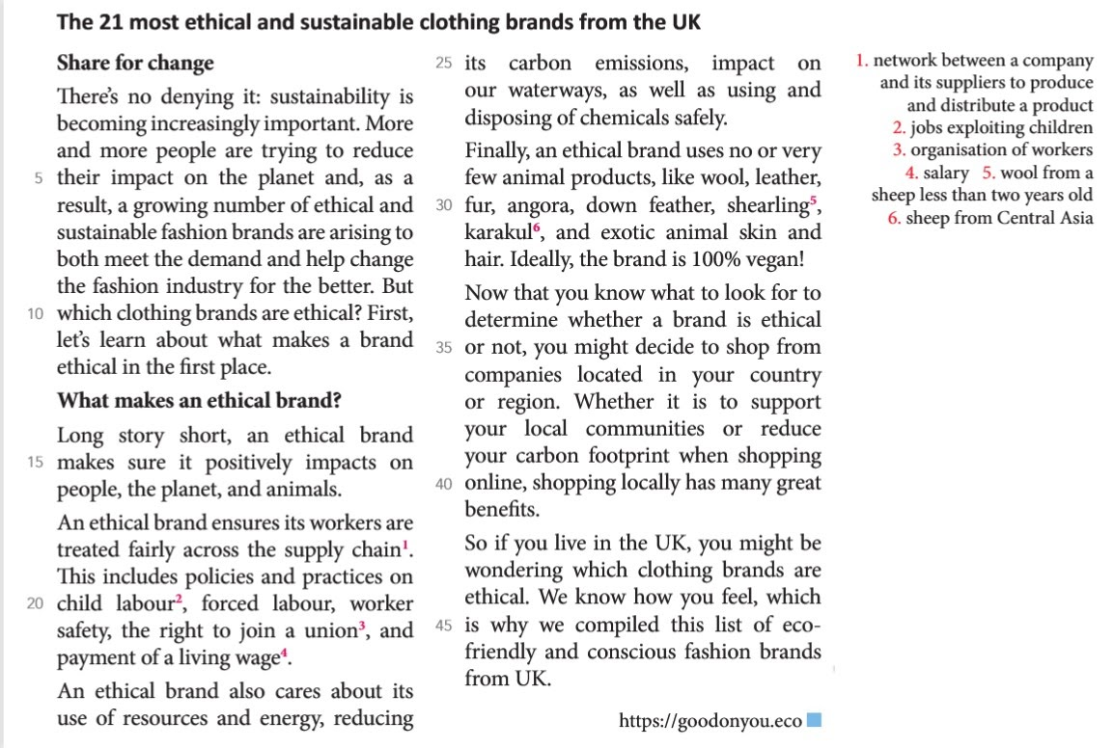

https://goodonyou.eco

Vocabulaire:
meet the demand
long story short
supply chain
dispose
wool
leather
footprint
to wonder
union
change sth for the better
ensure
child labour
carbon footprint
wage

Questions
- Explain the latest fashion trends
increased awareness of sustainability/ fashion labels
intent on improving fashion industry/ ethical brand/ ethical
practices/ fair treatment of labour force/ concerns for worker
safety/ union rights/ fair wages/ concerns for the environment/
lower carbon emissions/ water usage/ disposal of chemicals/
concerns for animals/ objective for brands to be 100 % vegan/
few or no animal products
- Explain how the inequalities of fast fashion are being countered

Step 5: Audio: Not a good look, destroying the world (LMU AMC p. 176)

Pédagogie différenciée: donner les 2 questions suivantes au groupe le plus faible et ne rien donner au groupe le moins faible.
1. Pick out the negative effects of fast fashion.
2. List the tips that are given.
https://www.hatier-clic.fr/miniliens/mie/9782401077287/21amc176.mp3

Script audio Not a good Look destroying the world
Hatier-clic.fr/21amc/176
Fashion is a trillion-dollar industry and according to the UN, it is also the second biggest polluter. Around half a million tons of microfibre clothing is now being dumped into the ocean every year, the same as three million barrels of oil.
Even in the average household, WRAP* estimates that the amount of new clothing bought by one family in a year gives off the same amount of emissions as driving a car for 6,000 miles, and to make, it takes enough water to fill 1,000 bathtubs.
Our love of clothes is also contributing to plastic pollution, with one wash load of polyester clothes sending up to 700,000 microplastic fibres back into the environment. But, do we at least appreciate our clothes once we’ve bought them? Well, we send around £140 million of our clothes to landfill every single year. And one in six of us have as many as five items in our wardrobe that we’ve never even worn. So here are some top tips how to break your fast fashion habits.
Number One: Get more wear out of your clothes
Even extending the life of your garments by less than a year can make a big difference. If half of us wore our clothes for an extra nine months, we could cut carbon emissions by 8%.
Number Two: Get second-hand shopping
Charity shops save over 300,000 tons of old clothes from landfill each year and online sites where you can buy, sell or swap used clothing are more popular than ever.
Number Three: Watch your washing
It takes nearly 4,000 litres of water to wash a single pair of jeans over their lifetime. Simply thinking twice about stuffing things in the wash that you’ve only worn once, can reduce the impact your clothes have on the environment, as can washing on a lower temperature.
Finally, Number Four: Get savvy with your shopping
If you are buying new clothes, see what stores have made commitments to combating fast fashion. Some shops are using more recycled material, whereas others offer lifetime repair services, or even vouchers for bringing in your old clothes. After all, fashion doesn’t just have to be about looking good, it’s also about doing good too.
*WRAP (Waste and resources action programme) is a British charity that works to help businesses achieve a circular economy: less waste, more sustainable products, efficient use of resources.
Vocabulary:
UN—landfill--Dump into the ocean--break your habits—wardrobe—swap—charity—savvy—commitment—garments—item—average—amount—bathtub
Corrigé
1. Pick out the negative effects of fast fashion.
- second biggest polluter/ tons of microfibre from clothes dumped in oceans/ equivalent to 3 million barrels of oil - quantity of new clothes in 1 family similar to driving a car 6,000 miles/ a family’s clothes take 1,000 tubs of bath water to make - polyester clothes pollute/ one wash load equals 700,000 microplastic fibres in the environment - £140 million worth of clothing to landfills every year/ unworn clothes in our cupboards
2. List the tips that are given.
Number 1: wear clothes for longer to cut carbon emissions Number 2: buy second hand clothes in charity shops Number 3: wash clothes less Number 4: shop at sustainable fashion shops

Step 6: Grammaire en contexte p. perfect/for et since
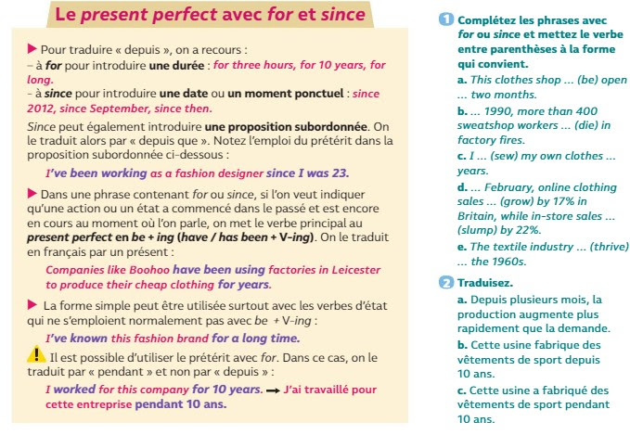

Corrigé:
Exercice 1:
a. This clothes shop has been open for two months.
b. Since 1990, more than 400 sweatshop workers have died in factory fires.
c. I have been sewing / have sewn my own clothes for years.
d. Since February, online clothing sales have grown by 17% in Britain, while in-store sales have slumped by 22%.
e. The textile industry has thriven / has been thriving since the 1960s.

Exercice 2:
a. For several months, production has been increasing faster than demand.
b. This factory has been manufacturing sportswear for 10 years.
c. This factory manufactured sportswear for 10 years.

2. 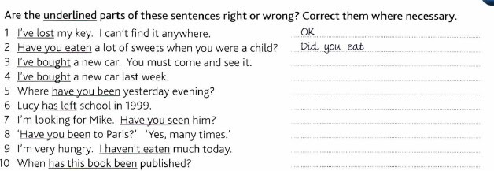

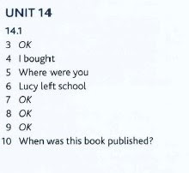
3) Match the following clothing/fashion related Idioms with their meanings:
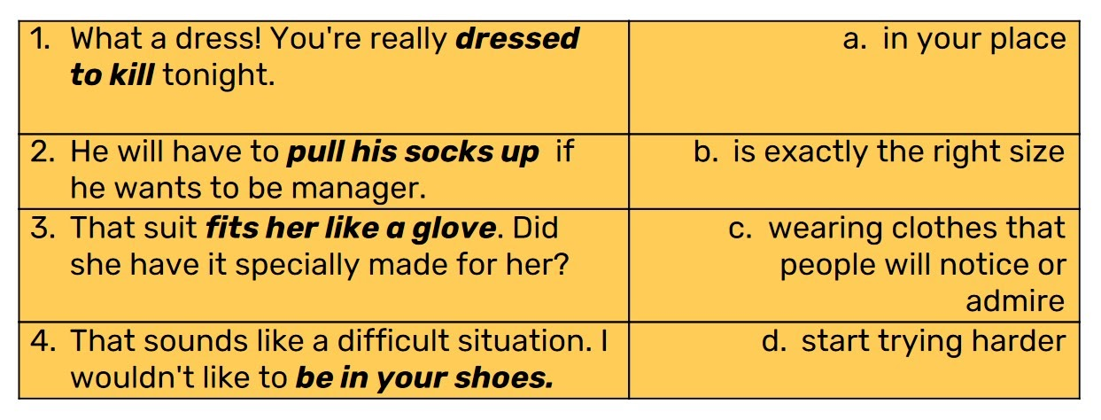
Key: 1-C/2-D/3-B/4-A

3)Make as many sentences as possible using the following key words:
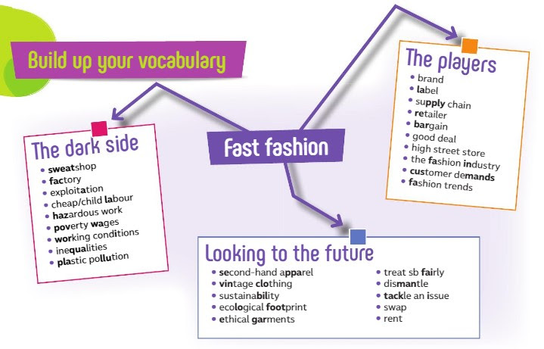
Step 7: The Downside of fast fashion: exploitation and sweatshops are at the core of fast fashion: it’s time to dismantle the system

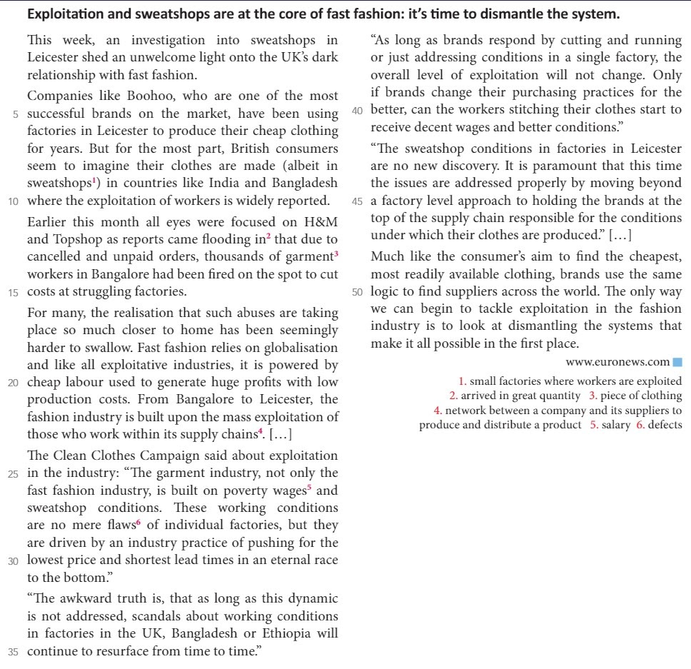

  - Complete the worksheet, then pick out elements to demonstrate that fashion brands are responsible for certain inequalities in the fashion industry.
mass exploitation/ cheap labour/ huge profits/ poverty level wages/ sweatshop conditions/ quest for rock-bottom prices/ quickest possible production time/ no loyalty to suppliers
  - Explain how such unjustness is not limited to developing countries
sweatshops in Leicester, Great Britain/ Boohoo has factories in Leicester/ employees dismissed without notice/ cheap clothing is produced

The downside of fast fashion
1. The following expressions appear in the article. Match them with their definition then use the expressions to predict the subject of the article.
a. take apart: |  | shed a light on
b. difficult to accept: |  | cut and run
c. explain or clarify sth unknown: |  | hard to swallow
d. leave quickly: |  | struggling
e. in financial difficulty |  | a race to the bottom
f. lose your job: |  | dismantle
g. sacrifice worker safety or quality standards: |  | be fired
2. Fill in the chart with information about the fast fashion industry from the article.
Business model | Workers | Solutions | Retailers | Places

Answers:

1. The following expressions appear in the article. Match them with their definition then use the expressions to predict the subject of the article.
2. a. take apart: dismantle
3. b. difficult to accept: hard to swallow
4. c. explain or clarify sth unknown: shed a light on
5. d. leave quickly: cut and run
6. e. in financial difficulty: struggling
7. f. lose your job: be fired
8. g. sacrifice worker safety or quality standards: a race to the bottom

2. Fill in the chart with information about the fast fashion industry from the article.
Business model | Workers | Solutions | Retailers | Places
cheap clothing  cheap labour  huge profits  low production costs  lowest prices  quick production | exploited  abused  poverty wages  sweatshop conditions  terrible working  conditions | stop pushing for the  lowest price  pay decent wages  improve working  conditions | Boohoo  H&M  Topshop | Leicester, UK  Bangalore, India  Bangladesh  Myanmar

Step 8: Work on your accent
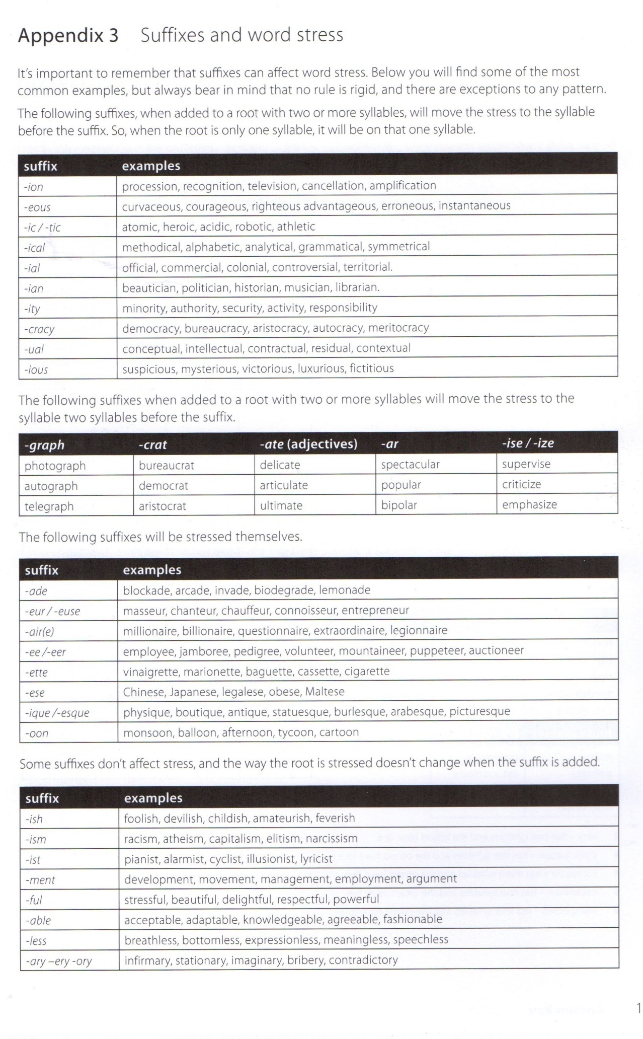
Exercise:

Which syllable is stressed? Underline it.
Extracts from text 1:
greenwash--colorful--crusader--extinction--rebellion--similar--activist--activity--photograph--climate--consumer--consumerism--company--synthetic--disruptive--hypocrite--hypocritical--environment--environmental--begin--beginning--sustainable--recycling--addressing--drastically--actually--individual--individualization--reassurance
Extracts from text 2:
ethical--sustainable--sustainability--industry--positive--positively--impact--animal--safety--resources--energy--carbon emission--chemical--finally--determine--community--benefit
Extracts from text 3:
trillion--industry--polluter--average--estimate--plastic pollution--environment--environmental--appreciate--reduce--temperature--commitment--material--charity
Extracts from text 4:
investigation--relationship--successful--exploitation--factory--globalization--responsible--condition--available--dismantle

Answers:
Extracts from text 1:
greenwash--colorful--crusader--extinction--rebellion--similar--activist--activity--photograph--climate--consumer--consumerism--company--synthetic--disrupt--disruptive--hypocrite--hypocritical--environment--environmental--begin--beginning--sustainable--recycling--addressing--drastically--actually--individual--individualization--reassurance
Extracts from text 2:
ethical--sustainable--sustainability--industry--positive--positively--impact--animal--safety--resources--energy--carbon emission--chemical--finally--determine--community--benefit
Extracts from text 3:
trillion--industry--polluter--average--estimate--plastic pollution--environment--environmental--appreciate--reduce--temperature--commitment--material--charity
Extracts from text 4:
investigation--relationship--successful--exploitation--factory--globalization--responsible--
condition--available--dismantle

Step 9: Recap: Time’s up.

Répartissez-vous en 2 groupes. Sélectionnez 20 mots du vocabulaire étudié pendant la séquence et écrivez un mot par papier. Echangez vos papiers avec ceux de l’autre groupe et commencez à jouer.
Tour 1: Décrivez le mot sans l’utiliser
Tour 2: utilisez uniquement 1 mot
A votre tour, vous avez 2 mn pour faire deviner à votre groupe un maximum de mots. Retirez ceux qui ont été devinés au fur et à mesure.
Puis c’est au tour de l’autre équipe de jouer pendant 1 mn avec le reste des cartes. Quand tous les mots ont été devinés, comptez vos points et passez au tour 2 et ainsi de suite.

Evaluation (test de leçon):

- Traduire les mots suivants de l’anglais vers le français: /10 pts
- landfill b) to dump c) raise awareness d)display e)sustainability f)mislead g)slam h)to trick i)as long as j)flooding k)supply chain l) union m)average n)item o)savvy p)hazard q)dispose r)bargain s)address t) amount

2. Traduire les mots suivants du français vers l’anglais: /5pts
- usine b)poubelle c)marquant, choquant d)à la mode e) une marque f)empreinte carbone g)vêtements (ne pas utiliser clothes) h)c’est une bonne affaire i)atelier d’exploitation humaine j) un militant
3. Traduis les expressions suivantes du français vers l’anglais: /10 pts
- Mettre en lumière 2. se voir accusé de quelque chose (ne pas utiliser to be accused of) 3. Répondre à la demande 4. Niveler par le bas 5. Être super bien habillé 6. Se mettre à la place de quelqu’un 7. Prendre position contre ou pour quelque chose 8) rendre le monde meilleur 9) En bref 10) Changer en mieux
4. Traduis les expressions suivantes de l’anglais vers le français: /4pts
- Shine a spotlight 2. Role model 3. Green credentials 4.Pull one’s socks up
5. Give the definition of:
- Greenwashing /3pts
- Extinction Rebellion /3pts
- Fast Fashion /2pts
6. Copy out and underline the stressed syllable: /10pts
Climate--environment--sustainability--energy--hypocritical--individual--consumer--industry--determine--factory--ethical--positive--safety--address--company--rebellion--synthetic--environmental--beginning--community
7. /10pts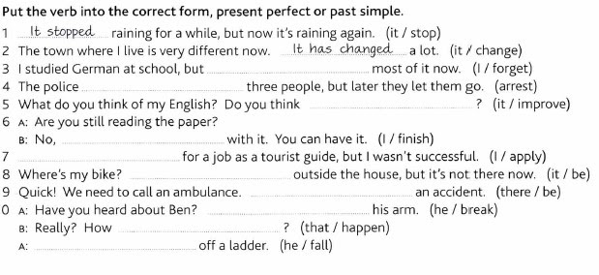
8. /10 pts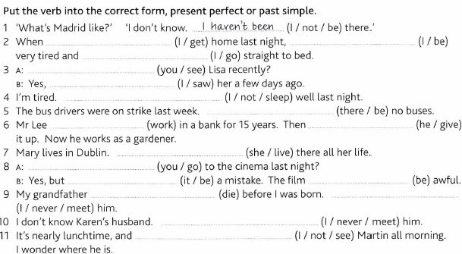
10. /8pts
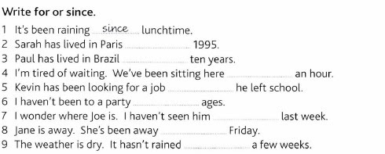
11. Explain what the problem with H&M’s campaign was: /3 pts
12. “Fast fashion is a problem of poor countries and poor people.” Comment./7 pts
13. What solutions can be found to tackle Fast Fashion issues? /5 pts

Correction du test de leçon

- Traduire les mots suivants de l’anglais vers le français: /10 pts
- landfill= décharge b) to dump= jeter c) raise awareness= sensibiliser d)display= afficher e)sustainability=durabilité f)mislead= induire en erreur, duper g)slam= descendre en flammes h)to trick= duper, tromper i)as long as= tant que j)flooding= inondation k)supply chain=chaîne d’approvisionnement l) union= syndicat m)average= moyenne n)item= objet, article o)savvy=qui s’y connaît p)hazard= danger q)dispose=se débarrasser de r)bargain= bonne affaire s)address= s’occuper de t) amount= quantité

2. Traduire les mots suivants du français vers l’anglais: /5pts
- usine= factory b)poubelle= garbage, dumpster c)marquant, choquant= striking d)à la mode= on-trend e) une marque = a brand f)empreinte carbone= carbon footprint g)vêtements (ne pas utiliser clothes) = garment h)c’est une bonne affaire= it’s a bargain i)atelier d’exploitation humaine= sweatshop j) un militant= an activist
3. Traduis les expressions suivantes du français vers l’anglais: /10 pts
- Mettre en lumière= shed a light on/shining a spotlight 2. se voir accusé de quelque chose (ne pas utiliser to be accused of)= be found guilty of 3. Répondre à la demande= meet the demand 4. Niveler par le bas= race to the bottom 5. Être super bien habillé= be dressed to kill 6. Se mettre à la place de quelqu’un=be in one’s shoes 7. Prendre position contre ou pour quelque chose= take a stand for or against sth 8) rendre le monde meilleur= make the world a better place 9) En bref= long story short 10) Changer en mieux= change for the better
4. Traduis les expressions suivantes de l’anglais vers le français: /4pts
- Shine a spotlight= Attirer l’attention sur 2. Role model= exemple à suivre 3. Green credentials= légitimité écologique 4.Pull one’s socks up= se retrousser les manches
5. Give the definition of:
- Greenwashing /3pts
Greenwashing: a superficial or insincere display of concern for the environment that is shown by an organization or a company

- Extinction Rebellion /3pts
international activist organisation, which uses non-violent methods to encourage those in power to take action on climate and environment issues.

- Fast fashion /2 pts
Clothes that are made and sold cheaply, so that people can buy new clothes often.
6. Copy out and underline the stressed syllable: /10pts
Climate--environment--sustainability--energy--hypocritical--individual--consumer--industry--determine--factory--ethical--positive--safety--address--company--rebellion--synthetic--environmental--beginning--community
7. /10pts
Voir à la fin de l’exercice 8 pour avoir les 2 corrigés en même temps
8. /10 pts

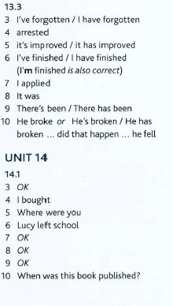
10. /8pts
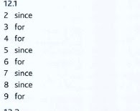

11. Explain what the problem with H&M’s campaign was: /3 pts
H&M pretended to be in favour of the environment, even to be environmentalists or activists whereas the conditions in which their clothes are made, above all their H&M conscious collection have awful consequences on the environment, contrary to what it pretends. It is therefore a deceiptive brand, their commitment for the environment is just greenwashing.
12. “Fast fashion is a problem of poor countries and poor people.” Comment./7 pts
Réponse libre, le contenu et la correction linguistique sont des éléments de la notation
13. What solutions can be found to tackle Fast Fashion issues? /5 pts
Réponse libre, le contenu et la correction linguistique sont des éléments de la notation

