The US Federal Government
There are three parts to the US Federal Government. Each part has a defined role and acts as a check on the other parts of the Federal Government.
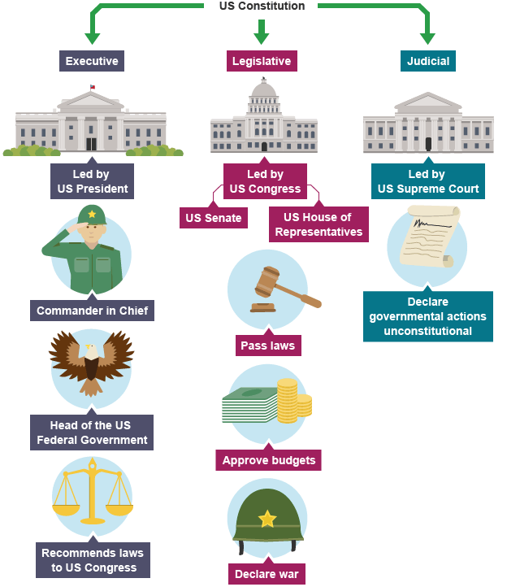
The executive branch is the office of the President. The role of the President is to oversee the running of the country and suggest new laws to improve the USA.
Note: the US President cannot introduce laws into Congress. This must be carried out by an elected congressional representative.
The legislative branch is the law making part of the federal government.
- Representatives from all 50 states meet at Congress (in Washington, D.C.)
- Congress is split into two houses: the House of Representatives (the lower chamber) and the Senate (the upper chamber)
- Unlike the President, members of the House of Representatives and the Senate can remain in power for as long as they continue to be elected
- The Senate comprises of 100 elected members. Each state – regardless of geographical size or population – returns two senators to Washington, D.C.
- Each senator is elected on a six year term. One-third of the Senate are elected every two years
- All 435 members of the House of Representatives are elected on a two-year term and serve the people of the congressional district they represent. States with higher population numbers return higher numbers of representatives e.g California has a population of almost 40 million and returns 52 representatives whereas Alaska has a population of around 734,000 and returns one representative - Democrat Mary Peltola (2024)
The judiciary is the Supreme Court
- The Supreme Court is the highest court in the USA
- Americans can appeal to the Supreme Court, if they feel their constitutional rights have been denied
- It has the power to assess laws
- It consists of nine Supreme Court Justices
- Unlike the other branches of the federal government, Supreme Court Justices are not elected but instead nominated by the President and rejected or confirmed by the Senate.

State government
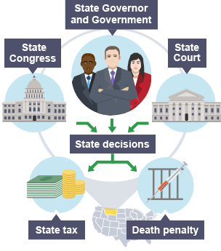
Each state has its own state government. The structure of each of the 50 state governments is similar to the structure of the federal government.
Montana, for example, has:
- A governor (Greg Gianforte, 2024) who maintains the government of the state and suggests new laws or spending plans
- A legislative building with two law-making bodies – the State Assembly and State Senate. Both must agree before decisions become law
- A State Supreme Court which is the highest court of appeal in Montana and interprets state laws

The powers of the President
US Presidents have defined powers as stated within the US Constitution.
Donald Trump is the 47th President of the United States of America (POTUS). The US presidential election is held every four years. An American citizen can serve a maximum of two terms as POTUS.
The President, as the head of the executive, has a lot of power. Article 11 of the US Constitution defines the powers the President can use without congressional approval and those where congressional approval must be sought.
Commander-in-Chief of the armed forces
The POTUS has the responsibility of defending the USA including ordering troops overseas. In January 2024, President Biden ordered US forces to destroy Houthi rebel targets in Yemen who were responsible for rocket attacks on international shipping in the Red Sea. However, only Congress can declare war, e.g. the Iraq War. Treaties must also be approved by the Senate.
Power of appointment
The President appoints thousands of people to help run the country, including members of the US Cabinet, e.g. Secretary of State Antony Blinken. Nominations for overseas ambassadors must have the approval of the Senate. Article Two of the US Constitution requires the POTUS to nominate Supreme Court justices and with Senate confirmation, requires justices to be appointed.
During his 2016-2020 presidency, Donald Trump was able to nominate and have approved three Supreme Court who all hold conservative views. They were Neil Gorsuch, Brett Kavanaugh and Amy Coney Barrett. The balance in the Supreme Court is 5-4 for those who hold conservative views as opposed those judges with more liberal views. This is important when the court takes a decision on issues such as abortion e.g. the Supreme Court overturned Roe V Wade (2022) which has previously guaranteed women the right to an abortion.
In 2022, President Biden nominated one Supreme Court judge – Ketanji Brown Jackson. She is the first black woman to serve as a Supreme Court judge and like President Biden her views are also considered more liberal.
Legislative power
Every year, the POTUS delivers his State of the Union Address to Congress. The President reviews the previous year and outlines spending plans and any proposals for legislation. The president cannot introduce legislation, only members of Congress can do this. Congress also controls the budget.
Power of veto
Before legislation becomes law, bills (new laws in the making) must be signed by the POTUS. If the POTUS disagrees with a new law they can refuse to sign it. This is called a veto. By January 2024, President Biden had vetoed 10 bills including a bill pertaining to electric vehicle chargers.
Congress has the power to override the presidential veto if a bill is passed by two-thirds of the representatives of both Houses. For example, in early 2021, Congress overturned President Trump’s veto on a defence spending bill.
Pocket veto
A 'pocket veto' or indirect veto is where a bill remains unsigned by the President and there is insufficient time, i.e. less than 10 days before Congress adjourns, for Congress to reject the Presidential veto. However, the use of pocket vetoes is very rare and has not been used by recent Presidents.
Executive Orders (EOs)
The President can bypass Congress on certain occasions by issuing Executive Orders (EOs). EOs allow the President to make laws without Congressional approval. Under President Trump, 219 EOs were issued. As of January 2024, Biden has issued 128 executive orders. President Biden’s use of executive orders includes actions to further tighten economic trading restrictions on Russia, in response to the Russian invasion of Ukraine.
Key fact
Congress can impeach or remove a President if they suspect any wrongdoing, although the use of this power is very rare.
As the only person elected by all Americans, Presidents have enormous power. In particular, popular presidents with a like-minded Congress have used their support to increase their power.
Since the 'War on Terror' following the September 11 2001 terrorist attacks, the powers of the President have increased.
The Supreme Court can act as a check against the power of the President. It has the power of judicial review and can decide that any law passed by the President and Congress is unconstitutional.

