Chapter 2: Trump 2.0
Recap: American institutions
Fill in the blanks

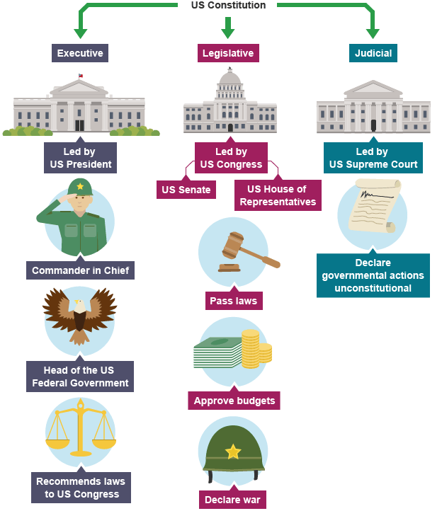
What is the system of checks and balances?
When was the Constitution written and by whom? Where is it now?
For more information about American institutions and political system, read the documents on cahier de prépa.

Introduction
Definitions: forms of government
From: Merriam-Webster dictionary
democracy
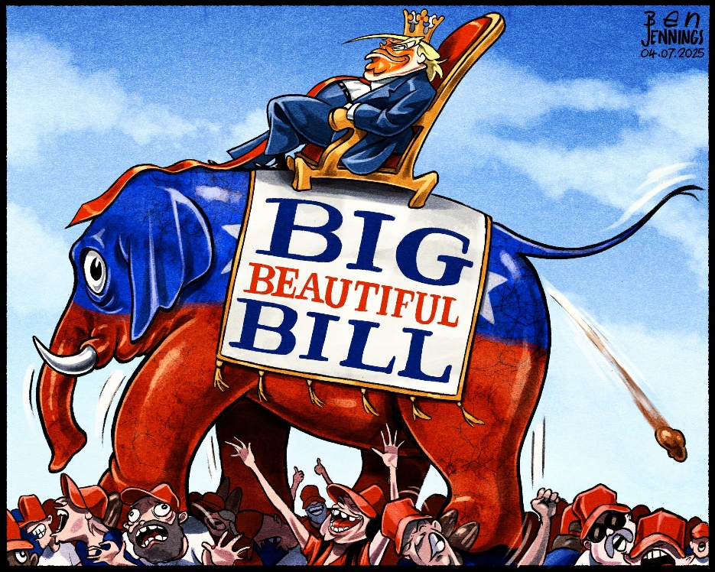
: government by the people : rule of the majority
: a form of government in which the people elect representatives to make decisions, policies, laws, etc. according to law

oligarchy
1: government by the few
2: a government in which a small group exercises control especially for corrupt and selfish purposes
Description:

Analysis:

Dictatorship, Authoritarianism, and Totalitarianism
From: UOLBB, December 1, 2024
Political systems are diverse, but certain forms of governance stand out for their concentration of power and control. Among these are dictatorship, authoritarianism, and totalitarianism, which are terms often used interchangeably but distinct in their meanings and applications. Each represents a different way of organising power, with unique implications for society, governance, and individual freedoms.
Dictatorship
A dictatorship is a political system in which absolute power is concentrated in the hands of a single individual, known as the dictator. This system is marked by the absence of legal or institutional checks on the dictator's authority, enabling them to make decisions without accountability. Dictators often rise to power through force or manipulation, relying on propaganda, censorship, and military control to maintain their grip. While the public has little to no role in governance, the dictator's personal traits, charisma, or ruthlessness frequently define the regime.
Authoritarianism
Authoritarianism describes a broader political system where power is concentrated in a single authority or a small group, but it does not necessarily revolve around one individual. Unlike totalitarian regimes, authoritarian governments focus primarily on controlling political power and suppressing dissent while allowing limited social or economic freedoms. The government typically justifies its rule as necessary to maintain order, security, or stability, often at the expense of political pluralism and civil liberties.
Totalitarianism
Totalitarianism represents the most extreme form of authoritarianism, where the state seeks to control every aspect of public and private life. Unlike dictatorships or general authoritarian rule, totalitarian regimes are ideologically driven, aiming to mobilise society around a singular, all-encompassing vision. The government enforces this ideology through education, propaganda, and surveillance, leaving no room for dissent or individual autonomy. Citizens are not only governed but indoctrinated, with the state dictating beliefs, behaviours, and even personal relationships. Leaders in totalitarian systems often cultivate a cult of personality, presenting themselves as godlike figures deserving of unconditional loyalty.
Although these systems share certain characteristics, they differ in their scope and mechanisms of control. All concentrate power and suppress opposition, but while dictatorship centres on the authority of one individual, authoritarianism often involves a group or ruling elite. Totalitarianism goes further by extending control into the personal lives and beliefs of citizens, aiming for total submission to the state's ideology. These distinctions help explain how different regimes function and impact the societies they govern.

- After reading all the definitions, how would you define Trump’s government? Justify.
- What are the elements that indicate if a democracy is strong, weak or flawed?
Document 1: These Words Are Disappearing in the New Trump Administration
By Karen Yourish, Annie Daniel, Saurabh Datar, Isaac White and Lazaro Gamio
March 7, 2025, The New York Times
As President Trump seeks to purge the federal government of “woke” initiatives, agencies have flagged hundreds of words to limit or avoid, according to a compilation of government documents.

- accessible
- activism
- activists
- advocacy
- advocate
- advocates
- affirming care
- all-inclusive
- allyship
- anti-racism
- antiracist
- assigned at birth
- assigned female at birth
- assigned male at birth
- at risk
- barrier
- barriers
- belong
- bias
- biased
- biased toward
- biases
- biases towards
- biologically female
- biologically male
- BIPOC
- Black
- breastfeed + people
- breastfeed + person
- chestfeed + people
- chestfeed + person
- clean energy
- climate crisis
- climate science
- commercial sex worker
- community diversity
- community equity
- confirmation bias
- cultural competence
- cultural differences
- cultural heritage
- cultural sensitivity
- culturally appropriate
- culturally responsive
- DEI
- DEIA
- DEIAB
- DEIJ
- disabilities
- disability
- discriminated
- discrimination
- discriminatory
- disparity
- diverse
- diverse backgrounds
- diverse communities
- diverse community
- diverse group
- diverse groups
- diversified
- diversify
- diversifying
- diversity
- enhance the diversity
- enhancing diversity
- environmental quality
- equal opportunity
- equality
- equitable
- equitableness
- equity
- ethnicity
- excluded
- exclusion
- expression
- female
- females
- feminism
- fostering inclusivity
- GBV
- gender
- gender based
- gender based violence
- gender diversity
- gender identity
- gender ideology
- gender-affirming care
- genders
- Gulf of Mexico
- hate speech
- health disparity
- health equity
- hispanic minority
- historically
- identity
- immigrants
- implicit bias
- implicit biases
- inclusion
- inclusive
- inclusive leadership
- inclusiveness
- inclusivity
- increase diversity
- increase the diversity
- indigenous community
- inequalities
- inequality
- inequitable
- inequities
- inequity
- injustice
- institutional
- intersectional
- intersectionality
- key groups
- key people
- key populations
- Latinx
- LGBT
- LGBTQ
- marginalize
- marginalized
- men who have sex with men
- mental health
- minorities
- minority
- most risk
- MSM
- multicultural
- Mx
- Native American
- non-binary
- nonbinary
- oppression
- oppressive
- orientation
- people + uterus
- people-centered care
- person-centered
- person-centered care
- polarization
- political
- pollution
- pregnant people
- pregnant person
- pregnant persons
- prejudice
- privilege
- privileges
- promote diversity
- promoting diversity
- pronoun
- pronouns
- prostitute
- race
- race and ethnicity
- racial
- racial diversity
- racial identity
- racial inequality
- racial justice
- racially
- racism
- segregation
- sense of belonging
- sex
- sexual preferences
- sexuality
- social justice
- sociocultural
- socioeconomic
- status
- stereotype
- stereotypes
- systemic
- systemically
- they/them
- trans
- transgender
- transsexual
- trauma
- traumatic
- tribal
- unconscious bias
- underappreciated
- underprivileged
- underrepresentation
- underrepresented
- underserved

- undervalued
- victim
- victims
- vulnerable populations
- women
- women and underrepresented

[…]
The above terms appeared in government memos, in official and unofficial agency guidance and in other documents viewed by The New York Times. Some ordered the removal of these words from public-facing websites, or ordered the elimination of other materials (including school curricula) in which they might be included.
In other cases, federal agency managers advised caution in the terms’ usage without instituting an outright ban. Additionally, the presence of some terms was used to automatically flag for review some grant proposals and contracts that could conflict with Mr. Trump’s executive orders.
The list is most likely incomplete. More agency memos may exist than those seen by New York Times reporters, and some directives are vague or suggest what language might be impermissible without flatly stating it.
All presidential administrations change the language used in official communications to reflect their own policies. It is within their prerogative, as are amendments to or the removal of web pages, which The Times has found has already happened thousands of times in this administration.
Still, the words and phrases listed here represent a marked — and remarkable — shift in the corpus of language being used both in the federal government’s corridors of power and among its rank and file. They are an unmistakable reflection of this administration’s priorities.
For example, the Trump administration has frequently framed diversity, equity and inclusion efforts as being inherently at odds with what it has identified as “merit,” and it has argued that these initiatives have resulted in the elevation of unqualified or undeserving people. That rhetorical strategy — with its baked-in assumption of a lack of capacity in people of color, women, the disabled and other marginalized groups — has been criticized as discriminatory.
Indeed, in some cases, guidance against a term’s usage has arrived alongside directives intended to eliminate the concept itself. Federal diversity, equity and inclusion initiatives are one example; the Gulf of Mexico is a very different one.
That shift is already apparent on hundreds of federal government websites. A New York Times analysis of pages on federal agency websites, before and after Mr. Trump took office, found that more than 250 contained evidence of deletions or amendments to words included in the above list.

