Germany’s ‘Firewall’ Against the _____________________ Is Being Tested as Never Before
A blowout win by the _____________________ Alternative for Germany party in a state election has revealed a split among voters about whether to uphold a decades-old strategy for sidelining extremists.
By Jim Tankersley, The New York Times, Sept. 7, 2026

For feminists, the deaths of ______________ and _______________ days apart deliver a double dose of grief
AP News By LAURIE KELLMAN and BILL BARROW
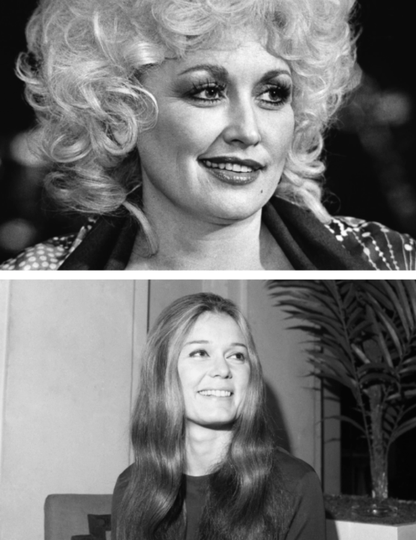
Updated 6:05 AM UTC+2, September 5, 2026
One shaped and delivered the language of feminism. The other rejected the label but showed how feminism can be done: with a microphone dusted in rhinestones, and without apology.

___________________ and ____________________ embodied two towering versions of the same idea: that women should know themselves well enough to make their own choices about matters intimate and societal. Their deaths eight days apart sent a double dose of grief around the world and across generations as many women (and some men!) asked who would take their places at the forefront of women’s rights.
________________, overtly political, went undercover as a Playboy bunny to deliver an exposé, founded Ms. Magazine and spent the rest of her life urging women to support each other. ______________________, on the other hand, defined herself as a larger-than-life daughter of the American South who told stories with music and included everybody — but refused to play politics or call herself a feminist.

