
Unit 1 : America at 250 – Is the American Dream back?
Document 1: video https://www.youtube.com/watch?v=NUp-qqT3LxY
Massive celebrations for America’s 250th birthday
- First part (=> 1’47)
  - Name a few of the events that took place as part of the celebrations

- Second part (1’47 – 3’09)
  - Who is JD Vance? What do we learn about his previous experience?

  - Fill in the blanks: “George ______________ read aloud the words of the incredible Declaration. ‘We hold these _______________ to be self-evident, that all men are created _________________, that they are endowed by their __________________ with certain unalienable rights, and that among these rights are ________________, ___________________ and the pursuit of ________________________.”
- Third part (3’09 – 4’00)
  - List the adjectives Trump uses to describe their Republic, the people, the constitution and the country (in the superlative form):

  - Who does he accuse and what does he accuse them of?

  - Find the English for :
    - Un regroupement :
    - Calomnier :
Documents 2, 3, 4:
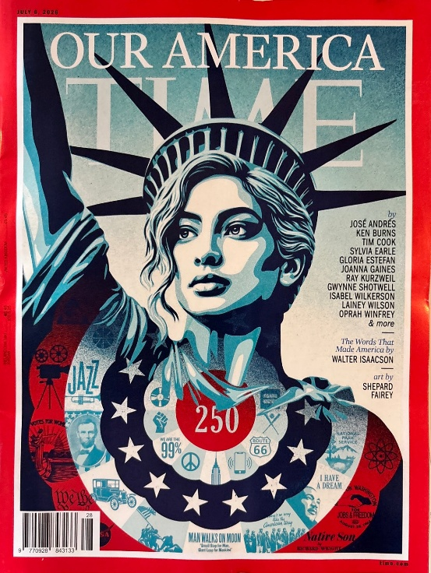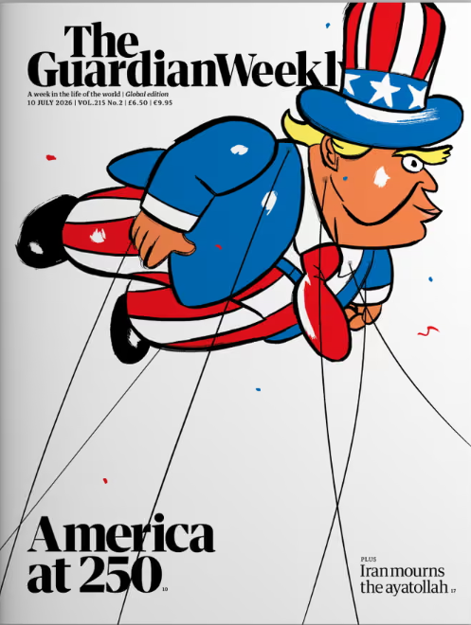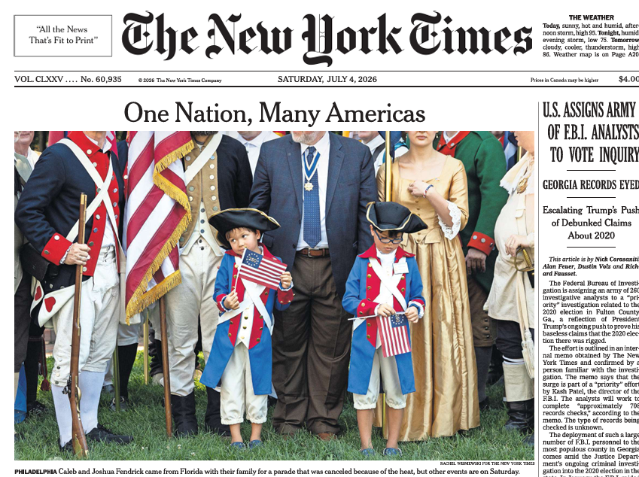
Decribe the three documents and compare them
Document 5
US marks 250th birthday with fireworks, flyovers and extreme weather
Bernd Debusmann Jr, DCand Nardine Saad, BBC, 5 July 2026
The US has marked its 250th birthday with fireworks and flyovers - but celebrations across the country were complicated by extreme weather.
"The American dream is back," US President Donald Trump told a cheering crowd during a delayed rally at the National Mall in Washington DC, before what he described as the world's largest fireworks display.
The 4 July federal holiday commemorates the 13 US colonies signing the Declaration of Independence in 1776 to end British rule.
Despite the celebrations, Trump has been criticised for making himself central to the milestone and politicising the celebrations.
The president's speech, which finished just before midnight, touched on political themes including the rejection of communism and the right to bear arms.
"Long live the cause of independence," he said. "May it reign forever and ever and ever. We will always be on top, we will never let our country fall, we will always be the best."
Trump capped off his remarks by calling the moment "only the dawn of the golden age of America" with its destiny "written by God".
Celebrations in the US capital were delayed because of a thunderstorm, which forced an evacuation of the National Mall earlier in the evening.
Guests attending the Salute to America, the Great American State Fair and Fifa fan zone were asked to seek temporary shelter in nearby buildings.
Once the storm had passed, festivities began again, including a flyover featuring the new Air Force One and a concert.
The grande finale - the fireworks show - was marked by a massive flurry of blasts, concluding at about 01:00 local time (05:00 GMT). The small crowd on Capitol Hill cheered before rapidly walking towards the exits as it began to lightly rain.
- Understanding the text
  - What does the word “holiday” mean in this context? (l.4)
  - What does the word “federal” (l.4) mean?
  - Which of these Washington monuments is the National Mall?
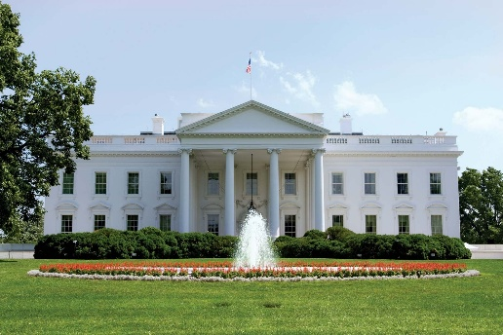
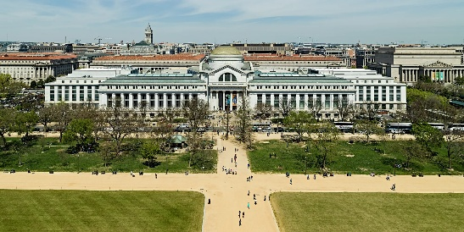
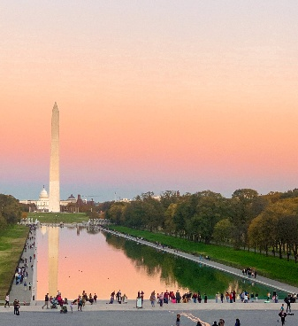
  - What was unexpected during the celebrations?
- Going further
  - Why would Donald Trump reject communism and celebrate the rights to bear arms (l.9)? What does it have to do with July, 4th?
  - Why does Donald Trump refer to God (l.13)?

