**Guns in the USA**

**Introduction**

The United States with less than 5% of the global population, has about 35% of the world’s civilian-owned weapons, thus ranking number one in firearms per capita. The country also holds the sad record of gun-related homicides among the world’s industrialized nations. The debate on gun ownership has **waxed and waned** in America over the last decades and it has repeatedly been **rekindled** by mass shootings invariably involving a gunman **snatching the lives** of innocent civilians. Still, despite the ever-growing number of gun-related incidents **roiling** the country, decision-makers **bent on** tightening gun ownership rules **have a hard time** pushing their bills through. One may thus wonder if pro-gun activists are fighting a losing battle.

**Vocabulary**

- to wax and wane: fluctuer, grandir pour finir par tomber

- to rekindle: reviver, ranimer

- to snatch: arracher, voler, ôter (ici, la vie de qq’un)

- to roil : secouer

- to be bent on + V-ING sthg: être déterminé à faire qqch

- a losing battle: une bataille perdue d’avance

**Historical background**

Americans’ tendency to be **trigger-happy** has traditionally been ascribed to **the legacy of the War of Independence and the Conquest of the American West**. The country having been built through successive wars against the British an the Spaniards, not to mention the bloody confrontations with native Americans, gun ownership and self-defence have always been seen as **part and parcel of US culture**, all the more so as in 1791 they were to be **enshrined in the 2nd Amendment to the US Constitution**.

“A well-regulated Militia, being necessary to the security of a free State, the right of the people to keep and bear Arms, shall not be infringed.”(ratified in December 1791, along with nine other articles of the Bill of Rights)

Indeed, back then, to avoid the cost of a regular army, the task of protecting the young republic from its enemies was assigned to civilian militias[1]. Not until the American Civil War broke out did the pivotal point occur, though. Indeed, the first industrial war caused gun manufacturers to increase their output substantially to meet the demand from both the Union and Confederacy. When the war drew to an end, soldiers were allowed to carry their guns home, which contributed to the spread of firearms nationwide so much so that it was normal that virtually every household should be armed.

During the post-war era, the image of men **armed to the teeth and ready to pull the trigger** to defend their territory was romanticized by the lore of the Wild West, spread by the hard-boiled detective story and the Hollywood film industry and then cultivated by pressure groups such as the NRA (National Rifle Association) in particular with the view to depicting **the right to bear arms as deeply ingrained in American culture**. Hence, there is no denying that in the contemporary era, the support for gun ownership should be related to the emergence of this powerful lobby.

It should be borne in mind that the NRA was originally founded in 1871 as a recreational club whose aim was to “promote and encourage rifle shooting on a scientific basis.” Not until the 1930s and the first control acts did it metamorphose into a lobby. Yet the group **flexed its muscles** in the 1970s when it **went to all lengths to** influence policy-making on firearms though a lobbying arm, the so-called Institute for Legislative Action. As time went by, it was to become one of the most powerful lobbies in the country, boasting millions of members and **having significant leverage** in Congress mainly thanks to a **staggering** budget.

Political assassinations in the 1960s and a spate of **killing sprees**, including mass school shootings under Clinton (Columbine being a case in point) caused successive administrations to depart from the **lax gun policy** Washington had pursued until then. Most of these changes (the ban on assault and military-style weapons or the introduction of background checks), albeit significant, did not buck the trend, given the scale of gun violence the country was to see under Obama. True, it undeniably **raised awareness** among the American public opinion insofar as in the 1990s polls indicated that 70 to 80 percent of Americans favoured stricter gun control laws. However, the fear of political retaliation from the NRA buried a new series of gun control bills in June 1999 and NRA membership **soared** again in the 1990s.

**Vocabulary**

- to be trigger-happy: avoir la gâchette facile

- to be ascribed to: être attribué à

- to be part and parcel of // deeply ingrained in // deeply rooted // deeply seated // deeply entrenched : faire partie intégrante de // être profondément ancré dans

- to be enshrined in : faire partie intégrante (de la Constitution)

- to flex one’s muscles: faire étalage de sa force

- to go to great lengths to + BV : faire de son mieux pour, s’efforcer de

- leverage (//clout): influence

- staggering budget: budget mirobolant

- a spate of : une série de

- albeit : quoique

- to buck the trend : inverser la tendance

- to raise awareness: éveiller les consciences à / sensibiliser à

- to bury / kill a bill: enterrer une loi

- to soar: monter en flèche

**Conclusion**

All in all, over the last decades, any attempt to impose stiffer regulations on gun buyers has been **an uphill struggle**. True, certain restrictions have been accepted, being consistent with the sacrosanct 2nd amendment to the US Constitution. The horror of mass shootings involving America’s youth has sensitized Americans to the human cost of lax gun regulations. Nonetheless, support for gun control has consistently ebbed and flowed, not only due to American’s attachment to the Constitution. The role of the NRA, also at the ballot box, has repeatedly proved seminal in **thwarting** progress. Party politics have also stalled reform, the generally gun-friendly Republicans having buried Obama’s gun control bill. The idea that “The only thing that stops a bad guy with a gun is a good guy with a gun” is still alive and well and gun ownership proponents remain unswayed by the argument that gun violence can only be stemmed through gun control. In short, the two sides of the debate **stick to their guns** so that politicians have had a hard time **breaking the stalemate** so far.

**Vocabulary**

* an uphill struggle: une tâche ardue, difficile
* to ebb and flow : fluctuer
* to thwart: contrecarrer
* to stick to one’s guns: camper sur ses positions
* to break a stalemate: sortir de l’impasse

**Writing tips**

**TO BE TO (au prétérit)** a (comme dans ce passage) la valeur de destinée

→ “it was to become one of the most powerful lobbies in the country”

Cette structure a aussi deux autres valeurs sémantiques :

Elle exprime la planification:

→ “The law is to be enforced by the end of 2025.”

Ou la réalisation conditionnelle:

→ “If gun violence is to be curbed, new laws will have to be passed.”

**NOT ONLY + AUX + S + VERB = l’inversion stylistique.** Dans une langue soutenue, on inverse parfois l’ordre canonique (sujet – verbe – COD) dans des phrases affirmatives pour mettre une idée en relief, mais uniquement après des structures spécifiques :

- Après un adverbe / une tournure adverbiale qui exprime la négation :

Hardly, never, seldom, rarely, no sooner.. than, nowhere, not only, on no account, under no circumstance, in no way:

→ “On no account are Americans more violence prone than others.”

Après only (only when, only by, only after):

→ “Only by tightening gun laws on the federal level will America become safer.”

Après so et such:

→ “So moved was Barack Obama that he burst into tears.”

A la place de ‘if’ dans les phrases conditionnelles :

→ “Had the victims of the onslaught been armed, they could have overcome the gunman.”

**The position of the Supreme Court of the USA ruling = District of Columbia v. Heller (2008)**

In a 5–4 ruling issued on June 26 2008, the Supreme Court affirmed the appellate court’s ruling. In so doing, it endorsed the so-called “individual-right” theory of the Second Amendment’s meaning and rejected a rival interpretation, the “collective-right” theory, according to which the amendment protects a collective right of states to maintain militias or an individual right to keep and bear arms in connection with service in a militia.

**Where do these people stand on gun control?**

Moms Demand Action, Brady campaign, David Hogg (March for our Lives), the National Rifle Association, most liberals, most conservatives, Don McLaughlin (Mayor of Uvalde, Texas), Matthew McConaughey

|  |  |
| --- | --- |
| in favour of **tighter** gun laws | in favour of **laxer** gun laws |
|  |  |

Which high-profile politician made a campaign video including footage of himself frying bacon on the barrel of his AR-15 gun for the 2016 presidential election ? Here’s the answer: <https://www.youtube.com/watch?v=EaZGaJrd3x8>

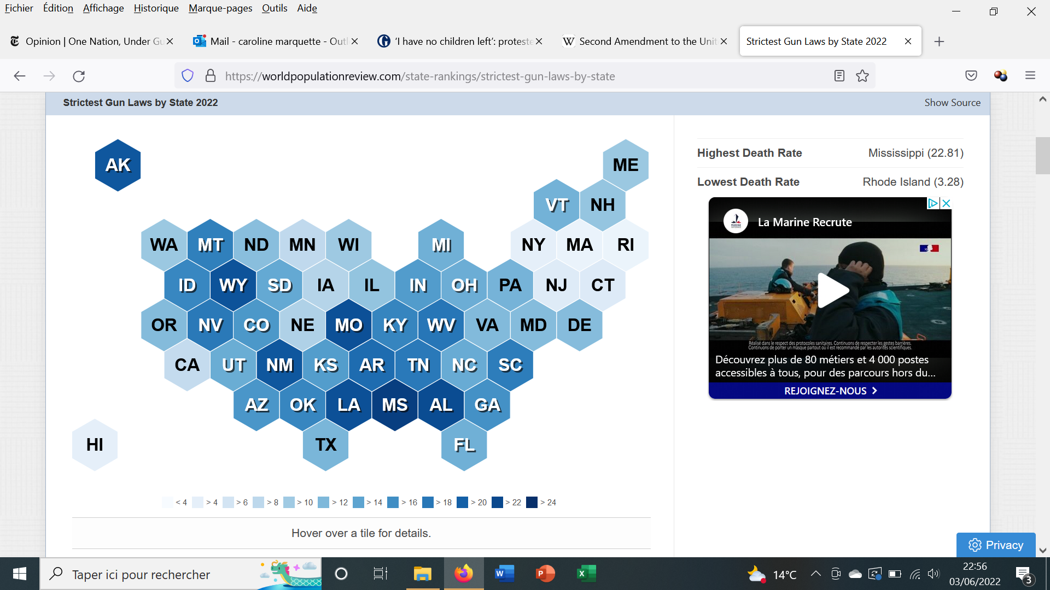

Name a few states with the strictest gun laws in the country :

Name a few states with the laxest gun laws in the country :

**“COMMONSENSE” GUN LEGISLATION** : rank the following measures from 1 to 8 depending on which one(s) seem(s) most likely to be implemented at the federal level in the coming months. Be ready to justify your answers.

|  |  |
| --- | --- |
| Raising age limit from 18 to 21 (the Raise the Age Act) |  |
| Implementing “red flag laws” (temporary removal of firearm from a citizen deemed a threat to himself / others) |  |
| Strengthening background checks |  |
| Requiring secure storage of guns |  |
| Implementing cooling-off periods |  |
| Dealing with the mental health crisis |  |
| Banning military-style assault weapons + high-capacity magazines (the Keep Americans Safe Act) |  |
| All-out ban on all types of guns |  |

**Quotes**

“No free man shall ever be debarred the use of arms. The strongest reason for the people to retain the right to keep and bear arms is, as a last resort, to protect themselves against tyranny in government.” (Thomas Jefferson)

“Disarm the people – that is the best and most effective way to enslave them.” (James Madison, “Father of the Constitution”)

“The only way to stop a bad guy with a gun is a good guy with a gun.” (*National Rifle Association* Executive Vice President Wayne LaPierre, Dec. 21, 2012 – one week after Adam Lanza shot and killed 26 people at [Sandy Hook Elementary School](https://www.britannica.com/event/Newtown-shootings-of-2012) in Newtown, Connecticut)

“The United States seems to have a not-so-secret death cult that believes that the angry god known as the Second Amendment must be periodically propitiated through ritual child sacrifice.” (Bret Stevens, Opinion columnist for the *NY Times*, May 2022)

**To what extent is US a global outlier on guns?** (https://www.youtube.com/watch?v=eBDz3BAVBjA)

…………………………………………………………………………………………………………………………………………………………………………………………………………………………………………………………………………………………………………………………………………………………………………

|  |  |  |  |
| --- | --- | --- | --- |
| the UK | Australia | New Zealand | Canada |
|  |  |  |  |

**Do a bit of research: what stands in the way of gun control?**

What is a filibuster?

What is Citizen United v. FEC (*Federal Election Commission*)?

**Debate:** Should graphic photos of gun violence be shown?

Should teachers be armed?

Should gun control be imposed?

**‘Ghost Guns’: What They Are and Why There Has Been a Fight Over Them**

* Annie Karni, Chris Cameron, *The New York Times*, March 26, 2025

A rule regulating the firearm kits was a centerpiece of President Joseph R. Biden Jr.’s gun control initiative. The Supreme Court has upheld the regulation, issued in 2022.

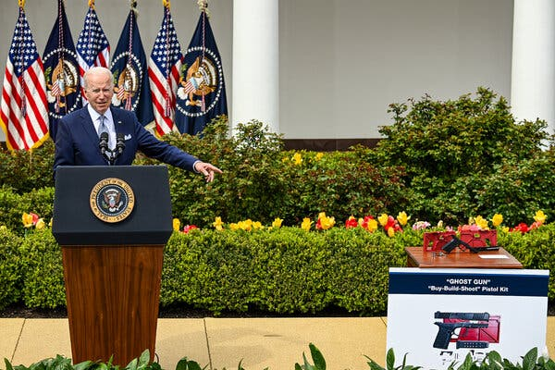

President Joseph R. Biden Jr. unveiled regulations against the D.I.Y. firearms known as ghost guns in 2022.

The Supreme Court on Wednesday [upheld federal restrictions](https://www.nytimes.com/2025/03/26/us/politics/supreme-court-ghost-guns.html) the Biden administration placed on “ghost guns,” drawing a spotlight to the kits that can be assembled into homemade firearms and the new front in the fight over gun control that they opened up.

Administration officials had said the popularity of the weapons had soared in recent years, particularly among criminals barred from buying ordinary guns. The regulation, issued in 2022 by the Bureau of Alcohol, Tobacco, Firearms and Explosives, broadened the bureau’s interpretation of the definition of “firearm” in the Gun Control Act of 1968. It did not ban the sale or possession of parts that can be assembled to make homemade guns, but it did require manufacturers and sellers to obtain licenses, mark their products with serial numbers and conduct background checks.

The rule was a centerpiece of President Joseph R. Biden Jr.’s broader initiative to address the proliferation of illegal weapons. Mr. Biden said in 2022 that the rule would “help save lives, reduce crime and get more criminals off the streets.”

But the federal effort to regulate ghost guns has been troubled by [uneven enforcement](https://www.nytimes.com/2022/12/15/us/politics/ghost-guns-biden.html), [significant loopholes](https://www.nytimes.com/2022/12/27/us/politics/ghost-guns-atf-rule.html) and court challenges. A federal appeals court had struck down the regulation, but in a 7-to-2 ruling on Wednesday, the Supreme Court said it could remain in place.

Here’s what you need to know about the weapons.

**What is a ghost gun?**

Traditional firearms are made by licensed companies and then bought from licensed gun dealers. All guns manufactured in the United States, as well as those imported from abroad, are legally required to have serial numbers that are typically displayed on the back of the frame.

In contrast, a ghost gun is sold in parts, and can be assembled at the home of an unlicensed buyer. Before federal regulations were put in place under the Biden administration, there was no need to pass a background check to obtain the components of a ghost gun. They are sold online as D.I.Y. kits, and typically shipped as “80 percent receivers.” That means the gun is 80 percent complete, and buyers have to assemble the final 20 percent themselves.

The key selling point for many buyers was that ghost guns were not required to have serial numbers, the critical piece of information that law enforcement agencies use to trace a gun from the manufacturer to the gun dealer to the original buyer.

**How hard are they to assemble?**

It’s easy and relatively inexpensive. According to a report by Everytown for Gun Safety, a gun violence prevention organization, an AR-15 build kit costs as little as $345.

The sales pitches usually promise little work for the buyer. One online purveyor assured that “building time doesn’t take too long,” adding, “Within an hour or two, you should be breaking it in at the range.”

The kits usually come with directions on how to finish the gun or link to YouTube tutorials. Typically, the only tool needed is a drill, and the kits are often sold with the necessary drill bits.

Many ghost guns are also sold with a “jig,” which fits around the frame or receiver to make assembly easier. One site said the jig could be used to complete a gun “in under 15 minutes with excellent results.”

According to Everytown for Gun Safety, the top five instructional videos on YouTube for building a ghost gun have drawn more than three million views.

**How long have ghost guns been around?**

Ghost guns aren’t new, but they are a growing problem. Even though kits to assemble guns have been sold since the 1990s, the market did not really take off until around 2009. That is when firearm sellers in California began offering unfinished receivers for the AR-15 and AK-47 series of guns, in an attempt to circumvent the state’s assault weapons laws, according to T. Christian Heyne of Brady, a gun violence prevention organization.

The problem of ghost guns did not become well known until 2013, when one was linked to a rampage by a gunman who killed five people in the vicinity of Santa Monica College in California.

Sales of ghost guns started to rise substantially around 2016, as people began buying kits to re-create a firearm based on the Glock 9-millimeter semiautomatic pistol.

**How prevalent are they now?**

There is no way to know how many ghost guns were in circulation before the rule was put in place, because of the lack of requirements for serial numbers or a background check.

But data shows that the prevalence of the weapons appears to be growing every year, especially in coastal blue states with strict firearm laws like California. Law enforcement officials in the state said ghost guns accounted for [25 to 50 percent of firearms recovered at crime scenes](https://www.nytimes.com/2021/11/14/us/ghost-guns-homemade-firearms.html) in an 18-month period from 2020 to 2021, and the vast majority of suspects caught with them were legally prohibited from having guns.

In 2021, the Justice Department reported that law enforcement agencies had recovered 19,300 homemade guns, about five times the number confiscated or found at crime scenes in 2018.

Proponents of stricter gun laws have been pushing for action on ghost guns to address the problem before it reaches epidemic proportions. Opponents have questioned the data showing their growth.

**Have they been linked to mass shootings?**

Some other mass shootings have been linked to ghost guns, like a 2019 attack at a high school in California where a 16-year-old killed two students. A ghost gun was also linked to a 2017 rampage in which a man killed his wife and four others in Northern California.

But analysts said ghost guns were not disproportionately linked to mass shootings. The bigger issue is that they have an outsize effect on day-to-day gun violence in communities of color across the country, gun safety groups said.

**How effective has the regulation been?**

There are significant limits to how much can be done through executive action to regulate ghost guns.

Officials and gun control groups have previously said that the regulation had [done little to stop the sale of key parts used to make ghost guns](https://www.nytimes.com/2022/12/15/us/politics/ghost-guns-biden.html), in part because the rule was created through executive action, rather than a statute validated by Congress.

The Biden administration then [moved to close a major loophole](https://www.nytimes.com/2022/12/27/us/politics/ghost-guns-atf-rule.html) in the rule by directing vendors to label some partially finished handguns with serial numbers, and to require that buyers of these parts undergo criminal background checks.

The powerful gun lobby strongly opposed the rule, and several conservative legal groups challenged it, arguing that it violated existing firearms laws and Second Amendment protections.

1. The militia spirit derives from an early American dependence on arms to protect themselves from foreign armies and hostile Native Americans. Survival depended upon everyone being capable of using a weapon. Prior to the [American Revolution](https://en.wikipedia.org/wiki/American_Revolution) there was neither budget nor manpower nor government desire to maintain a full-time army. Therefore, the armed citizen-soldier carried the responsibility. Service in militia, including providing one's own ammunition and weapons, was mandatory for all men. Yet, as early as the 1790s, the mandatory universal militia duty gave way to voluntary militia units and a reliance on a [regular army](https://en.wikipedia.org/wiki/Regular_army). Throughout the 19th century the institution of the civilian militia began to decline.