E2B/H2B

Anglais LVA
samedi 9 novembre 2024
DS type BCE (4 heures)

Consignes :
• écrire une ligne sur deux
• rédiger chacune des trois épreuves sur une feuille séparée
• noter le nombre de mots utilisés en fin de copie

CONTENTS
Document 1 – “The evolution of Britain’s extreme right” (The Economist, August 6, 2024)

Document 2 – “With Britain’s far-right on the march, Labour has a problem” (Andrew McDonald, Politico, August 1, 2024)
Document 3 – « Au Royaume-Uni, le modèle multiculturel a résisté aux émeutes d’extrême droite » (Cécile Ducourtieux, Le Monde, 6 septembre 2024)

Document 4 – graph published by The Economist (March 18, 2024)
Document 5 – photograph published by BBC News (November 12, 2023)

- Compréhension - Résumé analytique comparatif (30/100)
According to the two journalists, what makes the rise of the far-right hard to counter nowadays?

Answer the question in your own words. (350 words +/- 10 %)
- Expression personnelle - Rédaction argumentée (50/100)
In your opinion, is the UK still a model of multiculturalism?
Elaborate your personal opinions on this issue in your own words, supported by evidence and references drawn from documents 1-5 and at least two other pertinent cultural, civilizational or historical references from the English-speaking world (500 words +/- 10 %)
- Traduction (Thème) (20/100)
Translate into English the passages in bold from document 3 (including the title)

Doc 1. The evolution of Britain’s extreme right
- The Economist, August 6th 2024

They broke through the hotel doors soon after midday on August 4th. Around 700 far-right activists had gathered outside the Holiday Inn Express in Manvers, a suburb in the deprived northern town of Rotherham, that morning. The mob chanted “get them out” and “burn it down” at asylum seekers housed inside and hurled chairs, planks and bricks at the police. One rioter started a fire in a doorway.
The violence over the past two weeks in Britain has been horrifying. Sparked initially by the killing of three children on July 29th, the disorder took on a life of its own. Thousands have taken part in riots; violence has spread to 22 towns and cities. White nationalists have attacked mosques, asylum hotels and Muslim neighbourhoods and businesses. Fears of more trouble on August 7th were not realised as counter-demonstrators took to the streets.
In some ways the violence, and some politicians’ ambiguous response to it, recalls earlier bouts of far-right brutality. But in its scale and the way it was organised, it points to something new.
The first major race riot in Britain took place in 1919. Up to the 1970s they flared periodically, usually in urban centres and poor mixed neighbourhoods. Most riots since, with a handful of exceptions, have been between black youths and the police. The last big one, in 2011, was sparked when police shot dead a black man in London; five other people lost their lives. But the past week has seen “the most widespread far-right violence in Britain’s post-war history”, says Joe Mulhall of Hope Not Hate, a campaign group.
That is a shock. Until recently the far right in Britain appeared a diminished force, caught between a decline in racist attitudes and a winner-takes-all electoral system that favours big political parties. Throughout the 20th century the far right tried, and largely failed, to combine street activism with success at the ballot box. The British Union of Fascists (BUF), founded by Oswald Mosley, an aristocratic antisemite, attracted some 50,000 supporters in the 1930s but failed to make any electoral headway. After the second world war, Mosley turned to aggressive street campaigning in migrant communities.
That was a tactic continued in the 1970s by the National Front, a white-nationalist group that campaigned against the arrival of Ugandan Asians. In an infamous clash, in 1977, 500 National Front members marched through Lewisham, a multicultural borough in London, under a banner that read “clear the muggers off the streets” before brawling with police.
The electoral market for such extreme views, never that large, has steadily shrunk. Only 17% of people now say that to be truly British, it is very important to have been born in Britain, down from 48% in 1995. As a result a distinction has emerged between what academics term the “extreme right”, explicitly racist outfits like the National Front and the BNP, and the “radical right”, electoral movements whose ranks include populists like Nigel Farage, the leader of Reform UK.
Both have made headway. The radical right is more prominent than ever. Mr Farage, who shares many of the extreme right’s concerns about immigration, crime and policing, is one of five Reform UK MPs in Parliament following the election on July 4th. Like other stars of the populist right, he gets top billing on GB News, a television channel. Extreme-right actors have meanwhile found new ways of tapping old grievances.
Whereas in the past the extreme right was organised through institutions with leaders, organisational structures and membership lists, it is now a looser constellation of influencers and networks. Its leading figure is Stephen Yaxley-Lennon, a 41-year-old former football hooligan from Luton who uses the pseudonym Tommy Robinson. On July 27th he drew 30,000 people to a rally in London where speakers melded genuine local concerns, for example about the location of asylum hotels, with wild theories about Britain being an “occupied country”.
The English Defence League (EDL), an anti-Muslim group founded by Mr Yaxley-Lennon, is supposedly defunct. But its former members continue to share messages. Another important network is Patriotic Alternative. Whereas those associated with the EDL tend to be older hooligans, Patriotic Alternative targets a younger audience by organising video-gaming events and fight clubs. Neither group has many official members but both have a large reach through apps, says Julia Ebner, an expert on extremism at Oxford University.
The recent unrest does not appear to have been centrally organised. Instead local activists chose a specific location, announced an intention to congregate there and waited for their plans to be amplified via apps. This decentralised approach explains one difference with past riots, which tended to happen in cities. But in other respects the internet encourages uniform behaviour, as troublemakers repeat slogans pushed online. (780 words)
Doc 2. With Britain’s far right on the march, Labour has a problem
- Andrew McDonald, Politico, August 1, 2024
LONDON — Less than a month into the reign of the U.K.’s new Labour government, unspeakable tragedy struck.
In the seaside town of Southport, situated in north west England just outside Liverpool, three young girls were killed Monday in a knife attack on a Taylor Swift-themed danced class. A 17-year-old, identified as Cardiff-born Axel Muganwa Rudakubana, has been charged with murder and attempted murder.
In line with usual British police practice, the suspect was not initially named. But into that information void, far-right conspiracies about an establishment cover-up to protect the perpetrator, were poured — and turned quickly violent. Inaccurate social media posts in the immediate aftermath floated a false name and described the attacker as a newly-arrived asylum seeker.
On Tuesday a large crowd, said by police to be connected to the extreme nationalist English Defense League, hurled projectiles at a mosque, set fire to police vehicles and attacked officers in Southport. Fifty-three officers were treated for injuries. Several men were arrested and the protests were swiftly condemned by Britain’s new Prime Minister Keir Starmer as “thuggery,” and as an insult to a grieving community.
Beyond the immediate arrests, however, confronting the far right now presents an early, urgent problem for Starmer’s government. The disorder was the second gathering linked to far-right activity in the space of less than a week, after tens of thousands of supporters of activist and English Defense League founder Tommy Robinson filled Trafalgar Square in London Saturday.
Complicating matters as Labour looks for a response is Nigel Farage, the populist Reform UK leader and newly-elected member of parliament. Neither Labour or the Tories before them have been able to halt the rise of a politician who has repeatedly distanced himself from the far-right — while adopting some of its more popular talking points.
Farage has spent the past 24 hours fending off claims he fanned the flames of Tuesday’s unrest with a video posted on X just hours before the riots took place. In it, he questioned why the incident in Southport was not being treated as “terror-related” and suggested the “truth” about the identity of the suspect was being withheld.
Deputy Prime Minister Angela Rayner said Farage should not “stir up this fake news online,” while Brendan Cox — widow of murdered Labour MP Jo Cox, who was killed by a man with far-right views — went much further. He told the BBC that Farage’s remarks make him “nothing better than a Tommy Robinson in a suit,” a reference to the far-right, anti-Islam EDL founder.
The Reform leader has long kept his distance from Robinson, even quitting his old party UKIP in 2018 over its then-leadership’s “fixation” with him. But, his critics argue, his comments on the knife attack confer a kind of parliamentary legitimacy to views that would previously have stayed on the fringes of British politics. Reform made real gains in July’s election — winning 14 percent of the vote and bagging five MPs — making him harder to dismiss as a fringe figure. […]
Labour is meanwhile facing calls for a clampdown on the methods used by Britain’s far-right. “Misinformation has spread like wildfire online,” Hope not Hate’s Director of Research Joe Mulhall said. The new government could move to try and further counter disinformation on social media platforms such as X, where misinformation about the attack flourished. The U.K.’s Online Safety Act, introduced by the Conservatives, is in the process of being implemented. But the act doesn’t legislate for the removal of specific pieces of content. Instead, it’s about holding platforms to account more broadly.
Some […] say Labour needs to relentlessly deliver to get at the root causes of the far right’s spread. “Far-right and right-wing populism succeeds when it persuades a decent chunk of the majority that mainstream politics is not delivering for them,” Harry Quilter-Pinner, executive director of the left-leaning IPPR think tank said. “The big thing that progressives in the U.K. need to be thinking about is how we get back to a point where the vast majority of people feel that mainstream politics serves their interests.” (685 words)

Doc 3

Au Royaume-Uni, le modèle multiculturel a résisté aux émeutes d’extrême droite
Des « voyous d’extrême droite » qui ne déploient que de la « pure violence » et vont « regretter d’avoir pris part » aux émeutes ou d’avoir attisé la haine raciale et anti-musulmans en ligne. C’est ainsi que le premier ministre britannique, Keir Starmer, a qualifié ceux qui, début août, de Southport à Bristol en passant par Belfast, ont jeté des briques sur la police, des mosquées ou même tenté d’embraser des hébergements d’urgence de migrants. Le travailliste a refusé d’esquisser des explications à ces explosions de colère, écartant tout ce qui pouvait ressembler à un début de justification de la violence. Elles ont été attisées par des groupuscules et des activistes d’extrême droite, qui ont propagé la fausse information selon laquelle le meurtre de trois fillettes à Southport (nord-est de l’Angleterre) avait été commis par un migrant de confession musulmane.
La réponse du dirigeant aux émeutes a, jusqu’à présent, été exclusivement judiciaire : les arrestations ont été massives (plus d’un millier), la justice prompte et particulièrement sévère : des centaines de personnes sont déjà passées devant un juge, dont une majorité a été condamnée à des peines de prison. M. Starmer a choisi la même stratégie de la dissuasion que lors des émeutes de 2011 à Londres, quand il était directeur des poursuites judiciaires publiques.
Les violences ont pourtant éclaté dans des villes parmi les plus pauvres du pays comme Hartlepool, Middlesbrough, Rotherham, dans le nord de l’Angleterre, où les populations expriment un manque de confiance dans les partis de gouvernement après des décennies de dégradation de leur niveau de vie. Ces localités comptent par ailleurs davantage d’hébergements d’urgence de migrants que la riche Angleterre du Sud, car les loyers y sont moins élevés.
Pourtant, la ligne de Keir Starmer a fait consensus et ni la gauche ni la droite ne questionnent le modèle multiculturel national ou l’assimilation des Britanniques musulmans aux valeurs nationales. Certes, Nigel Farage, le chef de file du parti populiste Reform UK, a qualifié des heurts à Leeds de « politique du sous-continent [indien] ». Mais seule l’extrême droite extraparlementaire, en particulier sa principale figure, Tommy Robinson, tient le multiculturalisme et l’islam pour responsables de tous les maux d’une classe populaire blanche au fort sentiment de déclassement. (385 mots)

Doc 4
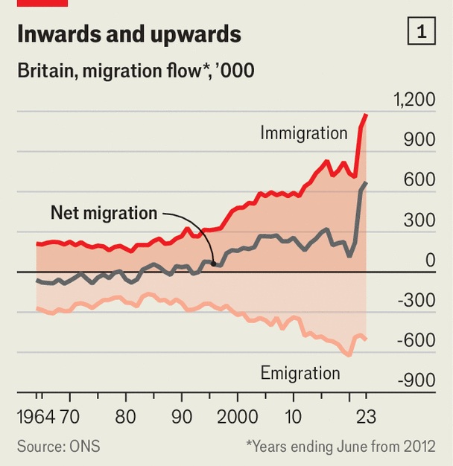

Doc 5
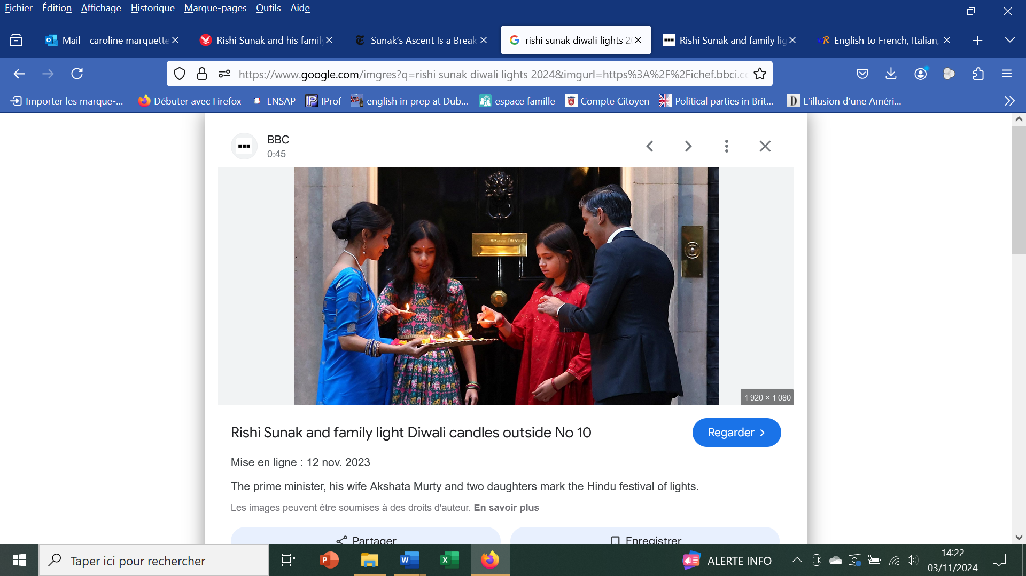
Rishi Sunak and his family light candles outside 10 Downing Street to mark Diwali.
NB: The five days of Diwali are known as the festival of lights, celebrating the triumph of light over darkness and the start of new beginnings for millions of people of the Hindu, Sikh and Jain faiths.

