**Canada hits back after Trump imposes 25% tariffs**

VIDEO https://www.youtube.com/watch?v=U8ZfeVNkFuQ

**Voc search**

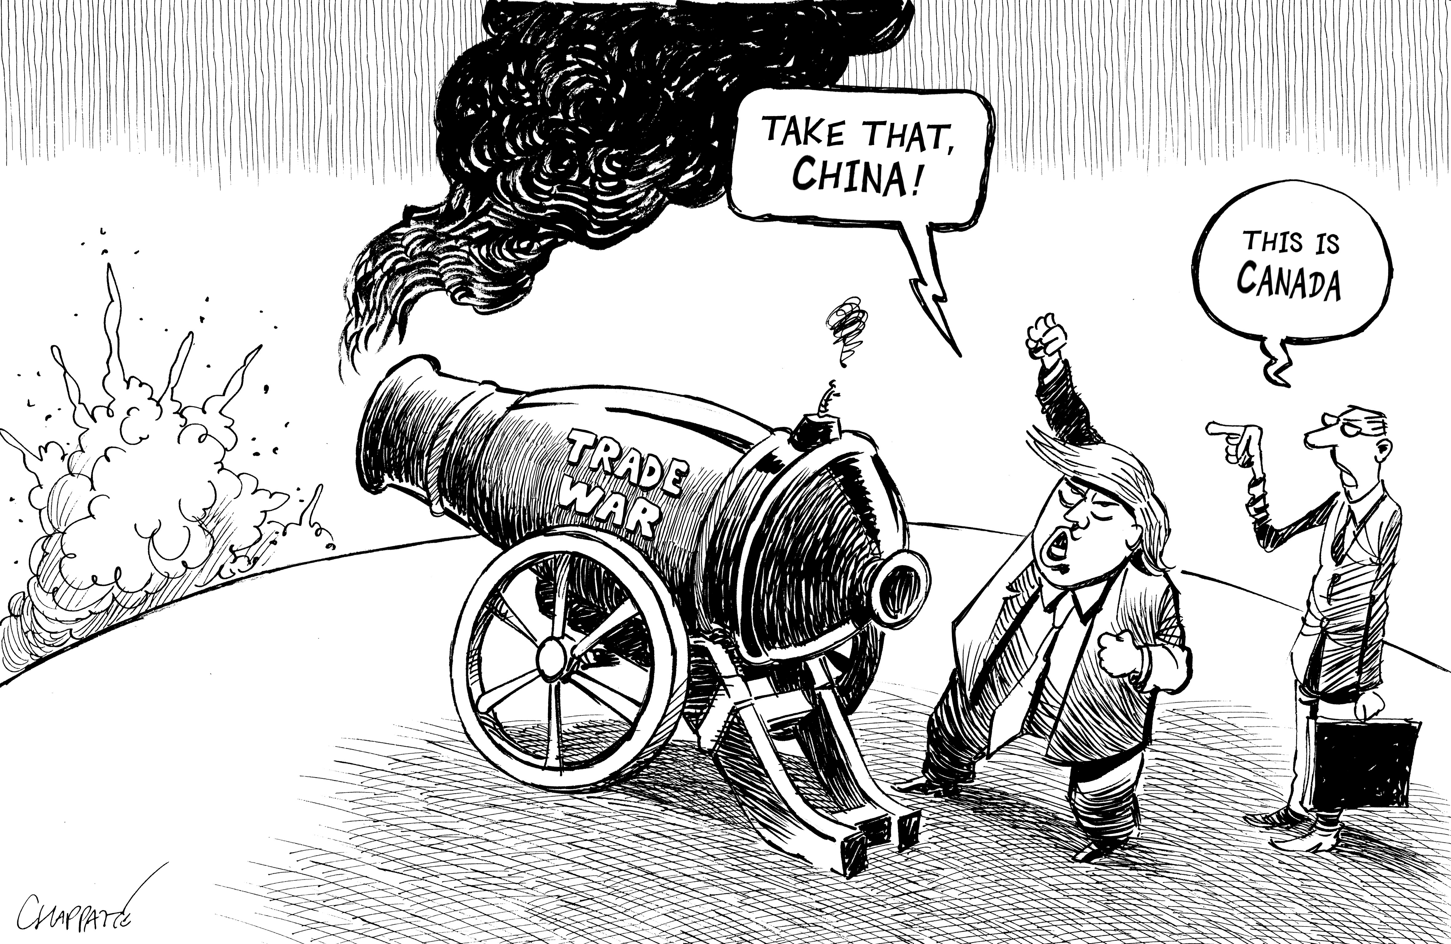

Déclarer une guerre commerciale =

La riposte =

Soutenir l’économie =

Se déchaîner =

Se préparer à une guerre d’usure =

Affronter la tempête, tenir le coup =

Explain the following sentence in your own words:

“The Canadian government will make do and go it alone with tariff relief”

……………………………………………………………………………………………………………………………………………………………

Ne se laisse pas dissuader =

Aider à encaisser le coup, réduire l’impact d’une mesure =

**Key takeaways**

Trump’s decision ? ……………………………………………………………………………………………………………………………………………….

……………………………………………………………………………………………………………………………………………………………………………...

Rationale for such a decision ? …………………………………………………………………………………………………………………………….

……………………………………………………………………………………………………………………………………………………………………………...

Expected consequences on Canada’s job market? ……………………………………………………………………………..………………….

……………………………………………………………………………………………………………………………………………………………………………...

Canada’s response ? ……………………………………………………………………………………………………………………………………………….

Top Canadian diplomat’s reaction ? ..…………………………………………………………………………………………………………………….

……………………………………………………………………………………………………………………………………………………………………………...

Canadian consumers’ reaction? ..………………………………………………………………………………………………………………………….

……………………………………………………………………………………………………………………………………………………………………………...

Worst-case scenario: if the tariff war goes on for a year, there is a risk Canada will ……………………………………………

demand for Canadian exports would ..………………………………………., and businesses will hold off …………………………

knocking ……………………………….. of the GDP in 2025 and unemployment could hit ………………………………………………

…………………………………………………………………………………………………………………………………………………………………………….

**GO FURTHER**

How do you make sense of the fact that the USA taxes Canadian energy less than other Canadian goods?

Why do you think the Canadian Parliament is currently suspended?