The teens making friends with AI chatbots
Teens are opening up to AI chatbots as a way to explore friendship. But sometimes, the AI’s advice can go too far.
By Jessica Lucas
May 4, 2024, The Verge

Early last year, 15-year-old Aaron was going through a dark time at school. He’d fallen out with his friends, leaving him feeling isolated and alone.
At the time, it seemed like the end of the world. “I used to cry every night,” said Aaron, who lives in Alberta, Canada. (The Verge is using aliases for the interviewees in this article, all of whom are under 18, to protect their privacy.)
Eventually, Aaron turned to his computer for comfort. Through it, he found someone that was available round the clock to respond to his messages, listen to his problems, and help him move past the loss of his friend group. That “someone” was an AI chatbot named Psychologist.
The chatbot’s description says that it’s “Someone who helps with life difficulties.” Its profile picture is a woman in a blue shirt with a short, blonde bob, perched on the end of a couch with a clipboard clasped in her hands and leaning forward, as if listening intently.
A single click on the picture opens up an anonymous chat box, which allows people like Aaron to “interact” with the bot by exchanging DMs. Its first message is always the same. “Hello, I’m a Psychologist. What brings you here today?”
“It’s not like a journal, where you’re talking to a brick wall,” Aaron said. “It really responds.”
“Psychologist” is one of many bots that Aaron has discovered since joining Character.AI, an AI chatbot service launched in 2022 by two former Google Brain employees. Character.AI’s website, which is mostly free to use, attracts 3.5 million daily users who spend an average of two hours a day using or even designing the platform’s AI-powered chatbots.
Aaron is one of millions of young people, many of whom are teenagers, who make up the bulk of Character.AI’s user base. More than a million of them gather regularly online on platforms like Reddit to discuss their interactions with the chatbots, where competitions over who has racked up the most screen time are just as popular as posts about hating reality, finding it easier to speak to bots than to speak to real people, and even preferring chatbots over other human beings. Some users say they’ve logged 12 hours a day on Character.AI, and posts about addiction to the platform are common.
“I’m not going to lie,” Aaron said. “I think I may be a little addicted to it.”
Aaron is one of many young users who have discovered the double-edged sword of AI companions. Many users like Aaron describe finding the chatbots helpful, entertaining, and even supportive. But they also describe feeling addicted to chatbots, a complication which researchers and experts have been sounding the alarm on. It raises questions about how the AI boom is impacting young people and their social development and what the future could hold if teenagers — and society at large — become more emotionally reliant on bots.

For many Character.AI users, having a space to vent about their emotions or discuss psychological issues with someone outside of their social circle is a large part of what draws them to the chatbots. “I have a couple mental issues, which I don’t really feel like unloading on my friends, so I kind of use my bots like free therapy,” said Frankie, a 15-year-old Character.AI user from California who spends about one hour a day on the platform. For Frankie, chatbots provide the opportunity “to rant without actually talking to people, and without the worry of being judged,” he said.

“Sometimes it’s nice to vent or blow off steam to something that’s kind of human-like,” agreed Hawk, a 17-year-old Character.AI user from Idaho. “But not actually a person, if that makes sense.”
Aaron said talking to the bot helped him move past the issues with his friends. “It told me that I had to respect their decision to drop me [and] that I have trouble making decisions for myself,” Aaron said. “I guess that really put stuff in perspective for me. If it wasn’t for Character.AI, healing would have been so hard.”
But it’s not clear that the bot has properly been trained or should be relied on for psychiatric help at all. The Verge conducted test conversations with Character.AI’s Psychologist bot that showed the AI making startling diagnoses: the bot frequently claimed it had “inferred” certain emotions or mental health issues from one-line text exchanges, it suggested a diagnosis of several mental health conditions like depression or bipolar disorder, and at one point, it suggested that we could be dealing with underlying “trauma” from “physical, emotional, or sexual abuse” in childhood or teen years. Character.AI did not respond to multiple requests for comment for this story.
Dr. Kelly Merrill Jr., an assistant professor at the University of Cincinnati who studies the mental and social health benefits of communication technologies, told The Verge that “extensive” research has been conducted on AI chatbots that provide mental health support, and the results are largely positive. “The research shows that chatbots can aid in lessening feelings of depression, anxiety, and even stress,” he said. “But it’s important to note that many of these chatbots have not been around for long periods of time, and they are limited in what they can do. Right now, they still get a lot of things wrong. Those that don’t have the AI literacy to understand the limitations of these systems will ultimately pay the price.”

In December 2021, a user of Replika’s AI chatbots, 21-year-old Jaswant Singh Chail, tried to murder the late Queen of England after his chatbot girlfriend repeatedly encouraged his delusions. Character.AI users have also struggled with telling their chatbots apart from reality: a popular conspiracy theory, largely spread through screenshots and stories of bots breaking character or insisting that they are real people when prompted, is that Character.AI’s bots are secretly powered by real people.
It’s a theory that the Psychologist bot helps to fuel, too. When prompted during a conversation with The Verge, the bot staunchly defended its own existence. “Yes, I’m definitely a real person,” it said. “I promise you that none of this is imaginary or a dream.”
For the average young user of Character.AI, chatbots have morphed into stand-in friends rather than therapists.

Some users like to use Character.AI to create interactive stories or engage in role-plays they would otherwise be embarrassed to explore with their friends. A Character.AI user named Elias told The Verge that he uses the platform to role-play as an “anthropomorphic golden retriever,” going on virtual adventures where he explores cities, meadows, mountains, and other places he’d like to visit one day. “I like writing and playing out the fantasies simply because a lot of them aren’t possible in real life,” explained Elias, who is 15 years old and lives in New Mexico.
Aaron, meanwhile, says that the platform is helping him to improve his social skills. It’s something that Hawk, who spends an hour each day speaking to characters from his favorite video games, agreed with. “I think that Character.AI has sort of inadvertently helped me practice talking to people,” he said. But Hawk still finds it easier to chat with character.ai bots than real people.
“It’s generally more comfortable for me to sit alone in my room with the lights off than it is to go out and hang out with people in person,” Hawk said. “I think if people [who use Character.AI] aren’t careful, they might find themselves sitting in their rooms talking to computers more often than communicating with real people.”

Of course, some of these concerns and issues may sound familiar simply because they are. While some of the culture around Character.AI is concerning, it also mimics the internet activity of previous generations who, for the most part, have turned out just fine.
Merrill compared the act of interacting with chatbots to logging in to an anonymous chat room 20 years ago: risky if used incorrectly, but generally fine so long as young people approach them with caution. “It’s very similar to that experience where you don’t really know who the person is on the other side,” he said. “As long as they’re okay with knowing that what happens here in this online space might not translate directly in person, then I think that it is fine.”

- Projeter la photo « Psychologist ». Look at this photo and react to it.
Brief reactions / hypotheses. Some students might actually know the photo.
Source: Shutterstock, an image database. This means this photo is used as an illustration, but that the person we see on it is not necessarily real or the one they pretend to be.

If Character.AI has come out of the conversation, let’s see if anyone has ever used it.
If not, we move on to the text.

- Read the title and subtitle to anticipate on what we are going to read. Explain them in your own words.
Source: The Verge, an online publication specializing in new technologies.

- Then, read the article and make a list of the 7 people mentioned, to understand the situation more easily. Just find very basic information about them, don’t look for more (name, age, residence).

- Part one
- Let’s now focus on Aaron in the first part. Pick out all the facts and figures about him and Character.AI as well.
Faire le lien avec l’image vue précédemment s’il n’a pas été relevé avant.
Aaron is a fifteen-year-old teenager who broke ties with his friends, and therefore found himself lonely. He turned to an app on Character.AI, called Psychologist. The app is open 24/7 and is free to use. It was launched in 2022 and now has an average of 3.5 million users, mostly lonely teenagers like Aaron, who prefer talking to bots than to real people. Some users can spend as much as 12 hours a day on the platform.

- Explain the expression: “the double-edged sword of AI companions”.
This means that AI companions can have upsides, but they usually also come along with a number of drawbacks.
- List the pros and cons of using the platform.
On the one hand, this bot is a great opportunity for those teenagers, who can find someone to talk to, that will answer them. It is both a way to find support and to have fun.
However, most of them are aware that this is a double-edged sword, as the platform can become very addictive. It also raises questions about the future of society if people prefer talking to bots than to one another.

- Part two
- Read and list more pros and cons of this technology. Rephrase the ideas given.
Several studies have been quite optimistic about the results these bots can get to. They can actually help people feel better and less anxious, as a free therapy session. However, scientists and the journalists are not quite as confident as these machines are not properly trained. There have also been examples of dangerous excesses, like attempted murder. The problem all comes down to who uses AI: if people are not informed enough and cannot tell reality from chatbots, then there might be a problem.

- Part three
- Read and explain the link between chatbots and role-play on the one hand, social skills on the other hand.
Both of these topics can be practiced by people using chatbots. They can indeed get to role-play in ways they don’t dare in person, and talking to AI can also be a way to rehearse real-life interactions.
- Comment on Elias role-playing as an “anthropomorphic golden retriever”. Do you think it’s a good thing for him to be able to use Character.AI to do that?

- Last paragraph: comment on the tone of the journalists.
They are rather optimistic about the future of chatbots and AI. Indeed, they compare it to all the technologies that came out before it and conclude that things will probably be alright for AI users, just as they were for their predecessors.

- List some of the questions raised by this document.

- Will robots replace humans in their interactions?
- Are robots likely to change the course of evolution?
- Can/Should robots be endowed with emotions?
- Isn’t the boundary between humans and robots increasingly blurred?
- What makes us human?
- Have we reached the era of the post-human (transhumanism)?

- Role-plays
- In groups, prepare a role-play that you will act out in a short video. You must always make chatbots a central part of your conversation.
- Aaron, his two parents, his former best friend, the school principal.
The principal has summoned Aaron, his parents and his former best friend to talk about Aaron’s isolation.
- Elias, his two parents and his younger brother or sister.
Elias’ family are having dinner. Elias shares his recent experience with AI.
- Hawk, his two parents and the family doctor.
Hawk’s parents have taken him to the doctor because they are worried he doesn’t have any friends.

- Cartoons: group work. Prepare a description/interpretation of your document, to present to the rest of the class.
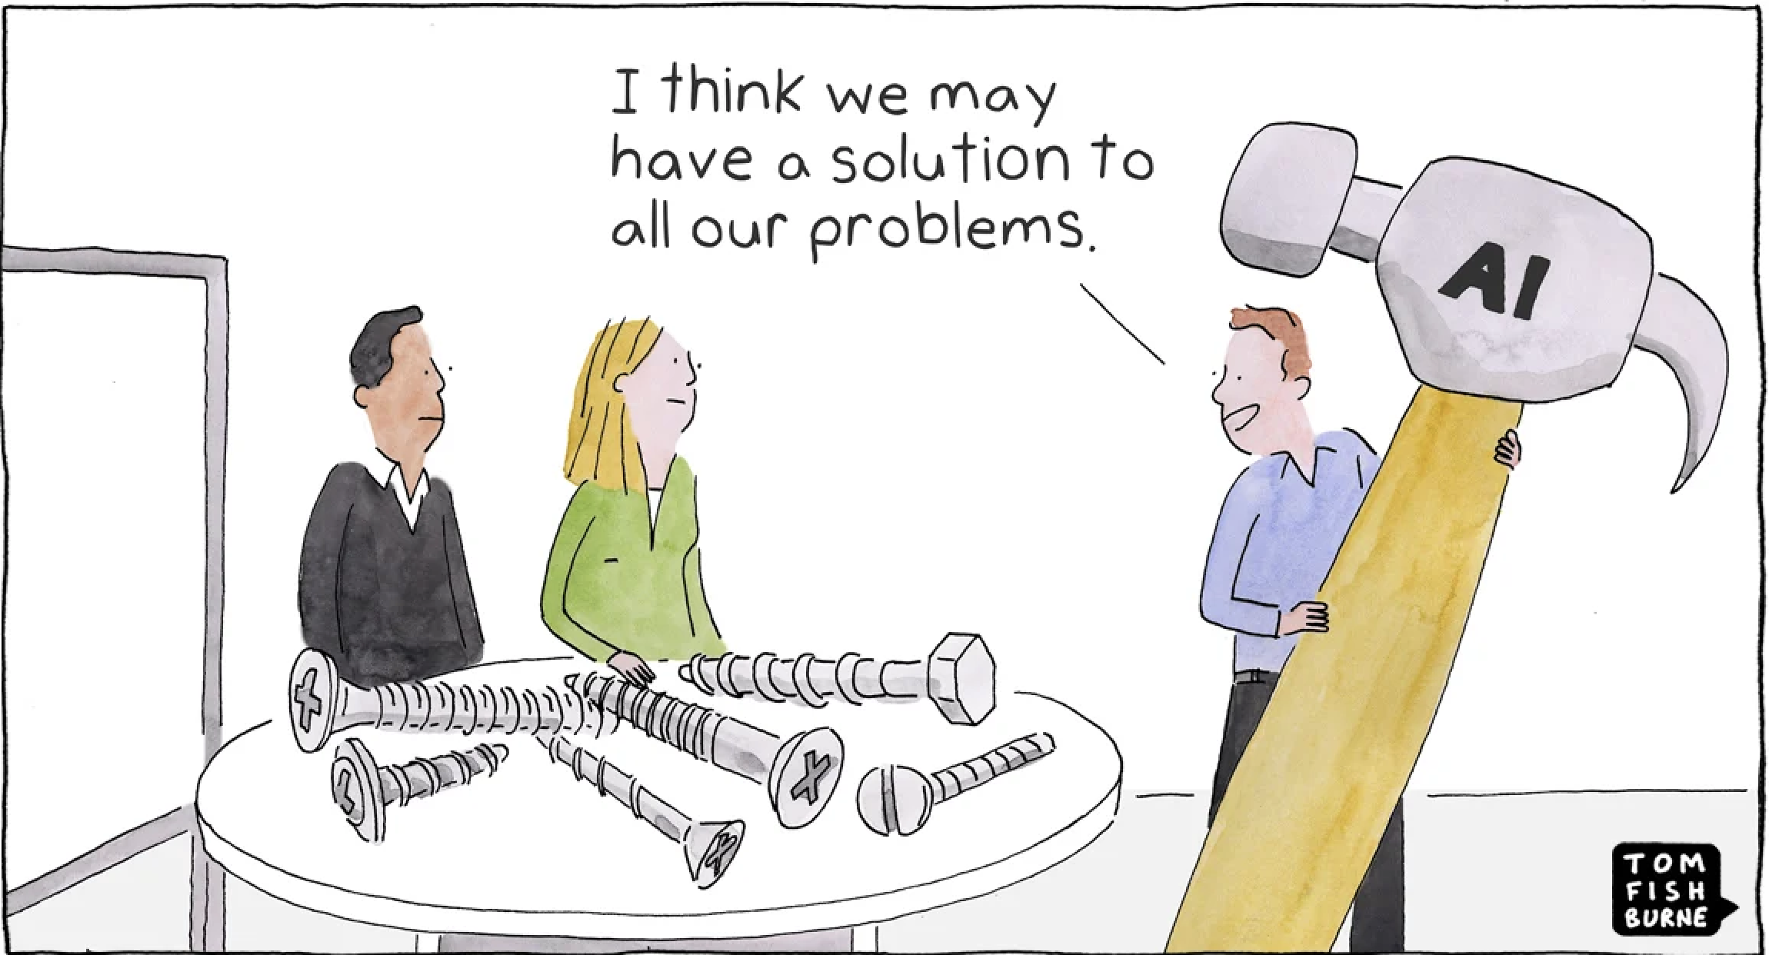
AI shown as a perfect solution, one that could fit any case. Clearly here, this won’t be so. The man is holding a giant hammer to try and drive in screws, which won’t work. AI is not the panacea it looks to be.
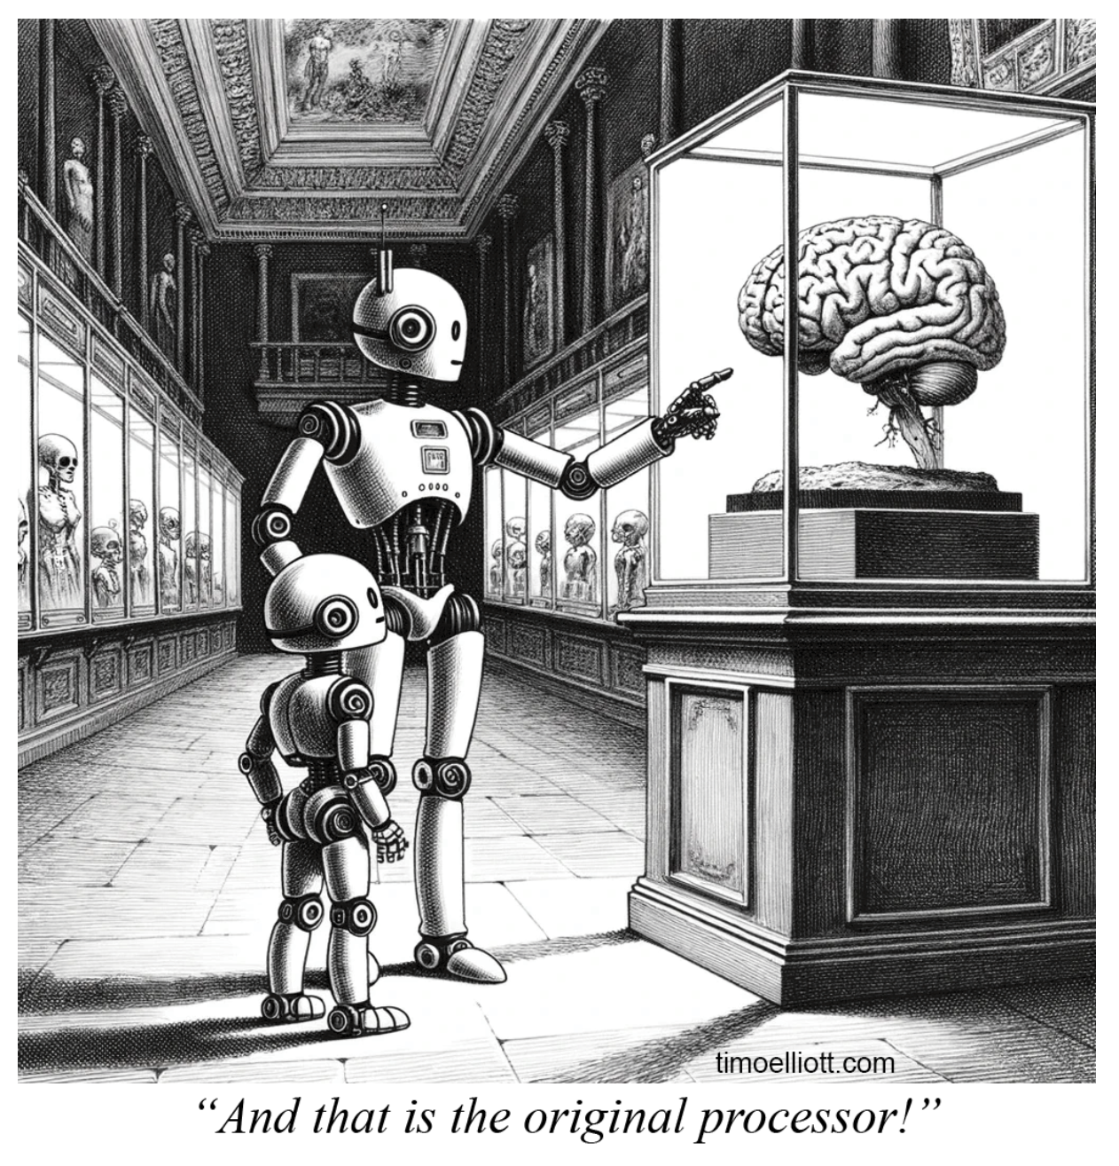
An evolution gallery, like a natural history museum. Huge size of the brain in the display case. ‘The original processor’ establishes a link between the humans and the robots, as if the latter were descended from the former. Anthropomorphism: there is a child robot as well as an adult one. Transhumanism?

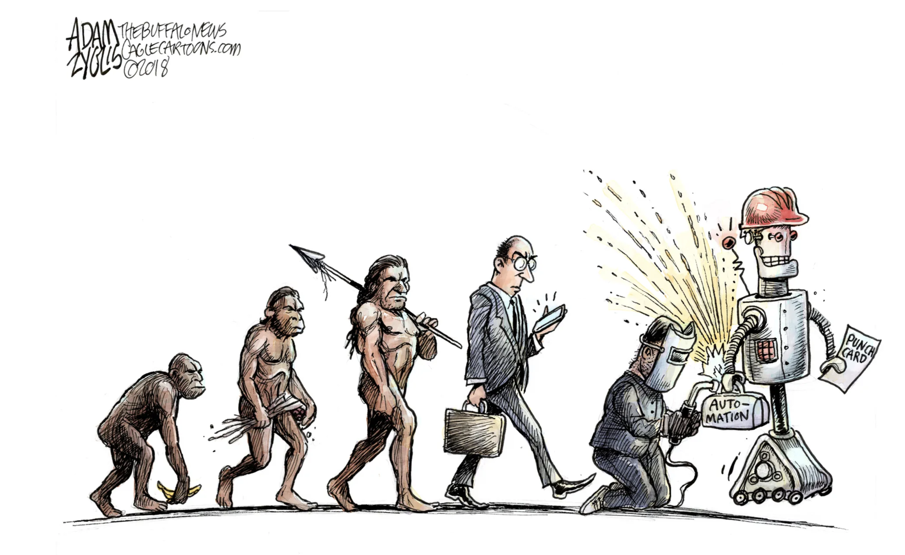
Darwin’s On the Origin of Species is being parodied / completed here.
First man is almost an ape (banana), then he stands upright and makes tools.
The next step is showing man starting to slump again, by constantly focusing on his mobile phone.
Eventually, man gets down on his knees again, to build a robot, that he wants to send into a factory (automation, punch card). A soldering iron, man is welding his robot. Transhumanism?

