DS 1- ECT2 – 4 octobre 2025– Anglais LVB Mme Missaghi Haritoonian

Sujet Type BCE - ELVi 4h

Ce sujet comporte les 5 documents suivants:

- Document 1: AI is starting to wear down democracy - The New York Times, June 26, 2025
- Document 2: AI, Democracy, And Jobs - Forbes, September 24, 2025
- Document 3: L’IA peut améliorer les institutions démocratiques en permettant aux citoyens de vraiment faire entendre leur voix - Fonds Monétaire International - décembre 2023
- Document 4: AI in Politics, The Washington Post, November 30, 2023
- Document 5: Survey on the impact of Online disinformation and hate speech - Ipsos, September 2023

- Résumé analytique comparatif

Répondre dans la langue cible à la question posée en 250 mots (+/- 10%) en identifiant et en comparant les informations pertinentes dans les documents 1 et 2, sans commentaire personnel ni paraphrase.

According to Document 1 and Document 2, to what extent does AI threaten democracy?

- Expression personnelle: essai argumenté

Répondre dans la langue cible à la question posée en 400 mots (+ ou - 10%), en réagissant au contenu du dossier, sans paraphraser celui-ci, tout en développant son opinion personnelle. Vous devez illustrer votre argumentation avec des exemples culturels, civilisationnels et/ou historiques du monde anglophone.

In your opinion, can society survive the disruptive power of AI?

- Traduction du français en anglais (thème)

Traduire uniquement la partie du texte indiquée en français en gras et entre crochets [...]

Traduire du français en anglais de <<L’opinion>> à <<avoir>>

Document 1:

A.I. Is Starting to Wear Down Democracy, Steven Lee Myers and Stuart A. Thompson, The New York Times, June 26, 2025

Since the explosion of generative artificial intelligence over the last two years, the technology has demeaned or defamed opponents and, for the first time, officials and experts said, begun to have an impact on election results.

Free and easy to use, A.I. tools have generated a flood of fake photos and videos of candidates or supporters saying things they did not or appearing in places they were not — all spread with the relative impunity of anonymity online.

The technology has amplified social and partisan divisions and bolstered antigovernment sentiment, especially on the far right, which has surged in recent elections in Germany, Poland and Portugal.

In Romania, a Russian influence operation using A.I. tainted the first round of last year’s presidential election, according to government officials. A court there nullified that result, forcing a new vote last month and bringing a new wave of fabrications. It was the first major election in which A.I. played a decisive role in the outcome. It is unlikely to be the last.
In the unusually concentrated wave of elections that took place in 2024, A.I. was used in more than 80 percent, according to the International Panel on the Information Environment, an independent organization of scientists based in Switzerland.
In India, the practice of cloning candidates became commonplace — “not only to reach voters but also to motivate party workers,” according to a study by the Center for Media Engagement at the University of Texas at Austin.

At the same time, however, dozens of deepfakes — photographs or videos that recreate real people — used A.I. to clone voices of candidates or news broadcasts. According to the International Panel on the Information Environment’s survey, A.I. was characterized as having a harmful role in 69 percent of the cases.

There were numerous malign examples in last year’s American presidential election, prompting public warnings by officials at the Cybersecurity and Infrastructure Security Agency, the Office of the Director of National Intelligence and the Federal Bureau of Investigation.
The most intensive deceptive uses of A.I. have come from autocratic countries seeking to interfere in elections outside their borders, like Russia, China and Iran. The technology has allowed them to amplify support for candidates more pliant to their worldview — or simply to discredit the idea of democratic governance itself as an inferior political system.

One Russian campaign tried to stoke anti-Ukraine sentiment before last month’s presidential election in Poland, where many Ukrainian refugees have relocated. It created fake videos that suggested the Ukrainians were planning attacks to disrupt the voting.
Saman Nazari, a researcher with the Alliance 4 Europe, an organization that studies digital threats to democracies, said this year’s elections in Germany and Poland showed for the first time how effective the technology had become for foreign campaigns, as well as domestic political parties.

“A.I. will have a significant impact on democracy going forward,” he said.
The major social media platforms, including Facebook, X, YouTube and TikTok, have policies governing the misuse of A.I. and have taken action in several cases that involved elections. At the same time, they are operated by companies with a vested interest in anything that keeps users scrolling, according to researchers who say the platforms should do more to restrict misleading or harmful content.
This month, the company disclosed that it had detected a Russian influence operation that used ChatGPT during Germany’s election in February. In one instance, the operation created a bot account on X that amassed 27,000 followers and posted content in support of the far-right party, Alternative for Germany, or AfD. The party, once viewed as fringe, surged into second place, doubling the number of its seats in Parliament.

Document 2:

AI, Democracy, And Jobs, John Werner, Forbes, September 24, 2025

We know intuitively that many people distrust AI. But why? Is it because of job displacement, or something else? And how big will the cycle of job displacement be? How many jobs will be ultimately lost to AI?

These are largely unanswered questions at this point. We don’t know exactly how the biggest tech transformation of our lifetime is going to play out. Recent BLS stats show jobs are dropping – but is that because of AI?
One major concern is that people are going to “fight back” against AI basically out of their own self-interests.
“AI might get a lot more human-like, or we might just not care that it's only simulating something like empathy,” says NPR Correspondent Sally Helm.

But there’s also another kind of anxiety around the capabilities of LLMs: namely, that with the power of AI to create misinformation, a right-wing populist movement may be able to use it for campaigns that are the stock in trade of authoritarian models.
“In the next decade and beyond, our caudillo syndrome, together with AI’s disruptive nature, will only make governance that much more difficult. Here, my research leads me to believe we are entering a ‘populist super-cycle’ that could last years, as belief that the system is broken continues to trend upward. We should expect increasingly more contested elections around the world, further sowing the seeds of distrust.” (For reference, with “caudillo syndrome,” Young is talking about a concept of a strong leader retrieving power from an order that doesn’t seem to have popular backing.)

About a decade ago, I got really interested in the rise of populism,” said Noreena Hertz, an author on AI and jobs. “Why were people voting, across the world, for these right-wing populist leaders? I started researching it, and one of the key drivers was, it turned out, automation.”

A lot of this fear, she indicated, is still pretty theoretical.

“What was really interesting was, it wasn’t necessarily that people voting for right-wing populists had had their jobs taken away by automation, but they were very scared that their jobs would be taken away by automation. So when I think about what’s happening now, and where we’re at today, one of the things that’s on my mind is, are we going to see a populist uprising? With AI as its focus? … a populist uprising on the left, not the right. Because what makes this potential set of job dislocations very different, of course, is that it's white collar workers who are likely to be dislocated, rather than blue collar workers.”

Hertz spoke to what she called a “cadre” of left-wing political leaders speaking to people about AI.

“They are already speaking about this very clearly, when you look at their rhetoric about AI and jobs. So are we moving into a situation where, if we do nothing about it, where, instead of, let's say, immigrants being the ‘other’ and being under attack by populists, it will be people here, the tech elite, facing the ire?”

That was by no means the sole focus of the panel. Some pretty great people in AI talked about opportunity, too, and about how to gird the workforce with what it needs to thrive.

But we have to look at the challenges, too. We have to look with clear eyes at human response, at how human workers will be affected. For instance, there’s data out there suggesting that women will be less served by tools that allow workers to skill up and manage AI, which panelists agreed workers will need to do.

Document 3:

L’IA peut améliorer les institutions démocratiques en permettant aux citoyens de vraiment faire entendre leur voix - Hélène Landmore, Fonds Monétaire International, décembre 2023

[L’opinion redoute que l’intelligence artificielle (IA) ne soit en train de saper la démocratie ou s’apprête à le faire. L’IA risquerait de supprimer des emplois, de déstabiliser l’économie et de creuser le fossé entre riches et pauvres. Elle serait aussi susceptible de renforcer la concentration du pouvoir au sein d’une poignée d’entreprises technologiques et d’affaiblir les structures étatiques destinées à réglementer le secteur. Certains craignent en outre que les géants de la technologie et les États ne délèguent de plus en plus le pouvoir de décision aux machines, pour finir par substituer une « algocratie » à la démocratie, les règles n’étant alors plus définies par le peuple, mais par des algorithmes.

Cette vision dystopique fait fi de notre capacité actuelle à orienter le développement de l’IA. En tant que sociétés humaines, nous avons la capacité politique (du moins pour le moment) et la responsabilité de remédier aux effets préjudiciables que l’IA pourrait avoir.] La technologie nous offre aussi la possibilité d’exploiter l’IA pour améliorer notre démocratie de telle sorte que nous soyons collectivement plus en mesure d’administrer, et pas simplement de réglementer, l’IA.

À l’instar d’autres défis éthiques et politiques, comme la modification du génome, la gouvernance de l’IA ne réclame pas uniquement plus d’interventions des experts et un surcroît de réglementation, mais davantage d’expression et de participation citoyennes, par exemple pour décider de la façon dont nous gérerons les effets distributifs de l’IA sur l’économie. Comme d’autres sujets de préoccupation mondiaux, tels que le changement climatique, la bonne gouvernance de l’IA exige que cette voix démocratique soit entendue au niveau des institutions internationales. Par chance, l’IA peut promouvoir une forme de démocratie plus inclusive, participative et délibérative, y compris à l’échelle planétaire.

Document 4:

Cartoon by Jimmy Margulies, The Washinton Post, November 30, 2023
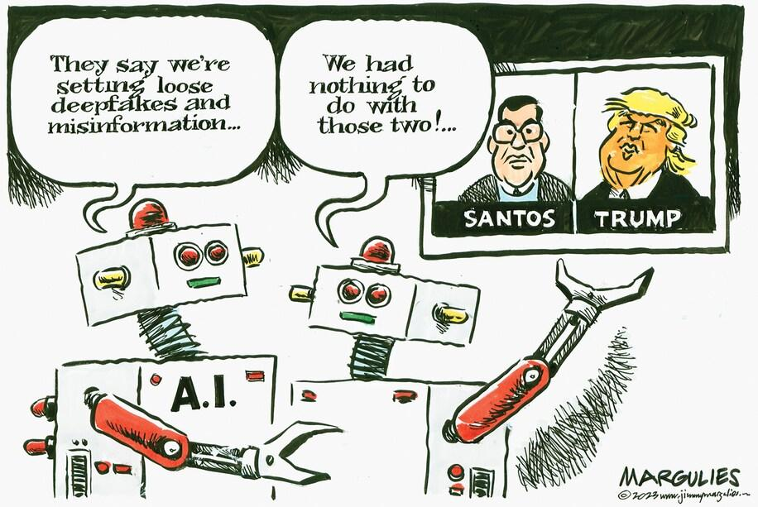

Document 5:

Survey on the impact of Online disinformation and hate speech - Ipsos , September 2023

People's faith in themselves to distinguish real and fake news vs their belief in the average person in their country to do the same.
