DS 2- ECT2 – 17 janvier 2026 – Anglais LVA Mme Missaghi Haritoonian

Ce cahier comporte 2 sujets :

- un sujet de type BCE - ELVi (pages 1 à 7)

Ecoles concernées : Audencia, Brest Business School, Burgundy School of Business, EDHEC Business School, Emlyon business school, Clermont school of Business, ESCP, ESSEC, Excelia, Grenoble Ecole de Management, HEC Paris, ICN, INSEEC, Institut Mines-Télécom Business School, ISC, SKEMA, South Champagne Business School, TBS Education.

- un sujet de type ECRICOME (page 8)

Ecoles concernées : EM Strasbourg, Montpellier Business School, Kedge, Neoma, Rennes School of Business

Vous traiterez un des 2 sujets au choix. Vous pourrez rendre vos copies au plus tôt 30 mn avant la fin de l’épreuve. Aucun document n’est autorisé.

Sujet Type BCE - ELVi 4h

Ce sujet comporte les 5 documents suivants:

- Document 1: Elon Musk’s speech to far-right rally should have us all thinking about the power social media companies hold over our democracies, The Conversation, Sept 19, 2025.
- Document 2: They Seek to Curb Online Hate. The U.S. Accuses Them of Censorship, The New York Times, Dec 24, 2025.
- Document 3: Sortir du Far West numérique : une stratégie européenne dans l’âge sombre de la Silicon Valley, Le Grand Continent, 20 nov 2025.
- Document 4: Big Tech is the most profitable and valuable industry, Forbes Global, 2021
- Document 5: Cartoon: The Algorithm did it, Patrick Chappatte, Oct 10, 2021.

- Résumé analytique comparatif

Répondre dans la langue cible à la question posée en 350 mots (+/- 10%) en identifiant et en comparant les informations pertinentes dans les documents 1 et 2, sans commentaire personnel ni paraphrase.

According to Documents 1 and 2, how does Big Tech affect democracy?

- Expression personnelle: essai argumenté

Répondre dans la langue cible à la question posée en 500 mots (+ ou - 10%), en réagissant au contenu du dossier, sans paraphraser celui-ci, tout en développant son opinion personnelle. Vous devez illustrer votre argumentation avec des exemples culturels, civilisationnels et/ou historiques du monde anglophone.

In your opinion, is it possible for democracies to find a common response to the challenges posed by Big Tech?

- Traduction du français en anglais (thème)

Traduire uniquement la partie du texte indiquée en français en gras et entre crochets [...]

Traduire du français en anglais de << Grâce >> à <<déresponsabilisation>.

Document 1:

Elon Musk’s speech to far-right rally should have us all thinking about the power social media companies hold over our democracies, Verena K.Brandle, The Conversation, Sept 19, 2025.

Elon Musk seems to enjoy awkward surprise appearances. Joining a far-right rally in London via livestream, he demanded the “dissolution” of the British parliament, falsely linked immigration to violence, and warned that the only option for protesters was to “fight back” or “die”.

He did similar in January 2025 when he joined a campaign event of the German far-right party Alternative for Germany (AfD). Again over video he told supporters that “the German people are really an ancient nation” and the AfD is “the best hope for the future of Germany”.

It appears that the currently second-richest person in the world has become a mascot for the European far-right. In 2022, Musk bought one of the major social media platforms, then Twitter, to promote “free speech”. He stepped right into the ongoing “culture war” that is currently polarising US politics and finding traction across Europe. This makes him a problem for democratic politics.

The combination of massive wealth, far-right ideology and power over a large share of public discourse is a recurrent issue for democracy in general, but its negative effects have become even more prevalent in the age of social media. Two aspects are of particular importance here: social media companies’ monetising of user data and a dependence of democratic politics on platform discourse.

Social media runs on an advertisement-based revenue model. Every click or lingering over a post produces data and metadata which are a lucrative resource. Social media companies make a lion’s share of their revenue from charging advertisers to show ads to specific users based on such data. Some of us might remember Mark Zuckerberg replying “Senator, we run ads” when asked during testimony before the US Senate in 2018 how he made money without charging users for his services.

Importantly, advertisers do not only come in the form of clothing brands, restaurant chains and protein shakes. Political parties, governments, think-tanks, and foundations have all paid for ads on social media.
Studies show that social media has contributed to political polarisation during crucial political moments such as Brexit. It also harms democratic discourse when it facilitates online abuse that excludes already minoritised groups from democratic debate. Too often, such abuse is directed at minority women and girls as well as LGBTQ+ people.

Meta has followed X’s turn towards a right-leaning interpretation of “free speech”. It has abolished its third party fact-checking programme, widely credited with helping to manage disinformation.
Meanwhile, politicians across Europe struggle to decide what to do about Musk’s destabilising comments. Keep in mind that governments are doing (or thinking about doing) business with big tech leaders. This situation is politically complex, to say the least, because Musk and others, while being outspoken about their annoyance with aspects of democracy, are also at the forefront of developing the AI technologies many nations are relying on in their hope for economic growth.

This means that Musk has cracked the code for success in capitalist democracies: he makes the headlines with extreme statements, allows debates to unfold “freely” on his platform, and makes some of his money from the generated data.

This situation has created a strange relationship between democratic politics and social media leaders. For people like Musk, there is almost an economic incentive to engage in politics, riling up people and pressuring governments. He is both a business leader and a political actor.

“Free speech” regulations on social media platforms and their leaders’ political stances are increasingly at odds with democratic guidelines. Democracies need to have a more focused debate about how to minimise this incentive structure for destabilising politics.

Document 2:

They Seek to Curb Online Hate. The U.S. Accuses Them of Censorship, Adam Satariano, The New York Times, Dec 24, 2025.

Josephine Ballon and Anna-Lena von Hodenberg lead a German legal aid organization that assists individuals facing online abuse and violent threats.
Clare Melford runs a British group that helps identify disinformation.
Imran Ahmed is a British activist who runs an organization that has chronicled anti-vaccination content on social media.
On Tuesday, the Trump administration accused all of them of a campaign of censorship against Americans.

The four individuals, along with a former senior European Commission official, Thierry Breton of France, were barred from entering the United States after Secretary of State Marco Rubio labeled them “radical activists” who undercut free speech.
On Wednesday, European officials including President Emmanuel Macron of France criticized the Trump administration’s decision.

“These measures amount to intimidation and coercion aimed at undermining European digital sovereignty,” Mr. Macron said on social media. “The rules governing the European Union’s digital space are not meant to be determined outside Europe.”

Thomas Régnier, a spokesman for the European Commission, said, “Our digital rules ensure a safe, fair and level playing field for all companies, applied fairly and without discrimination.”

The travel ban is a major escalation in a dispute between the Trump administration and Europe over the regulation of online content and social media.

In the United States, free speech protections allow social media companies to set their own content policies. And Mr. Trump and others on the right have successfully pushed social media firms to roll back moderation rules that they viewed as silencing conservative voices.
In Britain and the European Union, there are certain restrictions on hate speech and open bigotry. In 2022, the European Union passed a law called the Digital Services Act that requires social media companies to meet transparency standards and to remove certain racist, antisemitic and violent content if it violates national laws.

The Trump administration sees the Digital Services Act as an attempt to force American platforms to censor speech globally — an allegation European officials deny.

The issue came to a head this month when the European Commission, the executive branch of the European Union, fined Elon Musk’s social media platform X $140 million. The commission said that the site had violated the Digital Services Act by selling verification check marks that allow users to mislead others about their identities, by maintaining opaque advertising practices and by refusing to provide researchers with data access. In response, Mr. Musk said the European Union should be abolished.

Mr. Breton helped draft the digital services law when he was a European commissioner overseeing digital policy.

The other individuals facing a travel ban were involved in nonprofit organizations that the Trump administration accused of targeting American social media companies and users.
Ms. Ballon, co-chief executive of HateAid, a German group that assists victims of online attacks, said she received an email on Tuesday notifying her that her visa had been revoked.
HateAid, founded in 2018, provides counseling, safety advice and litigation financing to help victims of online attacks take legal action against perpetrators. The group, which Ms. Ballon runs with Ms. von Hodenberg, also lobbies for stronger regulation of social media companies in Germany and the rest of the European Union.

Ms. Ballon and Ms. von Hodenberg said in a statement, “We will not be intimidated by a government that uses accusations of censorship to silence those who stand up for human rights and freedom of expression.”

Ms. Melford runs the Global Disinformation Index, a group that provides risk ratings to advertising firms to help them avoid placing ads on websites seen as spreading disinformation and harmful content. In a statement, the group called the travel ban “an authoritarian attack on free speech and an egregious act of government censorship.”

Mr. Ahmed is the chief executive of the Center for Countering Digital Hate, which has teams in Britain and the United States. Mr. Musk sued the group in 2023 after the organization documented a rise in hate speech on Twitter following his acquisition of the platform, which is now called X. An American court dismissed the lawsuit last year as a violation of the right to free speech.

Document 3:

Sortir du Far West numérique : une stratégie européenne dans l’âge sombre de la Silicon Valley, Milena Harito, Le Grand Continent, 20 nov 2025.

Depuis une dizaine d’années, nous vivons sous l’emprise d’une puissance numérique qui ne cesse de s’étendre. Une grande partie de nos pensées, de nos échanges, de nos désirs, de nos opinions, est désormais répertoriée, détenue et monétisée par cinq géants américains.

Nos recherches sur Google ont d’abord alimenté des revenus publicitaires ; puis, à partir de 2004, nos courriels, nos documents, nos photos, ont été absorbés par des outils intégrés, transformant chaque interaction en donnée exploitable.

En une décennie, le pouvoir des Big Tech, des entreprises toutes extra-européennes, s’est installé dans chaque composante de notre infrastructure numérique et de nos données. De 2015 à 2025, leur emprise ne cesse de s’étendre, consolidant leur domination.

Face à ces géants du numérique, plus personne ne semble détenir de légitimité.
La possession par ces entreprises de l’infrastructure numérique confère un pouvoir économique et idéologique sans précédent sur les citoyens et les pays européens.

La domination économique est plus importante qu’on ne croit : sous les 264 milliards d’euros de dépenses directes de l’Europe pour ces services se cache une extraction de valeur encore plus importante, qualifiée par certains de techno-féodalisme.

[Grâce à l’effet d’échelle et à leur quasi-monopole, ces plateformes bâtissent une économie de rente : Amazon capte une part de chaque vente sur sa plateforme, à coût marginal proche de zéro. Airbnb, Uber, fonctionnent sur le même principe d’échelle, de monopole et de rente. Leur puissance financière leur permet d’éliminer toute concurrence potentielle, consolidant ainsi leur domination.

La force de ces plateformes est aussi idéologique : via leurs algorithmes, elles exercent une influence politique considérable. La propagande, la haine, la manipulation électorale, tout cela s’appuie sur un pouvoir algorithmique qui échappe à tout contrôle.

Elon Musk, en achetant Twitter pour 43 milliards de dollars en 2022 ; a mis un chiffre sur ce pouvoir immense d’influence dans de nombreux pays. Ses interventions personnelles dans les élections au Royaume-Uni, en Allemagne ou en Moldavie illustrent la menace directe que représente cette influence.

Alors que ce pouvoir des plateformes commence à effacer celui des médias traditionnels, leur responsabilité est diluée, invisible, dissimulée derrière des algorithmes et des comptes anonymes.
La liberté d’expression a graduellement glissé jusqu’au droit à l’anonymat et à la déresponsabilisation.]
Document 4

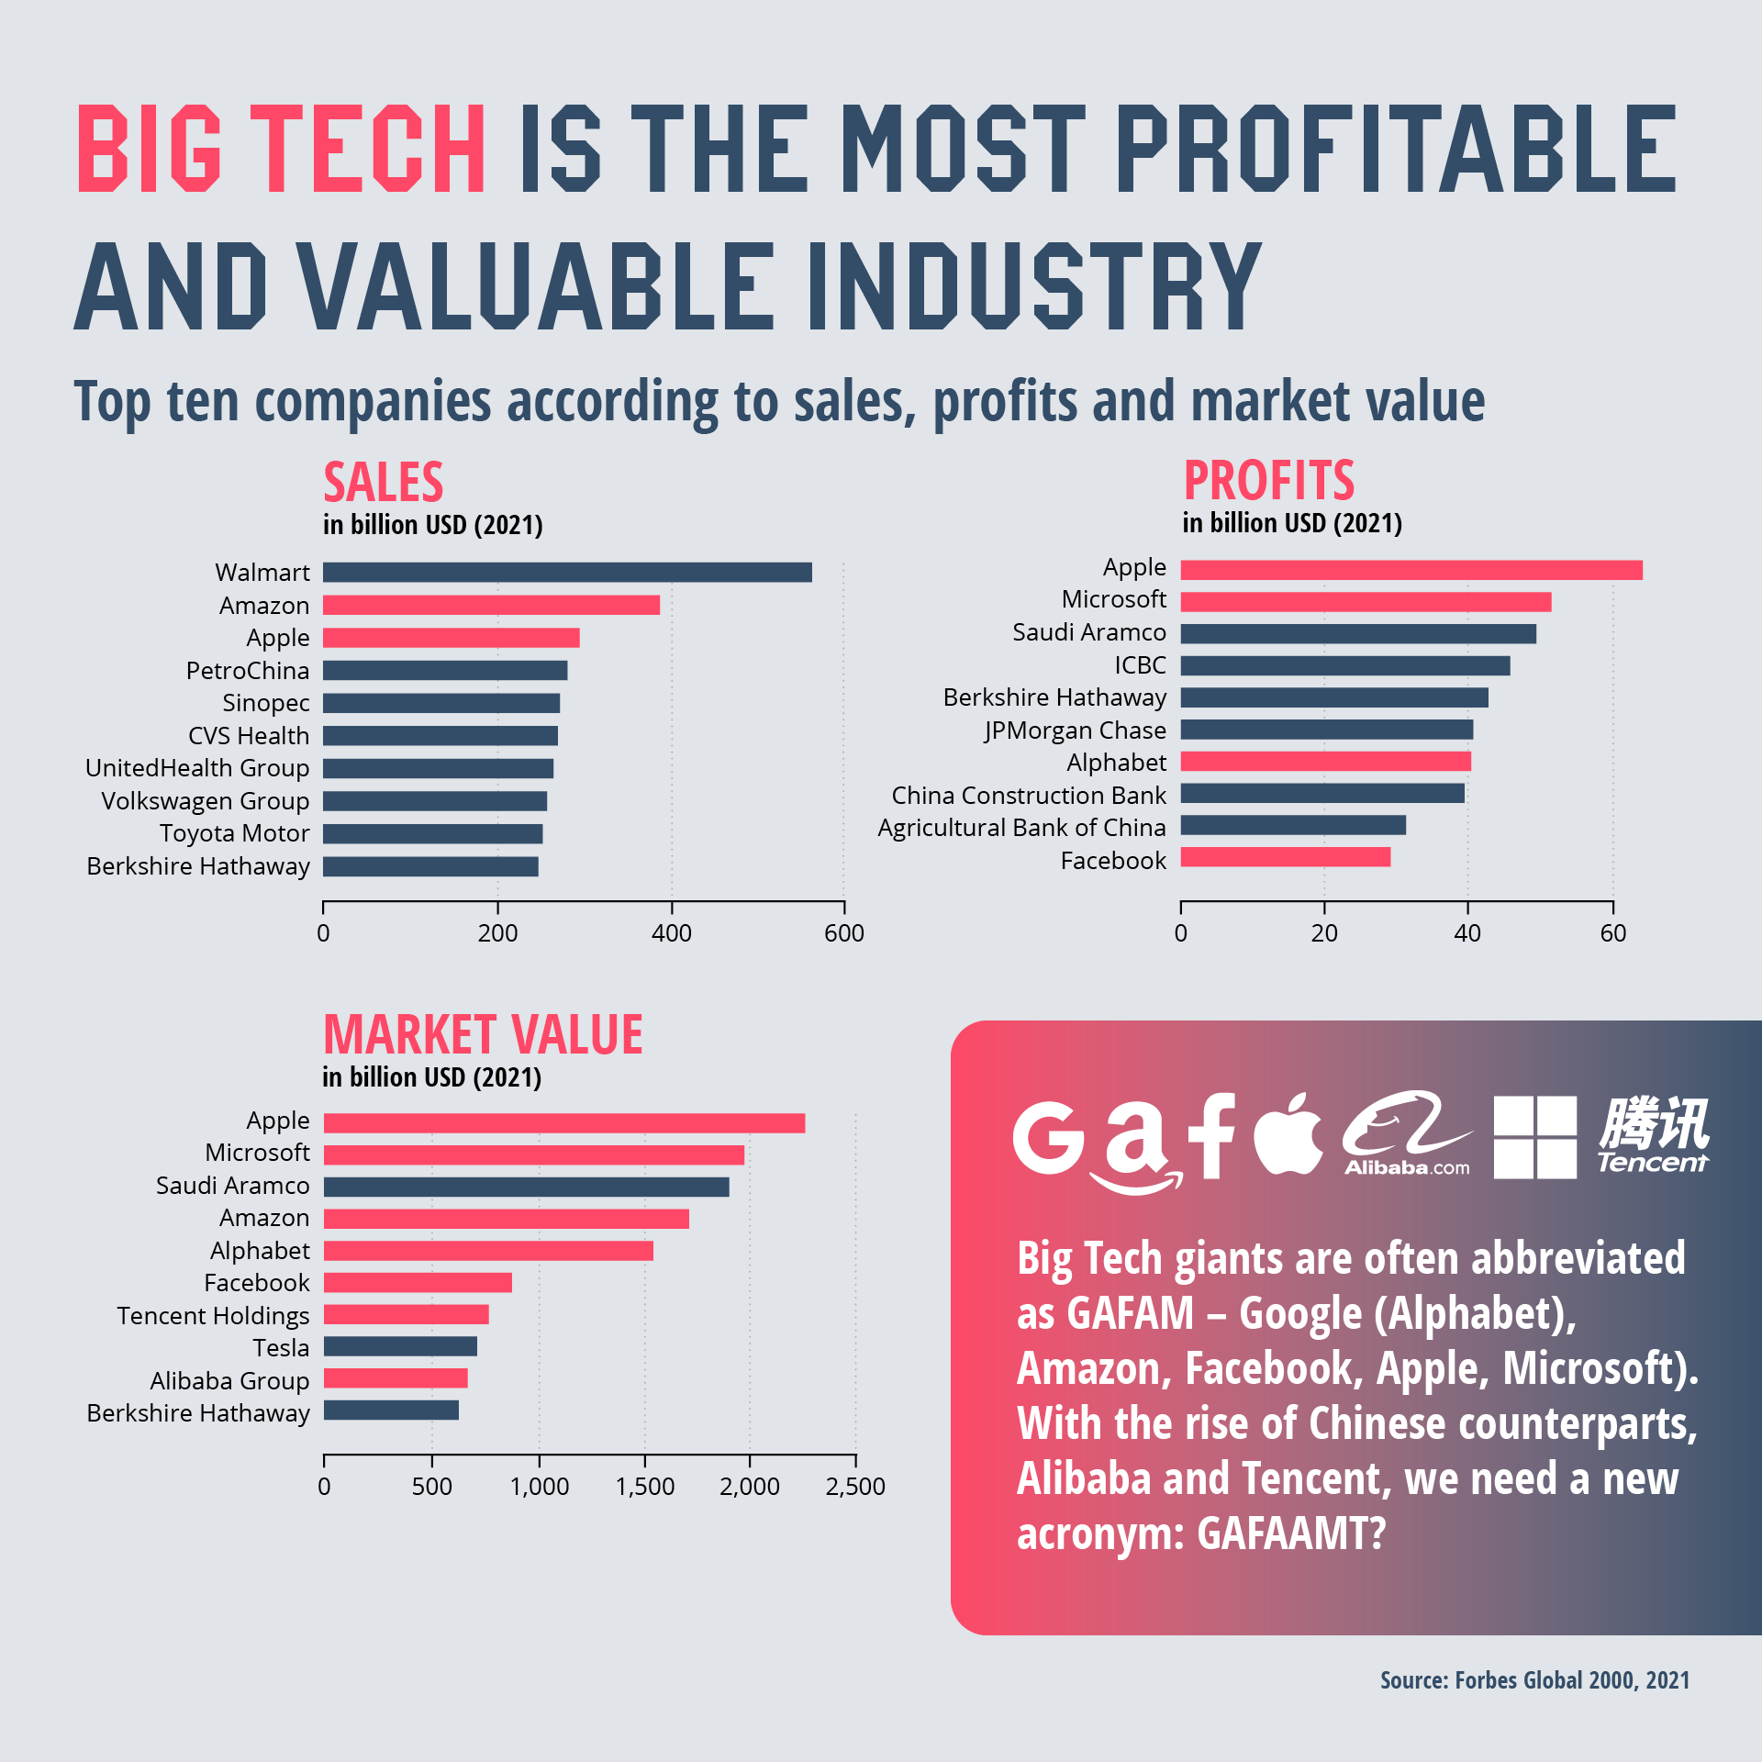
Big Tech is the most profitable and valuable industry, Forbes Global, 2021

Document 5

Cartoon: The Algorithm did it, Patrick Chappatte, Oct 10, 2021.
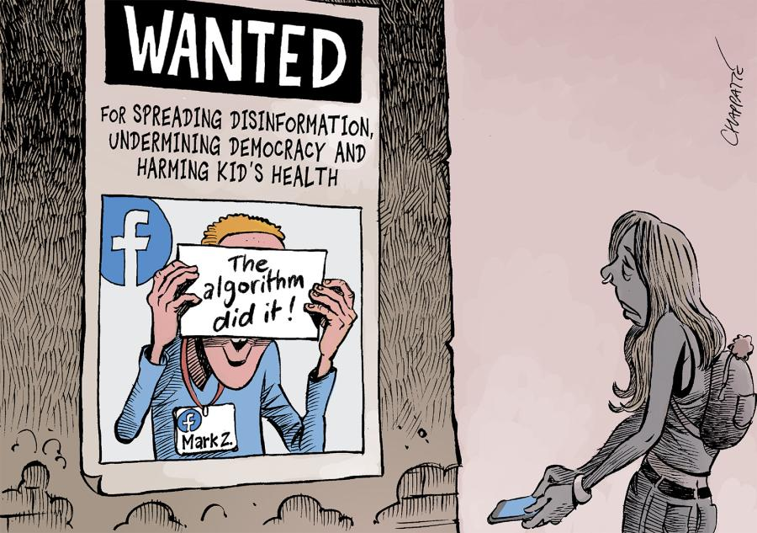

Sujet Type ECRICOME - 3h

1 - Version

They Seek to Curb Online Hate. The U.S. Accuses Them of Censorship.

The travel ban is a major escalation in a dispute between the Trump administration and Europe over the regulation of online content and social media.
In the United States, free speech protections allow social media companies to set their own content policies. And Mr. Trump and others on the right have successfully pushed social media firms to roll back moderation rules that they viewed as silencing conservative voices.
In Britain and the European Union, there are certain restrictions on hate speech and open bigotry. In 2022, the European Union passed a law called the Digital Services Act that requires social media companies to meet transparency standards and to remove certain racist, antisemitic and violent content if it violates national laws.
The Trump administration sees the Digital Services Act as an attempt to force American platforms to censor speech globally — an allegation European officials deny.
The issue came to a head this month when the European Commission, the executive branch of the European Union, fined Elon Musk’s social media platform X $140 million. The commission said that the site had violated the Digital Services Act by selling verification check marks that allow users to mislead others about their identities, by maintaining opaque advertising practices and by refusing to provide researchers with data access. In response, Mr. Musk said the European Union should be abolished.
The New York Times, 24 December 2025

2- Thème
Je fus interrompu au milieu de l’après-midi par mon voisin Leo Horowitz. Il était inquiet de ne pas m’avoir aperçu de la journée et venait s’assurer que tout allait bien. [...] Il dut trouver étrange que je ne le fasse pas entrer et se douta que je lui cachais quelque chose. Il insista :
​— Vous êtes certain ? demanda-t-il encore d’un ton curieux.
​— Absolument. Rien de spécial. Je travaille.
​Il vit soudain apparaître derrière moi Duke qui s’était réveillé et voulait voir ce qui se passait. Leo ouvrit de grands yeux.
​— Marcus, que fait ce chien chez vous ? Je baissai la tête, honteux. [...]
​— Je voulais aller voir Alexandra, expliquai-je. Et j’ai vu le chien qui sortait de la propriété. Je me suis dit que je pourrais l’amener ici, le garder pour la journée et le ramener ce soir en faisant croire qu’il était venu chez moi de son propre chef.
​— Vous êtes tombé sur la tête, mon pauvre ami. C’est un vol au sens propre du terme.
​— C’est un emprunt, je n’ai pas l’intention de le garder. J’en ai juste besoin quelques heures.
Joël Dicker, Le Livre des Baltimore, 2015

3- Essai -Les candidats traiteront l’un des deux sujets proposés et indiqueront le nombre de mots employés (de 250 à 350). Indiquer le nombre de mots utilisés en portant les mentions suivantes très lisiblement et à l’encre: repère formé d’un double trait // dans le texte écrit après chaque tranche de 50 mots, décompte chiffré cumulatif (50, 100, 150, etc) en regard dans la marge, total exact en fin d’exercice.

- Who should define the boundaries of free speech?
- Disinformation or censorship: which poses a greater threat to democracy?

