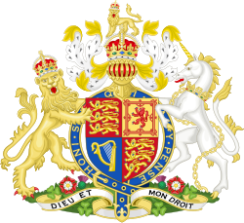
British Monarchy chronology

Event | Date | Explanation
Norman Conquest | 1066 | William, Duke of Normandy, invaded England, defeating Harold II at the Battle of Hastings, establishing Norman rule.
Magna Carta signed | 1215 | King John was forced by rebellious barons to sign this charter, limiting royal power and establishing the principle that the king was subject to the law.
Wars of the Roses begin | 1455 | A series of civil wars for control of the throne between the House of Lancaster (red rose) and the House of York (white rose).
Tudor Dynasty begins | 1485 | Henry Tudor (Henry VII) defeated Richard III at Bosworth Field, ending the Wars of the Roses and founding the Tudor dynasty.
Elizabeth I ascends the throne | 1558 | Elizabeth I became queen, marking the beginning of the Elizabethan era, a period of English Renaissance and naval dominance.
Union of the Crowns | 1603 | James VI of Scotland inherited the English throne as James I, uniting England and Scotland under one monarch.
English Civil War begins | 1642 | Conflict between Parliamentarians and Royalists over the power of the monarchy, leading to the execution of Charles I in 1649.
Restoration of the Monarchy | 1660 | The monarchy was restored after the Interregnum, with Charles II returning from exile to take the throne.
Glorious Revolution | 1688 | James II was overthrown in a bloodless coup, and William III and Mary II were invited to rule, establishing constitutional monarchy.
Act of Union (Great Britain) | 1707 | The parliaments of England and Scotland passed acts uniting the two kingdoms into a single state, Great Britain.
Hanoverian Dynasty begins | 1714 | George I, Elector of Hanover, became King of Great Britain, marking the start of the Hanoverian dynasty.
Victorian Era begins | 1837 | Victoria became queen at age 18, and her reign saw the height of the British Empire and the Industrial Revolution.

19th and 20th centuries

Event | Date | Explanation
Victorian Era begins | 1837 | Victoria’s reign marked the height of the British Empire, industrialization, and global influence.
Victoria becomes Empress of India | 1876 | Victoria was proclaimed Empress of India, formalizing British rule over the subcontinent.
Edwardian Era begins | 1901 | Edward VII’s reign saw social and technological changes, leading up to World War I.
George V reigns during WWI | 1910–1936 | George V led the monarchy through World War I and the rise of the British Commonwealth.
Name change to Windsor | 1917 | The royal family changed its name from Saxe-Coburg and Gotha to Windsor due to anti-German sentiment during WWI.
Abdication of Edward VIII | 1936 | Edward VIII abdicated to marry Wallis Simpson, leading to the accession of George VI.
Elizabeth II becomes Queen | 1952 | Elizabeth II ascended the throne, beginning the longest reign in British history.
Coronation of Elizabeth II | 1953 | Elizabeth II was crowned in a grand ceremony, symbolizing post-war renewal and the modern monarchy.
Silver Jubilee of Elizabeth II | 1977 | Celebrations marked 25 years of Elizabeth II’s reign, showcasing national unity.
Death of Princess Diana | 1997 | The death of Diana, Princess of Wales, sparked global mourning and reflection on the monarchy’s role.
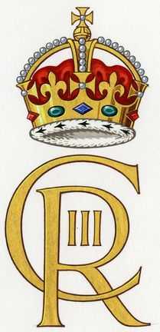
21st century

Event | Date | Explanation
Golden Jubilee of Elizabeth II | 2002 | Celebrated 50 years of Elizabeth II’s reign with major public events across the UK and Commonwealth.
Marriage of Prince William and Catherine Middleton | 2011 | The royal wedding of the future King William and Catherine (Kate) Middleton was a global media event.
Diamond Jubilee of Elizabeth II | 2012 | Marked 60 years of Elizabeth II’s reign, featuring a Thames river pageant and concerts.
Birth of Prince George | 2013 | The birth of Prince George, first child of Prince William and Catherine, secured the succession.
Death of Prince Philip | 2021 | The death of Queen Elizabeth II’s husband, Prince Philip, Duke of Edinburgh, after 73 years of marriage.
Platinum Jubilee of Elizabeth II | 2022 | Celebrated 70 years of Elizabeth II’s reign, the first British monarch to reach this milestone.
Death of Queen Elizabeth II | 2022 | The Queen passed away at Balmoral on 8th September 2022, ending her historic 70-year reign and beginning the reign of King Charles III.
Accession of King Charles III | 2022 | Charles III became King upon the death of his mother, Elizabeth II, beginning a new era for the monarchy.
Coronation of King Charles III | 2023 | Charles III was formally crowned on 6th May 2023 in a ceremony that reflected both tradition and modern values.

Roles and powers of the British Monarch

Category | Role/Power | Description
Constitutional | Head of State | The monarch is the symbolic head of the United Kingdom and the Commonwealth realms.
 | Royal Assent | The monarch must sign bills into law, though refusal is extremely rare (last veto in 1708).
 | Appointing the Prime Minister | The monarch invites the leader of the majority party in Parliament to form a government.
 | Dissolving Parliament | The monarch can dissolve Parliament, but this power is now ceremonial (Fixed-term Parliaments Act).
Executive | Head of the Armed Forces | The monarch is the ceremonial commander-in-chief of the British Armed Forces.
 | Declaring War and Peace | The monarch formally declares war and ratifies treaties, but real power lies with Parliament.
 | Appointing Ministers and Honours | The monarch appoints ministers, judges, and awards honours (e.g., knighthoods) on PM’s advice.
Judicial | Fountain of Justice | The monarch is the symbolic source of justice, though judicial independence is absolute.
 | Judicial Appointments | The monarch formally appoints judges, but selections are made by an independent commission.
Legislative | Opening and Closing Parliament | The monarch opens Parliament with the King’s/Queen’s Speech and prorogues (ends) sessions.
 | Addressing Parliament | The monarch delivers the annual King’s/Queen’s Speech, outlining the government’s agenda.
Symbolic | Head of the Commonwealth | The monarch serves as a symbolic leader for the 56-member Commonwealth of Nations.
 | National Unity and Ceremony | The monarch performs ceremonial duties (e.g., Trooping the Colour, Remembrance Day).
Religious | Supreme Governor of the Church of England | The monarch is the head of the Church of England and appoints bishops on PM’s advice.

The British monarch’s role is largely ceremonial and symbolic in the modern constitutional system.
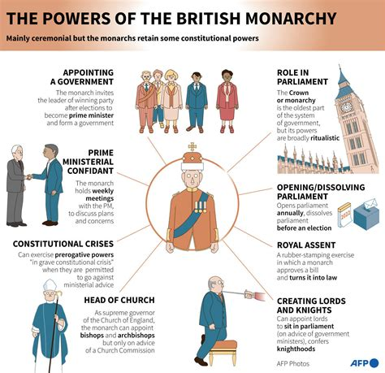
What they can do: They serve as the head of state, head of the Commonwealth, and the symbolic head of the Armed Forces and the Church of England. They perform constitutional duties like giving Royal Assent to laws (which is now a formality), appointing the Prime Minister (based on election results), opening and dissolving Parliament, and delivering the King’s/Queen’s Speech. They also play a key role in national ceremonies and diplomatic functions.
What they cannot do: The monarch does not govern—they cannot make or veto laws, declare war, or interfere in political decisions. Real executive power rests with the elected government and Parliament. The monarch must remain politically neutral, never publicly giving their opinion on political issues and act on the advice of ministers, ensuring the stability and continuity of the constitutional system.

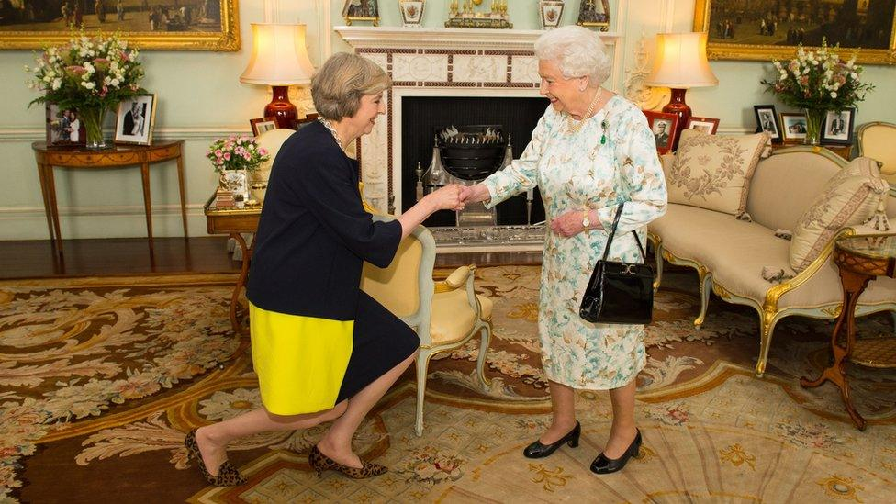
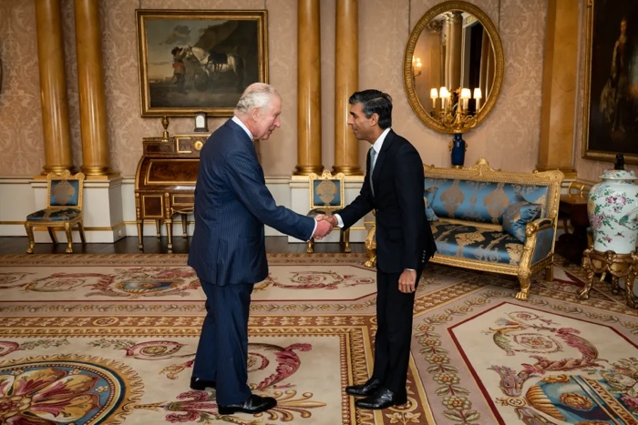

King Charles III welcoming the then Prime Minister Rishi Sunak at the start of an audience in Buckingham Palace in 2024

The late Queen Elizabeth II welcoming the then Prime Minister Theresa May at the start of an audience in Buckingham Palace in 2016

The Monarch keeps in close contact with the prime minister and is regularly kept up-to-date on all important national matters. Weekly meetings between the late Queen Elizabeth II and her Prime Ministers have been taking place since she became the monarch in 1952.
The PM usually meets the monarch on Wednesday at Buckingham Palace. The King holds a weekly Audience with the Prime Minister to discuss Government matters. The Audience is entirely private: no special advisers attend and there is no official record of what is said. Though The King remains politically neutral on all matters, he is able to 'advise and warn' his ministers - including his Prime Minister - when necessary.

Game: real or ceremonial power?

 | Statement | Answer
1 | The British monarch can veto a law passed by Parliament.
2 | The monarch appoints the Prime Minister.
3 | The monarch can declare war without Parliament’s approval.
4 | The monarch is the head of the Church of England.
5 | The monarch can dissolve Parliament whenever they want.
6 | The monarch must sign bills into law (Royal Assent).
7 | The monarch can choose which political party forms the government.
8 | The monarch is the commander-in-chief of the British Armed Forces.
9 | The monarch can create new laws.
10 | The monarch delivers the King’s/Queen’s Speech at the State Opening of Parliament.
11 | The monarch can remove a Prime Minister from office.
12 | The monarch appoints judges and bishops.
13 | The monarch can refuse to open Parliament.
14 | The monarch represents the UK at international events like the Commonwealth Heads of Government Meeting.
15 | The monarch has the power to change the constitution.

True or False Quiz: 20th-Century Dates

 | Statement | Answer
1 | Edward VII became king in 1901, marking the start of the Edwardian era.
2 | The royal family changed its name to Windsor in 1910.
3 | Edward VIII abdicated the throne in 1936 to marry Wallis Simpson.
4 | George VI reigned during World War II.
5 | Elizabeth II became queen in 1953.
6 | The coronation of Elizabeth II took place in 1953.
7 | Princess Diana died in 1996.
8 | The Silver Jubilee of Elizabeth II was celebrated in 1977.
9 | The Golden Jubilee of Elizabeth II was celebrated in 2002.
10 | The Diamond Jubilee of Elizabeth II was celebrated in 2012.
11 | Prince William married Catherine Middleton in 2010.
12 | Prince George, the first child of Prince William and Catherine, was born in 2013.
13 | The Platinum Jubilee of Elizabeth II was celebrated in 2021.
14 | Queen Elizabeth II died in 2022.
15 | King Charles III was crowned in 2023.

Which event do you think had the biggest impact on the monarchy in the 20th century?
How do you think the role of the monarchy changed during Elizabeth II’s reign?
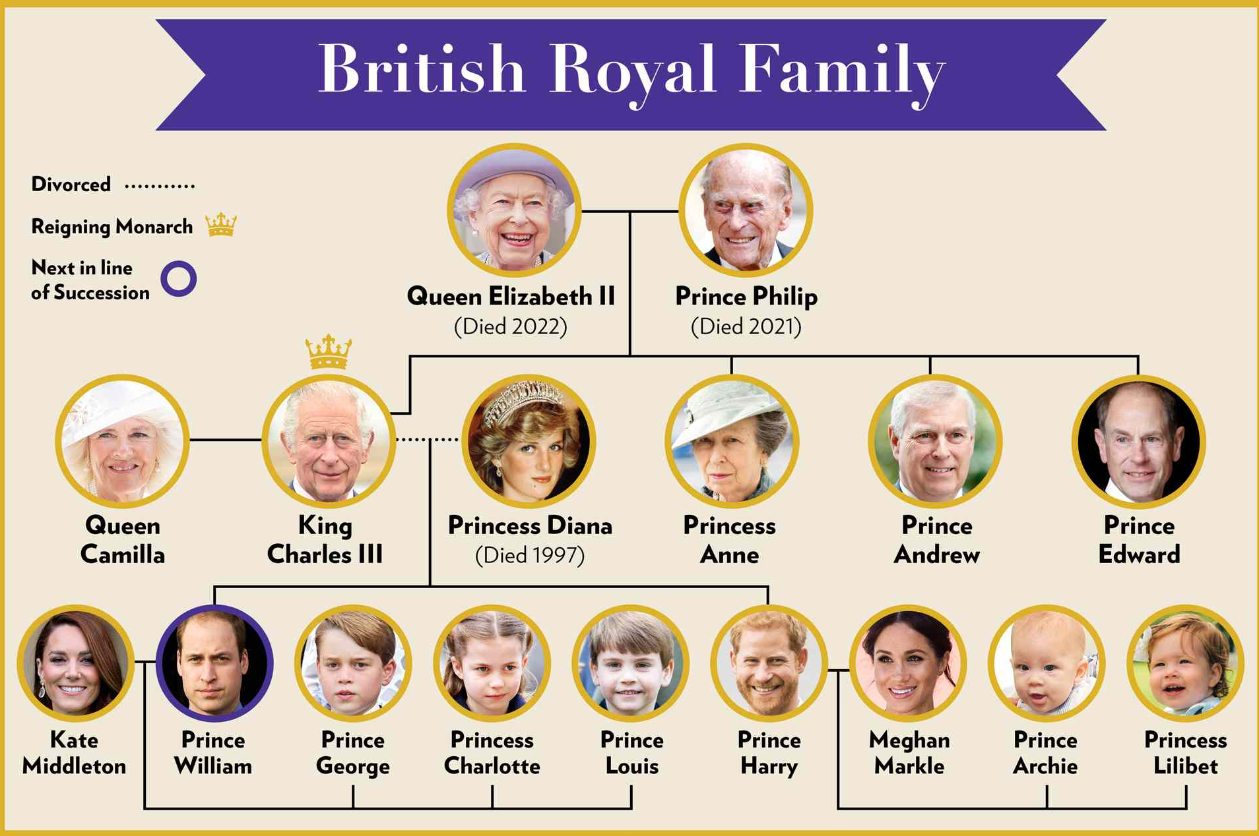
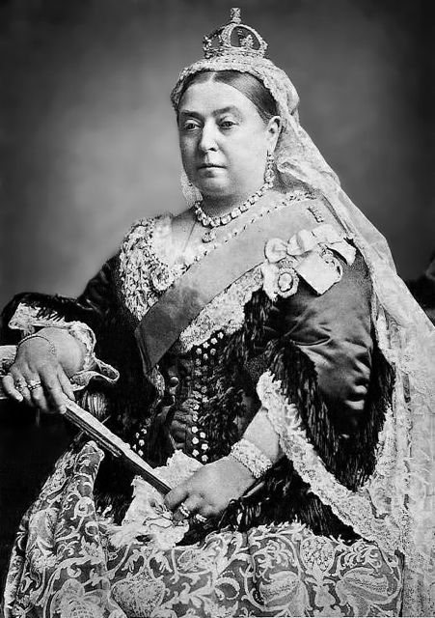

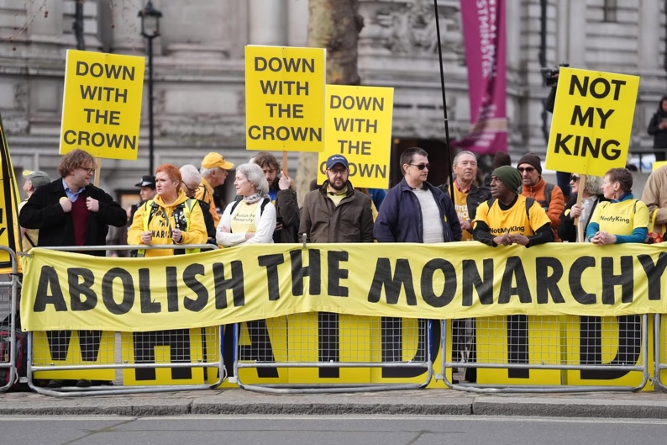
Anti-royalist protesters gather in London to voice opposition to both the royal family and the monarchy as a British institution – March 2026

Queen Victoria – 1882

