A dis-United Kingdom ? - Part 1 : The Monarchy

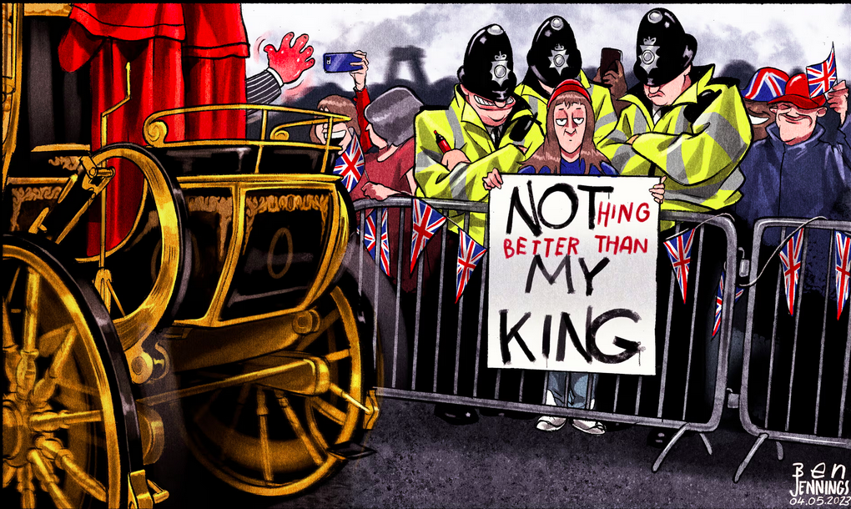
DOCUMENT 1

Consider the cartoon (describe + analyse, using the method sheet) and guess the context.

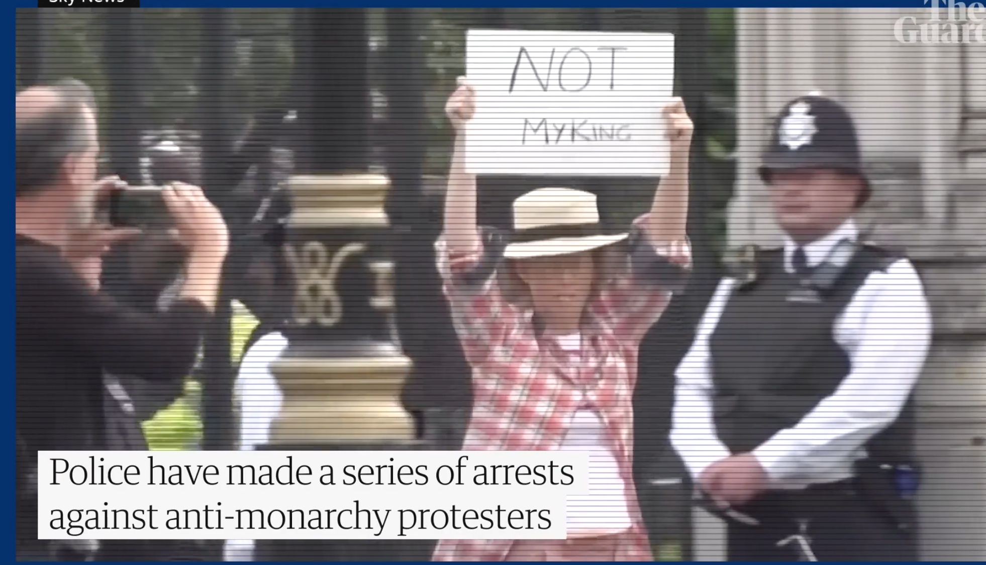
DOCUMENT 2 – Videos

2a) The anti-monarchy protesters among mourners threatened with arrest: 'Not my King' - The Guardian 13/09/2022 https://www.youtube.com/watch?v=sSleul0RJsU

1. Watch the video without sound first (until 1’06)
a) Pick out the words written on the placards / signs
b) Pick out elements linked to royalty as a traditional institution and react
c) Find elements linked to protesting in the video

2. Now watch with the sounds. Pick out key words (stressed words).
a) Pick out words about royalty and words about policing.
b) Who are the people interviewed (jobs/points of view)?
c) Recap the ways of protesting used by protesters.
d) Do you think freedom speech was not respected in this situation?

2b) King's Coronation: Metropolitan Police 'regret' arrest of six anti-monarchists
SkyNews 8th May 2023 https://www.youtube.com/watch?v=dEwoAZkfWkM
Part 1 (until 0.36)
a) Pick out proper nouns (politicians, places, institutions)
b) Pick out numbers and what they represent. Recap the situation
Part 2
a) Recap what the journalist explains about the new law (until 1’05)
b) Who and why have protesters been arrested?
c) What are the arguments given by the police to justify the arrests?

To go further : Documentary – Art TV - Not My King : Republicanism in the UK
https://www.youtube.com/watch?v=Y_wpgZyOe08


The Public Order Act 2023 is a significant piece of legislation in the UK that introduces new offences and expands police powers related to public order.
The Public Order Act 2023 considerably strengthens the legal framework around protests in the UK, with a focus on preventing serious disruption to critical infrastructure and services. It remains a contentious piece of legislation due to its impact on civil liberties
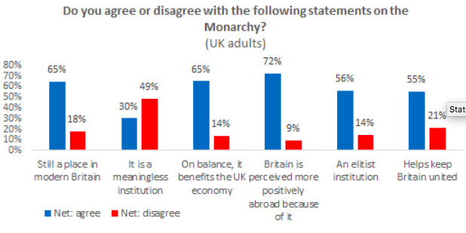
DOCUMENTS 3a 3b 3c 3d 3e
3a
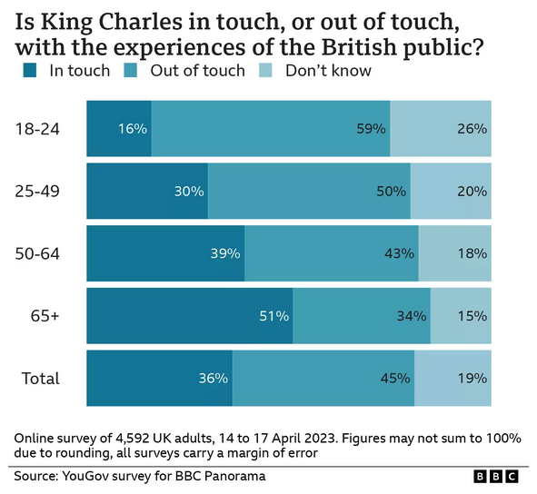

https://www.opinium.com/our-longest-reigning-monarch/

3b
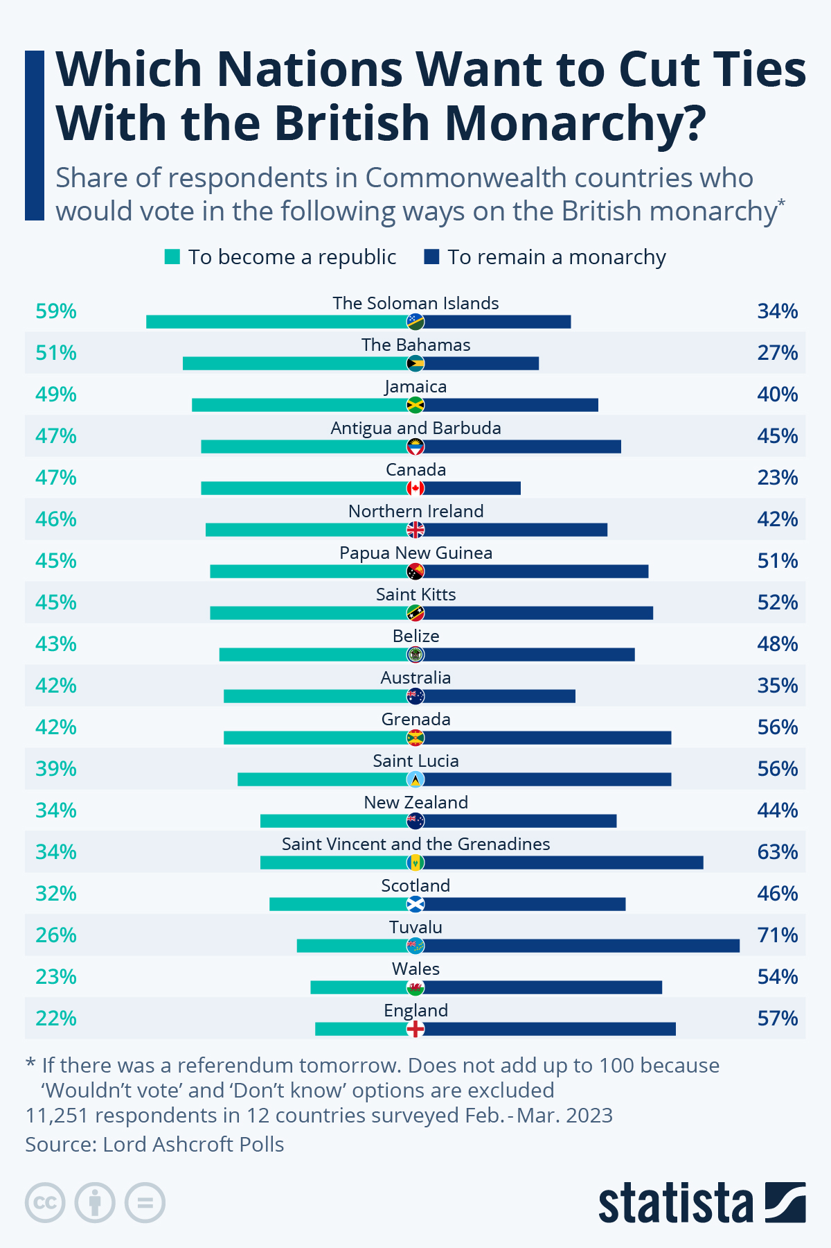

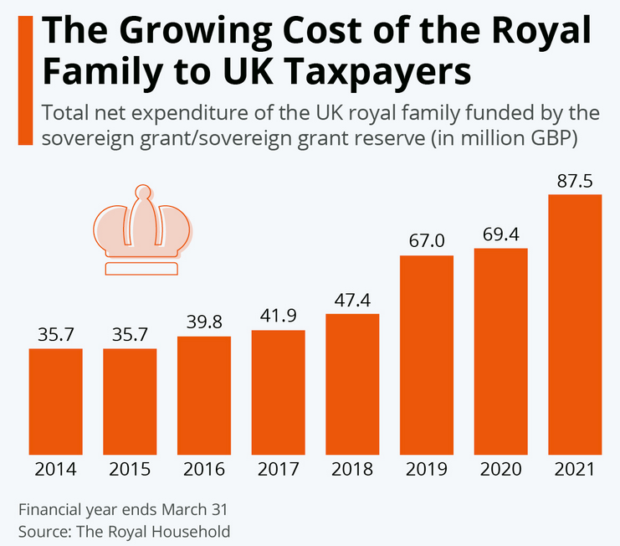

`

3c

3d

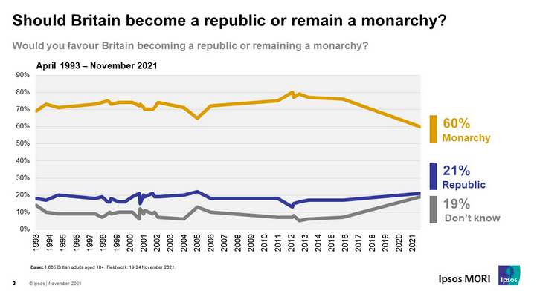

PAIRWORK : choose two charts to study with your partner and comment.
Use the method and vocabulary sheet.

3e

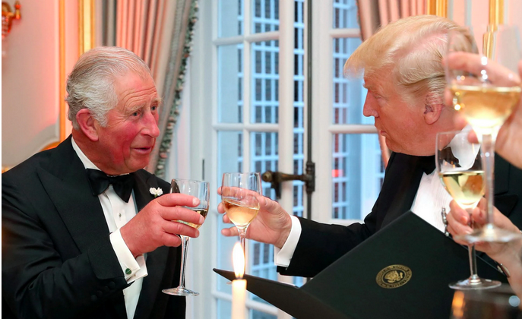
DOCUMENT 4

King Charles III meets with Trump and addresses Congress | AP News
Steven Sloan, Josh Boak, Mary Clare Jalonick, Darlene Superville – 29th April 2026

WASHINGTON (AP) — King Charles III marked the 250th anniversary of American independence from Britain with gratitude that the two countries united to build “one of the most consequential alliances in human history” while urging “that we ignore the clarion calls to become ever more inward-looking.”
Speaking Tuesday to a joint session of the U.S. Congress, Charles repeatedly highlighted the historical and cultural ties that he said have cemented an enduring bond between the United States and the United Kingdom. But even as he spoke in unifying, optimistic terms, he delivered a series of nuanced warnings encouraging leaders in the U.S. to remain collaborative and engaged in global affairs.
He said the alliance between the U.S. and the U.K., tested anew by President Donald Trump’s war in Iran, “cannot rest on past achievements.” Charles urged “unyielding resolve” in backing Ukraine against Russia and heralded the NATO alliance that Trump has consistently undermined.
The king praised religious pluralism and interfaith dialogue in terms that are rare in Trump’s Washington. As the White House rolls back regulations aimed at denting climate change, the king encouraged those in power to “reflect on our shared responsibility to safeguard nature, our most precious and irreplaceable asset.”
At one point, Charles traced the notion of checks and balances on executive power to the Magna Carta, the foundational legal document sealed by King John in 1215. Trump told The New York Times earlier this year that he was constrained only by “my own morality.”
And acknowledging a scandal that has roiled politics in both the U.S. and U.K., Charles subtly alluded to the victims of Jeffrey Epstein, the convicted sex offender with ties to British officials, including the king’s brother, Andrew.
Charles is on a four-day visit to the U.S. intended to both celebrate American independence and to repair the country’s fraying relationship with the U.K. He hardly arrived in Washington as an oppositional figure to Trump. Joined by Queen Camilla, Charles had a warm greeting with the president and first lady Melania Trump at the White House earlier Tuesday. The leaders met privately in the Oval Office for a meeting Trump later described as “really good,” adding that Charles is a “fantastic person.”
Trump hosted the royal couple for a state dinner later Tuesday in the White House. The guests included tech leaders such as outgoing Apple CEO Tim Cook and Amazon founder Jeff Bezos, along with conservative Supreme Court justices and several Fox News journalists and hosts.
During his roughly 20-minute speech to Congress, the king, who is expressly apolitical, never directly criticized Trump. Still, the contrast was apparent at times and some British commentators described his speech as more political than they had expected. Charles is just the second British monarch to address a joint session of Congress. His mother, Queen Elizabeth II, delivered a similar speech in 1991 highlighting the historic ties between both countries and the importance of their democratic values.
Many of the lawmakers in the room were at Saturday’s White House Correspondents’ Dinner, which was disrupted by a shooting that authorities have described as an attempted assassination against Trump.
Meanwhile, Trump’s up-and-down relationship with British Prime Minister Keir Starmer has taken a particularly sour turn over the past several months as the Republican president has sought to rally international support for the war in Iran. Trump criticized Starmer, who has largely resisted his overtures, by saying, “This is not Winston Churchill that we’re dealing with.”
Trump has also imposed tariffs on the U.K. and warned of additional levies despite a Supreme Court ruling earlier this year that has made such unilateral moves more challenging. Trump threatened just last week to slap a “big tariff” on the U.K. if it doesn’t scrap a digital services tax on U.S. technology companies. Trump has more broadly challenged the traditional trans-Atlantic alliance with efforts to annex Greenland and threats to walk away from NATO. He has repeatedly imposed tariffs on and taunted Canada, a member of the British Commonwealth.
If Charles offered low-key criticism of Trump, the president didn’t seem to mind. He said later that the king “made a great speech”. I was very jealous,” he said.



Watch a video here : https://apnews.com/article/king-charles-us-state-visit-trump-congress-4cd294e6333b4a9ba7ada2af4dd71aa9

Watch the King’s address to Congress: https://www.youtube.com/watch?v=wxD2XhsCJDM

Vocabulary

Find words and expressions in the text which belong to the lexical field of ROYALTY / CEREMONY / SOFT POWER corresponding to the definitions:

- A one-sided action taken without consultation : ……………………………
- A strong, urgent appeal : ……………………………
- A lasting connection between nations: ……………………………
- Not aligned with any political party : ……………………………
- A deteriorating partnership : ……………………………
- Firm determination: ……………………………
- To take control of a territory : ……………………………
- To reduce the intensity or importance of something : ……………………………

- Idiomatic expressions - Match the expressions and phrasal verbs to their meanings:
A. To reverse or reduce regulations.
B. To impose a tariff forcefully.
C. To consider something important.
D. To gather or mobilize support.

  - Rally support
  - Slap a tariff on
  - Roll back
  - Take seriously

Grammar

1. Inversion for emphasis : Negative adverbs (e.g., hardly, rarely, never, not only) at the beginning of a sentence require inversion (subject-auxiliary swap).
  - Hardly had he arrived... (Past Perfect)
  - Rarely do we see... (Present Simple)
Rewrite the following sentences using inversion for emphasis:
- We had rarely seen such a diplomatic speech.
→ ………………………………………………………………………………………
- She had never addressed Congress before.
→ ………………………………………………………………………………………

2. Modal verbs for nuance

A. Modal verbs (may, might, could, must, can) express speculation, possibility, or necessity.
  - The visit is intended to repair the relationship. (Passive + infinitive for purpose)
  - He might address the issue of tariffs. (Possibility)
Rewrite the following sentences using modal verbs for speculation:
- It is possible that Trump will impose more tariffs.
→ ………………………………………………………………………………………
- The king must have known about the historical ties to slavery.
→ ………………………………………………………………………………………

B. Modal Verbs for Obligation/Necessity
  - Must/Have to: Strong obligation (external or internal).
    - You must address the historical injustices.
  - Should/Ought to: Advice or moral obligation.
    - Leaders should acknowledge the enduring impact of slavery.

Choose the correct form:
1. Modern leaders (should/must) be held accountable for historical injustices.
2. The U.K. (has to/must) repair its relationship with the U.S. to maintain the alliance.

3. Passive Voice for Diplomacy & Formality

A. Passive Voice in Diplomatic Contexts
- The passive voice is often used in formal or diplomatic contexts to:
  - Avoid assigning blame (e.g., "Mistakes were made.").
  - Emphasize the action rather than the doer.
Rewrite the following active sentences in the passive voice:
1.Trump imposed tariffs on the U.K.
→ ………………………………………………………………………………………
2.The king delivered a speech to Congress.
→ ………………………………………………………………………………………

B. Passive Voice with Modal Verbs
- Passive voice + modal verbs (e.g., can be, should be, must be) is common in formal writing.
  - The issue should be addressed by modern leaders.
  - The historical ties must be acknowledged.
Rewrite the following sentences using passive voice + modal verbs:
1. Leaders must acknowledge the enduring impact of slavery.
→ ………………………………………………………………………………………
2.The U.K. should repair its relationship with the U.S.
→ ………………………………………………………………………………………

QUESTIONS
- How does King Charles III use soft power in his speech to Congress? Illustrate with examples from the text.
- Why might Trump’s unilateral actions (e.g., tariffs) be seen as a challenge to the enduring bond between the U.S. and U.K.?
- In what ways does the article contrast Charles’s apolitical role with Trump’s political style?
Role play:
- Act out a discussion between the King and Trump during the state visit.
- Act as the King’s press secretary, answering questions from “journalists” about the state visit.
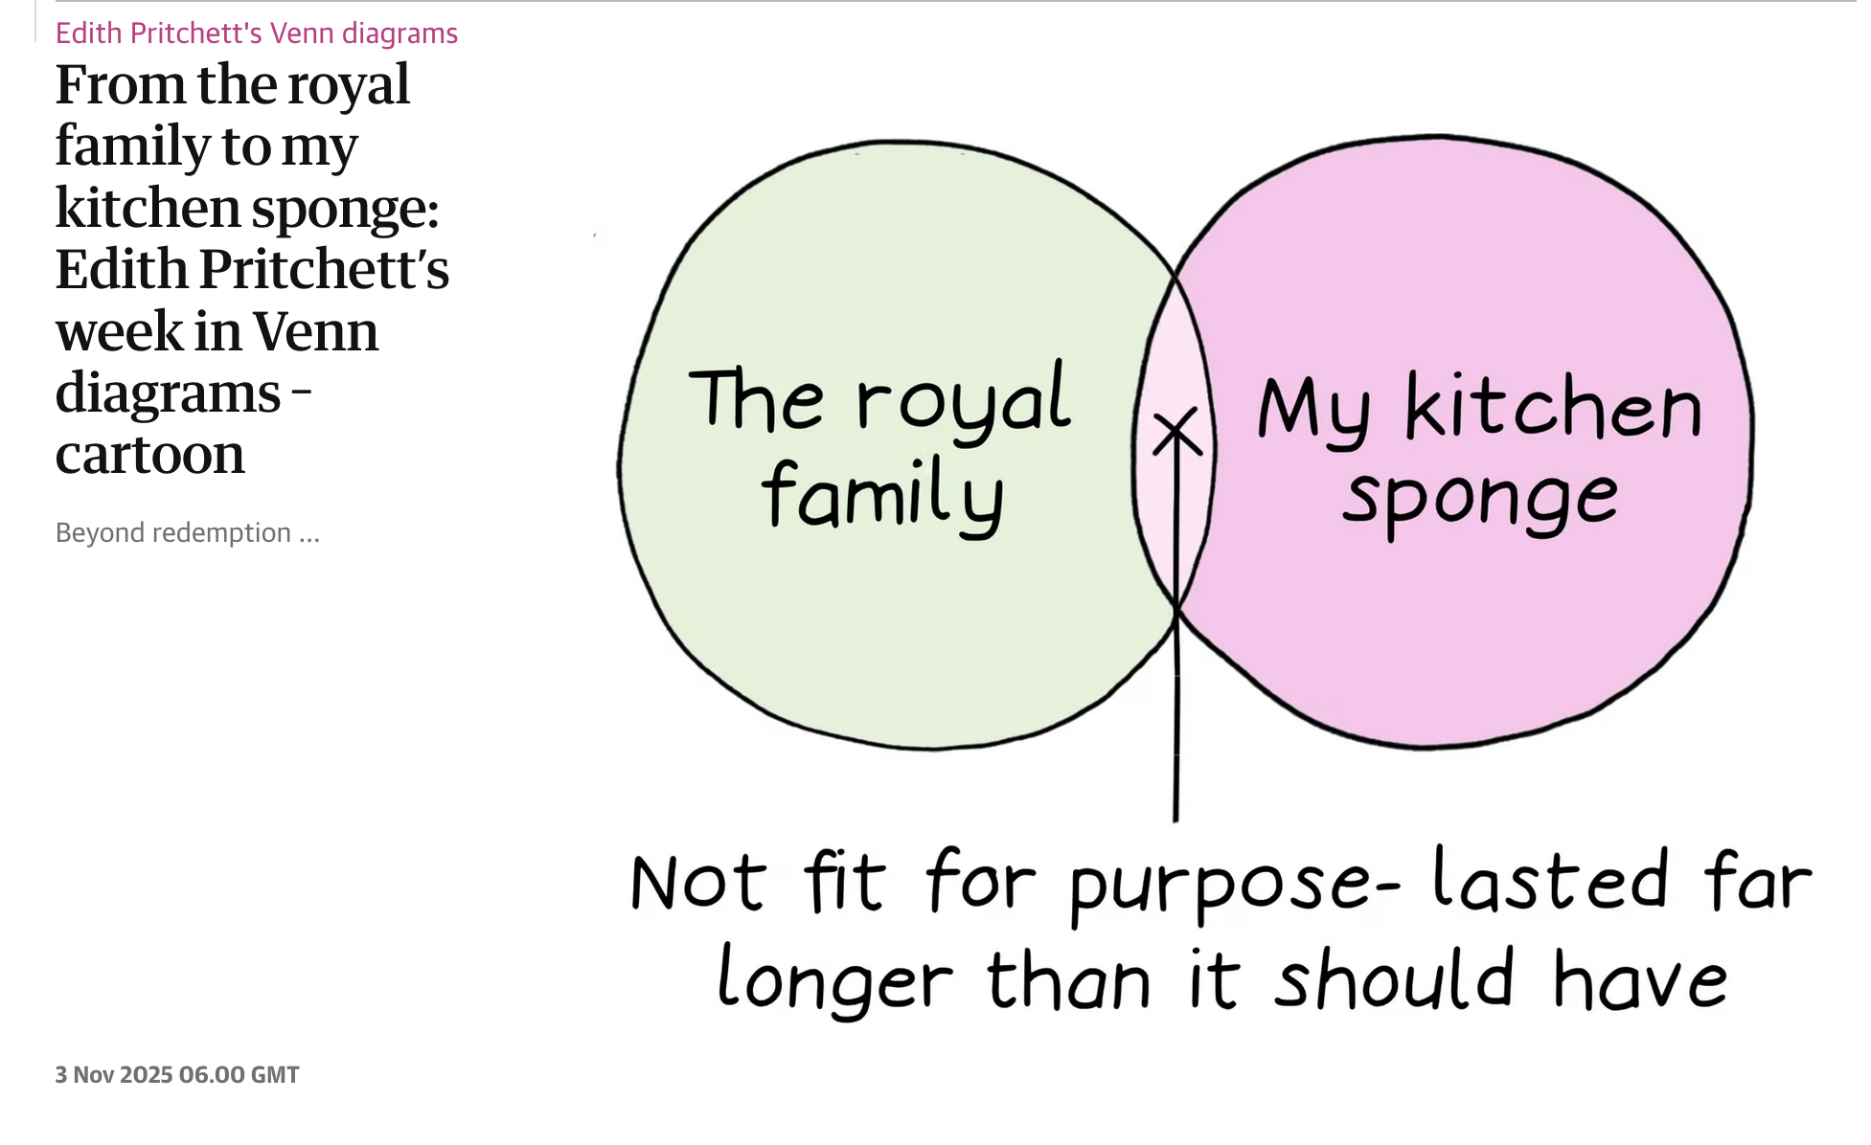

DOCUMENT 5 NYC Mayor Mamdani encourages King Charles to return Koh-i-Noor diamond.
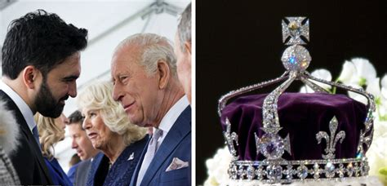
Alexa Herrera, Marcia Kramer – CBS News – 29th April 2026

New York City Mayor Zohran Mamdani said if he talks to King Charles III during his visit, he would encourage the king to give back a diamond with a long, controversial history.
A jewel called the Koh-i-Noor is contained inside the Crown of Queen Elizabeth. The diamond is believed to have originated from India. It was given to Queen Victoria in 1849 as a condition of the Treaty of Lahore, which ended the first Anglo-Sikh War.
The Crown Of Queen Elizabeth The Queen Mother is of platinum and contains the famous Koh-i-
Many Indians believe the diamond still belongs to India and that the British stole it.
The jewel came up when Mamdani was asked Wednesday about King Charles' visit.
"I would probably encourage him to return the Koh-i-Noor diamond," he said.
The 105.6-carat jewel is inside a crown given to Queen Elizabeth II's mother in 1937. It's on display at the Tower of London. It has had many previous royal owners, including heads of the Mughal Empire, shahs of Iran, emirs of Afghanistan, and Sikh Maharajas, according to the Historic Royal Palaces. In 2016, India's Culture Ministry said the government would make every possible effort to get the diamond back. For many Indians, the loss of the Koh-i-Noor is symbolic of the country's subjugation under colonial rule. Pakistan, Iran and Afghanistan have also squabbled over who should have the jewel.
Speaking to CBS News New York on Wednesday, Dr. Amanda Foreman, a royal contributor, said King Charles doesn't own the Koh-i-Noor diamond. The nation owns it. "The king has no more power to return the diamond than he has to return Buckingham Palace to the people," Foreman said.

React! Was it a good idea for the NYC mayor to bring this up? Should King Charles give the diamond back?

DOCUMENT 6 King Charles visits Bermuda as slavery reparations debate resurfaces during royal tour
Video Sky News – 2nd may 2026 - https://www.youtube.com/watch?v=Gh6sNngsLNA

    - Analyse the title and imagine what the video will be about (who/where/what/when)
    - Pick out words belonging to the lexical field of “debate” and explain what is at stake in the video. What are the two sides presented here?
    - Debate: Should modern institutions (e.g., royal families, banks) be held accountable for the actions of their ancestors? Why or why not?
    - Critical Thinking: How might reparations for slavery be implemented in a way that is fair and meaningful?

CARICOM = Caribbean Community

Reparations are proposals for former colonial powers, including the British monarchy, to acknowledge and help address the harms caused by colonialism and slavery. They can take the form of financial compensation, formal apologies, development support, or the return of cultural artifacts. Supporters see them as a matter of historical justice, while critics question whether present-day institutions should be held responsible for past actions.

A live debate between journalists and panelists on the BBC website : https://www.bbc.com/news/live/uk-65390037 - published 25 April 2023

What the panellists said : We're bringing our coverage of the monarchy debate to a close shortly. Here is a little flavour of what the panellists were discussing.
Polly Toynbee thinks the monarchy should go, and describes it as a symbol of inherited wealth in a society that is becoming less equal.
Billy Bragg thinks we should keep the monarchy, but wants to end its constitutional role. He is hoping to see a written constitution one day, with the people made sovereign. He also says Buckingham Palace should become a museum.
Prof Jason Arday questions how connected people still feel to the monarchy, and notes the changing attitudes of young people. He says there is an opportunity to redistribute the wealth of the monarchy, especially in the context of today's cost of living crisis.
Charles Moore disagrees, suggesting the benefit of redistributing money from the monarchy would be trivial in the context of public spending. He says the monarchy is a guarantee of legitimacy, and suggests the UK wouldn't be united if it was not a kingdom.
Juliet Samuel says the monarchy does change, but slowly over time. She believes the rituals and dramas of the monarchy contribute to a sense of a collective identity.

Alys Davies – BBC Reporter
The panellists clashed over a number of topics, ranging from how relevant the monarchy is to different generations, to the wealth of King Charles and his future as head of state in Commonwealth nations.
A memorable line from Polly Toynbee concerning the monarchy's future stands out, in which she said: "the likelihood of three white men" ruling until the end of this century was "depressing" - referring to the line of succession from King Charles, to Prince William, to Prince George.
Another that sticks out, this time from Charles Moore was: "It's very interesting to me what we call our country and what it's called is the United Kingdom of Great Britain and Northern Ireland. And that's very significant because if it wasn't a kingdom, it wouldn't be united."

Thème

"Mais c'est de l'hypocrisie !" La neutralité de Charles III mise à mal dans un documentaire de la BBC. - Olivia Micenmacher – Point de Vue – 23rd Decembre 2025
Mon problème c'est que je possède une incapacité innée à me taire". En novembre 1986, ainsi se décrit le prince Charles, lors d'une conférence sur l'architecture urbaine. Cet extrait diffusé dans le premier épisode de What's the monarchy for ?, un documentaire en trois parties réalisé par David Dimbleby pour la BBC, donne le ton de ce volet consacré au pouvoir politique du souverain au Royaume-Uni et à l'influence que celui-ci pourrait exercer sur son gouvernement malgré la consigne de neutralité. Devant l'image du Premier ministre Keir Starmer tendant une invitation à Donald Trump pour une visite d'État de la part de Charles III, dans le Bureau ovale de la Maison Blanche, le journaliste affirme : "Le roi est utilisé pour flatter le président des États-Unis. Si l'invitation avait été envoyée au nom de Starmer, il l'aurait dédaignée". Soft power ou réel pouvoir ?
La question qui agite le réalisateur : pourquoi donner une quelconque légitimité aux conseils ou aux recommandations de quelqu'un qui n'est élu par personne ? Mieux encore, que comprendrait un martien qui viendrait sur Terre, voyant les images d'Élisabeth II saluant des milliers de Londoniens au balcon, à qui on expliquerait que cette femme qui semble être la leader du pays, n'a, en réalité, pas beaucoup à dire sur ses affaires.

ESSAY : “Is the British Monarchy still relevant today?”. Discuss (150 words) Illustrate your answer with relevant examples.

