The Victorian Era (UK)

Timeline / Historical landmarks

**1832 Reform Act**: considerably extended men’s voting rights

1833 Slavery abolished in the British Empire

**1833 Factory Acts** (1833, 1844, 1847, 1850, 1853): regulated working hours and work conditions for women, children, and men in the UK

**1834 Poor Law Amendment Act**: creation of workhouses for the poor

**1837 Accession of Queen Victoria**

**1838-1857 Chartism**: movement for political reform (to get universal suffrage; started with 1838 Charter)

1845 Beginning of **Irish famine**

1846 Repeal of Corn Laws: food prices reduced + beginning of modern free trade

1848 Revolutions in Europe

1851 First Great Exhibition

1865 Women’s Suffrage movement

1867 Second Reform Act: further extended voting rights

1870 Free primary education for all

1871 Trade Unions legalized

1884 Third Reform Act; foundation of Fabian Society

1900 Labour Party founded

1901 Accession of Edward VII

Context

* Calmer after Napoleonic wars and Romantic rebellion
* Yet **age of divisions and contradictions**: wealth v. misery, optimism v. anxiety, religious fervor / piety v. doubt. Called Victoria era for **Queen Victoria (1837-1901**): centralization; expansion; industrialization; imperialism; morality, piety, respectability.
* **“Mechanical age” / Industrial Revolution**: 19th century = great changes; demographic growth; rural pop 🡪 urban exodus; **modernization**, **urbanization**; technological advances, transportation (railway) = ++ commercial activity. **British Empire** =international commerce, wealth, status, pride (cf. Cecil Rhodes + “Rule Britannia” anthem). Belief in science (theoretical + experimental). **Utilitarianism** (Jeremy Bentham, John Stuart Mill, good measure: what serves the greater good) + **laissez-faire** theories, budding liberalism (**Adam Smith, “invisible hand”**).
* **“Two Nations”:** **industrialization**🡪 rural exile to the cities 🡪 rampant **urbanization**, crowded cities, squalid living conditions, diseases and epidemics, long working hours, severe poverty, crime. 🡪 UK divided into “two nations” (Benjamin Disraeli): rich v. poor, upper & middle classes v. working classes. Poor Law amendment (1834) created **workhouses** for the beggars and the sick. 🡪 increased misery and disease (Charles Dickens’ *Oliver Twist*).

+ division men v. women: ‘**separate spheres’** (woman= private, pious, domestic, warm, motherly, “**angel in the house**” ≠ man= public sphere, outside, active, money earner)

* **Reform:** gradual extension of **voting rights:** **Reform Acts** (1832, 1867) + working hours cut back and improved, esp. for women and children(**Factory Acts**); food prices & inflation checked (repeal of the Corn Laws, 1846); free elementary **education** for all (1870); **trade unions** legalized 1871; improvement of hygiene, fewer diseases & epidemics. Rise of **Feminist movements** (“the Woman’s question”): debates on women’s right of property, work, franchise (🡪 Suffragette movements late 19th c), “new woman” (independent, educated) + **Chartist movement** (late 1830s) for male suffrage, more democratic Parliament.
* **Beliefs:** Victorian age = religious; men and women expected to be pious, moral. “**Temperance**” movement= women against alcoholism, gambling… Religious movements (Anglican, Methodist, Evangelical): charity & philanthropy (supported reforms + education), also proselytism (missionaries sent to British colonies to “educate” and “civilize” local pops). Religion questioned 2nd half of the century: doubts on authenticity of the Bible + introduction of Evolution theory (**Charles** **Darwin, *On the Origin of Species*, 1859**).

Notable literary movements, genres, authors

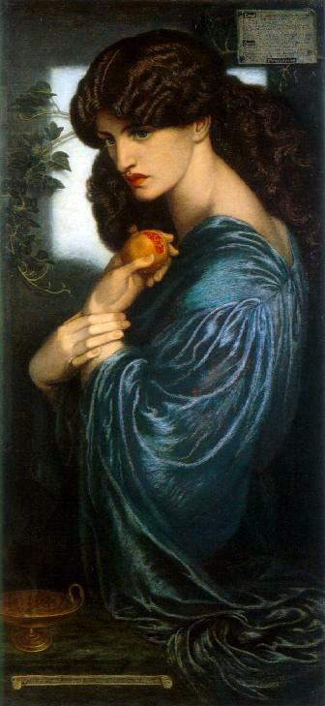**Aesthetics:**

Dante Gabriel Rossetti, Proserpine (1874)

* CriticJohn Ruskin, contributed to popularity of Turner & pre-Raphaelite paintings.
* **Pre-Raphaelites** or “Pre-Raphaelite Brotherhood”: painters (**Dante Gabriel Rossetti**, William Holman Hunt, John Everett Millais, Ford Madox Brown) attracted to pre-Renaissance aesthetic forms and beliefs; scenes from Bible, Shakespeare, Dante, Keats + social themes.
* William Morris, a famous painter, designer and decorator, produced textiles, furniture, wallpapers, with memorable floral patterns + wrote poems.
* 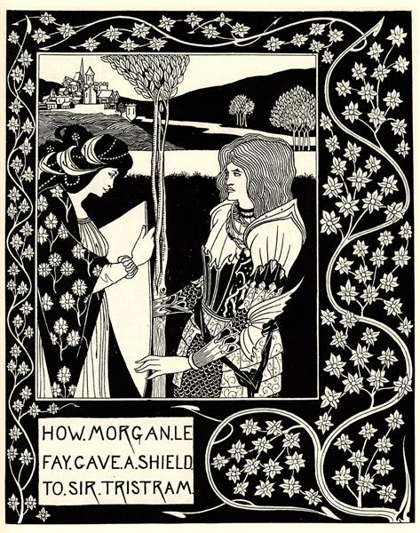Late 19th century: **Aestheticism** = “**art for art’s sake**”. Art = not a reflection of society or didactic tool: self-sufficient, beautiful in itself. “Decadence or “Fin de Siècle” movement: stressed difference art ≠ nature, fascination with myths and medieval times, privileged strange, grotesque, unnatural (cf. **Oscar Wilde**, **James McNeil Whistler**, **Audrey Beardsley**).

Poetry

Aubrey Beardsley 1894

* Alfred Tennyson, (“In Memoriam” (1850)). Most representative poet of the Victorian era; poems on loss, love, faith, doubt, truth and reality, religion and science, the poet.
* **Robert Browning**: known for his **dramatic monologues**: in “**My Last Duchess**” a Duke gradually reveals he murdered his wife. Studied men’s contradictions; inspired by the Renaissance, Italy, Florence.
* **Elizabeth Barrett Browning** (married to RB): poems about women and society, love and power. “Sonnets from the Portuguese”: major series of love sonnets after Shk; **“Aurora Leigh”** (1857), major, long epic about a woman’s intellectual and emotional growth.
* Dante Gabriel Rossetti: poems about sexual love and death, inspired by medieval courtly love & Dante)
* Christina Rossetti(D. Rossetti’s sister): poems about faith, love, death; renewed poetic form.
* Algernon Charles Swinburne: decadent, pagan, celebrated transgression, homosexuality, sensuality; addresses Satanism, masochism, lesbianism in his poems, and sparked scandals.
* Gerard Manley Hopkins: famous postmortem; on loss, nature, transcendence, God’s presence.

Drama

* Started again after the 1840s; new theatres, new work on costumes, settings, machinery. Most popular genres: **melodrama** and **pantomime**, often for satirical ends.
* **Oscar Wilde**: Irish-born writer, lived in London. Part of **Aestheticism = art for art’s sake** movement. Flamboyant, unconventional life; jailed for homosexuality. Major dramatist: brilliant **comedies** like *Lady Wintermere’s Fan* (1892), *An Ideal Husband* (1895), ***The******Importance of Being Earnest* (1895)**, about mistaken identities / quid pro quo. Comedies where brilliant use of **wit**; critique of Victorian hypocrisy, social codes, piety, and institutions like marriage. ***Salomé* (1891)**, a symbolist and decadent one-act play, about lust and desire.
* **George Bernard Shaw**: also Irishman, co-founded the Fabian society (socialist group, roots of Labour Party). Loved Ibsen; plays= to be watched *and* read; believed the theater could change ppl’s political beliefs and reform them. Plays address grim social issues: prostitution, slum landlords, war, charity. Most famous play: ***Pygmalion* (1914)**, abt impossibility of myth and romance in Victorian times.

The Novel

* More and more people reading bc of increased literacy, circulating libraries, cheaper printing process, railway (=quick & extensive circulation).
* Public’s favorite genre: **the novel**. 19th century: **the golden age of the novel.**
* Beginning of serialization after C. Dickens’ *The Pickwick Papers* (1836). Cheaper, maintained readers’ suspense, huge sales, illustrations: revolutionized literary market. Changed way authors wrote: climaxes and suspense at the end of instalments; novels now longer; multiple plots, more elaborate too; larger panorama of society;
* Many different genres of novels; often moralizing, proselyting works; direct or indirect political critique; action & adventure; gothic stories, fear and terror; and/or emphasis on emotion, sensation, to encourage benevolence and action. = immensely varied

**The Brontë sisters:**

Charlotte, Emily, Anne Brontë; published novels under male names (Currer, Ellis, and Acton Bell).

* **Charlotte Brontë’s *Jane Eyre* (1847**): 1st-person teacher falling in love with her employer, Mr. Rochester, already married to a mad woman locked up in the attic.
* **Emily Brontë’s *Wuthering Heights* (1847**) relates the passionate love between Heathcliff, a young adopted gipsy, and Catherine, his adoptive sister. When Catherine marries another man, Heathcliff vows to wreak vengeance on her and on his and her children. The novel, a memorable love story, is a technical tour-de-force with its several levels of embedded narratives and its complex temporality.
* Anne Brontë’s *Agnes Grey* (1847) is about the life of a governess and *The Tenant of Wildfell Hall* (1848) about a woman escaping her profligate husband.

‘**Condition of England’ novels (1830s-1850s)**: novels describing the consequences of the Industrial Revolution on the lives of the English people; reflect social and political concerns of the 1840s and 1850s in particular; mix of romantic and realistic elements.

* **Benjamin Disraeli**, (Tory Prime Minister): ***Sybil, or The Two Nations*, 1845** about poverty, social unrest, and the Chartist movement in the industrial north.
* **Elizabeth Gaskell**: didactic novels about the divide rural south/industrial north, and possible compromise between them, through a love story (*North and South* (1855)); other novels (*Wives and Daughters; Cranford*) describe everyday domestic life in small rural towns.
* Other “Condition of England” novels include C. Brontë’s *Shirley* (Luddite movement in Yorkshire) and Charles Dickens’ *Hard Times* (attack against utilitarianism).

**The “social” novel**:

* **Charles Dickens**, one of Britain’s most famous novelists. Social novels about condition of England in Victorian times; depicts whole society, all classes; dry humor. ***Oliver Twist* (1837-38**) (orphan brought up in a workhouse); *Hard Times*, 1854 (attack against rational utilitarian system of education), *David Copperfield* 1849-50, *Little Dorrit* 1857 in a prison, *Bleak House, 1853* (complex novel about legal absurdities in the UK), ***A Tale of Two Cities*, 1859** (about the French Revolution), ***Great Expectations,* 1860-61**.
* **William Makepeace Thackeray**: ***Vanity Fair* (1847-48**), a “novel without a hero”. Denounces hypocrisy, selfishness, prejudice, corruption of Victorian society with biting irony.
* **George Eliot** (Mary Ann Evans; male penname); free mores (religious sceptic, lived with a married man), shocked Victorian era. Famous novels: *Adam Bede* (1859), ***The Mill on the Floss* (1860),** or ***Middlemarch* (1871-72**). About changing rural communities; social determinism; strong heroines; moral novels.
* **Anthony Trollope** (the *Palliser Novels*): about politics, the press, and the Church; acid, lucid satire.

‘**Fin de siècle’**:

Late 19th century = anxiety, skepticism, disillusion; in art, development of **naturalism**, pessimistic view of mankind, analysis of social and biological determinism; parallel development of aestheticism (art for art’s sake) and decadence: dark artworks following man’s complex psyche.

* **Oscar Wilde**: Irish-born dramatist. Homosexual, unconventional, persecuted. ***The Picture of Dorian Gray* (1891**), decadent novel about art, morality, illustrates **aestheticism** principles (**art for art’s sake**), triumph of art over nature. Dorian Gray’s hedonism, depravity, and corruption modify his portrait.
* George Meredith: poetry & novels (evolutionism, man’s capacity for progress, transcendence of the self)
* **Thomas Hardy**: tragic novels on rural world, social determinism, Victorian prejudices & hypocrisy (esp. on Victorian conception of women’s “virtue”), urbanization v. nature (*Far From the Madding Crowd* 1874, *The Return of the Native* 1874, *The Mayor of Casterbridge* 1886, *Jude the Obscure*, 1895, ***Tess of the D’Ubervilles*, 1891** (a working-class woman is seduced, abandoned, and becomes a criminal).

**New genres: detective fiction, Gothic, adventure, SF, nonsense**

Late 19th c: development of **new genres**; indirect comment on social realities of the day and metaphysical themes; fantasy, adventure, dark fiction on hidden motives and instincts, influenced by scientific discoveries and Freud’s recent psychoanalytical theory.

**Detective stories**: developed 19th century, after Edgar Allan Poe:

* **Wilkie Collins**: ***The Woman in White* (1859**) and ***The Moonstone* (1868**) = among the first detective stories ever written; melodrama and suspense.
* **Arthur Conan Doyle;** penned adventures of amateur detective Sherlock Holmes and associate Dr Watson; cf. ***The Adventures of Sherlock Holmes* (1892**), *The Hound of the Baskervilles* (1902)…

**Gothic novels & adventure novels:**

* **Bram Stoker**, ***Dracula* (1897**). Landmark of Gothic, fantastic, and vampire literature. Irish author.
* **Robert Louis Stevenson** (Scottish): adventure novels (***Treasure Island* (1883**)) and Gothic novels (***The Strange Case of Dr Jekyll and Mr Hyde* (1886**), on evil Doppelgänger.
* **Rudyard Kipling**, born in India, celebrated Victorian values and the British Empire in his poems (“The White Man’s Burden”). His novel, ***Kim* (1901**), is a picaresque portraying a young Indian orphan, and offers a more nuanced vision of Indians. Kipling also wrote famous children’s stories (***The Jungle Book*, 1894**).

**SF**: **H.G. Wells**, ***The Time Machine* (1895**); *The Invisible Man* (1897), ***The War of the Worlds* (1898**) (about the invasion of the Earth by Martians). Scientific romances; critique of Victorian imperialism and prejudices; origins of Science Fiction.

**Nonsense**: 19th century works that defy conventional literature (**Lewis Carroll** (aka Charles Lutwidge Dodgson), ***Alice’s Adventures in Wonderland* (1865**) and ***Through the Looking Glass* (1871**)).

*From Françoise Grellet,* The Literary Guide