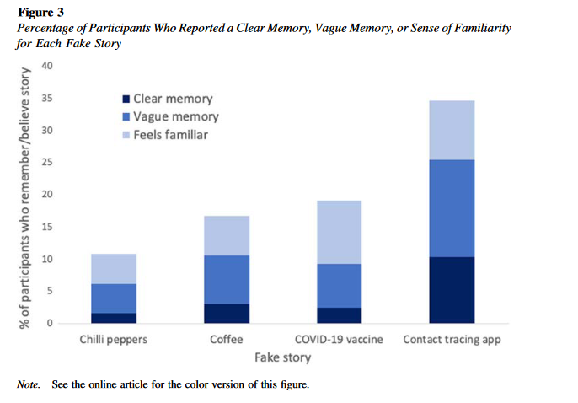
Journal of Experimental Psychology: Applied
Quantifying the Effects of Fake News on Behavior: Evidence From a Study
of COVID-19 Misinformation
Ciara M. Greene and Gillian Murphy
Online First Publication, June 10, 2021.

Different news was given (fake news) to informants about eating and drinking peppers and coffee and their effect on Covid + the concealed damage of a vaccine revealed + covid app used as a tracer

The four critical health behaviors assessed were (a) intention to eat
more spicy food, (b) intention to drink more coffee, (c) intention to get
a COVID-19 vaccine once available, and (d) intention to download a
government-funded contact-tracing app.

We report evidence that even a single exposure to health
misinformation may “affect” behavior. Memories are significant enough to influence behaviors .It is important to notethat we evaluated intentions to engage in health behaviors rather
than the behaviors themselves.

