Week n° | VOCAB LISTS – PERIOD 1
WK 3  16 Sept | TOOLBOX – Vocabulaire de l’analyse d’article de press (Cf. ‘TOOLBOX’ livret de colle).
WK 4 TEST
23 Sept
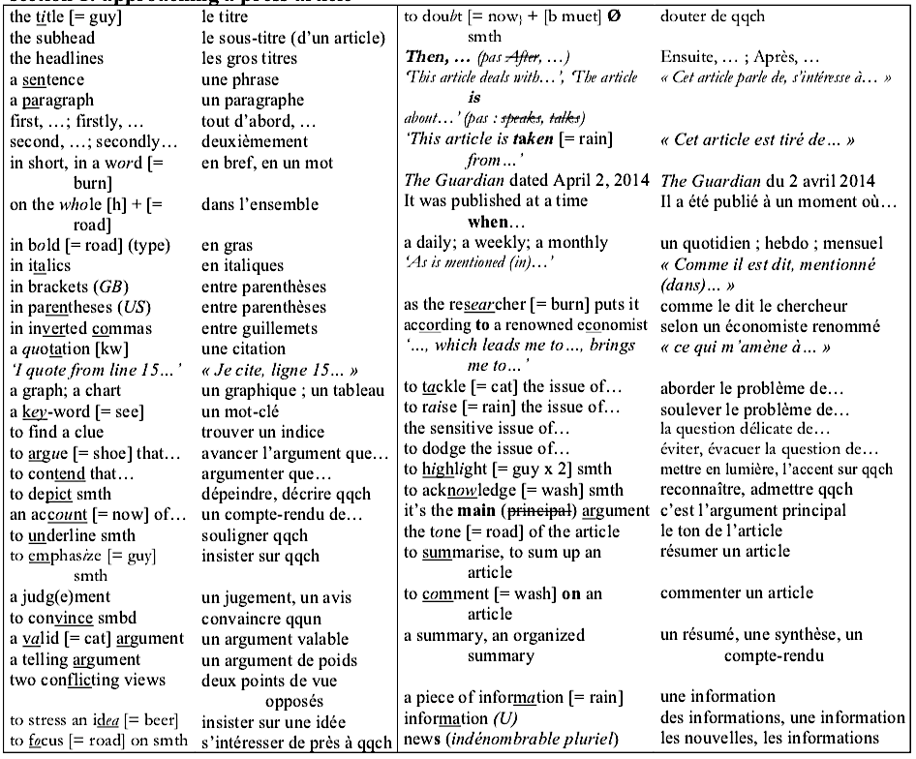
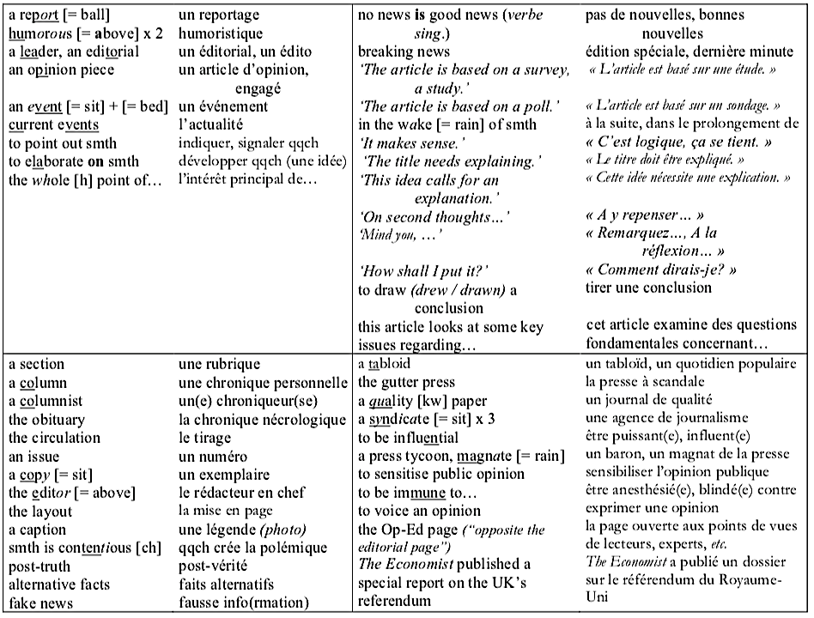

WK 5  30 Sept | SCIENCE & TECHNOLOGY
WK 6 test  07 Oct | SCIENCE & TECHNOLOGY
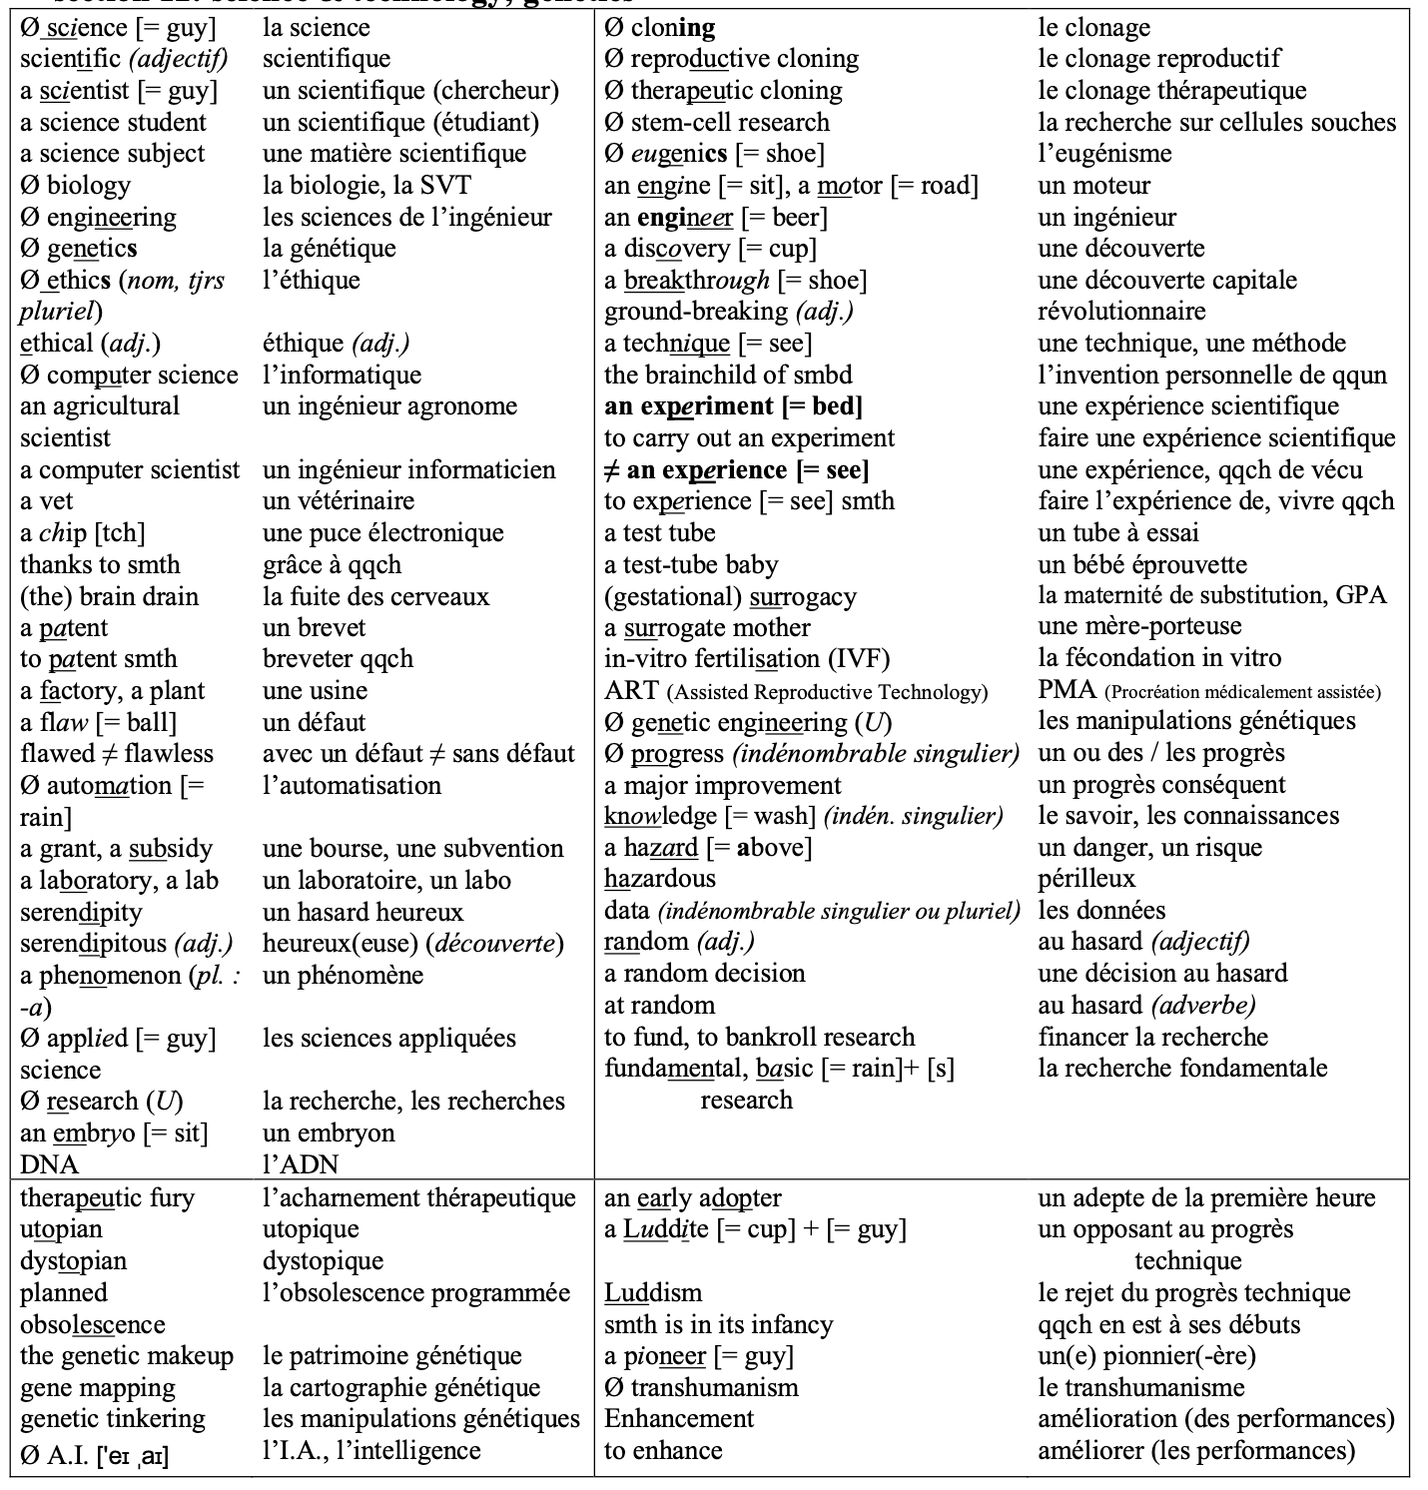

WK 7  14 Oct | IMMIGRATION, DREAMS OF A BETTER LIFE, CITIZENSHIP
WK 8 test  4 Nov | IMMIGRATION, DREAMS OF A BETTER LIFE, CITIZENSHIP
