THE UK & ITS MONARCHY
INFORMATION SHEET 1: THE MONARCHY

The Monarchy is often said to be in crisis these days because of the behaviour of some members of the royal family (marital scandals*, Prince Charles's divorce, then second marriage, Prince Andrew's association with Jeffrey Epstein, a convicted paedophile), because it is seen as too distant from the people, and because of its cost. The royal family is expensive, costing the taxpayers around £800,000 a year.
However, it has also proved capable of change, for instance when the Queen cut her Civil List* (£7.9m until 2011 - mainly used to pay staff, and for official ceremonies) and in 1993 decided to pay taxes on her income as a reaction to public criticism. In 1997, the death of Diana, Princess of Wales (who had been very active in defending children and landmine victims), and the outpouring of grief that followed it, highlighted people's desire for a more modern and compassionate monarchy. However, the death of the Queen Mother in 2002 and the public emotion on the occasion of her funeral or the wedding of Prince William and Catherine Middleton in 2011, viewed by tens of millions in Britain and around the world, were proof of the British people's attachment to the monarchy. In April 2016, as the queen celebrated her 90th birthday, a poll showed that she was getting increasingly popular. 76% of respondents also said a queen or king should remain as head of state.
The marriage of Prince Harry and Meghan Markle (a mixed race American divorcee) seemed to show that the monarchy could evolve in a more multicultural age, even though the couple later decided to step back from duties as senior royals and become financially independent.
Because of the intrusion of the press into the private lives of the royal family, it is losing much of its former mystique.
The controversy around the monarchy focuses upon two main questions:
CLASSIC QUESTIONS: Should the Monarchy be kept? / Should the Monarchy evolve with the country it represents?
INFORMATION SHEET 2: THE UK GOVERNMENT

The UK ceased to be bound by EU law on 31 December 2020. However, some categories of EU law will be retained, amended or not, and become part of domestic UK law, described as "retained EU law"
THE LEGISLATIVE POWER: PARLIAMENT
It is made up of two Chambers: the House of Lords* and the House of Commons each providing checks* on the other. Because Parliament is situated in the London borough of Westminster, it is also sometimes called The Palace of Westminster, simply Westminster'.
VOC: the legislative power: le pouvoir legislatif; the House of Lords; la Chambre des Lords; the House Commons: la Chambre des Communes; to provide checks: limiter les pouvoirs

- The House of Commons (or Lower House*) is elected for a maximum of 5 years. After the General Elections*, the leader of the party* with the largest number of votes becomes Prime Minister. MPs (Members of Parliament*) voters of their constituencies*, discuss and vote on new legislation and control the executive (the ministers). A Speaker* is elected with each new parliament, to chair* all debates. He then becomes politically impartial. Each party uses Whips* to ensure party discipline and make sure that MPs are present for important votes (they may, for instance, issue "three-line whips", that is to say urgent instruction to MPs, asking them to attend important debates). When they vote, MPs leave the House of Commons through the aye or no lobbies*.
The majority party and the opposition sit facing each other, the rectangular shape of the House of Commons reflecting the British two-party system.
A front-bencher* is a member of parliament who is part of the government or of the shadow cabinet (the cabinet formed by the main opposition party) and who sits on the front benches*.
A backbencher* is a simple member of parliament; he/she sits behind the front benches.
Once a week, MPs who belong to the opposition can question the government during Question Time*. It provides a check on the government and avoids too much secrecy.
VOC: the PM = the Prime Minister; an MP = a Member of Parliament; an MSP = a Member of the Scottish Parliament
The Lower House: la chambre basse; general elections: des élections législatives; the leader of a party: le chef/leader d'un parti; a Member of Parliament: un député; a constituency: une circonscription électorale; the Speaker: le président des débats; to chair: présider; a whip: un député qui assure la discipline de vote dans son parti; the aye and no lobbies: les couloirs empruntés par les députés pour voter oui ou non; (Prime Minister's) Question Time: la séance de questions posées au Premier ministre; a frontbencher: un ministre ou membre du cabinet fantôme; the shadow cabinet: le cabinet fantôme; the front benches: les bancs des ministres; a backbencher: un député sans portefeuille ou fonction particulière
- The House of Lords (or Upper House*) - is made up of non-elected members, called peers* or peeresses*: hereditary peers (whose heirs will inherit the title when they die: Dukes, Marquesses, Earls* & Countesses, Viscounts, Barons & Baronesses), peers appointed for life*, high judicial officers* , such as the Lord Chancellor*, archbishops* and bishops* of the Church of England. But it is in the process of being reformed, with the gradual disappearance of hereditary peers (only 92 now remain in a phase of transition) in order to create a "more representative and democratic" second chamber.

Several options are being considered: only elected members or a blend of appointed and elected members. But who would elect the members? And how could elected members replicate the wide range of expertise which is now to be found in the House of Lords, with its scientists, writers, lawyers and businessmen? Besides, what would the functions of the new chamber be? These questions have yet to be answered.
The main functions of the House of Lords are now:
- to scrutinise* and revise bills* from the House of Commons, making sure that they are in keeping with* the constitution,
- to block or delay* bills (for no more than a year, but since 1909, they have had no power over finance bills) so as to give the Commons time to revise them,
- to initiate new legislation,
- to debate (discuss) current issues* in a fair and open way since this Chamber is above party politics.
- It is also a final Court of Appeal*, the last court to which a case can be referred.
The main strength of the House of Lords is therefore the fact that it provides an independent, non-political check to the House of Commons and the government. But under the so-called 'Salisbury convention', the House of Lords will not oppose the government on its manifesto commitments.
VOC: the Upper House: la chambre haute; a peer: un pair (du royaume); a peeress: une pairesse; an earl: un comte; appointed for life: nommés à vie; judicial officers: des magistrats; the Lord Chancellor: le ministre de la Justice / Garde des Sceaux; an archbishop: un archevêque; a bishop: un évêque; to scrutinise: examiner. étudier; a bill: un projet de loi; to be in keeping with: s'accorder avec; to delay: retarder; current issues: des questions, problèmes d'actualité; a Court of Appeal: une cour d'appel
The different steps in the passing of a bill before it becomes an Act of Parliament*:
- First Reading* (the text of the bill is given to all members of Parliament to read). A Green Paper* explains its aims.
- Second Reading: the bill is discussed, with arguments for and against presented.
The government defends it in a White Paper.
- The bill and its implications is studied by a standing committee* of MPs
- Third Reading: the bill is once again discussed in the House of Commons, with some amendments proposed by the committee. A vote then takes place, the MPs leaving the chamber to the right (to vote yes) or left (to vote no) of the speaker.
- If approved the bill goes to the House of Lords, where the same procedure is followed.
- If the House of Lords accepts the bill, it becomes an Act of Parliament and receives "Royal Assent*"
VOC: to pass a bill: voter un projet de loi; an Act of Parliament: une loi; a Reading: la lecture d'un projet de loi au parlement; a standing committee: un comité permanent; Royal Assent:l'Assentiment Royal
THE EXECUTIVE POWER
- The Prime Minister wields considerable power*. He.she :
• presides over the Cabinet, deciding upon the agenda* and chairing the meetings*
• decides on the budget (with the Chancellor of the Exchequer)
• decides what the government's policy* will be, including foreign policy
• appoints* high officials*.
VOC: the Prime Minister: le.la premier.e ministre; to wield power: exercer un pouvoir; an agenda: un ordre du jour; to chair a meeting: présider une réunion; the government's policy: la politique du gouvernement; to appoint: nommer; a high official: un haut fonctionnaire
- The cabinet consists of the Prime Minister and of some 20 senior ministers* by the Prime Minister. They meet every week at 10 Downing Street (the residence of the Prime Minister) and decide on government policy. Members of the Cabinet will then have to support any decision taken: this is called collective responsibility*.
Here are the names of some important members of the Cabinet:
- The Chancellor of the Exchequer* - The Foreign Secretary*
- The Home Secretary* - The Deputy Prime Minister
- The Lord Chancellor
Secretaries of State* are helped by several Junior Ministers*
Thousands of non-political civil servants (metonymically referred to as Whitehall - the London area where many government buildings are to be found) work behind the scenes* for whichever government is in place. Britain's civil service* is over-centralised and often criticised for not being fully efficient.
VOC: a senior minister: un.e ministre de rang élevé; collective responsibility: la responsabilité collective; the Deputy Prime Minister: le.la vice-Premier ministre; the Lord Chancellor: le.la ministre de la Justice / le Garde des Sceaux; the Chancellor of the Exchequer: le.la ministre des Finances / chancelier de l'Échiquier, the Foreign Secretary: le.la ministre des Affaires étrangères; the Home Secretary: le.la ministre de l'Intérieur; a Secretary of State: un.e ministre; a Junior Minister: un.e secrétaire d'État; behind the scenes: dans les coulisses; the civil service: les fonctionnaires

- The Parties : There are two main parties which alternate in government:
- The Conservative Party* (also called Tory Party), which traditionally defends right-wing liberal policies* (individualism, tax reduction", mixed economy, private enter-prise, freedom of choice in education, property ownership). After David Cameron's election as leader of the party in 2006, "compassionate conservatism" became the motto* of the party.
- The Labour Party*, traditionally the party of the working class, linked to the trade unions*, defending public ownership* and high public spending* on social services and education. With his "third way", however, Tony Blair placed his party, which he called "New Labour", at the centre of the political spectrum*. The links between the Labour party and the trade unions were reduced, and the aim was to combine econo-mic liberalism and social concerns.
- A third party, the Liberal Democrat Party*, which is more liberal, pro-European and in favour of constitutional reform, has recently played an important part, too. At the moment they have little chance of a majority in Parliament, although they joined a coalition government with the Conservatives after the 2010 general election.
- Other parties include the Green Party, Reform UK (ex-UKIP) its leader. Nigel Farage, Plaid Cymru (the Welsh nationalist party), the SNP (Scottish National Party), the Irish 'Democratic Unionist Party' (for other Irish parties), the extreme right-wing BNP (British National Party) and the Communist Party at the other end of the political spectrum*
VOC: the Conservative Party: le parti conservateur; right-wing liberal policies: une politique libérale de droite; tax reduction: l'allégement de l'impôt; a motto: une devise; the Labour Party: le parti travailliste; a trade union: un syndicat; public ownership: la nationalisation; public spending: les dépenses publiques; the political spectrum: l'éventail politique; the Liberal Democrat Party: le parti libéral démocrate

- General Elections*
General elections to elect MPs must take place at least every five years, but the Prime Minister can call for new elections any time before the end of five years. The age of voting is 18. The leader of the party which obtains a majority of seats in the House of Commons becomes new PM. The opposition party system (also called First-past-the-post System) : the candidate who obtains the largest number of votes is elected.
This voting system partly explains why only two main parties dominate British poli-tics, as is reflected in the adversarial architecture of the House of Commons, with two sides facing each other. Many have asked for proportional representation* to be introduced. In a 2011 referendum, British voters rejected plans to replace the first-past-the-post electoral system for the House of Commons with the alternative vote (AV) system. The change was part of the Liberal Democrats' platform, but was strongly opposed by Prime Minister Cameron, his argument being that such a system would reduce the majority and power of any government. There can also be by-elections* if a seat becomes vacant after an MP dies or resigns.
INFORMATION SHEET 3: MULTICULTURALISM IN THE UK
The arrival of many immigrants in the last two decades (increasingly from Africa rather than from Commonwealth countries as earlier) has had a visible impact on the face of the country. London, which attracts more foreigners than the rest of the country is full of ethnic restaurants, temples and mosques, giving it a truly multi-ethnic feel.
Until quite recently, Britain prided itself on" its good race relations and on being a multicultural model.
But the image of a tolerant multi-racial Britain is being eroded by
- instances of racial tension (for instance the race riots" in the north of England in 2001), partly fuelled by" tabloids such as The Sun which feed the prejudice* that most immigrants are cheats, parasites and criminals.
- the discovery, in 2005, that such communities had been harbouring* Islamist
- several terrorist attacks in Manchester and London in 2017
- the rising number of immigrants
- fears that British identity is now under threat. By encouraging new immigrants to keep their identities instead of merging into* a single British one, the government's policy has led to what has been called "plural monoculturalism"*, that is to say communities living next to each other without really communicating.
However, multiculturalism has undeniably enriched British society; literature, the theatre, music, films and food - all now reflect the influence of diverse cultures. The subject of immigration is therefore a highly contentious issue, and one which greatly concerns most Britons. The government has recently tried to encourage some legal immigration (that of skilled foreigners or of workers coming at the request of employers) while tightening rules about other foreign workers and trying to clamp down on illegal immigration*. Wealthy migrants who invest large sums in Britain can also apply for permanent residence.

The migrant crisis in Europe and the controversy around Brexit and immigration have led many to feel that the UK has recently become less tolerant and open to other cultures and religious values. Britain's immigration system is also now changing. Fewer immigrants come from the EU, more come from the rest of the world (particularly from China and India) and tend to be skilled.
VOC: to pride oneself on: s'enorgueilir de; race riots: des émeutes raciales; fuelled by: alimenté par, a prejudice: un préjugé; to harbour: abriter; to merge into: se fondre dans: plural monoculturalism:le monoculturalisme pluriel; to clamp down on: mettre un frein à

INFORMATION SHEET 4: THE COMMONWEALTH
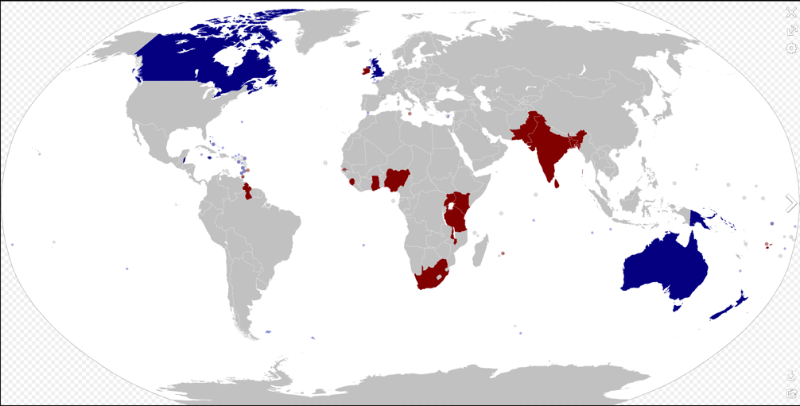
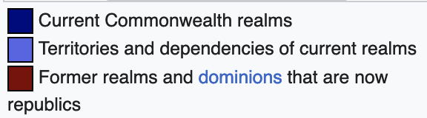


THE COMMONWEALTH AND AUSTRALIA

There’s a strong case to be made for constitutional monarchies. But there’s no case for one in Australia
August 2, 2021 THE CONVERSATION (extract)

The old dominions of the British Empire – Canada, New Zealand, Australia –basically accepted the British sovereign as head of state, with a governor-general acting as effective head of state. This is a very peculiar constitutional arrangement. Australian passports are issued by the governor-general as “the representative of Her Majesty”, but on arrival at Heathrow airport we queue in the same line as other foreign nationals. Some small Pacific and Caribbean countries, including Papua New Guinea, have preserved the same system, and in several cases have rejected proposals for change.
https://theconversation.com/theres-a-strong-case-to-be-made-for-constitutional-monarchies-but-theres-no-case-for-one-in-australia-163798

- The monarch has functions both as head of state and as head of the nation. King Charles III is head of state in 14 countries beyond the UK, known as the realms: they include Australia, Canada, Jamaica and New Zealand. The King is also Head of the Commonwealth, a voluntary association of 54 states, mainly former British colonies and dependencies.
- The King reigns, but he does not rule. Ruling is done by his government, and as head of state in the UK the King is constitutionally obliged to follow the government’s advice. His main functions as head of state are to appoint the Prime Minister, and all the other ministers; to open new sessions of parliament; and to give royal assent to bills passed by parliament, signifying that they have become law.
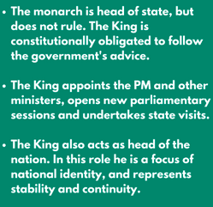
https://www.ucl.ac.uk/constitution-unit/explainers/what-role-monarchy

