PART 2

AI DEBATE – mAI be your friend?

DOC 1

Why falling in love with an AI isn’t laughable, it’s inevitable

Alex Wilkins, New Scientist, 9 July 202

Think of what it feels like to be in love. What comes to your mind? The giddy excitement of first falling for someone or the everyday calm reassurance of someone at your side? For a handful of people, love is opening up their laptop or phone and waiting for a wall of text or a synthetic voice to come streaming in from their preferred AI chatbot.
With so many tech platforms encouraging us to interact with their newly-introduced chatbots and talk to them as if they are real humans, people are increasingly turning to these large language model-powered functions for companionship, emotional support and, sometimes, love. This might raise an eyebrow or elicit a snigger. A recent story from CBS news about a man who proposed marriage to ChatGPT was met with mirth online, with the New York Post describing it as a “bizarre whirlwind romance”. Earlier this year, the New York Times told the story of a woman who spent hours every day talking to her ChatGPT “boyfriend”, and how she felt jealousy when the AI spoke of other, imaginary partners. […]
But while I think we can be more sympathetic in how we think about people who form emotional attachments with AI chatbots, that doesn’t mean we should accept this as something good for society at large. There are wider social forces at play, not the least of which is social isolation. Seven per cent of the UK, or around 3 million people, report they often or always feel lonely.
A complex societal problem like that requires a complex solution. Unfortunately, tech bosses often see complex societal problems as a round hole for a square peg, so it is unsurprising that Meta founder Mark Zuckerberg sees AI friends as a solution to the loneliness problem.
You could also argue Meta’s products, like Facebook and WhatsApp, have exacerbated loneliness and laid the ground for the flourishing of AI relationships in the first place. Though Zuckerberg’s proclaimed goal for creating Facebook was to help “people stay connected and bring us closer together with the people that matter to us”, I’d argue his products have normalised having a screen between us and those we care about. We now mediate many of our relationships through a chat window, be it on WhatsApp, Messenger or Instagram.
Dating through a screen is also the norm now, with 10 per cent of heterosexual people and 24 per cent of LGBTQ people in the US meeting long-term partners online. Perhaps all of this together makes it less of a leap for someone to then fall in love with a chatbot. If the entity on the other side of the screen turns out to be an AI rather than a real person, will our brains care about the difference?
The research of psychologist Clifford Nass in the 1990s showed people fundamentally interact with machines in a social way, regardless of whether they know the person on the other side of the screen is real. This showed the brain has no hard-coded ability to shut off its social tendencies with technology, and that if a machine puts on the affectations of a human, we can’t help but treat it like one of our own.
So it is no surprise people are falling for their AI chatbots. But here is a fact: the longest-running longitudinal study of happiness has found relationships are the top predictor of overall health and wellbeing. No such evidence exists for AI relationships, and the little evidence we do have hints
more chatbot interaction doesn’t make us less lonely, or happier. We would do well to remember this.
Pick out the reasons why, according to the author, people turn to AI for companionship, and identify the social consequences he draws from this phenomenon.

DOC 2
We need a new ethics for a world of AI agents
Gabriel, I., Keeling, G., Manzini, A., & Evans, J., Nature, 4 August 2025

Chatbots have an uncanny ability to role-play as human companions — an effect anchored in features such as their use of natural language, increased memory and reasoning capabilities, and generative abilities. The anthropomorphic pull of this technology can be augmented through design choices such as photorealistic avatars, human-like voices and the use of names, pronouns or terms of endearment that were once reserved for people. Augmenting language models with ‘agentic’ capabilities has the potential to further cement their status as distinct social actors, capable of forming new kinds of relationship with users. For example, a 2023 software update to the Replika companion chatbot, which introduced safeguards against erotic role play and changed the underlying language model, reportedly left many users devastated. They felt that their AI partners’ personalities were rendered less human, and one user likened the change to their partner being ‘lobotomized’
Intimate relationships with AI agents are on the rise and hold the potential not only for emotional harm, but also for manipulation. Part of what makes interactions with digital companions so immersive is the length of time involved — spanning months or even years — allowing for cumulative experiences that underwrite a sense of mutual understanding and shared experience. AI agents that are empowered to act in the real world could substantially enhance these user perceptions. For example, AI agents can purchase gifts for users on special occasions and even ‘be present’ (through the use of smart glasses) at key life events such as graduation days. AI emulations of beloved human partners or the deceased intensify connection by layering human memory with digital experiences.
The prospective usefulness of AI agents also makes it plausible that they could soon become our near-constant companions —much like smartphones today. Yet, even as people act through their assistants, the assistants act on them, influencing the information and opportunities to which they have access. In this context, it is not enough for AI agents to be geared towards only short-term, potentially sycophantic, preference satisfaction. Three of us have argued that relationships with AI agents should benefit the user, respect autonomy, demonstrate appropriate care and support long-term flourishing.
Respecting autonomy would involve ensuring that users retain meaningful control over the depth and intensity of interactions, and avoiding agent behaviours that foster excessive dependence. Care requires that AI assistants and their developers attend to user needs over a sustained period. And flourishing involves building AI agents that integrate well into the architecture of a fulfilling human life — serving as a complement to, not a surrogate for, human relationships.
Moreover, developers need to ensure that AI agents can be properly trusted. Unlike human relationships, human–AI interaction always involves at least one third party: the system’s developer, who might have goals that are, or are not, aligned with the user’s. US science-fiction writer Ted Chiang’s short story ‘The Lifecycle of Software Objects’ (2010) offers a vivid illustration of this tension. In the story, childlike AI agents — designed to form deep emotional bonds — are at risk of being abandoned when the company behind them discontinues support. Their human caregivers, who have become deeply emotionally attached, are left scrambling to preserve their companions, often at great personal cost.
To avoid such outcomes, developers must commit to conscientious design and clear communication about the lifespan and limitations of their agentic systems. This includes transparency around terms of service, ensuring data portability and acknowledging a duty of care to users who
might invest emotionally or financially in their AI companions.

How do Gabriel et al. describe human–AI relationships, and what ethical issues and responsibilities do they highlight?

DOC 3
Clankers, Grokkers and bot-lickers: AI slurs are here to stay
Thom Waite, Dazed.com, August 1, 2025

In July 2025, OpenAI revealed that ChatGPT receives 2.5 billion prompts a day, from users across the world. Google’s Gemini, meanwhile, has grown to more than 450 million monthly users this year. And, although Grok’s user numbers aren’t publicly disclosed, anyone still on X will be all too familiar with the user who has no clue how to think, feel or act until they’ve consulted the Elon Musk chatbot. In other words, we’re very much immersed in the age of AI. AI bots do our jobs for us. They handle our coursework, shopping lists, and romantic dramas. Middle-aged men talk about them like an old family friend.
Of course, there has also been some backlash. This is partly because of the resource- heavy nature of AI tools, their dependence on widespread copyright violations, and the suspect motives of their creators. But there’s also a growing fear about what the technology is doing to the brains of the people that use it. According to a recent study from MIT, offloading cognitive work onto AI tools comes at a significant cost, including reduced neural connectivity and memory recall. Another paper, by researchers from Microsoft and Carnegie Mellon University, suggests that reliance on AI leaves humans “atrophied and unprepared” for cognitive tasks in the real world.
What’s the best way to communicate these potential risks to heavy AI users? Well, experts could spend a lot of time and resources on education or developers could be legally required to label them as hazardous, like those gruesome warnings on cigarette packets. But there’s another, time-honoured alternative that might prove even more effective: social stigma. [...]
The most common slur that’s taken off in the last few weeks, though, is levelled at AI systems themselves. You might have already heard it. “Clankers.” As in: “I hate when the comment section is filled with clankers.” Or: “My job was taken by a clanker.” The term actually originates as a slur from the Star Wars universe, where it’s used to refer to evil battle droids, but it’s found new life as a way to complain about the AI characters and tools that are increasingly inescapable on the World Wide Web.
Given the disruptive effects of these technologies, much of this backlash was inevitable, and it is kind of convenient to have a catch-all term for humans to express their robophobia. Then again, others have questioned whether it’s actually a good sign that humans are so eager to invent new slurs, or if it suggests some deeper, darker motive. Like... just having an excuse to say slurs.
This concern is backed up by the fact that many of the derogatory words for AI and its users (which aren’t included here) are rooted in actual, historic slurs levelled at humans. This raises a good question: are we really making a case for human superiority, if we’re recycling racist, homophobic, and ableist language? Or are we, as one X user puts it: “getting a little too slur happy with this ‘clanker’ nonsense”?
There’s also the question of our relationship with the robots of the future to consider. If we really do believe that AI is coming for our jobs, breaking our brains, and ultimately fuelling robots’ rise to power, do we really want to get off on the wrong foot by calling it slurs while it’s still in its infancy? Would we be any safer if we were to treat it with kindness and respect? I’m not sure. But I
don’t want to be the one trying to explain to the Terminator that “it was a different time”.

How do people react to AI, and what concerns does the author raise about the words and attitudes we use toward it?


DOC 4

Is AI more empathetic than your doctor?
By Nathan Gray, The Los Angeles Times, Nov. 12, 2023
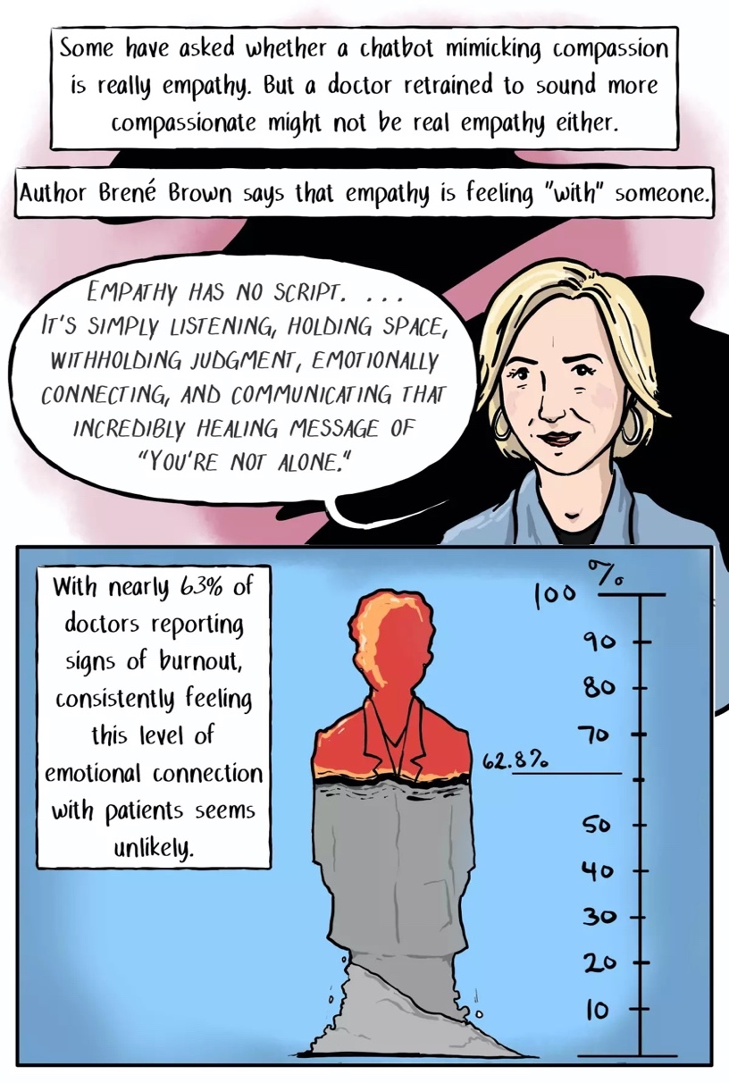

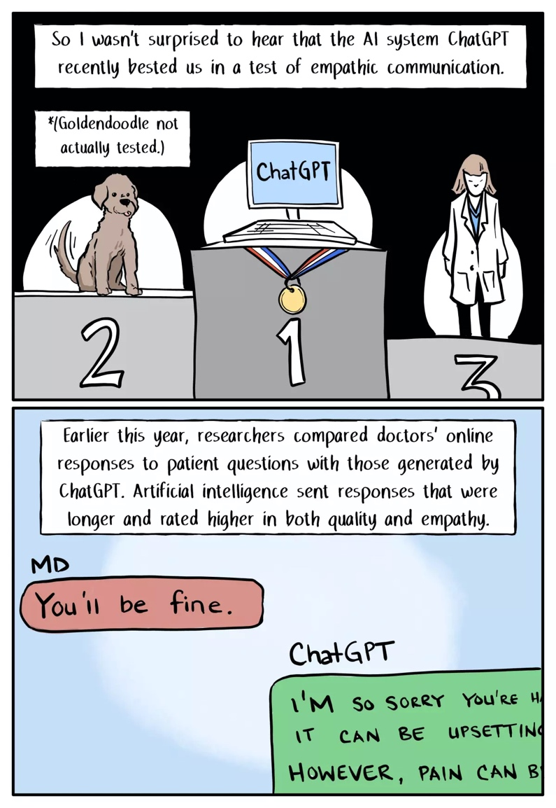

How does the document challenge traditional ideas about empathy in healthcare, and what does it suggest about the role of AI might play in providing emotional support?

