CB type X-ENS / CENTRALE - Anglais LV1

Consignes CENTRALE :
Partie A synthèse : 500 MOTS +/- 10% (DOC1,2,3,4)
Rédigez en anglais une synthèse des documents proposés.
Sans paraphraser les documents proposés dans le dossier, la.le candidat.e réalisera une synthèse de celui-ci, en mettant clairement en valeur ses principaux enseignements et enjeux dans le contexte de l'aire géographique de la langue choisie, et, en prenant soin de n’ajouter aucun commentaire personnel à sa composition. La synthèse proposée devra comprendre entre 450 et 550 mots et sera rédigée intégralement dans la langue choisie. Elle sera en outre obligatoirement précédée d’un titre proposé par le candidat.

Doc 1: The Star-Making Machine that Created "Donald Trump" - The New York Times, Suzanne Craig, 14/09/2024,
Doc 2: Screenshot of a Tiktok account promoting Trump and the MAGA movement, 12/10/2024
Doc 3: 'People said it destroyed his career': 33 pictures that defined British politicians - The Guardian, Jonathan Freedland, 03/02/2024
Doc 4: Meet Simon Harris, Ireland's first TikTok prime minister - Politico, Shawn Pogatchnik, 26/3/2024

Consignes X- ENS :
Partie A synthèse : 600 MOTS +/- 10% (DOC1,2,3,4)
+ Partie B : Rédaction d’un article d’opinion (DOC5) : article de Sophia Smith-Galer, publié par The Guardian, et intitulé “Nigel Farage's mastery of TikTok is impressive - and who could blame him? He just makes the most of social media.”

PARTIE A - SYNTHÈSE DE DOCUMENTS
Doc 1:
The Star-Making Machine that Created "Donald Trump"
The New York Times, Suzanne Craig, 14/09/2024

Late in the summer of 2003, a team of television producers stepped off the elevator on the 26th floor of Trump Tower eager to survey the set of their next reality show. Right away, they knew they had a problem. The first thing they noticed was the stench, a musty carpet odor that followed them like an invisible cloud. Then they spotted cracks in the wooden desks and credenzas. The décor felt long out of date, making the space seem like a time capsule from when Donald J. Trump opened the building early in his first rise to fame in the early 1980’s.
The place did not exactly buzz with energy either. Fewer than 50 people worked at Trump Organization headquarters in midtown Manhattan. At the office’s spiritual center, Mr. Trump’s own desk bore no evidence of work, no computer screens or piles of contracts and blueprints, just a blanket of news articles focused on one subject: himself.
“When you go into the office and you’re hearing ‘billionaire,’ even ‘recovering billionaire,’ you don’t expect to see chipped furniture, you don’t expect to smell carpet that needs to be refreshed in the worst, worst way,” recalled Bill Pruitt, a producer of this new NBC show. That program, “The Apprentice,” would be a game show, with a job in this office as the ultimate prize. But that prize, in a literal sense, stank. Making viewers believe the central conceit — that Ivy League graduates would eagerly humiliate themselves for a chance to learn at the side of this icon of success — would test the bounds of reality television magic.
This account of Mr. Trump’s first years on “The Apprentice” is drawn from my forthcoming book, “Lucky Loser: How Donald Trump Squandered His Father’s Fortune and Created the Illusion of Success.” It is based on interviews over several years, confidential records from the show, and the decades of Trump family financial and tax records obtained during a prior investigative reporting for The New York Times. (…)
Mr. Trump had mostly luck to credit for being discovered, at age 57, by Mark Burnett, then the hottest name in the hottest new television genre. With two groundbreaking reality hits under his belt — “Eco Challenge” and “Survivor” — Mr. Burnett was the darling of network executives, who were hungry for his next creation. His company, a well-oiled machine with a deep bench of producers, would handle the creative and business sides of the new show. Mr. Trump would need only to play a re-crafted version of himself.
Mr. Burnett’s team had contacted several moguls — Jack Welch, Warren Buffett and Richard Branson — who would not require a reputational makeover. But the producers concluded that those men lacked either the time or the necessary charisma. For better or worse, Mr. Trump, long a staple of the New York City tabloids, drew eyeballs and would never shy away from a camera.
“The Apprentice” would follow the same format as “Survivor.” Contestants would be divided into two teams and compete in a different “challenge” each week. At the end of an episode, the losing team would meet with Mr. Trump, who after encouraging some sniping among contestants would look at one and utter what became his signature phrase, “You’re fired!” The last two remaining contestants would compete in a season finale for a yearlong apprenticeship — with a salary paid by the network — at the Trump Organization.
Whether it would all work remained an open question. Not letting viewers see, or smell, Mr. Trump’s office would be the easy part. The producers would also need to invent a version of Donald Trump that did not actually exist — measured, thoughtful and endlessly wealthy — a complete rehabilitation of his public image. In the most recent Gallup survey measuring Mr. Trump’s reputation before the show, 98 percent of those polled knew his name, but 58 percent viewed him unfavorably.
“Our job was to make him look legitimate, to make him look like there was something behind it, even though we pretty much all knew that there wasn’t — but that was our job,” remembered Jonathon Braun, a producer who had worked on “Survivor.” “We weren’t making a documentary,” he added. “Richard Attenborough was not narrating this. This was an entertainment prime-​time network show.”
And that show created an unlikely reality TV star, one whose mysterious and yet undeniable

appeal to viewers would ultimately find its biggest stage on the presidential campaign trail.

Doc 2: Screenshot of a Tiktok account promoting Trump and the MAGA movement, 12/10
2024
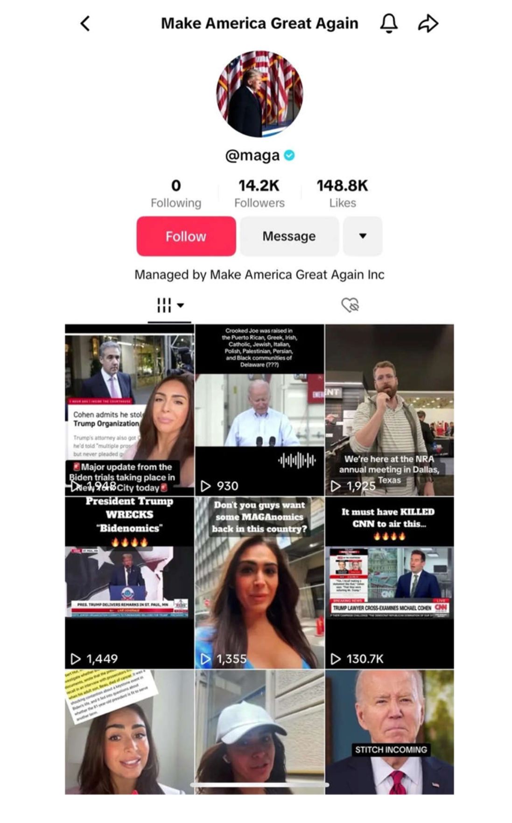

Doc 3: 'People said it destroyed his career': 33 pictures that defined British politicians
The Guardian, 03/02/2024, Jonathan Freedland

There’s a type of hard-boiled political operative who always has the TV on in the office – sometimes more than one – permanently set to the news channels and almost always with the sound turned down. You might think that’s because they need quiet to work, and should something of interest appear, they would turn the volume up. But that’s not quite right. This brand of political professional believes that, when it comes to watching news coverage, the sound is all but irrelevant. What registers with people – with voters – are the pictures.
Does the leader look strong and in command? Or weak and hesitant? Is the candidate smiling, brimming with confidence? Or brooding, head in hands? Do they look natural, at ease with ordinary people – or gauche and awkward, a visiting alien from Planet Politician? For any of these judgments, you don’t need to hear the words. The image alone tells the story.
Many of the 33 pictures collected here do that for some of the best-known figures of recent British political history. Take the 1986 photograph of Margaret Thatcher in a tank. At the time, it was mocked aplenty. And you can see that, were someone else to try the same pose, or wear those same goggles, ridicule would be the first response. Indeed, when failed Democratic presidential nominee Michael Dukakis attempted a similar stunt two years later, the resulting visual became an immediate TV ad – for his opponent. But for Thatcher it worked, making real what had, until then, been an imagining of the political cartoonists, casting Thatcher, she who had vanquished the Argentines in the Falklands war, as a latter-day Boudicca, a warrior queen, the Iron Lady.
The lasting images tend to work like that, crystallising, for good or ill, a view already loosely taking shape in the public – or at least the media’s – mind. Boris Johnson on a zip wire: national court jester, a lovable fool not to be judged by the harsher standards applied to more conventional politicians (an exceptionalism that Johnson exploited all the way to, and once inside, Downing Street). Nigel Farage: grinning John Bull and cavalier, ready to defy the nannying roundheads with their strictures against beer and fags. Theresa May and Ed Miliband: robot and geek, respectively, who, when attempting to do something spontaneous and recognisably human, such as dancing or eating a sandwich, seemed to struggle – sufficiently, in May’s case, to make the viewer blush with embarrassment.
Ed Miliband’s brother David was feted in the US as dashingly handsome – Vogue magazine confessed to a “crush” on the then foreign secretary – but at home the snappers decided he was a nerd, the last kid to be picked for the football team: he could be cast as Mr Bean. Even if the camera never lies, it often fibs – serving to confirm a previously unarticulated, frequently unfair prejudice. And once it has, it sticks.
And yet, the reason why many of the pictures collected here have such enduring power is that they capture not only the essence – real or imagined – of an individual, but an entire era. Need to evoke the optimism of mid-1960s Britain? Here’s the Beatles alongside Harold Wilson, who together trigger that folk memory in a split second.
Meanwhile, some photographs are capable of more than simply prompting a recollection: they serve as wordless historical essays, silently explaining the causes, or anticipating the effects, of the epochal events of the last century or more.
Neville Chamberlain brandishing the Munich Agreement of 1938 – the infamous “piece of paper” he had signed along with Adolf Hitler, supposedly promising peace between Britain and Nazi Germany – is a telling example. We see not just a politician, a microphone and a cheering crowd, but the naivete of a British prime minister bent on compromising with an enemy who we, with all the hindsight of history, know to have been fatally unappeasable. We see a British public, still drained by a global war that had ended just two decades earlier, applauding a prime minister who had won a promise that Britons and Germans would agree “never to go to war with one another again”. We see the encouragement this would give to the dictator, encouraging him in his ambition to conquer all of Europe – and the lethal consequences that would bring. All in a single snapshot.

Doc 4: Meet Simon Harris, Ireland's first TikTok prime minister
Politico, Shawn Pogatchnik, 26/3/2024

When Leo Varadkar shocked his party and the nation by quitting as Ireland’s prime minister, only one politician appeared ready to seize the moment: Simon Harris. The two clichés now most commonly applied to Harris, 37, are that he’s been “a young man in a hurry” and will be Ireland’s first “TikTok Taoiseach.” Both are true — and essential to understanding why Harris so convincingly won the race to become leader of the governing Fine Gael party and, soon, Ireland’s first Millennial premier.
By his own estimation, Harris has climbed the political ladder “a lot faster than I expected.” Next month, when lawmakers formally elect him Taoiseach, the Irish office title meaning “chief” and pronounced “tee-shuck,” Harris will become Ireland’s youngest-ever prime minister. His victory was assured when no other candidates stood against him, turning the contest to replace Varadkar, who stood down without warning Wednesday, into a one-horse race that ended Sunday.
Colleagues and political pundits long have billed the gangly County Wicklow lawmaker as a future Taoiseach thanks to his sharp oratory and listening skills, as well as his positive energy and work ethic. He’d already been identified as a natural politician as a teenager, growing up in a coastal commuter town south of Dublin, the son of a taxi driver and a special-needs assistant.
By 24 he was representing his native county of Wicklow in Dáil Éireann, the key lower house of the Oireachtas, Ireland’s two-chamber parliament, at a threshold moment for Fine Gael which had just enjoyed its biggest election victory. He gained an immediate seat on the most powerful parliamentary committee, Public Accounts. When Fine Gael suffered significant electoral losses in 2016 but survived atop a fragile minority government, he was thrust into the most difficult Cabinet post, health.
While Harris fared no better in delivering concrete results than his predecessors, he displayed a social media-friendly likability that rendered him seemingly immune to political damage in a post battling labor unrest, crowded hospital corridors, nightmare waiting lists, cost overruns and malpractice scandals. It helped Harris’ reputation as health minister that he had started his teenage political career by demanding better government support for special-needs children, citing his own younger brother Adam, who has autism.
In 2017 Harris married Caoimhe Wade, his longtime girlfriend and a cardiac nurse at a Dublin hospital for children. The Harrises have settled in his childhood home of Greystones, one of Ireland’s wealthiest communities boasting the most expensive property outside Dublin. They’ve gone on to have a girl and a boy, all documented in the tabloids with help from Harris’ own social media posts. It is a key characteristic of Harris the politician: ease at merging the personal and political on his active social media pages, including Facebook, Instagram and particularly TikTok.
His comfort with social media proved a powerful base for voter engagement when, following a 2020 election that left a weakened Fine Gael limping into a new three-party coalition government, Varadkar demoted Harris to a second-tier Cabinet post overseeing third-level education. The brief offered an ideal base for Harris to travel weekly from campus to campus, microblogging and selfie-shooting across the nation, building an image as a lawmaker more connected to the concerns of teens and 20-somethings struggling to start families and secure homes.
As Harris prepares to become Taoiseach his TikTok followers are approaching 100,000, more than 10 times that of his party’s account. As usual, in his latest post, Harris talks straight into the camera, thanks his hundreds of thousands of viewers for their “friendship,” and notes how far he’s come from his first political activism “as an opinionated, moody teenager.” He keeps his comments open on all forums but typically doesn’t reply to any of the hundreds of angry
messages demanding an immediate general election.

Partie B - Article d'opinion
Doc 5: Nigel Farage's mastery of TikTok is impressive - and who could blame him? He just makes the most of social media
The Guardian - Sophia Smith-Galer, 2/7/2024

Nigel Farage was born to be a TikTok star. He joined the platform in March 2022, announcing “it’s got to be done, it’s where it’s at” in a video that has been watched more than 600,000 times. He is still one of the first politicians to bother taking the platform seriously, and it is paying him vast dividends. The Guardian reported last week that Farage is outperforming all other UK parties and candidates on TikTok in terms of engagement and average views, according to data from 22 May to 17 June.
Farage has been prolific in his output since his election candidacy was announced. He posted several times a day for the first weeks of his campaign, flooding the algorithm with short, characterful videos that resonate powerfully with his fanbase. The recipe to his success is clear: he’s opinionated, comical and – most compellingly in British politics – himself.
You don’t need to be silly on TikTok, but it is where buffo politicians can excel. Much of the ire surrounding political campaigns this summer has focused on the humourlessness of Rishi Sunak and Keir Starmer. As the PM and the likely PM elect, they can’t really afford to take things lightly, but combined with their robot soundbites it has meant that they come across looking as if they have the emotional spectrums of kitchen cabinets.
It’s in this ecosystem where Farage’s TikToks – particularly his comic ones – are racking up the views. One in 10 British adults use TikTok as a source of news – putting it on par with the Guardian in 2023 – but many, many more will use it as a source of entertainment. (…)
Europe’s populist right understands the value of comedy but less extreme politicians are completely inarticulate about it. Not only does it humanise them, it games the algorithm to promote content that has absolutely nothing to do with their political agendas. The high view counts of the comedy material ensures that the videos about their political agendas are more likely to appear on users’ For You pages, even if they’re less effective.
And in terms of crafting the videos, Farage is an astute content creator. You can tell if someone benefits from making shock-jock material if they focus on pushing out shorter content – plenty of his videos are barely even six seconds long. But Farage doesn’t need long content. Making longer TikToks normally demands explanations and storytelling craft to maintain attention. He knows that saying something short and shocking is enough to get support and shares from those he targets.
This is a business of unforgiving video retention rates, with a video’s success dictated by how many people not only stick around to watch the first five seconds, but who go on to watch right until the end. TikTok audiences will love to watch him and hate to watch him, and the shorter the video, the more likely it is it will loop, guzzling in rewatch time.
A look through Farage’s posting history shows he hasn’t been afraid to experiment. There are videos made to look like fan edits, explainer formats and behind-the-scenes footage of the campaign trail, showing an agility and appetite for throwing stuff at the wall and seeing what sticks. He has a 23-year-old rightwing creator now assisting him, and he will also be emboldened by cross-pollination with Reform UK’s active TikTok following, too.
The overwhelming majority of British politicians do not have even 1,000 followers on TikTok. Farage, an anti-mainstream media figure who is constantly protesting about his lack of platforming, always stood the most to gain from an app such as TikTok: it’s a place you can build a platform with nothing other than a personality. When governments were busy toying with TikTok bans and kicking the app around like a geopolitical hot potato, the likes of Farage were already in the dressing room getting prepared. Now, in the throes of an election campaign in which political parties took their time getting on board with social media, other candidates are hurriedly trying to make TikTok content from square one. I imagine Farage doesn’t care; he is already basking in the spotlight.

