
Climate tech solutions and climate realities :
green tech or greenwashing?

VOCAB – CLIMATE CHANGE and CLIMATE TECH

Activity 1 - Find words around these themes, in 4 groups:

Group 1. Climate and environment Group 2. Human impact and pollution
Group 3. Climate solutions and technology Group 4. Policy, responsibility, society

……………………………………………………………………………………………………………………………………………………..….

……………………………………………………………………………………………………………………………………………………..….

……………………………………………………………………………………………………………………………………………………..….

……………………………………………………………………………………………………………………………………………………..….

……………………………………………………………………………………………………………………………………………………..….

……………………………………………………………………………………………………………………………………………………..….

Activity 2 - Match the word to its definition
Definitions:
a. The variety of living species in an ecosystem
b. Doubt or questioning of claims
c. Belief that technology alone can solve complex problems
d. The total amount of greenhouse gas emissions caused by an individual, organization, or product
e. Systems designed to improve energy efficiency through technology
f. Achieving net-zero carbon emissions
g. Large-scale technological interventions to control the climate
h. Ability to recover from shocks or disasters
i. Meeting present needs without harming future generations
j. Unexpected outcomes resulting from actions

Words :
- Carbon footprint
- Geoengineering
- Sustainability
- Smart grids
- Tech solutionism
- Biodiversity
- Unintended consequences
- Resilience
- Carbon neutrality
- Skepticism

Activity 3 - Fill in the blank

Word Box: carbon capture, global warming, trade-offs, digital monitoring, innovation, environmental justice
- Satellites are used for __________ of deforestation and pollution.
- Many scientists warn that __________ is causing more extreme weather events.
- __________ in battery technology is essential for electric cars and renewable energy.
- Communities demand __________ to ensure that vulnerable populations are not disproportionately affected by climate change.
- There are always __________ when implementing new environmental policies.
- Some companies invest in __________ to remove CO₂ from the atmosphere.

DOC 1 – Scientists and Climate Change - 2023
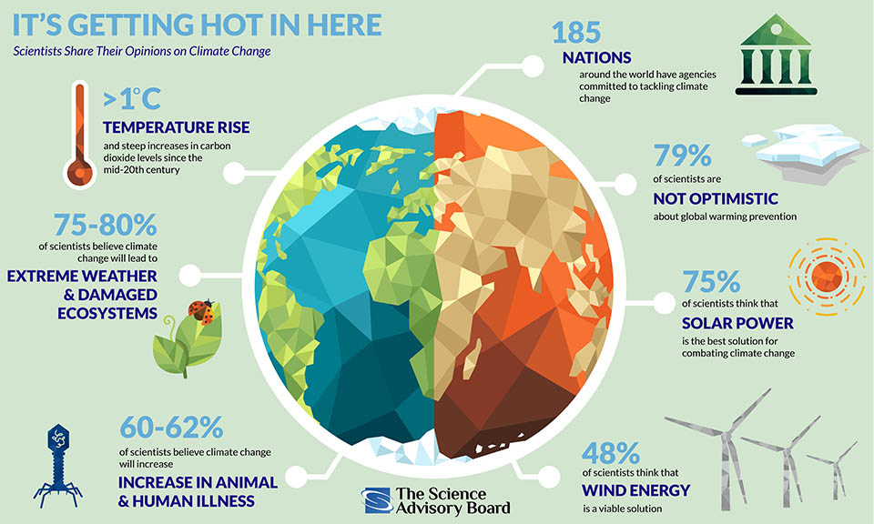

https://www.scienceboard.net/

DOC 2 – Climate Tech vs. Cleantech: what's the difference?

Watch the video and propose a definition of both terms.
https://www.youtube.com/watch?v=OskYAE3P9oI&t=78s

……………………………………………………………………………………………………………………………………………………..….

……………………………………………………………………………………………………………………………………………………..….

……………………………………………………………………………………………………………………………………………………..….
……………………………………………………………………………………………………………………………………………………..….

DOC 3 – Videos from the United Nation Environment Programme (UNEP)
Recap what you’ve learnt from how tech projects are helping in Malawi and in Saint Kitts and Nevis
https://www.unep.org/technical-highlight/how-technology-helping-communities-across-globe-adapt-climate-change

……………………………………………………………………………………………………………………………………………………..….

……………………………………………………………………………………………………………………………………………………..….

……………………………………………………………………………………………………………………………………………………..….
……………………………………………………………………………………………………………………………………………………..….

……………………………………………………………………………………………………………………………………………………..….

……………………………………………………………………………………………………………………………………………………..….

……………………………………………………………………………………………………………………………………………………..….
……………………………………………………………………………………………………………………………………………………..….

……………………………………………………………………………………………………………………………………………………..….

……………………………………………………………………………………………………………………………………………………..….

……………………………………………………………………………………………………………………………………………………..….

