Climate and tech solutionism

DOCUMENT 1 – Tom Toles – The Washington Post - 2010
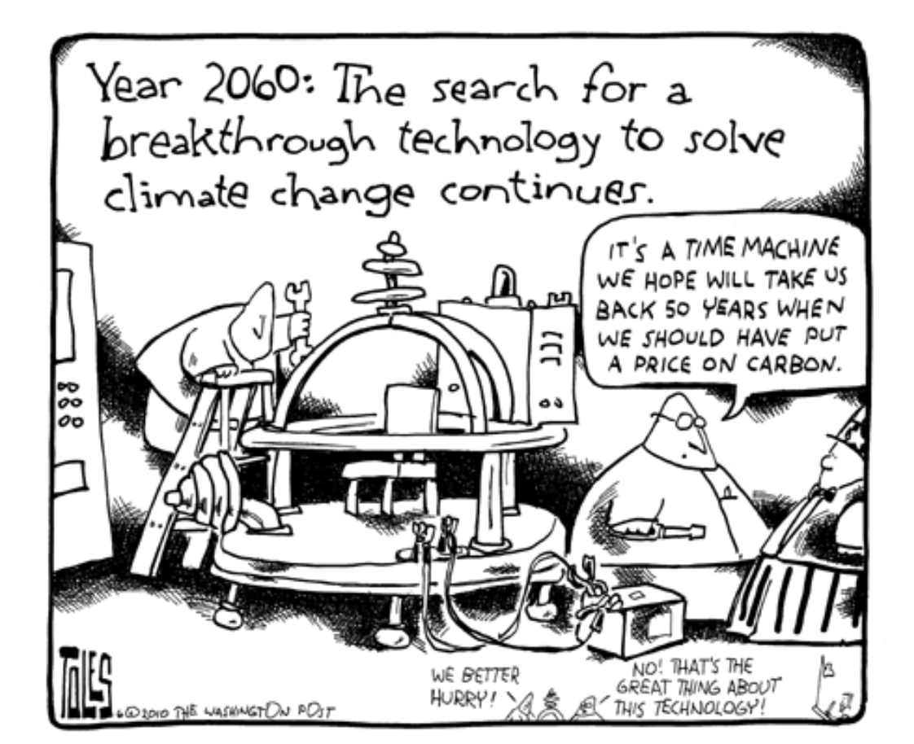

Q: How does the cartoon use humor and satire to criticize society’s approach to solving climate change?

DOCUMENT 2
Big tech is increasingly promising to pay for spiking power costs. But there’s not much to enforce it
Ella Nilsen – 22nd January 2026 – CNN
As an electricity crunch drives bills higher around the country, big tech companies building power-hungry data centers are increasingly offering to pay for more of the energy they consume, so everyday people don’t get stuck with the bill.
At least, that is the message from seven large tech companies in new letters responding to three Senate Democrats’ investigation into how data center buildout nationwide is impacting electricity prices. But while these companies can make commitments, there are few regulations to ensure those promises are kept.
In mid-Atlantic states especially, a sudden boom in data center growth combined with a lack of new power to supply them has caused sharp electricity bill spikes in states including Maryland, Virginia, New Jersey and the District of Columbia. Around the country, certain areas where data centers were built saw electricity costs jump as much as 267% compared to five years ago, a 2025 Bloomberg News analysis found.
Seven companies, Google, Amazon, Microsoft, Meta, Coreweave, Equinix and Digital Realty, responded to questions from the senators on how many data centers they had, how much power those facilities needed, and how they plan to procure and pay for that power.Google said it would pay for all of the electricity it would use to power its fleet of data centers and would make changes to how it manages and pays for energy use when the grid’s power usage is at its highest, a time period when data center power use can drive up prices for other customers.Similarly, Meta told CNN it pays for the “full costs for energy used by our data centers” as well as funding “new and upgraded local infrastructure.”
Yet, it is exceedingly difficult to know exactly how much big tech companies are actually paying electrical utilities for the power they consume. That’s because there are often secret contracts inked between utilities and data centers, rather than a public rate case, said Ari Peskoe, director of the Harvard Law School’s electricity law initiative. While there is a patchwork of states trying to adopt rules around data center companies paying higher electricity rates, there is currently no federal equivalent.
Senator ChrisVan Hollen, whose home state of Maryland has seen neighboring Virginia’s massive data center buildout show up in residential electricity bills, has introduced a federal bill requiring companies to cover their energy costs. “Big tech companies are finally beginning to acknowledge that their data centers are saddling consumers with higher electricity costs and straining our power grid – but they still refuse to take full responsibility for these problems they are creating,” Van Hollen said in a statement. “Without action from Congress, they will continue to evade accountability.”
However, there are signs that the public outcry over costs has reached the White House. Last week, President Donald Trump teased an announcement from Microsoft that it would cover the cost of its electricity and help update the grid, acknowledging the public concern over high electricity prices. “We will have much to announce in the coming weeks to ensure that Americans don’t ‘pick up the tab’ for their POWER consumption, in terms of higher Utility bills,” Trump said in a Truth Social post last week.
On Friday, a group of northeastern governors and the Trump administration announced they were asking PJM, the country’s largest electrical grid operator, to hold an emergency power auction focused on getting big tech companies locked into 15-year contracts to pay for the power costs to feed their data centers. That would essentially ensure the world’s largest companies pay for their future power needs, and the region could depend on that money to pay for power for a long period of time.
Peskoe said it’s a sign that companies and the administration are taking the issue seriously – but it’s no guarantee progress will happen. “What I think is positive is they are acknowledging there is a problem here that needs to be solved,” he said.

Q : What problem are rising electricity costs causing for U.S. consumers, and how are big tech companies and government authorities attempting to address it?

DOCUMENT 3

Will AI Underwrite the Next Climate Tech Boom?

Time Magazine, January 2026 – Justin Worland

Every January, when the World Economic Forum comes to town, Davos stops being a quaint skiing town and becomes a corporate pantheon. The world’s biggest companies take over the storefronts with glossy displays—signals to investors, policymakers, and one another about what matters most.
Six years ago, the promenade was a catwalk for ESG and climate. This year AI was everywhere—seemingly at climate’s expense. But beyond the glossy displays, another conversation was taking hold among tech companies, investors, and project developers: AI will require an enormous amount of electricity to scale. Unlocking its promise means investing in—and partnering with—the energy companies that can deliver power quickly and reliably.
This has been largely understood as a climate problem. More energy means more emissions. But really it should be understood as a climate opportunity. As companies pour hundreds of billions of dollars into AI, they are also pouring hundreds of billions into energy. And many of the firms positioned to do that happen to be building the clean-energy technologies that could decarbonize the grid at the same time.
“This is one of the largest purchasing budgets in history,” says Chase Lochmiller, the CEO of Crusoe, a data center developer known for treating power supply as its starting point. “It can provide a massive demand signal for new energy technologies that are burgeoning.”
The question now is to what degree those new low-carbon technologies can beat out growth in gas generation.
In a way this insight isn’t new. Over the last two years, as electricity demand started rising in the U.S., power companies offered an enthusiastic narrative arguing that expanding to meet this need would allow them to invest in clean energy. But what struck me in Davos this month was how AI's capital intensity has turned this from utility talking points into a genuine investment thesis with animal spirits behind it.
To understand that enthusiasm, just look at the companies at the center of the conversation. Some of the darlings on the ground included businesses like Bloom Energy, which builds fuel cells that provide onsite generation. Its stock is up 500% in the last year. Big firms, too, are riding the wave. In Davos, companies like Schneider Electric and Johnson Controls touted their efficiency technologies, and have seen their stock rise to boot. Constellation Energy, whose stock has more than doubled in the last two years, talked about the bright future for nuclear power as data center developers race to buy the company’s low-carbon electrons.
The other thing that struck me in Davos is the role of the data center developers. In much of the broader climate zeitgeist, tech companies and data center developers are the villains because they are producing new sources of emissions. This may be true in a sense, but it is also true that they are a key driver of demand for clean power—especially in the U.S.—at a time when the political winds are not in favor of anything green-tinged. “The number one factor in terms of building new data centers is the availability of land with, ideally, clean power,” said Abhijit Dubey, president and CEO of NTT DATA, on a TIME panel in Davos. “Do we have actual clean power available? That defines where we are building data centers.”
To be clear, despite what some of the most committed data center developers may say, a substantial portion of new electricity demand in the U.S., the world’s biggest market for data centers, will be met with gas power. And Washington has used data center expansion as a pretext to insist that coal-fired power plants remain online, too.
But one thing I keep coming back to in 2026 is that from an emissions perspective the U.S. isn’t the only place that matters, even as data centers present new challenges to decarbonization. If today’s investments can actually make clean energy cheaper and more reliable than fossil fuels, the AI boom might end up accelerating decarbonization globally, even if it creates near-term emissions challenges in the U.S.

Q : What challenge does the growth of AI and data centers create for the energy sector, and how could it also present an opportunity for clean-energy development?

DOCUMENT 4

‘A Trojan horse of legitimacy’: Shell launches a ‘climate tech’ startup advertising jobs in oil and gas

The Guardian – Molly Taft – 28th February 2024

A sleek new startup promising to ‘advance the energy transition’ launched earlier this month promising to “[connect] thousands of innovators across the globe to tackle difficult energy and climate challenges”.
The venture, Onward, is owned by Shell, a company that brought in $28bn in profits from oil and gas last year. The company’s website says it is “accelerating pathways to energy innovation”, serving as a “hub for innovation, collaboration and entrepreneurialism”, and creating a “compelling, evidence-based picture of the benefits of a net-zero future”. Team bios include descriptions of an ideal day “in our clean energy future”: kitesurfing, snorkeling and hiking.
However, despite an abundance of green imagery and language, much of the platform, which until recently was called Studio X, appears to focus on improving oil and gas outcomes, an analysis by Drilled and the Guardian has found.
Projects like Onward “[allow] Shell to pretend it’s helping find solutions instead of just accelerating the climate crisis”, Paris Marx, a technology critic and host of the Tech Won’t Save Us podcast, told Drilled. A Shell spokesperson said: “Shell has endeavoured to be clear in communications that Studio X was set up to develop and scale up new techniques to explore for oil and gas. These fuels remain essential to the global energy system and we are proud to provide them. We have maintained that this is an important part of our business, even as we invest in the low carbon system of the future.” The spokesperson added that in 2023, $5.6bn of Shell’s overall capital spend, nearly a quarter of the total, was on “low carbon energy”. They did not provide a breakdown of those expenditures.
Onward is just the latest of several climate tech projects by fossil fuel companies. Shell has at least three other projects created to invest in energy startups, and in 2022, according to the company, it invested 89% more than it did the previous year in “low-carbon energy solutions”. Saudi Aramco, the world’s largest oil company, has a $7bn fund and a portfolio of investments in renewables, storage, carbon capture and sequestration, and futuristic fuels like hydrogen and ammonia. Exxon, meanwhile, has plans to invest $7bn in carbon capture and storage, hydrogen and “lower-emission fuels” through 2027. In January, representatives from Shell, Chevron, SoCal Gas, BP, Southern Company, and Saudi Aramco were all on the guest list at a cleantech industry conference in San Diego.
However, many experts say these ventures are largely part of a broad greenwashing strategy.
The world’s leading climate authority has said that all oil and gas exploration must cease worldwide by 2030 in order to avoid the worst impacts of the climate crisis. But even as they flaunt their involvement in climate tech and investment in climate “solutions”, major fossil fuel companies are ramping up production and doing away with previous climate promises and targets.
In conversations with other outlets, Onward’s CEO, Jeff Allyn, said that the organization aims to help solve thorny problems, like “scope 3” emissions, with the energy transition. “The more people we have engaged with the community, the quicker we can create new and innovative solutions to the challenges we face,” Allyn told Axios in February.
The emphasis on collaboration to solve the climate crisis is one that consistently crops up in oil and gas public communication, said Melissa Aronczyk, a professor of journalism and media at Rutgers University.
“Behind the idea of collaboration is the idea that everyone is an equal stakeholder in this movement, that we are all in together to combat climate change,” she said. “But that’s really not what’s going on.”
Aroczyk pointed out that at recent UN climate meetings, oil and gas companies, their lobbyists, and other polluters have been consistently invited to the table under the guise of collaboration – invitations that have enabled them to further block needed action.
“It’s a Trojan horse of legitimacy,” she said. “You’re under cover of the idea that the climate movement is an all-hands-on-deck situation, but what you’re really doing is bringing in players who have very different ideas of what it means to ‘solve’ the climate crisis.”

Q - What is the main concern about Shell’s new climate tech startup, and how does it relate to the company’s overall role in the energy transition?

