

ANGLAIS - Durée : 3 heures – MP2I
RAPPEL DES CONSIGNES
• Utiliser uniquement un stylo noir ou bleu foncé non effaçable pour la rédaction de votre composition
• Ne pas utiliser de correcteur.
• Écrire le mot FIN à la fin de votre composition.
L'usage de toute machine (calculatrice, traductrice, etc.) est strictement interdit.

Rédiger en anglais et en 400 mots une synthèse des documents proposés, qui devra obligatoirement comporter un titre.
Vous indiquerez impérativement le nombre total de mots utilisés (titre inclus) et vous aurez soin d'en faciliter la vérification en mettant un trait vertical tous les vingt mots.
Des points de pénalité seront soustraits en cas de non-respect du nombre total de mots utilisés avec une tolérance de ± 10 %.
Concernant la présentation du corpus dans l'introduction, vous n'indiquerez que la source et la date de chaque document. Vous pourrez ensuite, dans le corps de la synthèse, faire référence à ces documents par « doc.1 », « doc. 2 », etc.

DOC 1

San Francisco sues nation's top food manufacturers over ultra-processed foods
Wilfredo Lee - December 3, 2025 - The Associated Press

The city of San Francisco filed a lawsuit against some of the nation's top food manufacturers on Tuesday, arguing that ultra-processed food from the likes of Coca-Cola and Nestle are responsible for a public health crisis. City Attorney David Chiu named 10 companies in the lawsuit, including the makers of such popular foods as Oreo cookies, Sour Patch Kids, Kit Kat, Cheerios and Lunchables. The lawsuit argues that ultra-processed foods are linked to diseases such as Type 2 diabetes, fatty liver disease and cancer.
"They took food and made it unrecognizable and harmful to the human body," Chiu said in a news release. "These companies engineered a public health crisis, they profited handsomely, and now they need to take responsibility for the harm they have caused."
Ultra-processed foods include candy, chips, processed meats, sodas, energy drinks, breakfast cereals and other foods that are designed to "stimulate cravings and encourage overconsumption," Chiu's office said in the release. Such foods are "formulations of often chemically manipulated cheap ingredients with little if any whole food added," Chiu wrote in the lawsuit.
The other companies named in the lawsuit are PepsiCo; Kraft Heinz Co; Post Holdings; Mondelez Int; General Mills; Kellogg; Mars Incorporated; and ConAgra Brands. None of the companies named in the suit immediately responded to emailed requests for comment.
U.S. Health Secretary Robert F. Kennedy Jr. has been vocal about the negative impact of ultra-processed foods and their links to chronic disease and has targeted them in his Make America Healthy Again campaign. Kennedy has pushed to ban such foods from the Supplemental Nutrition Assistance Program for low-income families.
An August report by the U.S. Centers for Disease Control and Prevention found that most Americans get more than half their calories from ultra-processed foods. In October, California Gov. Gavin Newsom signed a first-in-the-nation law to phase out certain ultra-processed foods from school meals over the next decade. San Francisco's lawsuit cites several scientific studies on the negative impact of ultra-processed foods on human health.
"Mounting research now links these products to serious diseases—including Type 2 diabetes, fatty liver disease, heart disease, colorectal cancer, and even depression at younger ages," University of California, San Francisco, professor Kim Newell-Green said in the news release.
The lawsuit argues that by producing and promoting ultra-processed foods, the companies violate California's Unfair Competition Law and public nuisance statute. It seeks a court order preventing the companies from "deceptive marketing" and requiring them to take actions such as consumer education on the health risks of ultra-processed foods and limiting advertising and marketing of ultra-processed foods to children.
It also asks for financial penalties to help local governments with health care costs caused by the consumption of ultra-processed foods.

DOC 2

Ultra-processed foods have more in common with cigarettes than vegetables, study finds
Holly Evans – 6th February 2026 - The Independent

Ultra-processed foods (UPFs) should face stricter regulation, a study has argued, after it found that they were more similar to cigarettes than to fruit and vegetables. Research from three US universities found that both products have been engineered to encourage consumption and addiction, and called for public health efforts to limit their impact.
Evidence from 50 countries now links high UPF consumption to rising rates of obesity, neurological changes and metabolic dysfunction, such as Parkinson’s disease. Recent estimates indicate that one American dies every four minutes from preventable diseases associated with these products. Scientists from Harvard, Duke University and the University of Michigan found both industries had used similar strategies to evade regulation and increase product appeal, which “collectively hijack human biology”.
While ultra-processed foods include obvious culprits like potato chips, candy and frozen pizza, there are also some that people may believe are good for them, such as packaged granola bars, sports drinks and fruit-filled yoghurt.
Examples of this would include marketing claims on products such as protein bars that indicate they are “low fat” or “sugar free”, tactics which scientists say are “health washing” akin to similar moves by the tobacco industry to advertise cigarette filters in the 1950s.
Both cigarettes and UPFs are engineered to deliver a “just right” dose of reinforcing substances: nicotine in the case of cigarettes, and refined carbohydrates and fats in the case of UPFs. The study, which was published in the healthcare journal The Milbank Quarterly, analysed data from the fields of nutrition, addiction science and public health history to draw comparisons.
While reducing smoking was one of the most significant public health achievements of the 20th century, UPFs continue to dominate the global food market, with calls for policy tools to be enforced that include restrictions on child-targeted marketing and limited availability in schools.
The study concluded: “UPFs should be evaluated not only through a nutritional lens but also as addictive, industrially engineered substances. Lessons from tobacco regulation, including litigation, marketing restrictions, and structural interventions, offer a roadmap for reducing UPF-related harm. Public health efforts must shift from individual responsibility to food industry accountability, recognising UPFs as potent drivers of preventable disease.”
Prof Ashley Gearhardt from the University of Michigan, a clinical psychologist specialising in addiction and one of the study authors, said her patients made the same links: “They would say, ‘I feel addicted to this stuff, I crave it – I used to smoke cigarettes [and] now I have the same habit but it’s with soda and doughnuts. I know it’s killing me; I want to quit, but I can’t.’”
She added: “We just blame it on the individual for a while and say, ‘Oh, you know, just smoke in moderation, drink in moderation’ – and eventually we get to a point where we understand the levers that the industry can pull to create products that can really hook people.”

DOC 3

Americans on healthy food and eating – Pewresearch – May 2025

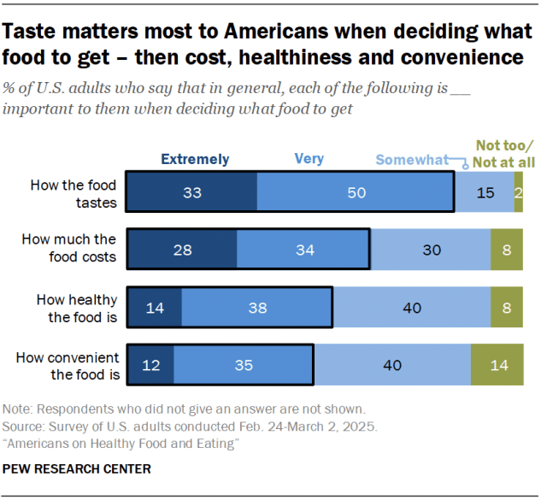

DOC 4

Will you notice any change at the grocery store because of RFK Jr.’s new food guidelines? You already have By Vanessa Yurkevich – CNN - Jan 9, 2026

The food pyramid is getting turned upside down, with protein and dairy gaining more prominence in the suggested American diet. Sugar and processed foods are getting shunned even more with warning labels. It has whiffs of MAHA, as the new dietary guidelines for Americans promote controversial saturated fats.
But if you think big changes are coming to the grocery store, think again: They’ve already happened, as consumers have been making the shift to healthier foods for years. “I think it reinforces a lot of what the consumer knows about protein being good for you, the need for avoiding excessive calories in certain categories, try to avoid excessive sugar,” said Michael Swanson, chief agricultural economist at the Wells-Fargo Agri-Food Institute. “I think that this is a continuation of a message that they’ve heard for many, many years.”
New dietary guidelines are released by the Department of Health and Human Services and the Department of Agriculture every five years. Federal programs like the Supplemental Nutrition Assistance Program, or SNAP, and Women, Infants and Children, or WIC, as well as public schools, have to follow the guidelines. But for everyday Americans, it’s just a recommendation.
More than half of Americans say heathy food is important when deciding what to eat, according to the Pew Research Center. And the Deloitte Center for Health Solutions revealed seventy-six percent of Americans would prefer to use food over prescription medications to support their health. Consumer food brands are already aligned with the new dietary pyramid because that’s where consumers have been heading for years. The Consumer Brands Association, which represents companies like PepsiCo, General Mills, Land O’Lakes and Nestle, told CNN in a statement it looks forward to working with the administration on the new guidelines.
Healthy food products have the fastest growing sales in most grocery categories, according to Neilsen IQ and Food Health Co., which tracked more than 300,000 grocery store receipts. PepsiCo revealed in July plans to release products boosted with fiber or protein after changing consumer preferences weakened demand for its drinks and snacks. It also revamped marketing of its Lay’s chips to highlight that product is made with real potatoes. Kraft-Heinz announced in September it would split into two companies after marquee products like Kraft Mac & Cheese, Lunchables and Velveeta stalled with customers looking for healthier options. In June, the company said it would remove all artificial colors from its brands. Kellogg broke up its company in 2023, spinning cereal and snacks into one division while focusing on a “plant-based foods company” in the other.
The new dietary guidelines also place protein – meats, eggs and whole dairy - at the top of the chart. The macronutrient is having a moment, especially in the wellness space, with Americans trying to get it in any form they can. Companies are releasing protein-enhanced pancakes, Cheerios and Pop-Tarts. In September, Starbucks announced it was adding protein to its cold foam.
So while there won’t be any immediate changes at your local grocery store because of the new dietary guidelines, it could foreshadow more of what’s to come.
“The food companies very much keep a finger on the pulse of what’s selling well and what’s driving those sales,” Swanson said. “There’s a feedback loop between the consumer asking for it and the food companies moving to give it to them.”

