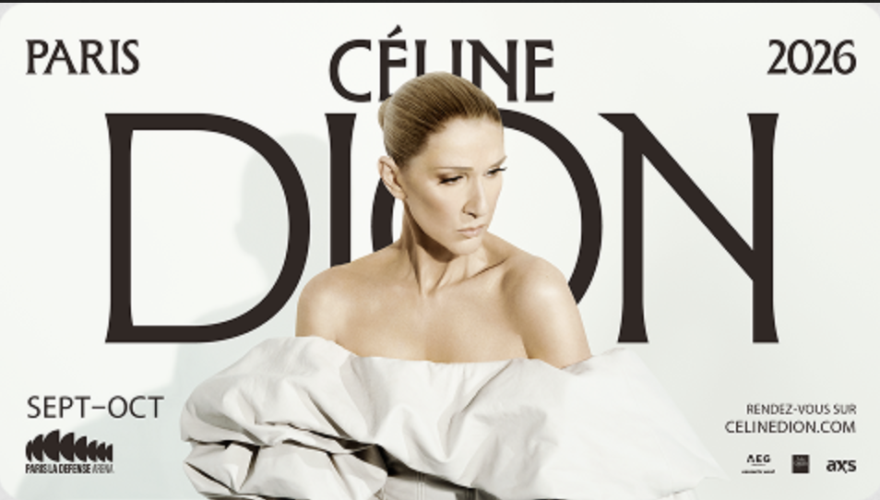
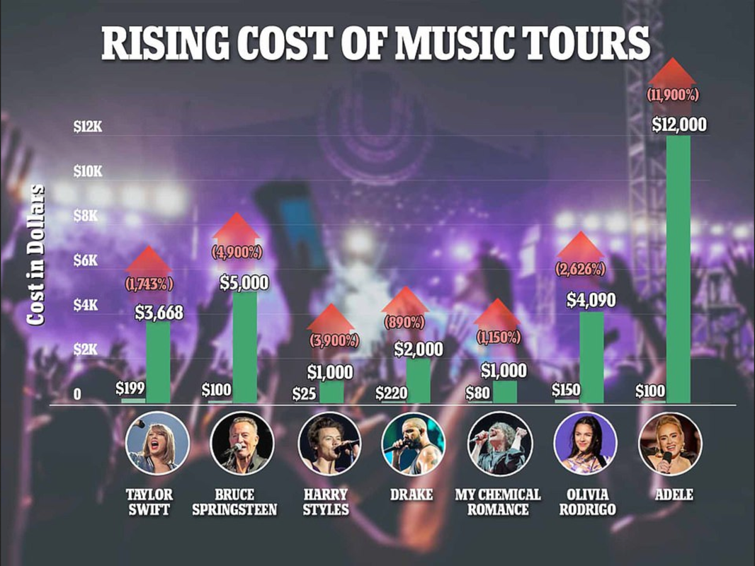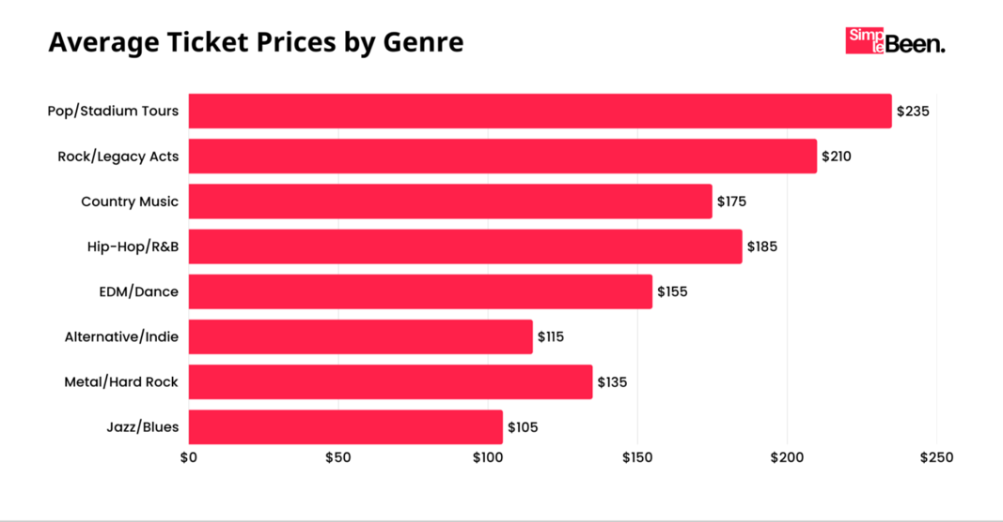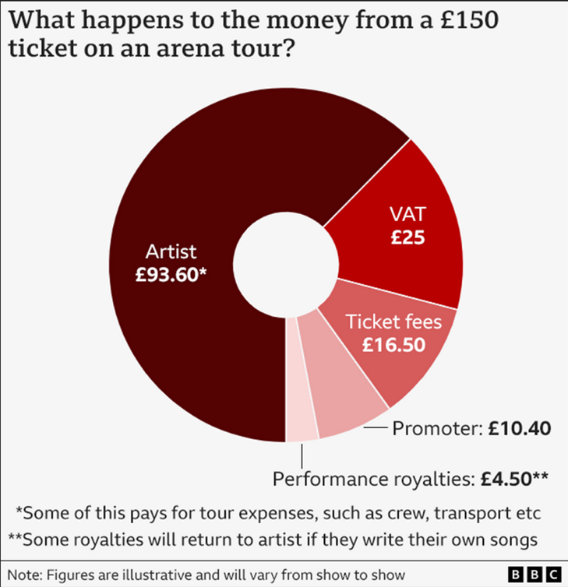

SYNTHESIS - CONCERT PRICES

DOC1 - The best gig I ever saw cost £4. Spiralling concert prices are a cultural disaster
John Harris Wed 8 Oct 2025 THE GUARDIAN
The 21st century may be a time of human estrangement, but the pleasures of watching our favourite band or singer play live surely unite millions of us. There is something about the whole ritual that crystallises what popular music fundamentally is: a profoundly democratic artform that will always soundtrack the lives of just about everybody.
But perhaps all that is on its way out. When it comes to big names, gig-going is becoming absurdly expensive. The ticket market is now both byzantine and hierarchical, often carving up audiences into no end of tiers. Thanks to the exploitative absurdity of “dynamic pricing” and resale websites, it also charges people much more than even the original face-value ticket prices. To track what’s going on in terms of average price rises can therefore be very difficult. But in the face of an ongoing cost of living crisis, the eye-watering upward trend is crystal-clear, and driven by those artists in the commercial super league of music. That may suit them and the industry players who take a cut, but it is starting to look like very bad news for everything music is supposed to represent.
The Manchester-based digital marketing agency Dark Horse recently published a report centred on a large handful of big-selling acts, and the differences between the prices they charge now and charged in 2005. (…) If ticket prices had gone up line with inflation, the average cost would now be £34.18. “This means fans are currently paying nearly three times more than what would be expected based on inflation alone,” the Post said. “The most significant jump in prices has occurred recently, with an 80.5% increase since 2021.”
There are heroes here too. Hats should be raised to the former Housemartins and Beautiful South frontman Paul Heaton, who recently capped prices for his gigs at big indoor venues at £35. Last week, those gnarled veterans the Cure announced summer dates with core prices starting at £77.50: their leader, Robert Smith, says dynamic pricing is a “scam” that is “just driven by greed”. (…)
There are some rising costs that musicians and venues cannot avoid: energy bills, the increasingly stupid prices charged by hotels, how much Brexit has added to touring expenses. Perhaps understandably, the huge decline in sales of music as a physical product has focused the mainstream industry’s attention on wringing as much money as possible from live performance. But a concert market dominated by a single corporate giant – Ticketmaster, is another part of the story.
Connected with all this is a change in many people’s understanding of what a gig actually is. I am quite old. The best concert I have ever seen was probably the Smiths at Salford University in the summer of 1986 – when they were in their pomp, and a ticket cost £4 (£12 in today’s prices, according to the Bank of England website). (…) The embodiment of the modern gig economy, by contrast, is the kind of sterile indoor arena that entails maximum efficiency – playing to as many people as you can in as few nights as possible – or, for music’s aristocracy, those huge stadiums.
These venues are a byword for astronomical prices, and contribute to audiences’ modern expectations of big screens and pyrotechnics and with no allowance for rough edges or artistic funny business. If you are paying big money to get in, that is hardly unreasonable. Yet it is also bad news for music’s creative health, and how people are likely to judge the kind of grassroots gigs that happen in more modestly sized places. Part of music’s current transformation is the fact that so many of the UK’s small venues – where ticket prices remain low, and are largely static – are still closing down, at speed. But if they are competing with gigantic spectacles staged in arenas and sports venues, is it any wonder that they find themselves struggling? Worse still, the insane money people have to pay for big gigs surely limits their spend on smaller ones.
The result is an art-form being shorn of its edges and twisted out of shape: if you ever wonder why so much 21st-century music seems to have so little to say about the troubling state of the world, its greedy economics are surely part of the explanation. Just to make this clear: plenty of music of substance is still being made. But how does this music break through and achieve the dream of mass communication when the gap between the grassroots and music’s upper echelons now seems so impossibly huge, and success involves more of a surrender of ethics and creative bravery than ever? (…)

DOC 2 - Concert Tickets Aren’t Expensive Enough Actually, Says Live Nation CEO
By Lauren Boisvert September 23, 2025, VICE
Live Nation CEO Michael Rapino recently claimed that concert tickets should cost way more, actually, while speaking at CNBC and Boardroom’s Game Plan conference. According to Rapino, who has a net worth of $997.1 million, concert tickets have been “underpriced” for “a long time.”
Rapino compared popular concerts to sports games, insinuating that sports fans actually enjoy spending thousands of dollars on tickets. By this logic, concertgoers should embrace higher prices, or at least learn to like it. “Music has been under-appreciated,” he said. “In sports, I joke it’s like a badge of honor to spend 70 grand for a Knicks courtside [seat]. They beat me up if we charge $800 for Beyoncé.”
Spending 70 grand on Knicks tickets is only cool if you have 70 grand in disposable income to spend on Knicks tickets. As usual, a millionaire CEO has said something so wildly out of touch that the veil keeping us all periodically shielded from the ever-present threat of late-stage capitalism has thinned once more.
Listen, with music—as with any art if you’re really serious about it—spending exorbitant amounts of money does not always equal appreciation. But beyond appreciation, there’s the question of accessibility. By claiming actually affordable ticket prices as “under-appreciation,” Live Nation risks alienating fans who simply can’t afford to fork over thousands of dollars to see Taylor Swift, or whoever.
Maybe that becomes an argument about the rising extravagance of mainstream pop concerts. Never fear, Rapino commented on this phenomenon as well.
“The cost has gone up” on concert tickets in recent times, he said, and some of that can possibly be attributed to inflation, different venue types, and artist demand. A lot of it is the direct influence of Live Nation and Ticketmaster’s monopoly on live music. But also, said Rapino, the increases have to do with mainstream artists turning concerts into an “investment in the experience.”
Referencing Beyoncé’s Cowboy Carter Tour, Rapino pointed out that she had “62 transport trucks” along with her. “That’s a Super Bowl she’s putting on every night. 10 years ago, there might’ve been 10 trucks.”
Yeah, and 10 years ago I paid $99 total for three tickets to see Fall Out Boy and Paramore on tour together. When does the madness end?
“We have a lot of runway left,” the Live Nation CEO continued. “So when you read about ticket prices going up, the average concert price is still $72. Try going to a Laker game for that, and there’s 80 of them. The concert is underpriced and has been for a long time.”
It’s important to note here that Rapino’s estimate of $72 for the average concert ticket is not strictly correct. According to data from Pollstar, the average stadium concert ticket in the U.S. actually costs $128.64. An arena show is $98.78, an amphitheater is $70.72, a theater $75.09, and a club show $43.95. The total average of all these came in at around $83.
Rapino’s initial figure is close, sure. But there’s no telling if he was taking into account venue differences. There’s also dynamic pricing to contend with, which has caused many complaints over the years. Most recently, U.S. Oasis fans raised hell when their Live ’25 tour dates went on sale.
“[Artists] are forfeiting margin for the experience,” said Rapino. “You hear about these $100 million grosses, that artist, depending on the show, might only take home 30 percent of that, spending 70 on the show.”
I’m sure actual billionaire Taylor Swift is really suffering from that measly 30 percent. Meanwhile, Eras Tour tickets on the secondary market reached between $1,652 and $3,801. One fan paid $5,500 for her tickets. Face-value tickets started at an average between $49 and $449, with VIP tickets between $199 and $899.
While there are still opportunities to spend $50 max on a ticket, those prices simply don’t exist for more popular, mainstream artists. If you want to see Beyoncé, Taylor Swift, Lady Gaga, or anyone else who falls under that umbrella, you’re going to have to shell out the big bucks. That, however, should not be the norm. There’s something severely broken in the system if people are going into massive amounts of debt just to see a pop star jump around for three hours.

DOC 3 - Live Nation’s CEO Says Concerts Are ‘Underpriced’ and in Demand. Are They Really?
September 22, 2025 ROLLING STONE By Jon Blistein
The live-entertainment industry is defined by its contradictions. Concerts seem to be more popular than ever, yet for every successful run, there’s a growing number of tours being canceled for financial reasons. Post-Covid inflation has driven up prices everywhere, including the cost of putting on a great tour, leading to higher ticket prices.
Speaking last week at CNBC and Boardroom’s Game Plan conference, Live Nation CEO Michael Rapino took a rosier outlook, insisting that the demand for live entertainment has never been higher, and tickets are “underpriced.”
“Music has been underappreciated,” Rapino said, especially compared with sports. “In sports, I joke it’s like a badge of honor to spend 70 grand for a Knicks courtside [seat]. They beat me up if we charge $800 for Beyoncé.” He added, “We have a lot of runway left. So when you read about ticket prices going up, the average concert price is still $72. Try going to a Laker game for that, and there’s 80 of them. The concert is underpriced and has been for a long time.”
But many fans may not feel like Rapino’s assessment of the situation matches their experience as concertgoers and ticket buyers. (…)
Even if Rapino did argue that concerts are still underpriced, he acknowledged that prices are rising. Much of that is due to the type of production many of the world’s biggest artists aim for. He added that “the cost has gone up” alongside the “investment in the experience.” (…)
Artists aiming to put on a great, elaborate show, while also making a living and paying a fair wage to their crews, certainly contribute to the cost of rising ticket prices. But those factors also exist alongside others, like sky-high fees, dynamic pricing (where prices fluctuate based on demand), and ongoing issues with scalpers. The significant power Live Nation and Ticketmaster have accumulated since their 2010 merger has ultimately left artists and fans with few other options but to accept the terms they set for the live-entertainment industry.
It’s possible that the landscape could shift soon. Last year, the Department of Justice filed an antitrust suit against Live Nation, accusing the company of operating as a monopoly. (Live Nation has denied the allegations, and the suit remains ongoing.) And just last week the Federal Trade Commission filed its own suit, accusing Ticketmaster of hiding fees from customers until checkout; allowing scalpers to “exceed” ticket-purchase limits; and then letting those same scalpers resell those tickets at significant markups on Ticketmaster’s own resale platform.
But for now, there is something revealing about the status quo. When fans purchase tickets marked up by dynamic pricing, or when scalped tickets sell on secondary platforms for hundreds more than face value, that ultimately shows exactly how much people are willing to spend on concert tickets. Or at least how much some people are willing to spend, if they can afford it. And in the U.S., there are still a lot of people who can afford it, at least for now, as wealth inequality grows and the economy feels increasingly unstable.
(…) Pollstar’s 2024 year-end report contained some possible warning signs. The report noted that there were “more festival and tour cancellations” in 2024 than at any time since the Covid-19 shutdown and the Great Recession between 2007 and 2009.

DOC 4 - Cartoons
a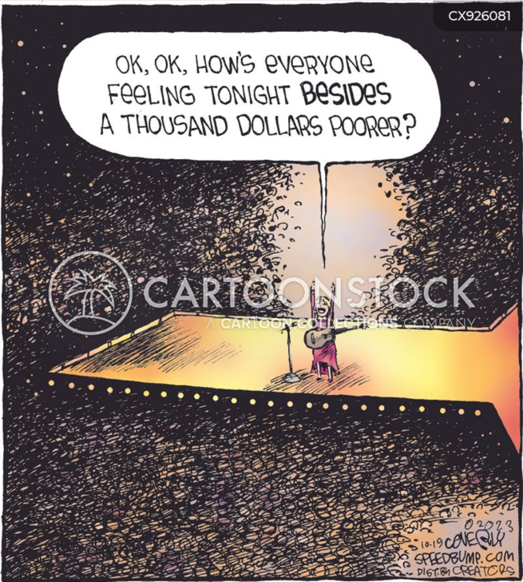 b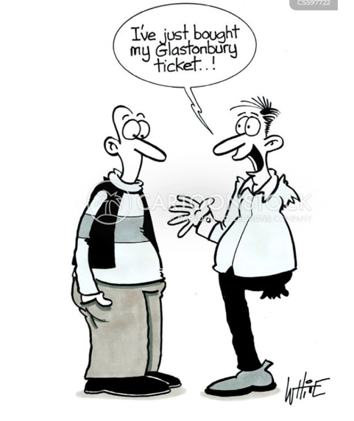 c 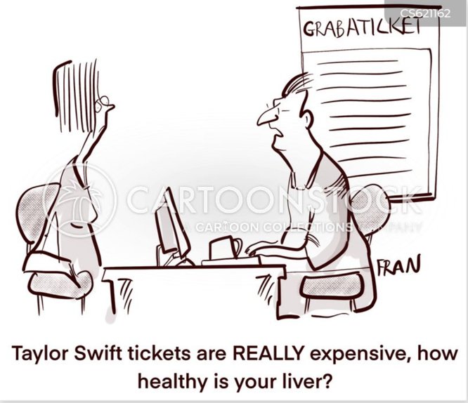
d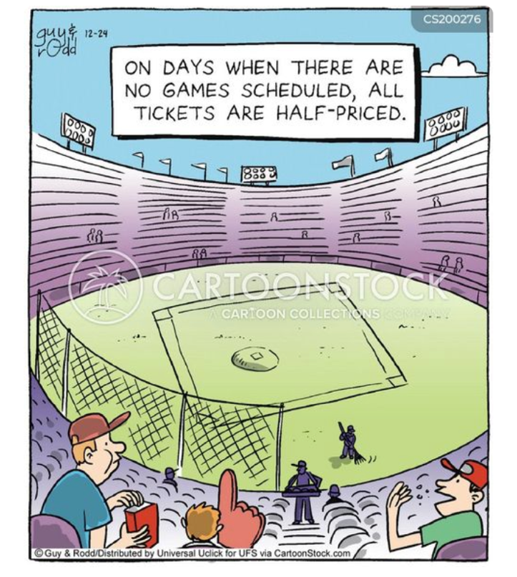e 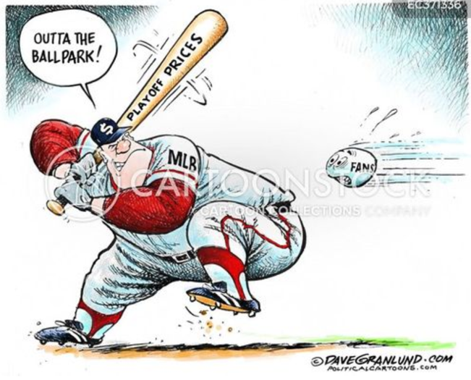

complex
Gradin, niveau

