**BOOKLET 2 - US DEMOCRACY IN TURMOIL?**

**I. Check mate?**

1. Explain the principle of checks and balances.
2. 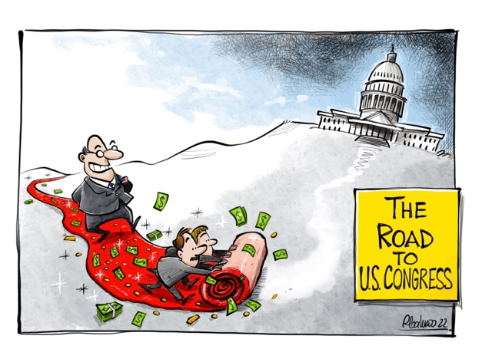Explain the limits of this principle according to these cartoons.

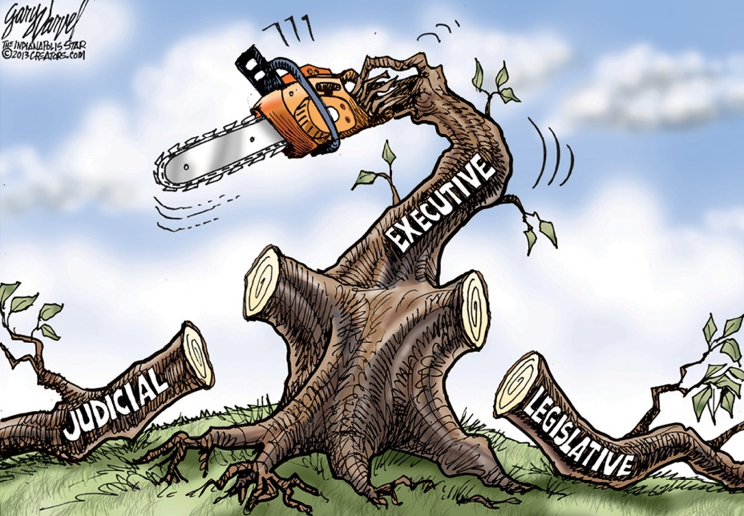

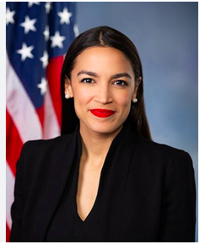**II. DEMOCRACY IN CRISIS?**

**DOCUMENT 1**

# Congresswoman Alexandria Ocasio-Cortez questions US democracy

<https://www.youtube.com/watch?v=NHVUcSG8j7g>

**WATCH THE VIDEO, TAKE NOTES AND EXPLAIN:**

**1) Why is AOC saying it is difficult to maintain the opinion that the US political system is truly democratic?**

**2) What are the main points that AOC makes to explain why the system is undemocratic?**

**3) How does she define the US System ?**

**4) Discuss : how could this be addressed ?**

**Gerrymandering** is the fact of changing the borders of an area in order to increase the number of people within that area who will vote for a particular party or person. To manipulate the boundaries of an [electoral](https://www.google.com/search?client=safari&sa=X&sca_esv=b127d74134c48222&rls=en&biw=1591&bih=1191&q=electoral&si=AMgyJEu0vuRfTngwPFrZh1qV1iGHlnWqboJqmLYTY7A96cEVc5dTs1cg0z69Akca4F-14csGkI8CPDg1m3zxFT6J77NJeCGZOamtdtW7rBYf4_77c-aiGhg%3D&expnd=1&ved=2ahUKEwjXrq292_-NAxVdVEEAHe0dDQIQyecJegQIPRAS) [constituency](https://www.google.com/search?client=safari&sa=X&sca_esv=b127d74134c48222&rls=en&biw=1591&bih=1191&q=constituency&si=AMgyJEvfjzRzn-1LlmPs29qkb8mq82WISH80nReCyCJWHzRDs5O9l33m3CV_tBN-SU9qcxWGBaUuzKTAYqaow-f4vtz5JVJx2GYzjnfBjAK7bvHze5dRy0Y%3D&expnd=1&ved=2ahUKEwjXrq292_-NAxVdVEEAHe0dDQIQyecJegQIPRAT) so as to favour one party: *The boundary changes were denounced as blatant gerrymandering.*

**Etymology***:* early 19th century, from the name of Governor Elbridge Gerry of Massachusetts + “[salamander](https://www.google.com/search?client=safari&sa=X&sca_esv=b127d74134c48222&rls=en&biw=1591&bih=1191&q=salamander&si=AMgyJEt_i95eqLH3KOj-Ut-VGJJ7Gt4SYAI9UctJQHcZe6aQ7ydirmu-xF2owvAdv8uu8tOTVLzgeLiazu8qN1zPt3b--cqVi2zc7ui43n9dpINfUpedLhU%3D&expnd=1&ved=2ahUKEwjXrq292_-NAxVdVEEAHe0dDQIQgCt6BAg9EBY)”, from the supposed similarity between a salamander and the shape of a new voting district on a map drawn when he was in office (1812)



# TO GO FURTHER

# Vox- *The decline of American democracy in one graph* <https://www.youtube.com/watch?v=T6a87L_f7js>

# ABC News: Obama warns US 'dangerously close' to losing democracy <https://www.youtube.com/watch?v=L3KV8PCRFD4>

# NY Times - The First Signs of Tyranny, From People Who Missed Them | NYT Opinion

<https://www.youtube.com/watch?v=X_D-yW8v0Jo>

**The original Gerry-mandering map from the Smithsonian website**: <https://www.smithsonianmag.com/history/where-did-term-gerrymander-come-180964118/>

**DOCUMENT 2**

# American democracy is fine. It’s the republic that’s in trouble.

[Theodore R. Johnson](https://www.washingtonpost.com/people/theodore-r-johnson/) – 23/05/2024 – *The Washington Post*

Democracy got the third degree at Morehouse College on Sunday. President Biden delivered the commencement address at the nation’s only all-male historically Black college. His remarks were appropriately laudatory, paying homage to the contributions of alumni such as the Rev. Martin Luther King Jr. The day’s message was that democracy — the only thing that can create a fair and just nation — is again under siege. He [positioned himself as its champion](https://www.whitehouse.gov/briefing-room/speeches-remarks/2024/05/19/remarks-by-president-biden-at-the-morehouse-college-class-of-2024-commencement-address-atlanta-ga/), vowing, “that’s my commitment to you: to show you democracy, democracy, democracy is still the way.” It was a promise of representation. And a gentle plea to keep hope alive.

It seemed a fitting sermon for a nation whose faith in government is in short supply. Congress is historically unpopular; this year, more than [80 percent of us disapprove](https://news.gallup.com/poll/1600/congress-public.aspx) of the job it’s doing. For the first time in decades of polling, Americans hold [more negative than positive](https://www.pewresearch.org/short-reads/2023/07/21/favorable-views-of-supreme-court-fall-to-historic-low/) views of the Supreme Court. And polls routinely tell of a general dissatisfaction with the choices for president. Unsurprising, then, that satisfaction with democracy is also [at a record low](https://news.gallup.com/poll/548120/record-low-satisfied-democracy-working.aspx).

And yet, a higher percentage of eligible voters participated in the 2020 presidential election [than any since 1900](https://www.electproject.org/national-1789-present), a time before women could vote and when more than 90 percent of Black Americans lived in the disenfranchising South. That’s a sign of democratic health. What’s in bad shape is the republic, the very thing Benjamin Franklin declared in 1787 had been created.

The difference is more than semantic. At heart, democracy prioritizes the “dêmos,” or the people, while the republic depends on representatives who act as the people’s advocates. The combination of the two — a democratic republic — best describes a system in which government requires our consent, and then works on our behalf. Our history has seen the slow growth and expansion of democracy as excluded people forced the government to seek their consent, as well. Now, after nearly 250 years, we’re most of the way there. Biden went to Morehouse to point out Black people’s decisive role in making democracy more accessible for everyone — and to warn that these gains are at risk.

Let’s not forget that Morehouse College is in Atlanta, cradle of the Civil Rights movement. It’s a plurality-Black city that knows the fight for voting rights as well as anywhere. Nevertheless, in 2020, people still [waited in line for up to 10 hours](https://www.washingtonpost.com/politics/georgia-early-vote-lines/2020/10/12/f8ffcd8c-0ca9-11eb-8a35-237ef1eb2ef7_story.html) to cast a ballot. On campus that morning, the more glaring problem is with the republic resulting from our democratic processes. Our national representatives do not, as a group, inspire confidence in government.

Political scientists have shown that public policy is most responsive to elite and business interests and least to the average citizen. When nonvoters are asked [why they opt out of elections](https://knightfoundation.org/reports/the-100-million-project/), more than 70 percent cite either the Electoral College’s trumping of the popular vote, a belief that the system is rigged and corrupt, or the undue influence of big money. More than one-third of voters don’t think election outcomes represent the people’s will. Gerrymandering and the electoral college have turned a people’s decisive vote into elections with razor-thin margins. Party primaries and campaign financing discourage principled pragmatists from government office, instead incentivizing sensational behavior by politicians.

This kind of republic gives democracy a bad name. Alexander Hamilton said[at the Constitutional Convention](https://oll.libertyfund.org/titles/farrand-the-records-of-the-federal-convention-of-1787-vol-1) in 1787: “The voice of the people has been said to be the voice of God. … It is not true in fact.” Better to empower the rich and well-born to check the mass of people who “seldom judge or determine right.” James Madison offered an assurance that the people’s representatives would be men of character, “whose patriotism and love of justice” will make them resistant to selfish pursuits and blind partisanship. Americans today — including the men of Morehouse, no doubt — have reason to think that Madison misjudged it.

<https://www.washingtonpost.com/opinions/2024/05/23/crisis-america-democratic-republic/>

**QUESTIONS**

1. **Why did President Biden choose to deliver a speech at Morehouse College?**
2. **What distinction does the author make between "democracy" and "republic," and why does he argue that the republic is currently in trouble?**
3. **Which factors contribute to Americans' declining trust in their government and political system?**

**Translation challenge**

1. Say in English: *Plus de 70 % des personnes qui ne votent pas expliquent leur abstention par le fait que le Collège électoral l’emporte sur le vote populaire ou par l’influence démesurée de l’argent dans le système électoral.*
2. Find the sentence in the article that is a rephrasing of your translation.

# MINES-PONTS - Imagine 2 questions that could be asked at the *concours*. The first one is about explaining / clarifying a point made in the article, the second one will be about giving your personal opinion about an issue raised in the text.

**DOCUMENT 3**

# We’re witnessing American democracy in all its glory – not the rise of fascism

## **The US political system is facing challenges, but it is robust enough to overcome them – as it has often before power** [Fraser Nelson](safari-reader://www.telegraph.co.uk/authors/f/fp-ft/fraser-nelson/) 24th October 2024 – *The Telegraph*

If there is method to Donald Trump’s madness, then John Kelly would be the man to explain it. A former general in the US Marines, he was seen as a force of sanity when he went into the White House as Chief of Staff. What he saw, he now says, was a president who “certainly falls into the general definition of fascist”. In any other time, such a verdict, from such a well-respected source, could be devastating.

But this language has been used so often as to have lost its force. Kamala Harris has been [calling Trump a fascist too](https://www.telegraph.co.uk/us/comment/2024/10/24/as-donald-trump-surges-desperate-kamala-harris-is-finally-r/), following an absurd line of attack that the Democrats have been running for months. “Is democracy still America’s sacred cause?” Joe Biden asked at a speech in January. “It’s what the 2024 election is all about.” This is what *The Washington Post* thought the 2016 election was about. When Trump won, it adopted a new motto: “Democracy dies in darkness.”

But democracy, as it turns out, didn’t die. For all of Trump’s antics, [the US economy prospered](https://www.telegraph.co.uk/news/2024/09/26/trump-must-get-back-to-campaign-basics-harris-us-election/), employment hit a record high and poverty among African Americans hit an all-time low. A wider world, unsure how the mercurial Trump would react, was on good behaviour. This is why it’s harder to say that a Trump victory would lead to calamity: it didn’t last time. And, yes, he attempted to bend the democratic rules. But that ended not just in failure but in the strengthening – even a rebirth – of the system he tried to subvert.

It’s hard to cut through the hyperbole of the democracy-in-crisis narrative but James Gibson, a professor at Washington University, has sought to do so in his essay *Democracy’s Destruction?*, published last month. He looks at Trump’s attempt to cling on to power, with the president claiming “absolute proof” that the 2020 election had been rigged. This, it’s fair to say, was a serious challenge to the democratic system. Trump accused the Supreme Court of being “weak” for ignoring his claim, and 86 judges, many appointed by Republicans and some by Trump himself, also did so. Mike Pence, his [unflinchingly loyal vice president](https://www.telegraph.co.uk/world-news/2023/05/10/donald-trump-sexual-abuse-mike-pence-loyal/), point-blank refused to send the results back to the states after studying the Electoral Count Act of 1887. Trump howled, “hang Mike Pence” chants began, protesters came looking for him in the Senate chamber. But democracy and its institutions prevailed.

Prof Gibson then looks at surveys testing genuinely anti-democratic propositions in the aftermath of all this. Should the Senate be done away with? How many say that, no matter what, Biden would “never be my president”? Or refuse to recognise laws he passed? No more than 12 per cent went along with any of these statements; about the same as still believe that Nasa faked the moon landings. It’s not much of a basis to have serious concerns about the impending death of American democracy.

If anything, demand for democracy has been growing. The Supreme Court’s decision to [overturn Roe vs Wade](https://www.telegraph.co.uk/world-news/2023/12/19/kamala-harris-abortion-us-election-2024-democrats-biden/) put abortion law back into democratic control by allowing each elected state legislature to decide their own rules. Even this decision did not lead to a majority wishing to constrain the Supreme Court’s independence, let alone abolish it. Americans may curse the result of their elections or the judgments of the Justices but they have faith in the system.

The balance between freedom and authoritarianism is certainly moving the wrong way, but this is generally due to democratic pressure. Those of us who opposed lockdown, the smoking ban and other incursions on liberty need to concede that they were depressingly popular – so we can’t very well say it’s undemocratic. It just means that the case for liberty needs to be made a bit better.

Whether you see Trump as a political antichrist or a necessary corrective to a broken system, it’s hard to find evidence that he is, in any meaningful sense, a fascist. At this stage, all that matters is how well each side persuades its supporters to get out and vote – which usually means saying that this is a contest between light and dark, good and evil. Between dictatorship and democracy. Americans do all this very well. But it doesn’t show a system in crisis. It shows that America, in spite of everything, can still lay on the greatest democratic

show on earth.

**Compare with the title of an article (by a different author) published in the same right-wing British newspaper *The Telegraph* on the 19th June 2025:** *We are witnessing the death of American democracy**https://www.telegraph.co.uk/business/2025/06/19/we-are-witnessing-the-death-of-american-democracy/?ICID=search-landing-article*

**QUESTIONS**

1. What is the main issue raised in the text?
2. What role do public attitudes and institutions like the Supreme Court play in maintaining democratic stability ?

**Translation challenge**

1. Say in French: *The US economy prospered, employment hit a record high and poverty among African Americans hit an all-time low*.
2. Rephrase this sentence.

**MINES-PONTS :** “Saying that “US democracy is in danger” is exaggerated”. Discuss (180 words, ±10%) Illustrate your answer with relevant examples.

**DOCUMENTS 4 Comment on these graphs and poll results.**

# DOC 4a - The Authoritarian Threat Index

We’ve partnered with the independent experts at Authoritarian Warning Survey to evaluate the current level of threat to American democracy. The score from 1 (healthy democracy) to 5 (total dictatorship) compiles ratings from democracy experts across the country and political spectrum on six key metrics that are related to our priority work areas.

*https://protectdemocracy.org*

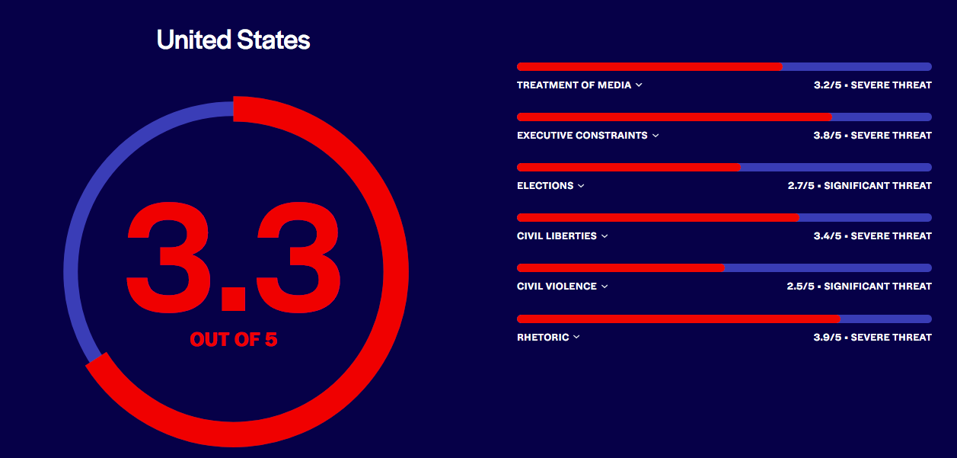

# DOC 4b – July 2025 NPR/PBS News Marist Poll

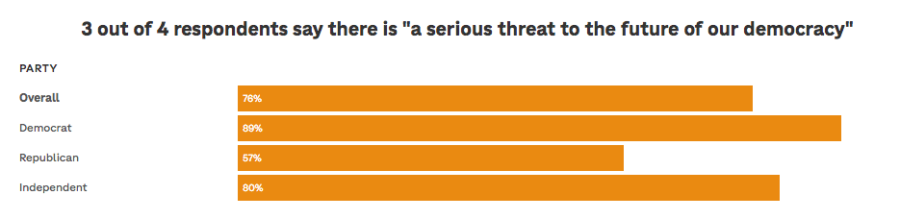

The overwhelming majority of respondents — 76% — said democracy is under serious threat. That's statistically unchanged from April of this year, but down significantly from August of 2023 when 87% overall said there was a serious threat to democracy. Republicans are largely responsible for the decline, going from 88% saying there was a serious threat — while Democrat Joe Biden was president — to 57% now.

**DOCUMENT 5**

# Former Supreme Court Justice Kennedy says ‘democracy is at risk’

The retired Reagan appointee joined a forum on threats to judges and the rule of law.

By [Josh Gerstein](https://www.politico.com/staff/joshgerstein) - POLITICO - 26/06/2025

Former Supreme Court Justice Anthony Kennedy warned Thursday that acrimonious political discourse and threats to judges are eroding the ability of the United States to serve as an example of democracy worldwide. “Many in the rest of the world look to the United States to see what democracy is, to see what democracy ought to be,” Kennedy said during an online forum about threats to the rule of law. “If they see a hostile, fractious discourse, if they see a discourse that uses identity politics rather than to talk about issues, democracy is at risk. Freedom is at risk.”

Kennedy, who stepped down from the court in 2018, avoided specifics during his 10-minute speech as part of a series of presentations by current and former judges. However, the Reagan appointee’s remarks appeared to be triggered at least in part by strident attacks President Donald Trump has mounted against judges, including some whom he appointed during his first term, who have ruled against the administration’s policies on immigration, firings of federal workers and his implementation of broad-based tariffs.

In March, Trump attacked U.S. District Court Judge James Boasberg as a “radical left lunatic” after he attempted to block the administration from deporting alleged Venezuelan gang members under a wartime presidential power Trump invoked. Trump also called for Boasberg, an Obama appointee, to be impeached. Last month, Trump issued a social media post denouncing “USA-hating” judges as “monsters who want our country to go to hell.”

The extreme rhetoric has come alongside a spike in threats against judges, although administration spokespeople have said the president opposes any threats and the Justice Department will prosecute them. “Judges must have protection for themselves and their families,” Kennedy said. “Our families are often included in threats.”

Some other participants were more explicit in calling out Trump’s salvos at the courts. While also not mentioning Trump by name, U.S. District Judge Esther Salas invoked the president’s statements more directly, arguing they are akin to attacks on judges that have caused other countries to slide into authoritarianism. “Judges are rogue. Sound familiar? Judges are corrupt. Sound familiar? Judges are monsters. Judges hate America,” Salas said. “We are seeing the spreading of disinformation coming from the top down.”

Salas, whose son was killed and her husband wounded by a disgruntled litigant at their New Jersey home in 2020, said the U.S. Marshals Service has tracked more than 400 threats against judges so far this year. “We’re going to break records — and not in a good way,” said the judge, an Obama appointee.

In his remarks Thursday, one day before his former Supreme Court colleagues are set to deliver their final rulings of the current term, Kennedy did offer some indirect praise for Trump. The retired justice repeatedly said he welcomed the ceasefire in fighting between Israel and Iran — a deal brokered by the White House. “The world is celebrating what looks like, what we hope might be, peace for a period of time in the Middle East,” Kennedy said. “Peace is what gives us the opportunity to make democracy stronger, to make freedom more attainable, to make freedom greater for ourselves and the rest of the world. We must always say no to tyranny and yes to truth.”

https://www.politico.com/news/2025/06/26/anthony-kennedy-democracy-judiciary-threats-00427714

**1. What is the main warning given by former Justice Anthony Kennedy in his speech?**  
A) The economy is declining rapidly  
B) The Supreme Court needs more power  
**C) Democracy is at risk due to hostile political discourse and threats to judges**   
D) The United States should change its Constitution

**2. According to the article, what has contributed to the rise in threats against judges?**  
A) Increased crime rates across the country  
**B) Political rhetoric and public attacks on judges**   
C) A lack of courtroom security  
D) The growing number of court cases

**3. How did Justice Kennedy express his concern about identity politics?**  
A) He said it helps voters make better decisions  
B) He praised its role in strengthening freedom  
**C) He said it distracts from real issues and weakens democracy**   
D) He didn’t mention identity politics at all

**4. How did U.S. District Judge Esther Salas relate political speech to authoritarianism?**  
A) She defended political leaders’ right to criticize judges  
B) She said authoritarian countries protect judges better  
**C) She said attacks on judges are similar to tactics used in authoritarian regimes**   
D) She denied any connection between rhetoric and violence

**5. What positive event did Kennedy mention in his speech, and why?**  
A) **A ceasefire between Israel and Iran — because peace supports democracy**   
B) Supreme Court decision about immigration — because it supported freedom  
C) A drop in crime rates — because it showed respect for law  
D) A new law protecting judges — because it ensures their safety

**Translation challenge - Find the equivalent in French in the article to :**

acrimonious (l.1) eroding (l.2) ought to (l.4) rule of law (l.5) fractious (l.5) identity politics (l.6) implementation (l.3) impeached (l.17) a spike (l.19) call out (l.23)

**MINES-PONTS**

1. According to the article, why does former Supreme Court Justice Anthony Kennedy believe that democracy in the United States is under threat? (80 words, ±10%)

Answer the question in your own words.

2. In your opinion, do attacks on judges threaten democracy ?

(180 words, ±10%) Illustrate your answer with relevant examples.