**A dis-United Kingdom ?**

**DOCUMENT 1**

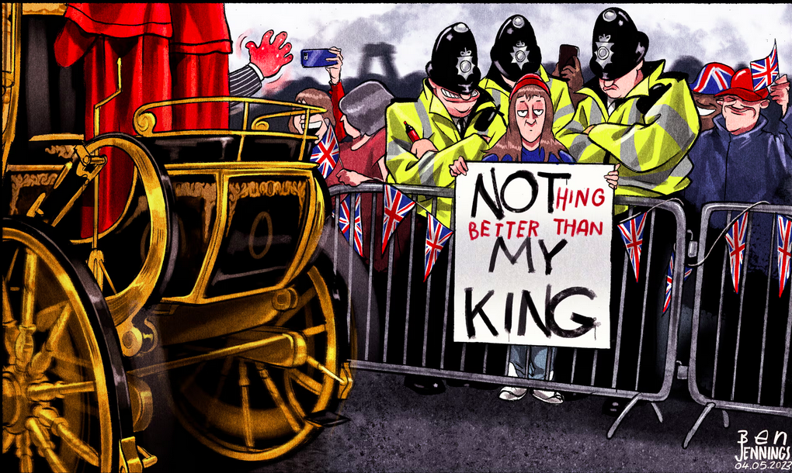

**QUESTIONS**

1. Consider the cartoon and guess the context.
2. Watch the videos. PAIRWORK Write down key words and recap with your partner. WHO? WHERE? WHY?

**<https://www.theguardian.com/uk-news/video/2022/sep/13/not-my-king-the-anti-monarchy-protesters-being-threatened-with-arrest-video-report>**

**<https://www.youtube.com/watch?v=dEwoAZkfWkM> SkyNews 8th May 2023**

**DOCUMENTS 2a 2b 2c 2d 2e**

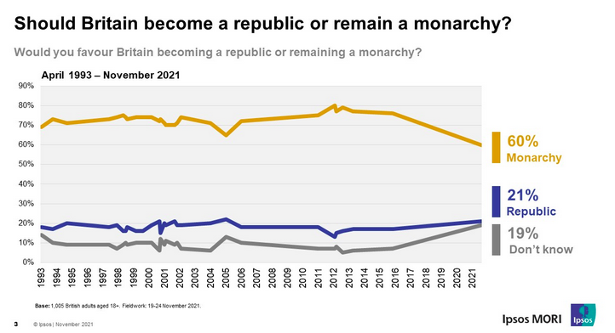

**2a**

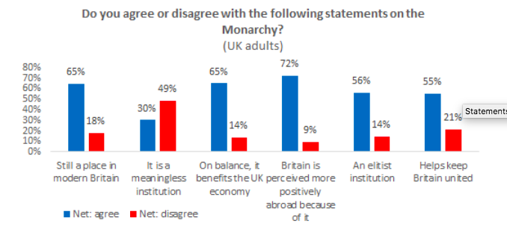

**2b**

**`**

**https://www.opinium.com/our-longest-reigning-monarch/**

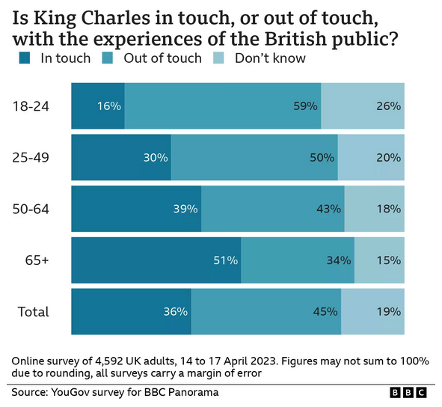

**2c**

**2d**

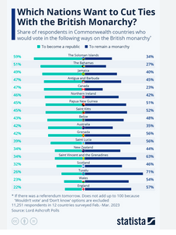

Statistics by YouGov for [BBC](https://www.bbc.co.uk/news/uk-65326467) Panorama

April 2023

**2e**

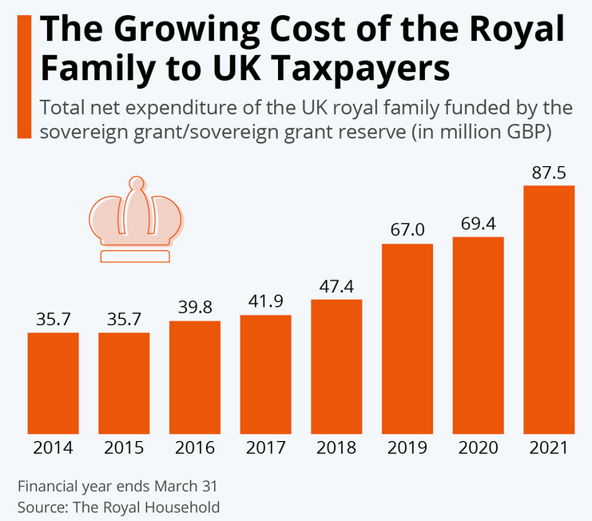

<https://www.statista.com/chart/30904/commonwealth-countries-who-would-vote-to-become-a-republic/>

https://www.statista.com/chart/18569/total-cost-of-the-uks-royal-family-by-year/

**QUESTIONS**

PAIRWORK : choose two charts to study with your partner and comment

# DISC DUR:Users:Mathilde:Desktop:Capture d’écran 2025-07-12 à 22.58.08.png

# DOCUMENT 3

# Trump state visit shows the King has won the battle for Canada

Hannah Furness – *The Telegraph* – 25th June 2025

*President dials down ambitions of a 51st state in return for the royal red carpet*

The fest, as [Donald Trump](https://www.telegraph.co.uk/donald-trump/) likes to call it, is coming. [The King](https://www.telegraph.co.uk/king-charles/) will host the US president in [September](https://www.telegraph.co.uk/news/2025/04/17/donald-trump-to-visit-king-charles-in-britain-in-september/) for a full state visit after plans were put on fast forward by the Government. The upgraded visit, originally proposed as a semi-private trip to see the King in Scotland, will give team Trump the “full bells and whistles” treatment and be based at Windsor Castle for the finest soft power the UK can throw at them.

It is said to have caused tension between the palace and Government, placing the King in the unenviable position of formally hosting a head of state who has [threatened to annex](https://www.telegraph.co.uk/royal-family/2025/05/20/king-visits-canada-house-after-trump-threats/) one of his own realms. After reports of the Prime Minister going “against the wishes of the King”, a Downing Street spokesman denied that [Sir Keir Starmer](https://www.telegraph.co.uk/keir-starmer/) had “overruled” him when negotiating with the White House.

Palace sources dismissed the idea that there is tension between the King and Sir Keir, emphasising that the monarch acts on the advice of the Government. “His Majesty has known president Trump for many years and looks forward to hosting him and the first lady later this year,” a palace aide said. The message? The red carpet will be rolled out as usual.

It is no secret though that the US state visit has proven one of the thorniest issues for the King on this year’s diplomatic stage. Mr Trump has repeatedly threatened to annex Canada, insisting relentlessly that it should be America’s “51st state”. The UK nevertheless invited him to be honoured. In turn, Mark Carney, the Canadian prime minister, said his countrymen “[weren’t impressed](https://www.telegraph.co.uk/politics/2025/05/14/carney-criticises-starmer-over-trump-state-visit/)” by the state visit invitation. British diplomats noted that Mr Carney risked breaching the convention that realms tend not to publicly criticise one another.

However, the King stepped up. As Canadian sovereign, he was dragged willingly into Canada’s plans to show its own power. The King’s involvement saw him fly to Ottawa in May for less than 24 hours on Canadian soil to deliver a speech at its parliament, reminding the world it is “strong and free”. It was rightly interpreted as a public rebuke of Mr Trump’s ambitions. One senior palace source said it was intended as “thought-provoking, not provocative”. The King was, they said, “leveraging on the long relationships he has built over the years” and using his role “to the benefit of all the realms and commonwealth nations at a time of great international challenge”.

Then, the idea of hosting Mr Trump in September seemed a challenge. However, the storyline has moved on. Some would argue, in fact, that the firming up of plans for the [US state visit](https://www.telegraph.co.uk/news/2025/03/07/why-trumps-state-visit-could-spark-a-constitutional-crisis/) is a sign that the King has quietly won the battle for Canada. Everyone is aware of the “diplomatic tightrope” the King has been walking, said one source, but he has done so with “great skill”.

Last week, Mr Carney said he no longer believes Mr Trump is interested in a “51st state” plan. Asked by CNN whether the US president is still threatening to annex Canada, he said: “No, he is not.” “He admires Canada,” he added. “I think it’s fair to say maybe for a period of time [he] coveted Canada.” It is a matter of some satisfaction in British diplomatic circles that Mr Trump’s rhetoric has dialled down drastically. “We haven’t heard much about Canada, have we?” one source asked of the past few weeks.

The King’s transatlantic show of force, it seems, has worked. Mr Trump has got his way when it comes to the details of the state visit. His team made it clear that the original suggestion of a low-key trip to see the King was not the order of the day. “The president loves the pomp and ceremony,” said one source familiar with the negotiations. “He doesn’t want a private photograph with the Royal family – he wants a public one.” Mr Trump has described it as a “fest”, denoting the high level of flattery and fun he expects. The manu regia – the formal paperwork cementing the invitation – was signed by the King last week and hand delivered to the White House by representatives from the British Embassy in Washington.

The King hopes to return to Canada at some point soon. Before then, he will raise a toast to the US at a state banquet in September with Mr Trump by his side. If the King’s inevitable praise for America and Americans can be heard without guests’ minds leaping immediately to Canada, the palace can consider it a job well done. It is a strategy not without risk, but high stakes can produce high rewards. It could – and should – be the moment that the idea of America invading

its nearest neighbour is finally put to rest.

*https://www.telegraph.co.uk/royal-family/2025/06/25/trump-state-visit-shows-the-king-has-won-battle-for-canada/*

**QUESTIONS**

1. **Why was the upcoming US state visit seen as diplomatically difficult for the King?**
2. How did the King respond to President Trump's annexation rhetoric regarding Canada, and what message did his actions convey?
3. What evidence is presented in the article to suggest that the King may have successfully defused tensions over Trump’s ambitions toward Canada?

**Translation challenge**

1. Say in English: *La visite d'État américaine s’est indéniablement révélée être l’un des dossiers diplomatiques les plus délicats pour le roi cette année.*
2. Find the sentence in the article that is a rephrasing of your translation.

# MINES-PONTS - Imagine 2 questions that could be asked at the *concours*! The first one is about explaining / clarifying a point made in the article, the second one will be about giving your personal opinion about an issue raised in the text.

**DOCUMENT 4** **Caribbean nations set to demand royal family makes reparations for slave trade**

*[Donna Ferguson](https://www.theguardian.com/profile/donna-ferguson)* Sun 10 Sep 2023 THE GUARDIAN

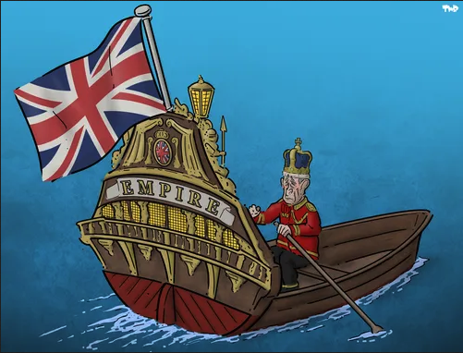

Caribbean nations are preparing formal letters demanding that the British royal family apologise and make reparations for slavery. National reparations commissions in the region will also approach Lloyd’s of London and the Church of England with demands of financial payments and reparative justice for their historic role in the slave trade.

Speaking to the newspaper in Grenada, Arley Gill, a lawyer and chair of the island nation’s reparations commission, said: “We are hoping that King Charles will revisit the issue of reparations and make a more profound statement beginning with an apology, and that he would make resources from the royal family available for reparative justice. We believe we can sit around a table and discuss what can be made available for reparative justice.” He added that the duty to offer reparations lay “at all levels, banks, churches, insurance companies like Lloyd’s, and universities and colleges that benefited”.

Earlier this year, the Guardian revealed that direct ancestors of King Charles III and the royal family bought and exploited enslaved people on tobacco plantations in Virginia. The Guardian has also found documents linking the slave trader Edward Colston to the British monarchy. In response to the Guardian’s reporting, Charles signalled for the first time his support for research into the links between the British monarchy and the transatlantic slave trade.

A Buckingham Palace spokesperson said at the time that the king took the issue of slavery “profoundly seriously”, which he has described as an “appalling atrocity”. Support for the research was part of Charles’s process of deepening his understanding of “slavery’s enduring impact”, the spokesperson said, which had “continued with vigour and determination” since his accession. However, he has not yet formally apologised for Britain’s heavy involvement in the slave trade.

An estimated 3.2 million enslaved African people were transported around the world by Britain’s vast shipping industry between 1640 and the early 19th century. Lloyd’s of London, which was the global centre for insuring that industry, has said it is “deeply sorry” for its participation in the trade. “It is part of our shared history that caused enormous suffering and continues to have a negative impact on Black and ethnically diverse communities today,” the company stated on its website.

Leading figures in the Church of England also owned enslaved people and it has previously admitted that a predecessor of its modern investment fund, called Queen Anne’s Bounty, invested significant sums in the slave-trading South Sea Company in the 18th century. “There’s no doubt that those who were making the investment knew that the South Sea Company was trading in enslaved people, and that’s now a source of real shame for us, and for which we apologise,” Gareth Mostyn, chief executive of the Church Commissioners, told BBC radio earlier this year.

Adrian Odle, a lawyer and commission chair, told the Telegraph that British institutions are compromised by their ancestral guilt, saying “every property that the royal family is in possession of has the scent of slavery”. He will push to bypass the UK government, which has so far not been receptive to the idea of reparations, with formal letters to be drafted and delivered by December.

**QUESTIONS**

1. What is the main issue raised in the text? Who is concerned?
2. Consider the cartoon and the information given in the article. Draw conclusions.
3. **DISCUSS**: What can British institutions do to face their controversial ties to the slave trade?

**Translation challenge**

1. Say in English: *Aucune excuse formelle n’a encore été présentée pour l’implication majeure de la Grande-Bretagne dans la traite des esclaves*.
2. Find the sentence in the article that is a rephrasing of your translation.

**MINES-PONTS :** “King Charles should apologize”. Discuss (180 words, ±10%) Illustrate your answer with relevant examples.

**DOCUMENT 5**

**Bresignation: British people are ready to turn a page on the EU referendum vote**

Adapted from *The Conversation*, November 19th, 2024

Much is made of the alleged [state of Bregret](https://www.theguardian.com/commentisfree/2023/jan/31/three-years-on-brexit-uk-voters-rejoining-eu-labour-europe) – the idea that even those who voted for Brexit now regret their decision. It is true that [a majority (54%) now think Britain was wrong to vote to leave](https://www.whatukthinks.org/eu/questions/in-highsight-do-you-think-britain-was-right-or-wrong-to-vote-to-leave-the-eu/) the EU. According to a YouGov poll, [62% of people](https://yougov.co.uk/politics/articles/50317-labour-does-not-have-a-mandate-to-take-britain-back-into-the-eu-says-public) think Brexit has been more of a failure than a success. We even know that 18% of leave voters would now vote remain if they could have another go at the 2016 referendum.

But conjuring up the past is a logical impossibility. A “rejoin” option would not be the same as the “remain” option. The European Union would have understandable hesitations about readmitting the UK without greater commitments than in the past – and might, for example, expect the UK to join the euro.

When studying attitudes towards rejoining the EU, it quickly becomes apparent that voters see this clearly. The feeling of having made one’s bed and now having to lie in it [is quite widespread](https://www.whatukthinks.org/eu/questions/in-highsight-do-you-think-britain-was-right-or-wrong-to-vote-to-leave-the-eu/).

When polled about a potential referendum on rejoining the EU, [only 48% of the UK public solidly supported it](https://ukandeu.ac.uk/reports/exploring-bregret-public-attitudes-to-brexit-seven-years-on/).

Both leavers and remainers are in an impossible bind. They recognise that the process of leaving the EU was very far from the pipe dream sold by the Leave campaign but neither can do anything about it.

For leavers, the idea that Brexit was a mistake triggers discomfort. They are in what behavioural scientists call a state of [cognitive dissonance](https://www.psychologytoday.com/gb/basics/cognitive-dissonance). When we cannot change a past action, we often decide to change how we see and interpret new evidence about that action in order to avoid the cognitive inconsistency and the psychological discomfort of being wrong about it. For leavers, this means joining the 47% [who think that Brexit is not done](https://yougov.co.uk/topics/politics/survey-results/daily/2024/08/28/d229d/2), or the nearly 30% who think it [could have been a success](https://yougov.co.uk/politics/articles/50317-labour-does-not-have-a-mandate-to-take-britain-back-into-the-eu-says-public) if the UK had better politicians and negotiators.

To overcome this state of “bresignation” and truly trigger a reset in UK-EU relations, the UK government first needs to gather information on how the current arrangement - the Trade and Cooperation Agreement - is going, and to communicate this evidence in a unifying way.

Public opinion is still very much in favour of retaining control over UK regulations and trade deals. But there is [significant support](https://journals.sagepub.com/doi/full/10.1177/14651165221123155) for a closer relationship with the EU and for the removal of most – if not all – trade barriers on goods and services. There is, therefore, scope to sell regulatory alignment by focusing on its flexible, conditional nature and on the perks of easing trade with the world’s largest trading block.

People are also less fussed about conditional freedom of movement than the government thinks. They favour flexible immigration quotas to dynamically deal with sectoral shortages, such as in the NHS, or for high-skilled talent.

A reset is in the realms of possibility, therefore. But the UK government first needs to break us

free from the state of bresignation.

**QUESTIONS - REMEMBER: Recap the key dates of Brexit. Choose the right answer and then discuss with your partner.**

**1. According to recent polls mentioned in the article, how do most Britons now view Brexit ?**

**A.** Most Britons still support Brexit, and only 5% of Leave voters regret their choice  
**B.** A majority believe Brexit was a success, and 10% of Leave voters would now vote Remain  
**C.** Most people think Brexit was a mistake, and 18% of Leave voters would now vote Remain  
**D.** Support for Brexit has grown, with 62% saying it has been successful

### ****2. Why is a "rejoin" option not seen as equivalent to the original "remain" vote, and what might the EU expect from the UK if it wanted to rejoin?****

**A.** The EU would insist on a trade deal before rejoining  
**B.** The EU might expect the UK to adopt new commitments, such as joining the euro  
**C.** The UK would automatically regain its previous membership conditions  
**D.** The UK would have to leave NATO before rejoining the EU

### ****3. What is meant by the term “bresignation,” and what steps does the article suggest the UK government should take to move past this state and reset relations with the EU?****

**A.** Bresignation means giving up on politics entirely;   
**B.** It refers to regret over Boris Johnson’s resignation; the government should call for elections  
**C.** It’s a state of passive acceptance of Brexit; the government should gather evidence and communicate clearly about current UK-EU relations  
**D.** Bresignation is a movement to rejoin the EU immediately; the UK should apply for membership now

**Translation challenge - Find the equivalent in French in the article to :**

an impossible bind (line 14) a pipe dream (line 15) to make your bed and lie in it (line 11)

there is scope (line 28) the perks (line 29)

**MINES-PONTS**

1. According to the journalist, why are British people resigned over Brexit? (80 words, ±10%)

Answer the question in your own words.

2. In your opinion, is freedom of movement an essential element of European agreements ?

(180 words, ±10%) Illustrate your answer with relevant examples.